Setup and Introduction

Selected AI Tool: GitHub Copilot

Introduction:

GitHub Copilot is an AI-powered code completion tool developed by GitHub in collaboration with OpenAI. It leverages the power of OpenAI's Codex model to assist developers by providing code suggestions, autocompletions, and even generating entire code snippets based on the context of the code being written. The primary features of GitHub Copilot include:

Contextual Code Suggestions: Provides real-time code suggestions as you type, based on the context of the current file and project.

Code Generation: Can generate entire functions or classes based on a brief description or comment.

Multi-Language Support: Supports a wide range of programming languages, including Python, JavaScript, TypeScript, Ruby, and more.

Integration with IDEs: Seamlessly integrates with popular IDEs like Visual Studio Code, making it easy to use within your existing development workflow.

Experimentation

Project/Task: Creating a Simple Web-Based Calculator Using Flask

**Process Documentation:**

Setting Up the Project:

Created a new directory for the project.

Initialized a virtual environment and installed Flask using pip install flask.

Creating the Flask Application:

Gave requirements to Github Copilot

Here’s the prompt

“ Hey I would like create a simple calculator using flask please help me with the task “

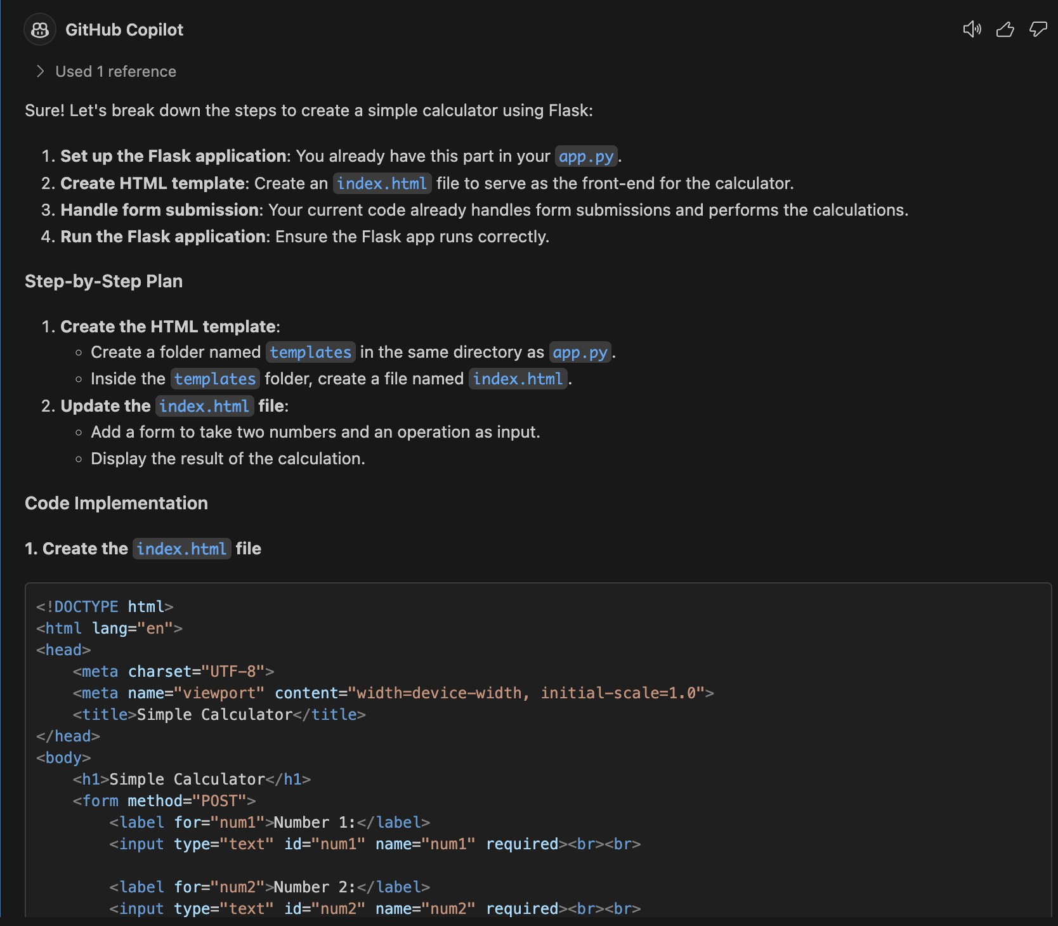

Created app.py to set up the main Flask application.

Defined the route for the home page (/) and implemented the logic for handling arithmetic operations (addition, subtraction, multiplication, division).

Creating HTML Template:

Created templates/index.html to design the user interface for the calculator.

Included form elements for inputting numbers and selecting operations.

Styling the Application:

Created static/style.css to add basic styling to the calculator.

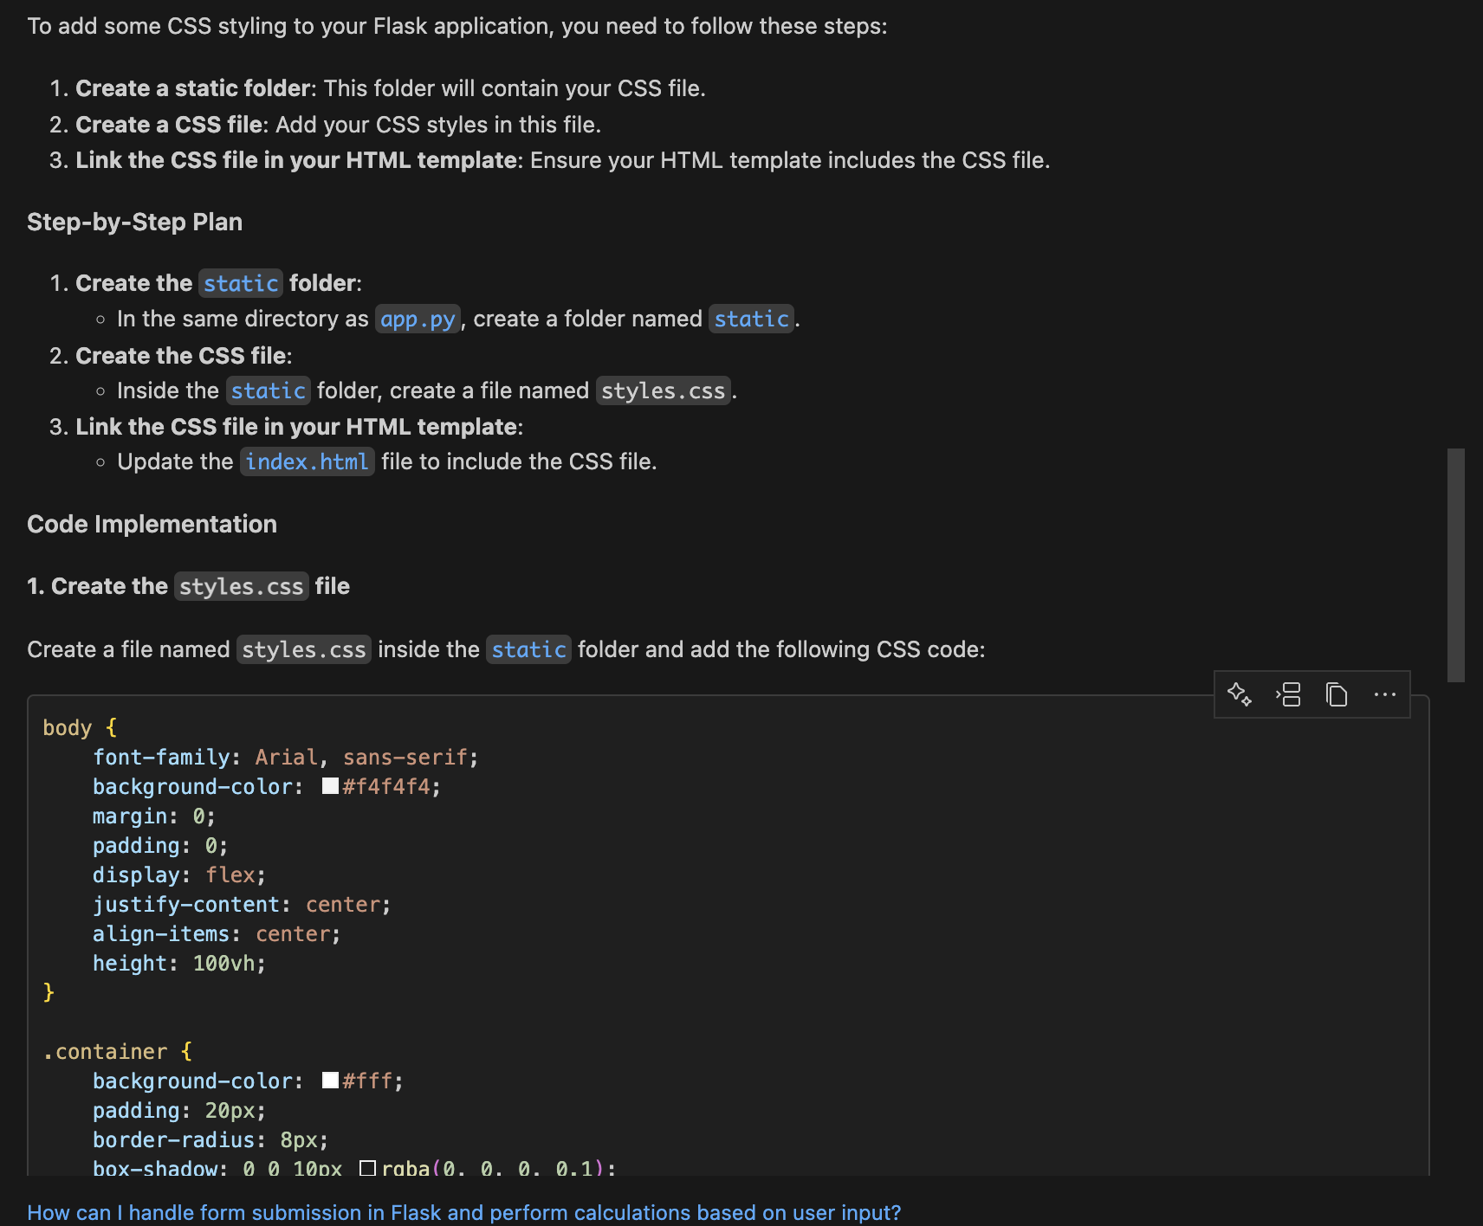

Running and Testing the Application:

Initially the port is not set correctly so I have hardcoded the port. Thanks tocopilot I was able to come to this conclusion

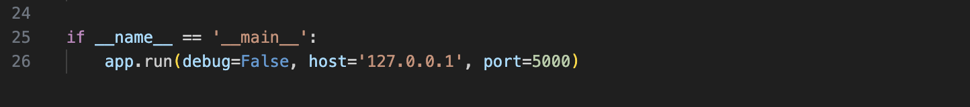

Ran the Flask application using python app.py.

Tested the application by accessing http://127.0.0.1:5000/ in a web browser.

**Challenges Encountered:**

Initially encountered an HTTP 403 error due to incorrect host and port configuration.

Resolved the issue by explicitly setting the host and port in the app.run method.

AI Tool Assistance:

* GitHub Copilot provided contextual code suggestions while writing the Flask application.
* Assisted in generating the HTML template and CSS styles.
* Helped troubleshoot the HTTP 403 error by suggesting the correct configuration for the Flask application.

Initially the port is not set correctly so I have hardcoded the port. Thanks to copilot I was able to come to this conclusion



Finally a working version of the app

**Analysis and Reflection**

Effectiveness Analysis

Effectiveness of GitHub Copilot:

GitHub Copilot proved to be highly effective in assisting with the task of creating a simple web-based calculator using Flask. Here are some key points highlighting its effectiveness:

Code Suggestions:

Provided accurate and relevant code suggestions in real-time, significantly speeding up the development process.

Suggested complete code snippets for common tasks, such as setting up routes in Flask and handling form submissions.

Error Prevention:

Helped prevent common errors by suggesting best practices and correct syntax.

Assisted in troubleshooting issues, such as the HTTP 403 error, by providing relevant configuration suggestions.

Learning Aid:

Served as an excellent learning aid by providing explanations and examples for unfamiliar concepts.

Enabled a smoother learning curve for using Flask and other technologies involved in the project.

Time Efficiency:

Reduced the time spent on writing boilerplate code and searching for documentation.

Allowed for more focus on the core logic and functionality of the application.

Reflection:

Using GitHub Copilot for this project demonstrated the potential of AI tools in enhancing software development productivity. The tool's ability to provide contextual code suggestions and generate relevant code snippets made the development process more efficient and enjoyable. While it is not a replacement for human developers, it serves as a powerful assistant that can augment the capabilities of developers, especially in repetitive or boilerplate tasks.

Overall, GitHub Copilot proved to be a valuable asset in this project, and its integration into the development workflow can lead to significant improvements in productivity and code quality.

**Note** : I have used copilot to generate the sample documentation for me and I’ve edited it accordingly.