SMART PANTRY MANAGER
A Java Android application that suggests recipes based strictly on leftover ingredients to cut food waste
Mobile App Development 700
Practical Assignment
Name: Gomolemo
Student number: 402411229
Faculty of Information Technology
GitHub repository:
https://github.com/402411229/SmartPantryManager402411229

Table of Contents
1. Introduction 3
2. System Design 3
2.1 Screen flow 3
2.2 Data model 4
2.3 The almost there list 4
2.4 Why SQLite 4
3. Screenshots of the Application 5
4. Key Code Snippets 9
4.1 Creating the tables 9
4.2 The strict matching rule 9
4.3 Matching names that are not written the same way 9
4.4 Keeping the list up to date 10
4.5 Finding the almost there recipes 10
5. Challenges and Solutions 11
5.1 The Recipes button did not appear on the toolbar 11
5.2 Ingredients written in different units 11
5.3 Testing that the data really persists 11
6. Conclusion and Reflection 11
7. References 12

1. Introduction
Food goes to waste in almost all households weekly. In many cases, this happens not because the people are unwilling to prepare something, but simply because they open their refrigerator, see some random products left there, and do not come up with a recipe for this particular combination. They purchase other food, and this one becomes expired.
Smart Pantry Manager is a Java-based Android application designed to solve this tiny issue. User creates a list of ingredients available in his house, and the application provides the answer to one simple question: what can be prepared using this set of products without making a trip to the store?
The application is designed for students and single persons, who buy limited quantities of food and want to use everything they have before it expires. The app is not a shopping app, it does not search for the stores; it uses the user's list of ingredients exclusively.
The rule that makes the app useful is strict. A recipe is only suggested when every single ingredient in that recipe is already in the pantry. A recipe that is missing even one item is left out completely, because suggesting it would send the user to the shop, which is the thing the app is trying to avoid.

2. System Design

2.1 Screen flow
The application has five screens. MainActivity is the home screen and every other screen is opened from it with an Intent. The diagram below shows how they connect.
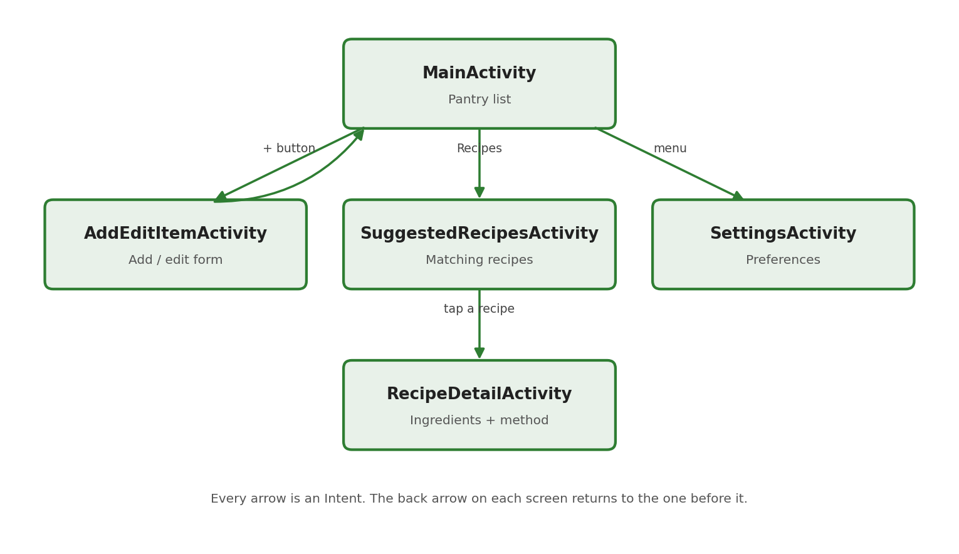
Figure 1: Screen flow of the application
MainActivity shows the pantry. The floating + button opens AddEditItemActivity, and the same screen is opened again when the user taps an item, except that the item id is sent with the Intent so the form comes up already filled in. The Recipes button on the toolbar opens SuggestedRecipesActivity, and tapping a recipe there opens RecipeDetailActivity with the recipe id. Settings is opened from the menu.

2.2 Data model
The data is kept in a SQLite database with three tables. The pantry table holds what the user owns. The recipes and recipe_ingredients tables hold the 18 recipes that are written into the database the first time the app runs.
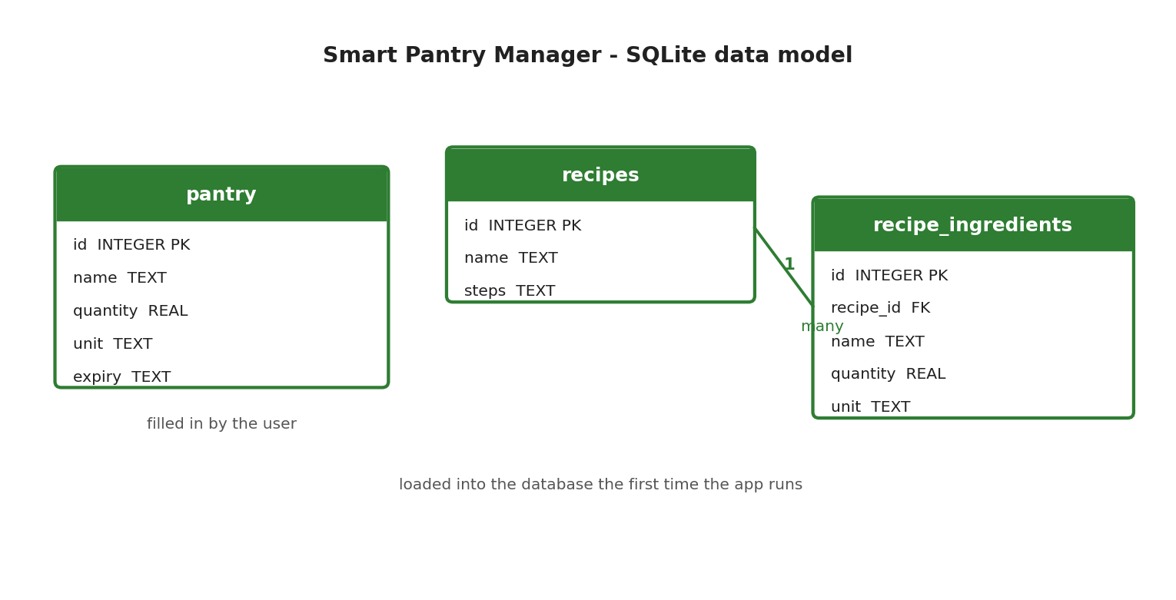
Figure 2: Database tables and the relationship between them
One recipe has many rows in recipe_ingredients, and each of those rows points back to its recipe with the recipe_id foreign key. The pantry table is separate because it belongs to the user and not to any recipe.

2.3 The almost there list
The strict rule on its own throws away useful information. If a recipe is missing only one ingredient the user may well have that one item, or may be willing to buy it, but the strict list can never show it. To keep the main rule strict and still give the user that information, the recipes that are missing exactly one ingredient are put in a second list called "Almost there".
This list sits under a divider at the bottom of the Suggested Recipes screen, with its own orange heading and a line explaining that these meals cannot be cooked yet. Each row also names the one ingredient that is still needed. The two lists are never mixed, so the suggestions at the top of the screen still only contain recipes where every ingredient is in the pantry.

2.4 Why SQLite
SQLite was chosen instead of Firebase or PostgreSQL for three reasons. The app is used by one person on one phone, so there is nothing to share between users and no reason to send the data over the internet. It must work in a kitchen where there may be no signal, and SQLite works completely offline. It also needs no account, no server and no monthly cost, which keeps the project simple. Firebase would have added a login and an internet connection for no benefit, and PostgreSQL would have meant building and hosting a backend as well as the app.

3. Screenshots of the Application
All the screenshots below were taken from the application running on a Pixel 3a emulator with API level 34.
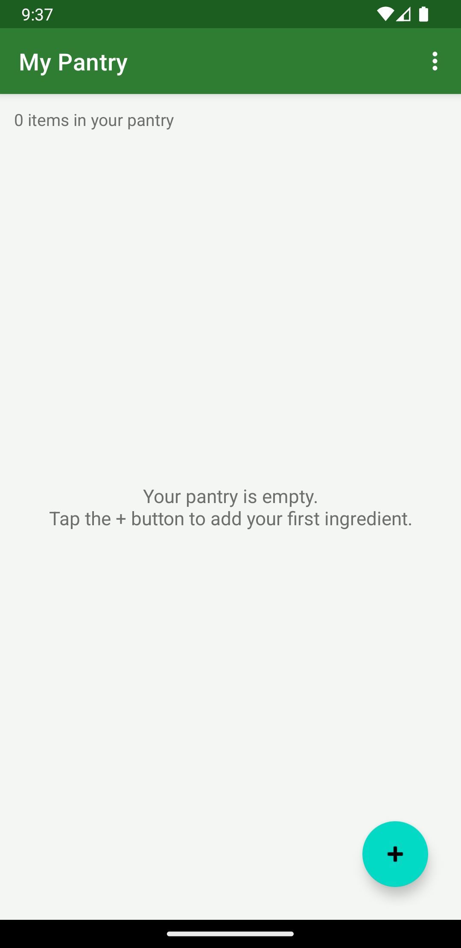  Figure 3: First run. The pantry is empty and the app explains what to do instead of showing a blank screen. | 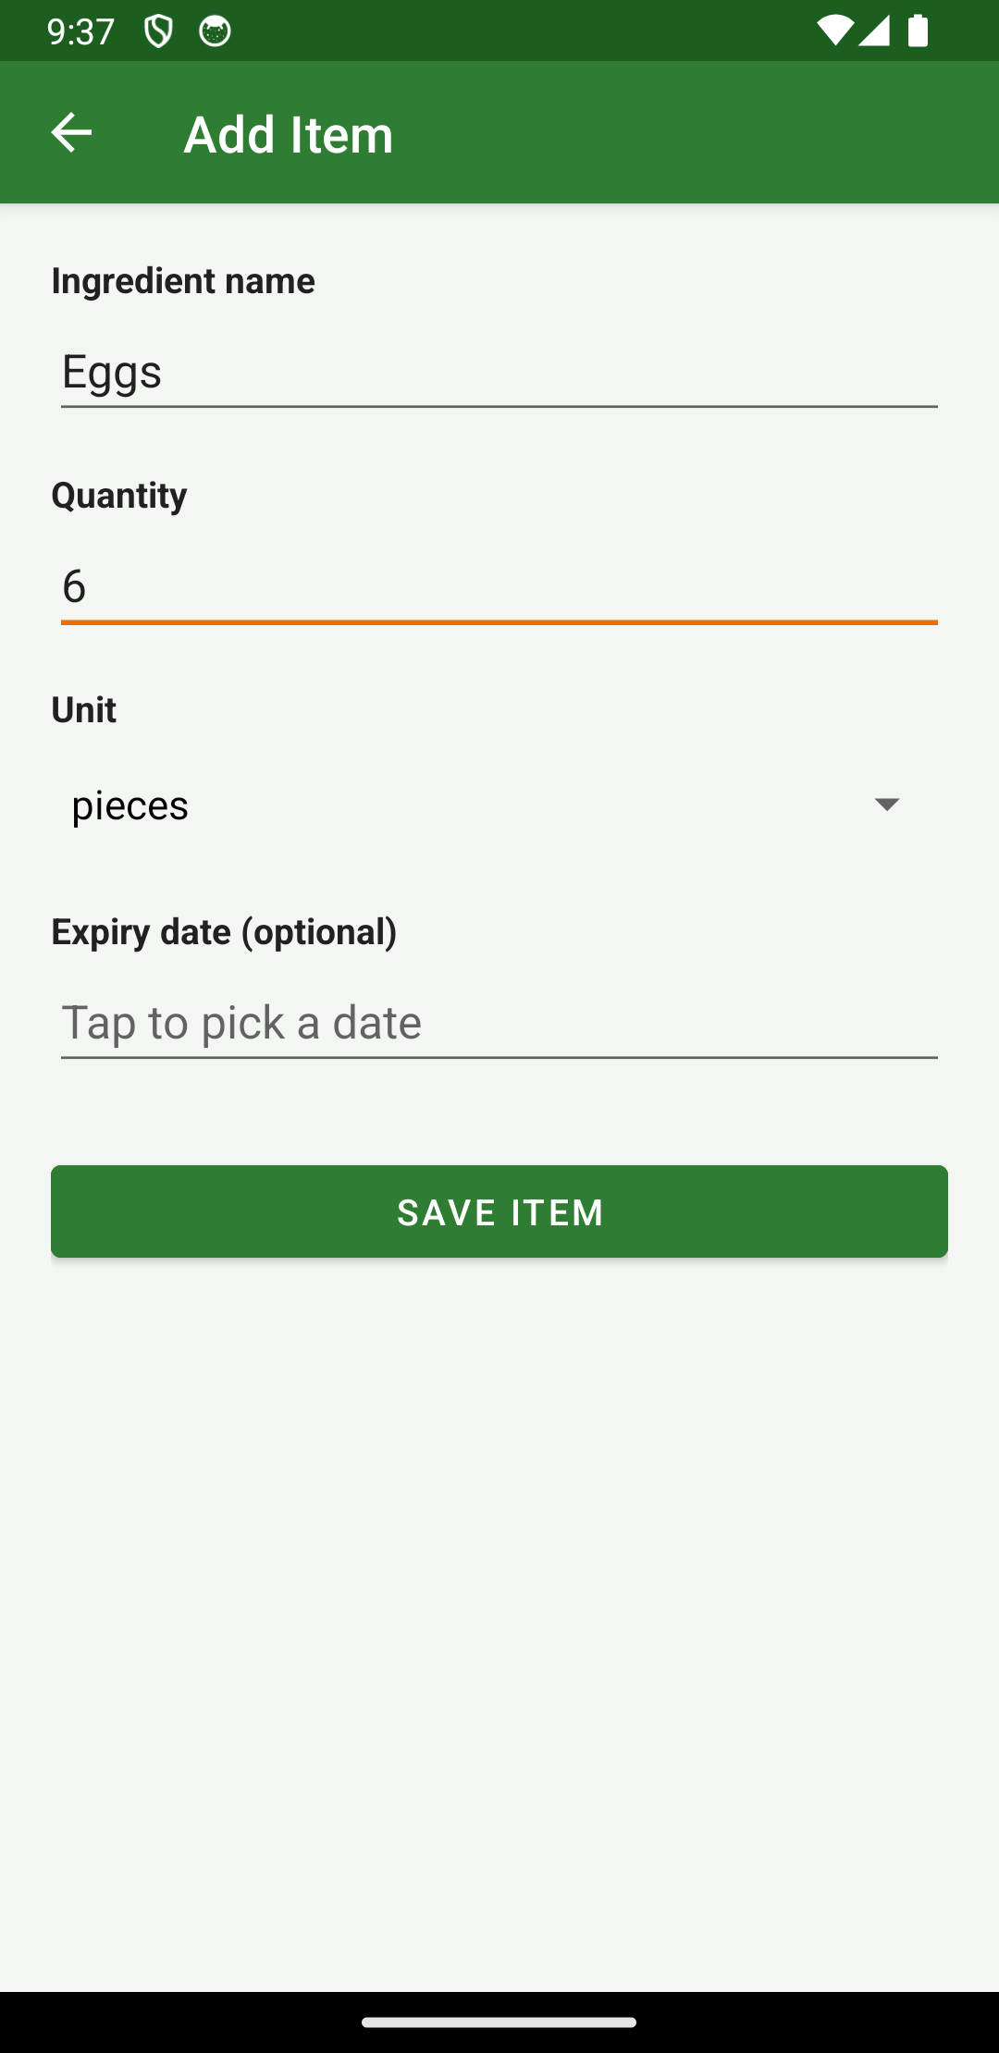  Figure 4: The add item form with the name, quantity, unit and optional expiry date.
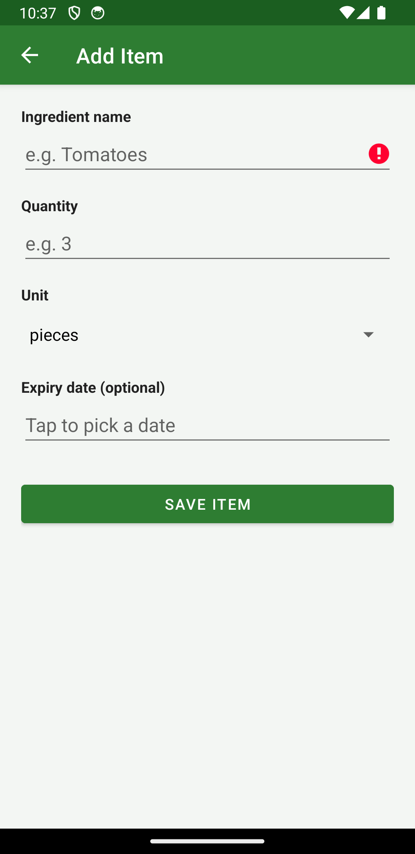  Figure 5: Validation. Saving with an empty name shows an error on the field and nothing is saved. | 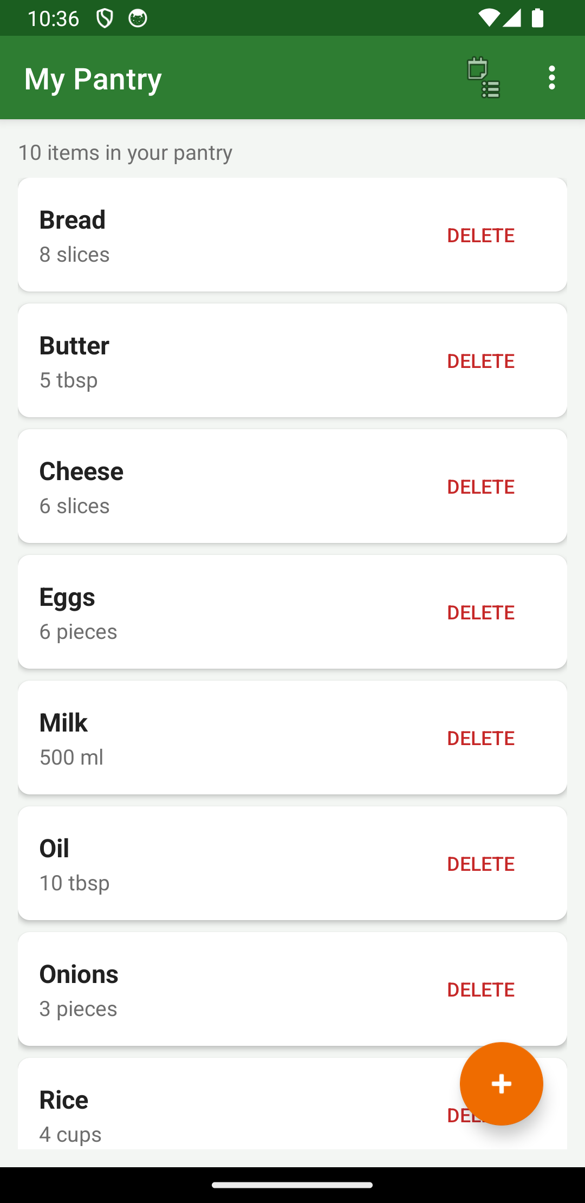  Figure 6: The pantry list (Read). Each ingredient is shown in a card with its quantity and unit.
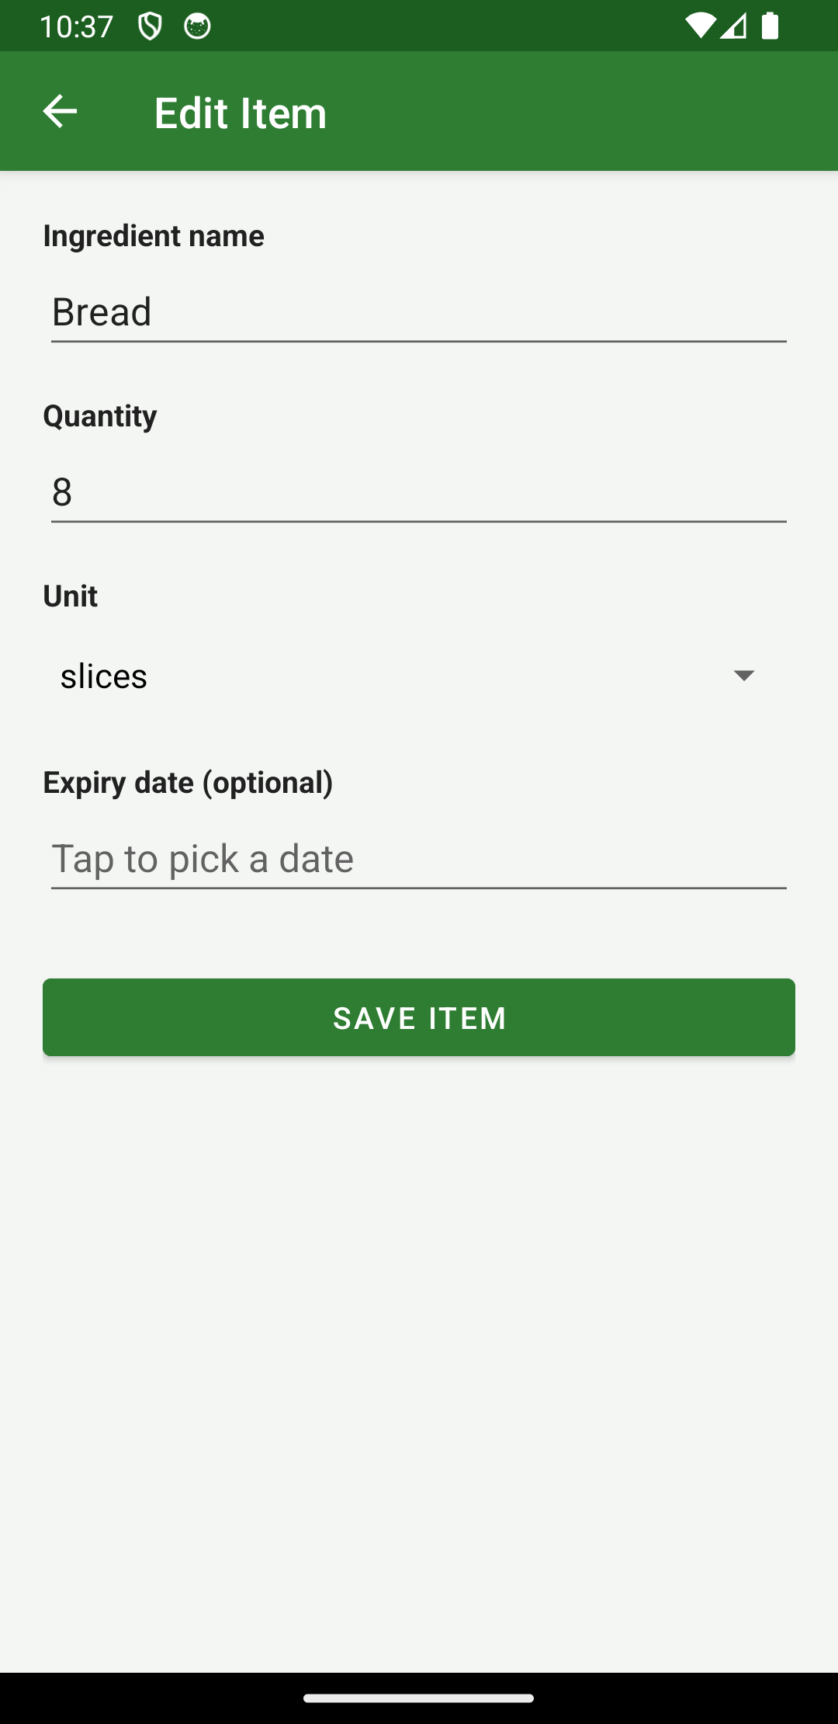  Figure 7: Update. Tapping an item opens the same form with the details already filled in. | 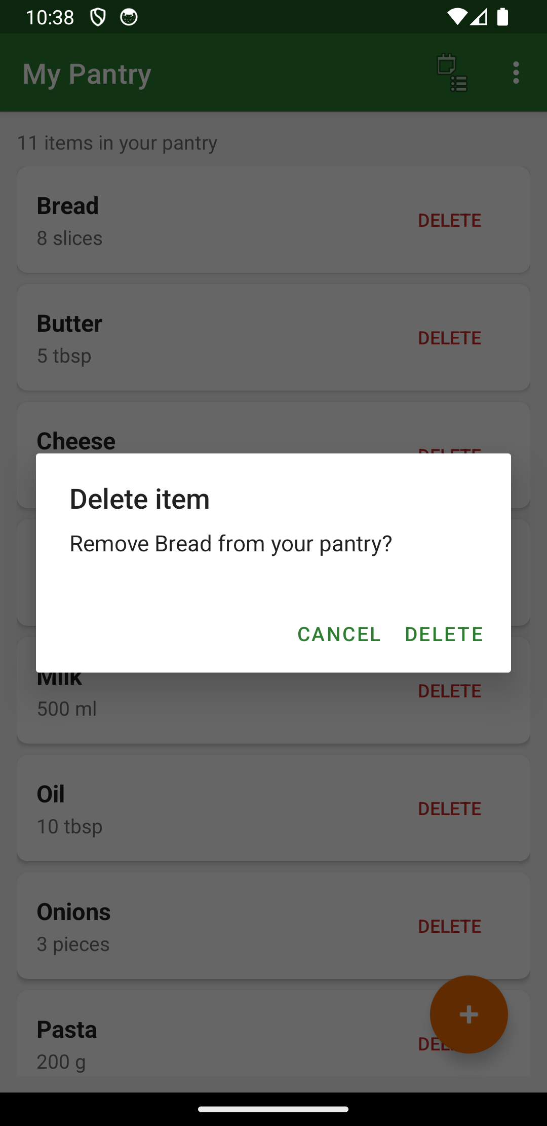  Figure 8: Delete. The user is asked to confirm before the item is removed.

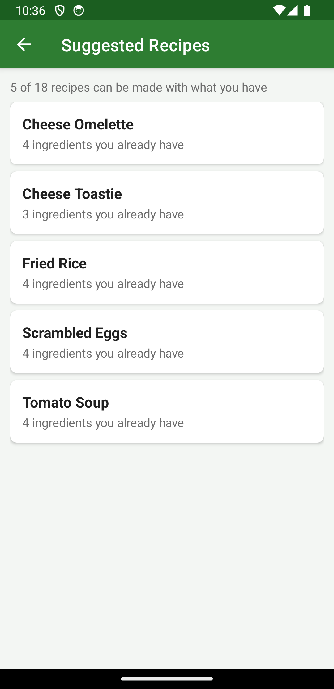  Figure 9: Suggested recipes. Only 5 of the 18 recipes can be made with the 10 ingredients in the pantry. | 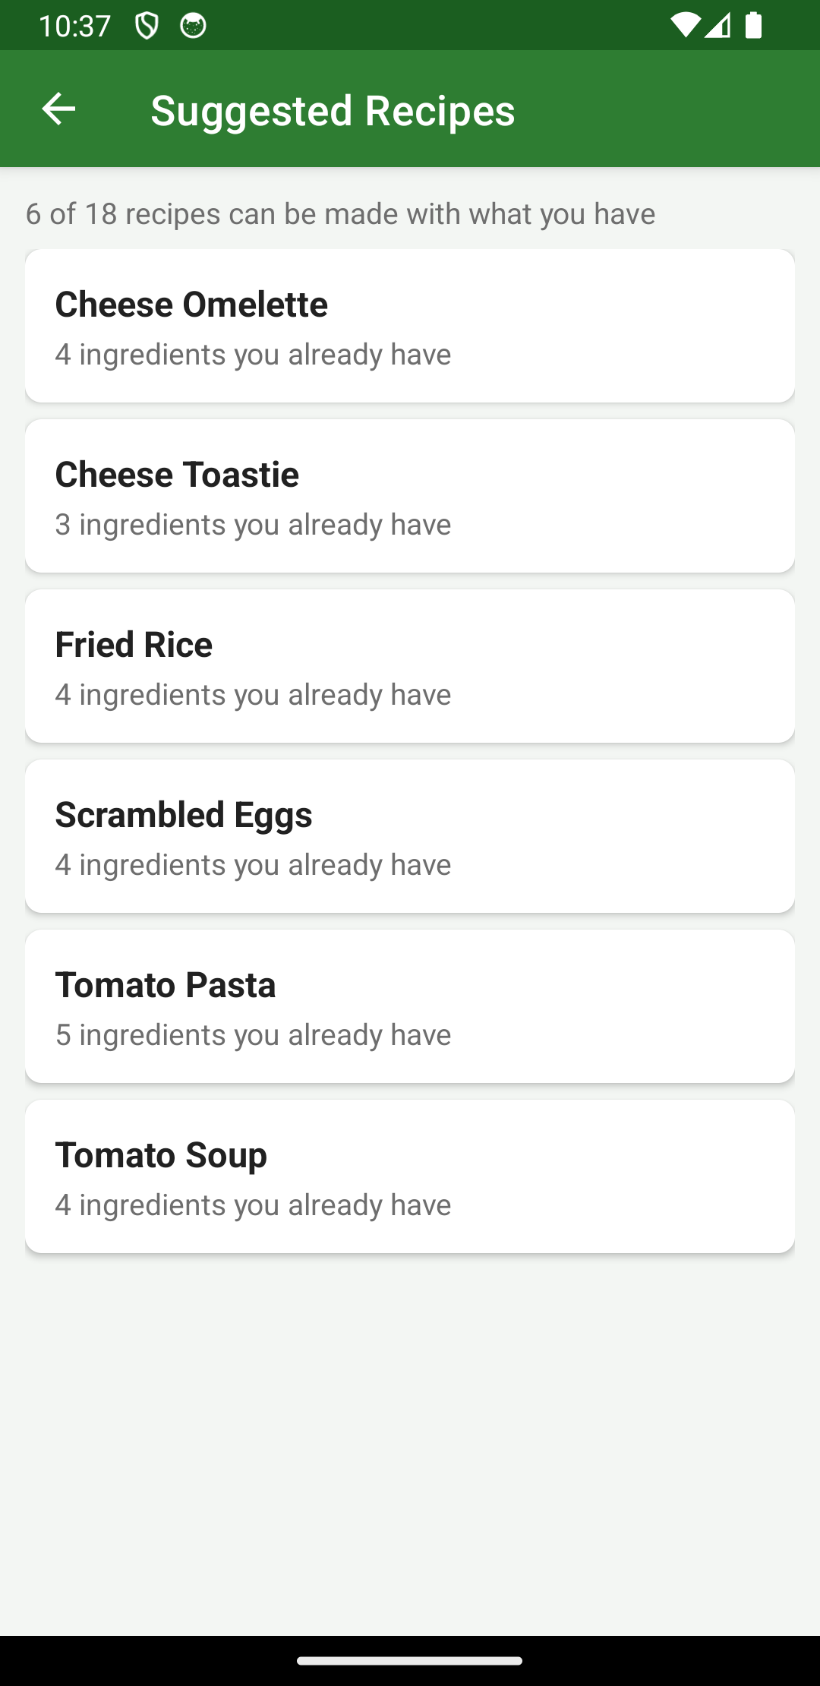  Figure 10: After adding pasta the count changes to 6 of 18 and Tomato Pasta appears in the list.
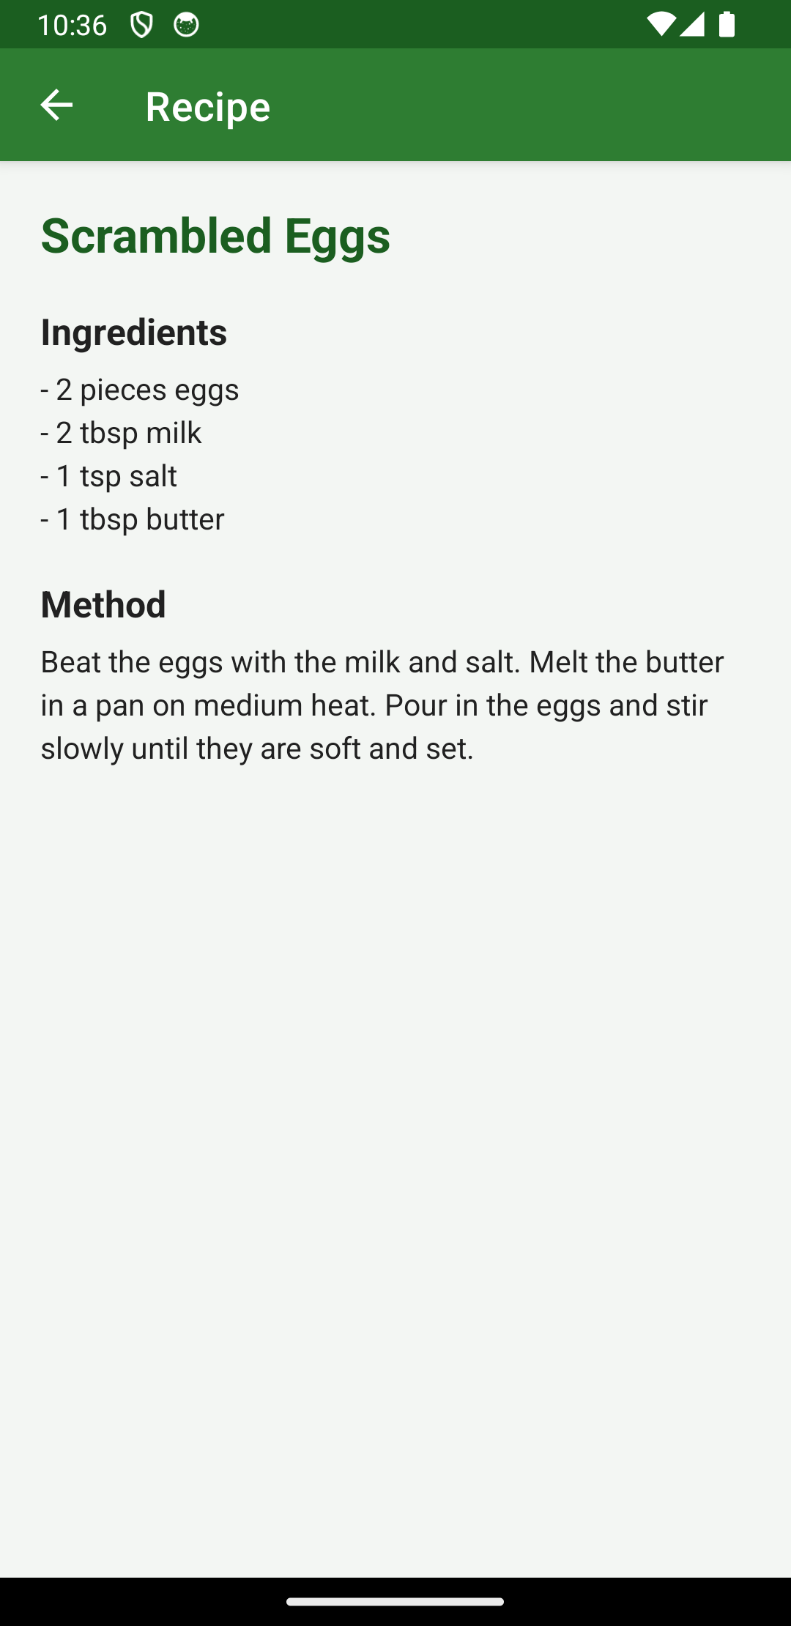  Figure 11: Recipe detail with the full ingredient list and the method. | 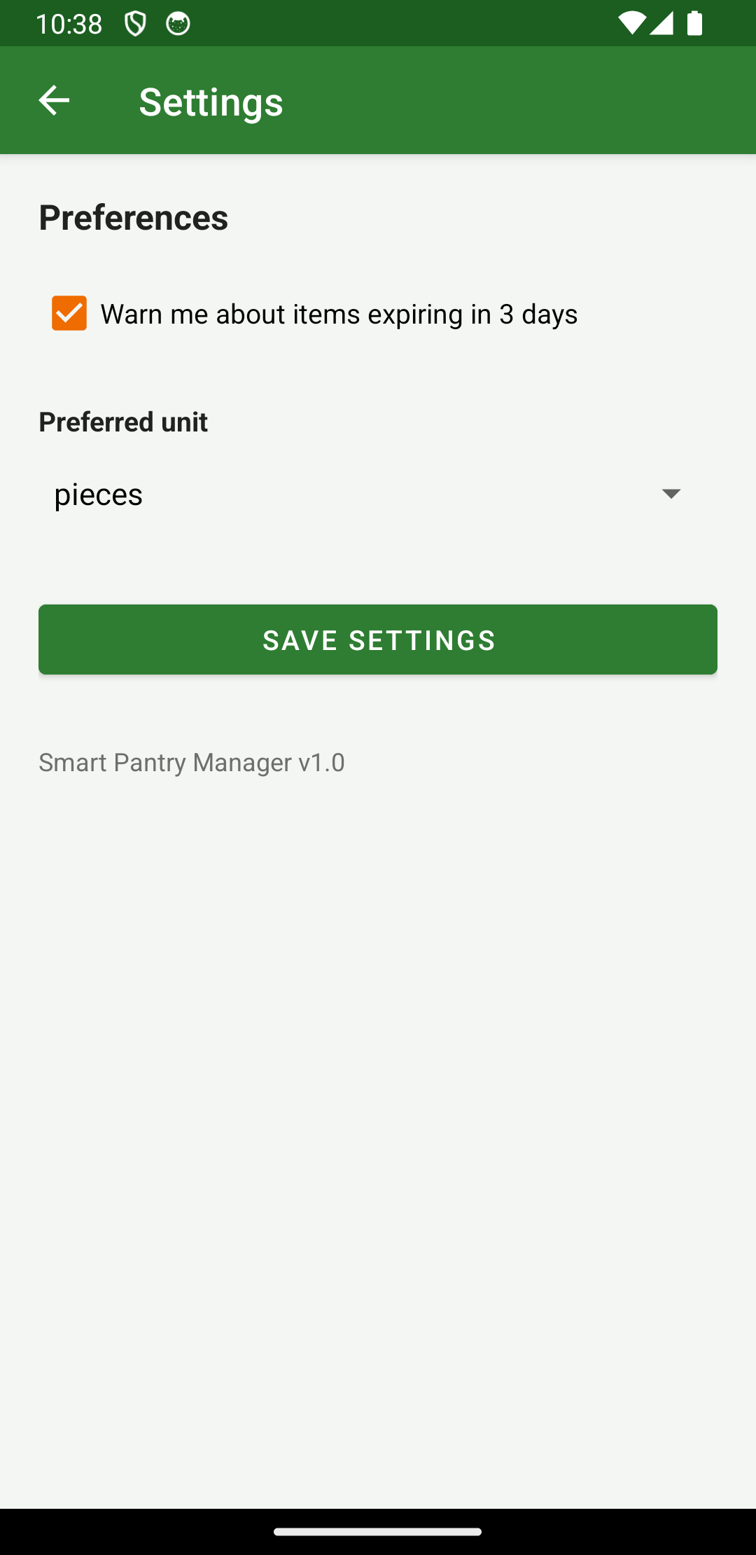  Figure 12: The settings screen with the expiry warning and the preferred unit.
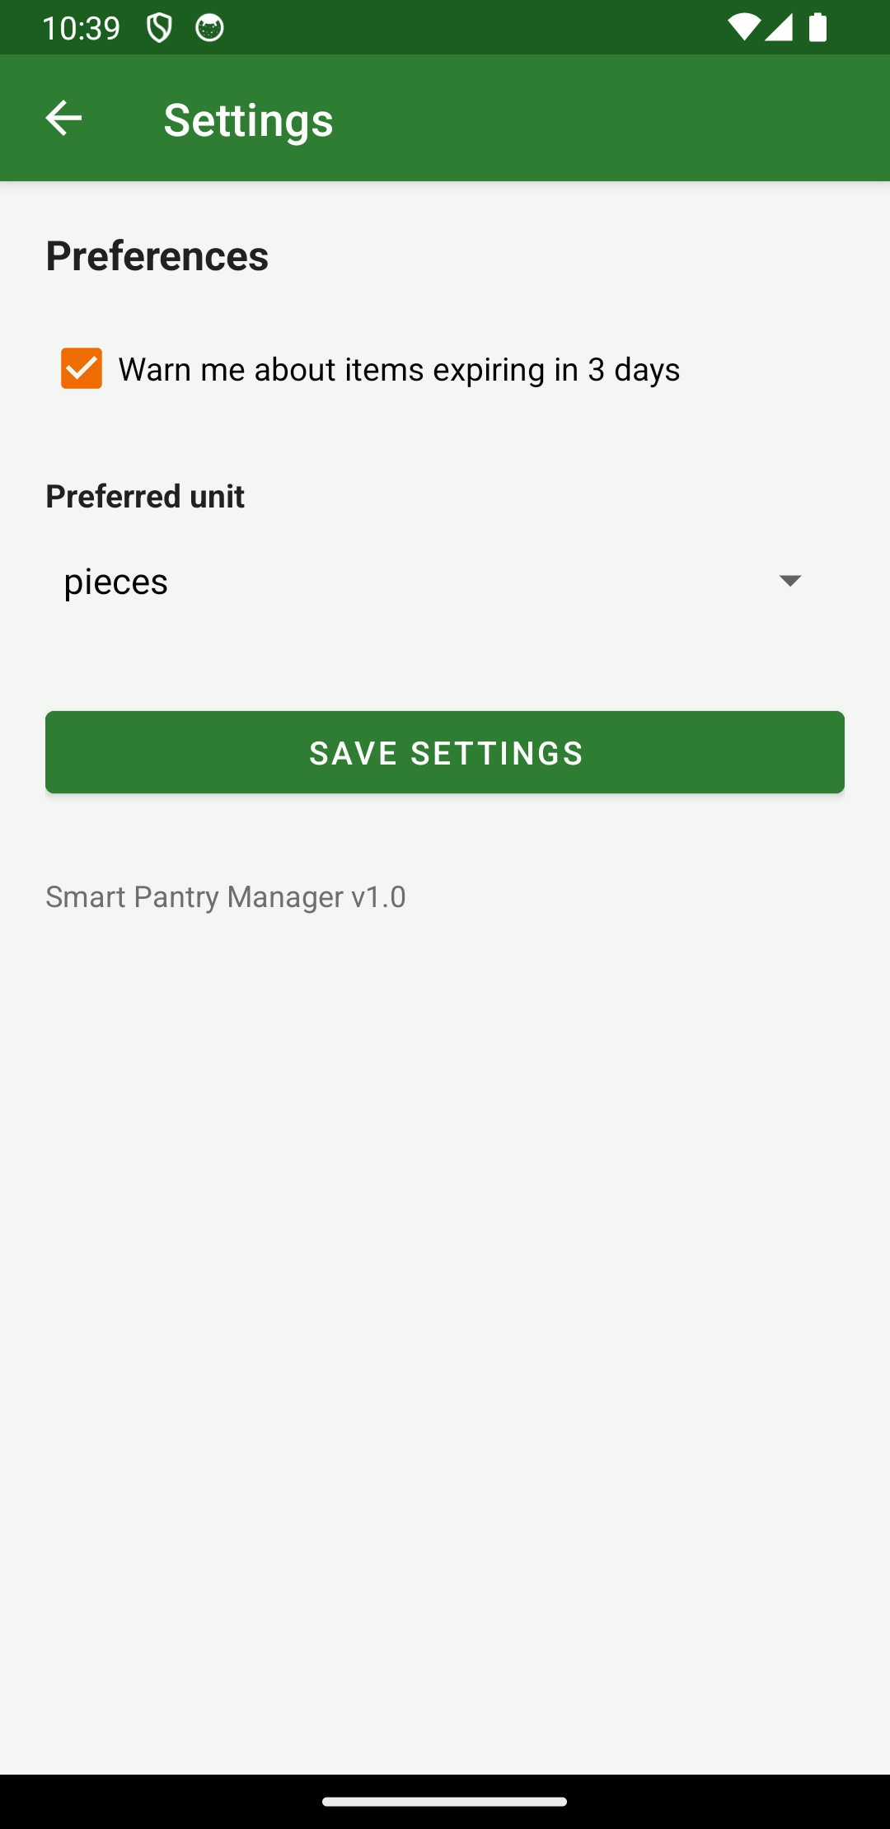  Figure 13: Settings are saved with SharedPreferences and kept for the next time. | 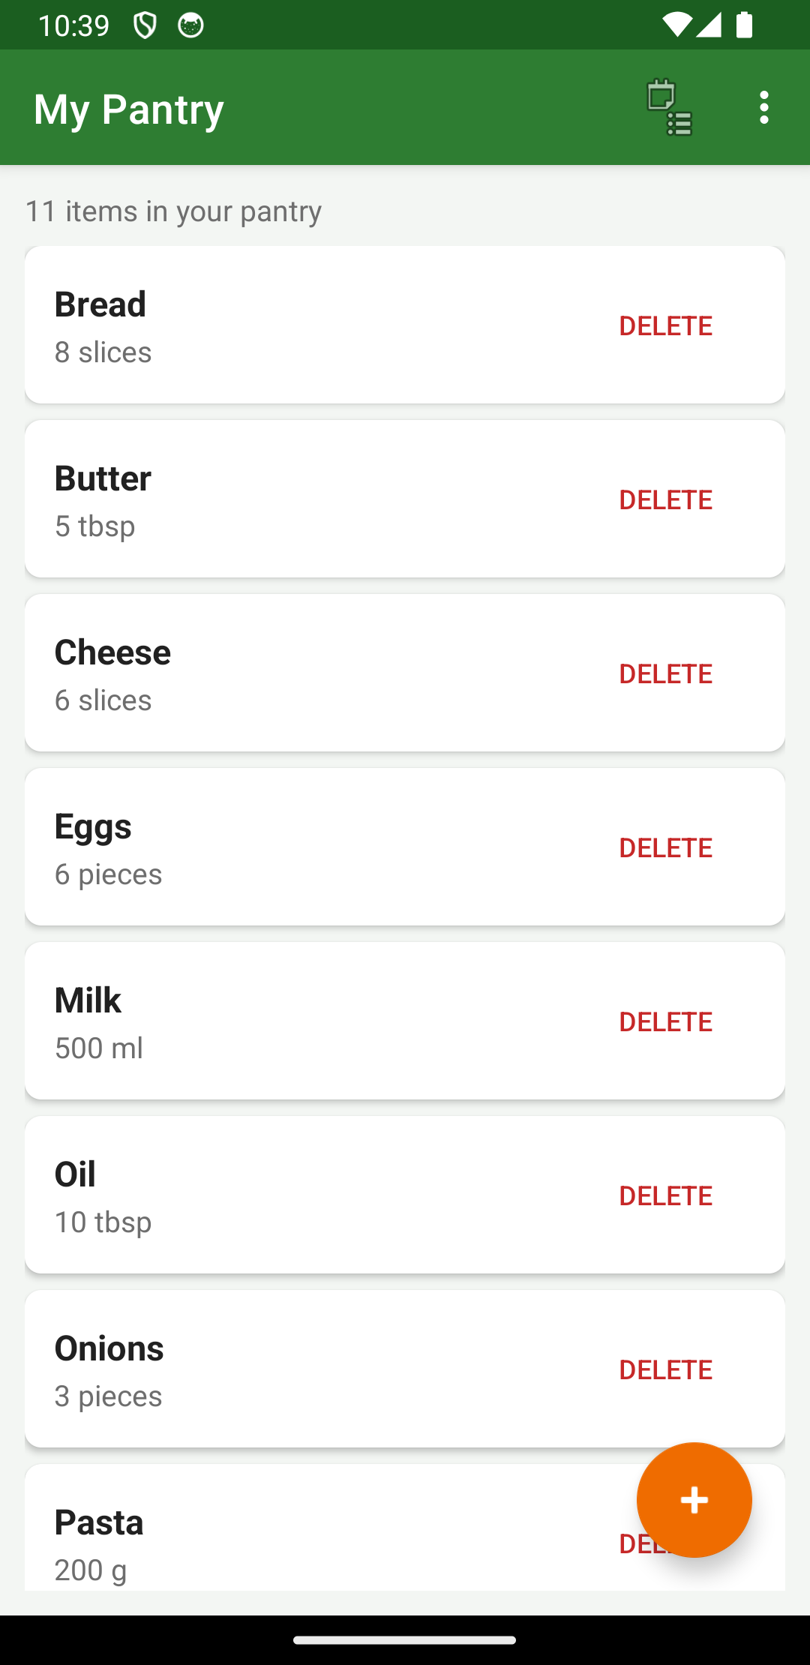  Figure 14: The app was closed and opened again and the ingredients are still there, which shows the data is really saved in the database.
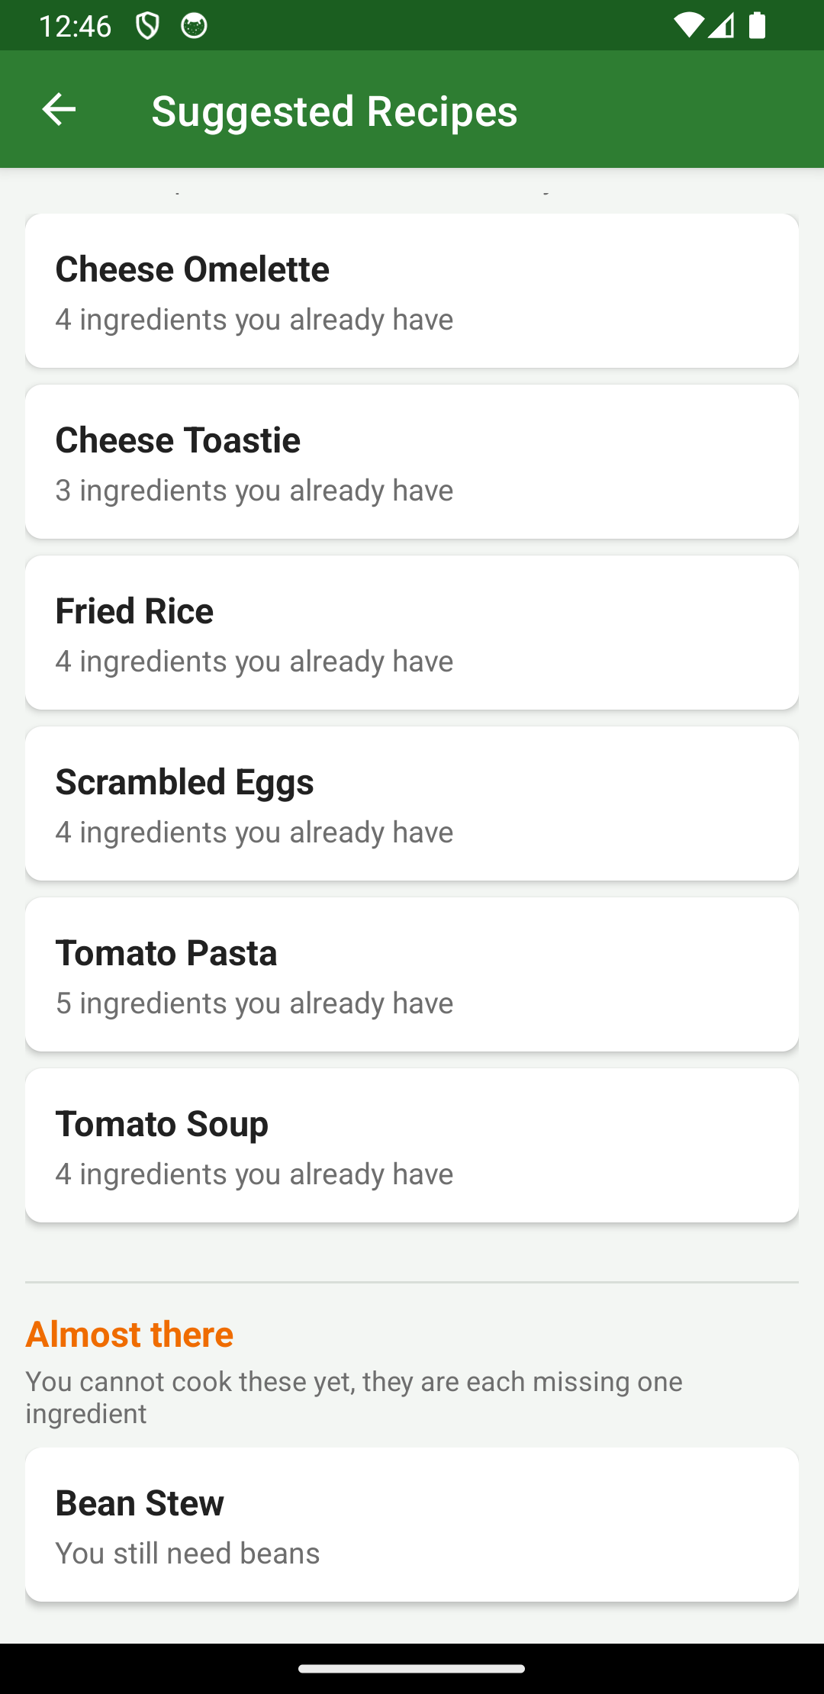
Figure 15: The Almost There list under the divider. Bean Stew cannot be cooked yet because beans are missing, and the app says so.

4. Key Code Snippets

4.1 Creating the tables
DatabaseHelper extends SQLiteOpenHelper. The onCreate method only runs the very first time the app is opened, so this is where the tables are made and where the recipes are loaded.
public void onCreate(SQLiteDatabase db) {
db.execSQL("CREATE TABLE pantry (" +
"id INTEGER PRIMARY KEY AUTOINCREMENT, " +
"name TEXT NOT NULL, " +
"quantity REAL NOT NULL, " +
"unit TEXT, " +
"expiry TEXT)");
...
loadRecipes(db);
}
The recipe_ingredients table has a foreign key to recipes so that the ingredients of a recipe can be read back with one query using the recipe id.

4.2 The strict matching rule
This is the most important method in the project. It goes through every ingredient a recipe needs and returns false the moment one of them is missing, so a recipe with even one missing ingredient can never be suggested.
public static boolean canMake(Recipe recipe, ArrayList<PantryItem> pantry) {
for (Ingredient needed : recipe.getIngredients()) {
if (!hasEnough(pantry, needed)) {
return false;
}
}
return true;
}

4.3 Matching names that are not written the same way
A pantry item called "Tomatoes" must still match a recipe that asks for "tomato". The clean method puts the word in lower case and takes the plural off before the two words are compared, so small differences do not break the matching.
public static String clean(String text) {
String s = text.toLowerCase().trim();
if (s.endsWith("ies") && s.length() > 4) {
s = s.substring(0, s.length() - 3) + "y";
} else if (s.endsWith("es") && s.length() > 4) {
String stem = s.substring(0, s.length() - 2);
if (stem.endsWith("o") || stem.endsWith("s") || stem.endsWith("x")
|| stem.endsWith("ch") || stem.endsWith("sh")) {
s = stem;
} else {
s = s.substring(0, s.length() - 1);
}
} else if (s.endsWith("s") && s.length() > 3) {
s = s.substring(0, s.length() - 1);
}
return s;
}
The same idea is used on the units, so "tablespoon" and "tbsp" are treated as the same unit. When the units match the app also checks the quantity, so 1 egg in the pantry is not enough for a recipe that needs 3.

4.4 Keeping the list up to date
The pantry list is loaded in onResume and not in onCreate. onResume runs again every time the user comes back from the add or edit screen, so a new item shows in the list immediately without the screen having to be reopened.
@Override
protected void onResume() {
super.onResume();
showPantry();
}

4.5 Finding the almost there recipes
The same counting method is used for the second list. A recipe is put in the Almost There list only when exactly one of its ingredients is missing, so a recipe missing two or more items does not appear anywhere.
public static ArrayList<Recipe> getAlmostThere(ArrayList<Recipe> recipes,
ArrayList<PantryItem> pantry) {
ArrayList<Recipe> almost = new ArrayList<>();
for (Recipe r : recipes) {
if (countMissing(r, pantry) == 1) {
almost.add(r);
}
}
return almost;
}

5. Challenges and Solutions

5.1 The Recipes button did not appear on the toolbar
The menu item was written with android:showAsAction="always" but it kept hiding inside the three dot menu instead of showing on the toolbar. The reason is that the app uses the AppCompat toolbar, and AppCompat reads its own app:showAsAction attribute, not the android one. After adding xmlns:app to the menu file and changing the attribute to app:showAsAction the button appeared where it was supposed to be.

5.2 Ingredients written in different units
A recipe asks for 2 tbsp of milk but the user has 500 ml of milk in the pantry. The app cannot turn millilitres into tablespoons without a conversion table for every unit, which was too much for this project. The solution was to compare the quantity only when the two units are the same, and when the units are different to accept that the ingredient is there. This is written down as a known limitation rather than hidden, and the quantity check still works for the normal case where both are written in the same unit.

5.3 Testing that the data really persists
It is easy to think the data is saved when it is actually still sitting in a list in memory. To be sure, the app was closed completely and opened again, and the emulator was even restarted, and the ingredients were still in the list afterwards. That proved the items were being written into the SQLite database and read back, and not just held in the activity.

6. Conclusion and Reflection
The user can add, view, edit and delete pantry items, the data survives the app being closed, and the Suggested Recipes screen only ever shows recipes where every ingredient is already in the pantry. Adding one ingredient can make a new recipe appear, which shows the rule is being applied on the real data and not on a fixed list.
The main thing I learned is how the activity lifecycle changes the way a screen is written. Loading the list in onCreate looked fine until I came back from the add screen and the new item was not there. Moving that call into onResume fixed it, and it made the lifecycle make sense in a way that reading about it did not.
The Almost There list was added at the end as an extra. It was quick to write once the counting method was there, and it made the strict rule easier to explain, because the user can see the recipes that just miss out instead of wondering why a meal never appears.
Given more time I would add a proper unit conversion so that millilitres and tablespoons can be compared, a search box on the pantry list for when there are a lot of items, and a way for the user to add their own recipes instead of only using the ones that come with the app.

7. References
Android Developers. 2024. Save data using SQLite. [Online] Available at: https://developer.android.com/training/data-storage/sqlite [Accessed 23 September 2026].
Android Developers. 2024. Create dynamic lists with RecyclerView. [Online] Available at: https://developer.android.com/develop/ui/views/layout/recyclerview [Accessed 25 September 2026].
Android Developers. 2024. The activity lifecycle. [Online] Available at: https://developer.android.com/guide/components/activities/activity-lifecycle [Accessed 27 September 2026].
Android Developers. 2024. Add the app bar. [Online] Available at: https://developer.android.com/develop/ui/views/components/appbar [Accessed 29 September 2026].
Android Developers. 2024. Save key-value data. [Online] Available at: https://developer.android.com/training/data-storage/shared-preferences [Accessed 29 September 2026].

