**《面向对象Java编程》上机作业3**

|  |  |
| --- | --- |
| **学号：** |  |
| **姓名：** |  |
| **班级：** |  |
| **日期：** |  |

**1.** 创建一个名为Rectangle的类，来表示一个使用宽度和高度作为属性的矩形。矩形的宽度和高度由构造方法来确定（要求长和高的范围为10~50）。为Rectangle类创建下列方法：

① getArea返回矩形的面积;

② getPerimeter返回矩形的周长;

③ drawRect使用星号(*)作为描绘字符画出该矩形的形状（画出的矩形为空心，边长为宽度和高度去除小数点之后的整数）。

在另一个类TestRectangle中编写main方法来测试Rectangle类。

|  |
| --- |
| * **问题分析** |
| * **代码实现** |
| * **运行结果** |
| * **思考及总结** |

**2.** Define an interface, called **VolumeArea**, within which there’re:

* a static and final variable PI (with the value 3.14159), and
* two abstract methods volume(double radius) and area(double radius).

Write another class **MyCircle** which implements the interface **VolumeArea**. Overriding the two methods:

* volume(double radius) to return a value zero (as the volume of a circle is 0), and
* area(double radius) to return the area of the circle.

Write the third class **MySphere**, also implements **VolumeArea**. Overriding the two methods:

* volume(double radius) to calculate and return the volume of the sphere (using (4π*r*r*r)/3);
* area(double radius) to calculate and return the surface area of the sphere (using 4π*r*r).

Write a main class with the main method to test the methods in **MyCircle** and **MySphere**, set the radius of the circle and sphere both to 3.5. And display the results.

|  |
| --- |
| * **问题分析** |
| * **代码实现** |
| * **运行结果** |
| * **思考及总结** |

**3.** **按如下要求定义两个类ClassA和ClassB：**

- 类ClassA 中定义一个char类型属性xVar（将其赋值为65）和一个窗口中输出xVar 值的方法myPrint()。

- 类ClassB 是类ClassA 的子类，其中定义一个int 类型属性yVar（将其赋值为16）和String 类型的属性strVar（将其赋值为“java program!”）；类 ClassB 中也定义了一个名为myPrint 的方法，其功能为在窗口中输出yVar 和strVar 值；类ClassB中还有一个方法printAll( )，该方法中分别调用父类和子类的myPrint()方法做输出。

- 编写一个测试类TestClassDriver，在主方法中创建类ClassB 的对象bObj，调用printAll( )方法输出对象bObj 的属性值。

|  |
| --- |
| * **问题分析** |
| * **代码实现** |
| * **运行结果** |
| * **思考及总结** |

**4.** 请根据以下UML图，编写相关的三个类：

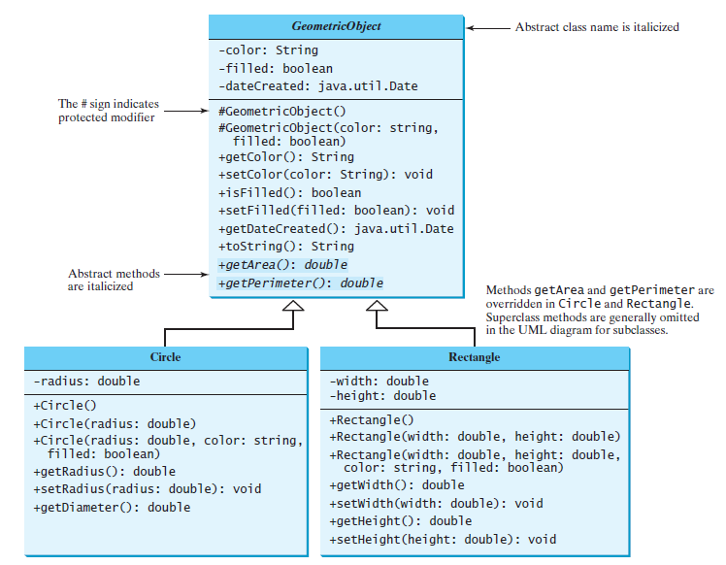

另外定义一个主类，main方法中对上图中设计的各个方法进行测试。

TIPs: ’+’符号表示public修饰的属性/方法；’-‘表示private修饰；’#’表示protected修饰；斜体表示abstract修饰的类/方法。

|  |
| --- |
| * **问题分析** |
| * **代码实现** |
| * **运行结果** |
| * **思考及总结** |

**5. 按如下要求，编写应用程序：**

**-** 编写一个抽象类Animal，其成员变量有name，age，weight表示动物名、年龄和重量。方法有showInfo( )、move( )和eat( )，其中后面两个方法是抽象方法；

- 编写一个类Bird继承Animal，实现相应的方法，通过构造方法给name，age，weight分别赋值，showInfo( )打印鸟名、年龄和重量，move( )方法打印鸟的运动方式，eat( )打印鸟喜欢吃的食物；

- 编写一个类Dog继承Animal，实现相应的方法，通过构造方法给name，age，weight分别赋值，showInfo( )打印狗名、年龄和重量，move( )方法打印狗的运动方式，eat( )打印狗喜欢吃的食物；

- 最后编写测试类TestAnimal，用Animal类型的变量，调用Bird和Dog对象的三个方法。

- 要求：将Animal、Bird和Dog三个类定义在包中（包名为你的名字或姓名缩写），而测试类TestAnimal在缺省包中。

|  |
| --- |
| * **问题分析** |
| * **代码实现** |
| * **运行结果** |
| * **思考及总结** |

**6.** (*Math: The* **Complex** *class*) A complex number is a number of the form where *a* and *b* are real numbers and *i* is The numbers **a** and **b** are known as the real part and imaginary part of the complex number, respectively. You can perform addition, subtraction, multiplication, and division for complex numbers using the following formula:

You can also obtain the absolute value for a complex number using the following formula:



Design a class named **Complex** for representing complex numbers and the methods **add**, **subtract**, **multiply**, **divide**, and **abs** for performing complex-number operations, and override the **toString** method for returning a string representation for a complex number. The **toString** method returns **a + bi** as a string. If **b** is **0**, it simply returns **a**.

Provide three constructors **Complex(a, b)**, **Complex(a)**, and **Complex()**. **Complex()** creates a **Complex** object for number **0** and **Complex(a)** creates a **Complex** object with **0** for **b**. Also provide the **getRealPart()** and **getImaginaryPart()** methods for returning the real and imaginary part of the complex number, respectively.

Write a test program that prompts the user to enter two complex numbers and display the result of their addition, subtraction, multiplication, and division. Here is a sample run:

|  |
| --- |
| Enter the first complex number: 3.5 5.5  Enter the second complex number: -3.5 1  3.5 + 5.5i + -3.5 + 1.0i = 0.0 + 6.5i  3.5 + 5.5i - -3.5 + 1.0i = 7.0 + 4.5i  3.5 + 5.5i * -3.5 + 1.0i = -17.75 + -15.75i  3.5 + 5.5i / -3.5 + 1.0i = -0.5094 + -1.7i  |3.5 + 5.5i| = 6.519202405202649 |

|  |
| --- |
| * **问题分析** |
| * **代码实现** |
| * **运行结果** |
| * **思考及总结** |