**《面向对象Java编程》上机作业6**

|  |  |
| --- | --- |
| **学号：** |  |
| **姓名：** |  |
| **班级：** |  |
| **日期：** |  |

1. 编写一个图形用户界面程序，模拟一个简化的微波炉界面。如下图所示。

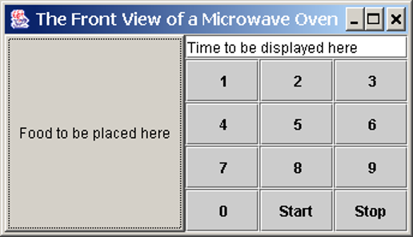

|  |
| --- |
| * **问题分析与解答** |
| * **代码实现** |
| * **运行结果** |
| * **思考及总结** |

1. (*Creating a simple calculator*) Write a program to perform add, subtract, multiply, and divide operations, figure shown as below

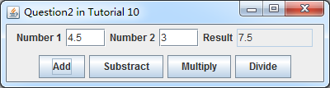

|  |
| --- |
| * **问题分析与解答** |
| * **代码实现** |
| * **运行结果** |
| * **思考及总结** |

1. 设计图形用户界面。界面上有三个按钮，分别是“红色”，“黄色”，“绿色”，当点击红色按钮，界面背景颜色变红色；当点击黄色按钮，界面背景颜色变黄色；当点击绿色按钮，界面背景颜色变绿色。

|  |
| --- |
| * **问题分析** |
| * **代码实现** |
| * **运行结果** |
| * **思考及总结** |

1. 编写一个允许学生在文本字段中输入一个数的程序，并创建一个每当用户单击一次就将此数加1的按钮，以及另一个每当用户单击一次就将此数减1的按钮。界面效果如下图所示。



|  |
| --- |
| * **问题分析** |
| * **代码实现** |
| * **运行结果** |
| * **思考及总结** |

1. Write a GUI program, following the figure below. User can input the name and id within the according text fields, and comments in the text area.

There are also three buttons at the bottom of the window:

* Save button can be clicked to save user inputs into an external file, named “comments.txt” within the same folder where the program is;
* Reset button can be clicked to remove all previous input;
* Cancel button can be clicked to exit the program.

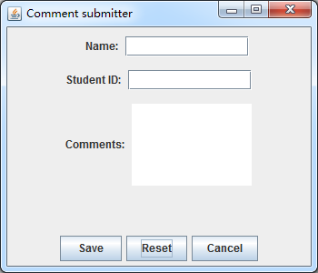

|  |
| --- |
| * **问题分析** |
| * **代码实现** |
| * **运行结果** |
| * **思考及总结** |