BazToGo - System Documentation

Alexander McCutcheon, Braden Prather, Nathan Gilbert

Table of Contents

1. Introduction
2. Project Details
   1. Project Timeline
3. System Analysis
4. System Design
5. System Implementation
6. System Requirements
7. Ethical and Legal Concerns
8. Conclusion

Introduction

BazToGo is an online mobile ordering and delivery service intended to aid in the overcrowding that occurs at Baswell Techionery between classes.

Development Team

Project Members: Nathan Gilbert, Alexander McCutcheon, Braden Prather

Roles

Nathan: Client-side application development.

Alex: Team leader and organizer. Responsible for documentation and development of the BazToYou delivery portion of the application.

Braden: Responsible for documentation and database integration.

Project Details:

Project Timeline:

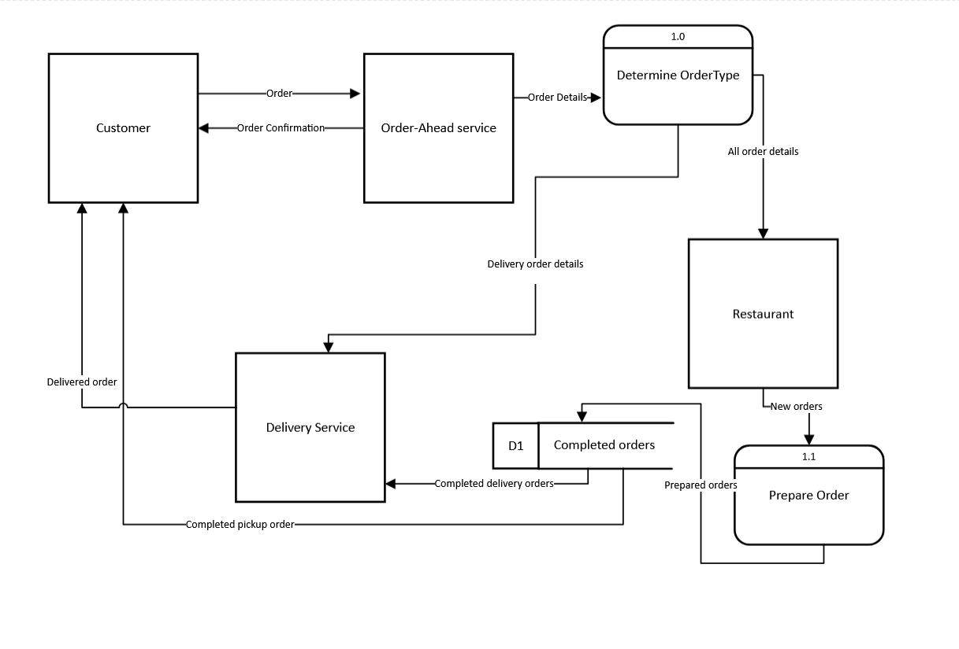

System Design:

• Include and explain UI

System Implementation:

• Tools, platforms, APIs … versions – how to install/use them

• Provide link(s) to your code repository – explain how to use/install/run that

• Explain key components of your code

• Include code snippets, screenshots, illustrations.. as required

• Describe key aspects of the implementation process…libraries.. dependencies…

• Explain how to download/install/run/maintain the application

System Requirements:

Hardware requirement, software requirement, other specifications

Ethical and Legal Considerations:

List and explain all the ethical and legal considerations relevant to the project or any other project of

similar nature. I have included some general items (not an exclusive list) that may help you write this

section:

• Are there any legal or professional code that apply to this project?

• Copyrights: Who owns the software? Sales rights?

• Liabilities: Is any party accountable for maintenance? Loss of property/resources due to

errors/malfunctioning of the system?

• Cyberattack / data theft / someone hacks the system: Who is responsible? What has been done

to prevent this?

• What could be some unethical usage of the system? How are/can they be prevented?

• Include other considerations that you can think of.

Conclusion

…………….