### INF-2B Natural Image Classification Task 1 Report

Task 2.2:

The 2 largest eigenvalues: 14.383095313936090, 11.384970972153763.

The first five rows of E2:

|  |  |
| --- | --- |
| 0.307983111873521 | 0.0941630560639841 |
| -0.107190068011302 | 0.103257837149263 |
| -0.0543638578929347 | -0.0559819788069004 |
| 0.0102186827971333 | -0.0400129159196361 |
| -0.0135682600619131 | 0.0421653772983205 |

The first five rows of XPCA:

|  |  |
| --- | --- |
| -1.77617463233227 | 0.300201757575069 |
| -1.98030687916530 | 0.190675055342996 |
| 9.87152759338393 | 2.11902255496648 |
| 0.836502916842919 | -0.384584141380611 |
| 1.38410762664313 | -1.95957428471935 |

Task 2.3:

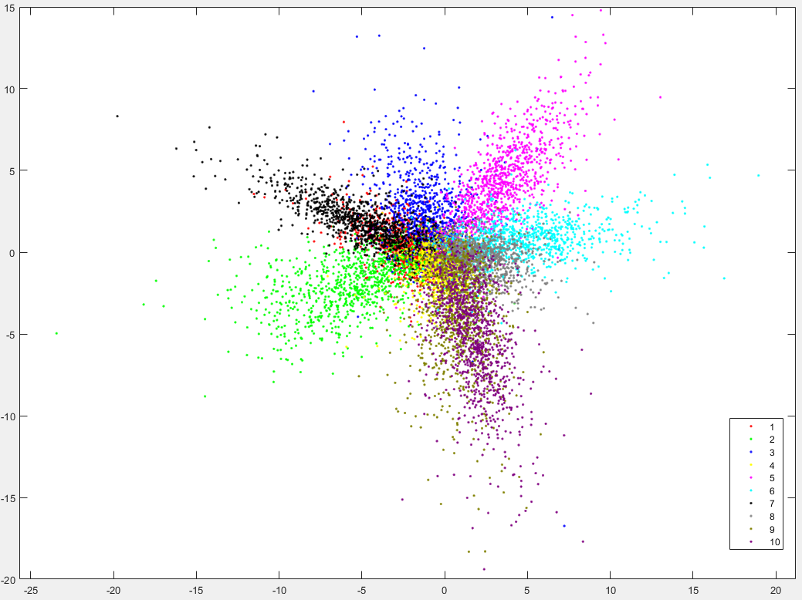

Task 2.4:

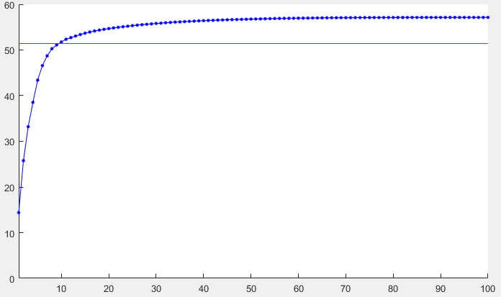

As the cumulative variance shows, we need at least 10 variance to show 90% of the total variance.

Task 2.5:

Since the rest 90% of the variance only expresses 10% of the total variance, when we classify the test feature in future tasks, we can decrease the runtime significantly by only using 10% of the most significant features, in exchange the rate of approximately 10% loss in accuracy.

Also, in the scatter graph, we can see that some of the classes have almost same direction of distribution (class 1 and 7, 9 and 10), with almost every class have clustered in the center, making classification of the ‘fuzzy’ pictures inaccurate.