### INF-2B Natural Image Classification Task 3 Report

Task 4.1:

K-NN classification with 100 feature:

|  |  |  |  |  |  |  |  |  |  |  |  |
| --- | --- | --- | --- | --- | --- | --- | --- | --- | --- | --- | --- |
|  | | **Predicted Class** | | | | | | | | | |
| Class1 | Class2 | Class3 | Class4 | Class5 | Class6 | Class7 | Class8 | Class9 | Class10 |
| **Actual Class** | Class1 | 83 | 0 | 2 | 4 | 1 | 2 | 5 | 0 | 1 | 2 |
| Class2 | 2 | 84 | 2 | 3 | 0 | 1 | 4 | 1 | 2 | 1 |
| Class3 | 0 | 2 | 85 | 1 | 3 | 3 | 1 | 1 | 2 | 2 |
| Class4 | 2 | 2 | 1 | 92 | 1 | 0 | 1 | 1 | 0 | 0 |
| Class5 | 0 | 1 | 4 | 0 | 84 | 6 | 0 | 3 | 2 | 0 |
| Class6 | 0 | 0 | 3 | 1 | 0 | 83 | 0 | 5 | 1 | 7 |
| Class7 | 3 | 2 | 2 | 1 | 1 | 1 | 89 | 1 | 0 | 0 |
| Class8 | 0 | 1 | 5 | 0 | 4 | 10 | 0 | 75 | 3 | 2 |
| Class9 | 0 | 3 | 4 | 3 | 2 | 4 | 0 | 2 | 78 | 4 |
| Class10 | 3 | 0 | 1 | 1 | 0 | 2 | 0 | 0 | 2 | 91 |

Accuracy: 84.4%

K-NN classification with 2 feature:

|  |  |  |  |  |  |  |  |  |  |  |  |
| --- | --- | --- | --- | --- | --- | --- | --- | --- | --- | --- | --- |
|  | | **Predicted Class** | | | | | | | | | |
| Class1 | Class2 | Class3 | Class4 | Class5 | Class6 | Class7 | Class8 | Class9 | Class10 |
| **Actual Class** | Class1 | 41 | 16 | 1 | 17 | 0 | 0 | 14 | 7 | 0 | 4 |
| Class2 | 11 | 28 | 14 | 9 | 0 | 0 | 22 | 3 | 11 | 2 |
| Class3 | 1 | 8 | 42 | 6 | 3 | 0 | 13 | 5 | 22 | 0 |
| Class4 | 28 | 5 | 2 | 21 | 1 | 2 | 5 | 19 | 5 | 12 |
| Class5 | 0 | 0 | 3 | 3 | 68 | 3 | 2 | 9 | 12 | 0 |
| Class6 | 0 | 2 | 1 | 6 | 2 | 68 | 0 | 15 | 2 | 4 |
| Class7 | 15 | 24 | 14 | 10 | 0 | 0 | 24 | 2 | 8 | 3 |
| Class8 | 6 | 3 | 8 | 7 | 4 | 18 | 4 | 26 | 6 | 18 |
| Class9 | 5 | 7 | 13 | 5 | 7 | 2 | 8 | 9 | 39 | 5 |
| Class10 | 7 | 1 | 0 | 16 | 1 | 9 | 1 | 18 | 2 | 45 |

Accuracy: 40.2%

Gaussian full classification with 100 feature:

|  |  |  |  |  |  |  |  |  |  |  |  |
| --- | --- | --- | --- | --- | --- | --- | --- | --- | --- | --- | --- |
|  | | **Predicted Class** | | | | | | | | | |
| Class1 | Class2 | Class3 | Class4 | Class5 | Class6 | Class7 | Class8 | Class9 | Class10 |
| **Actual Class** | Class1 | 92 | 0 | 0 | 5 | 0 | 0 | 3 | 0 | 0 | 0 |
| Class2 | 4 | 84 | 4 | 2 | 0 | 1 | 4 | 1 | 0 | 0 |
| Class3 | 2 | 3 | 78 | 2 | 3 | 0 | 6 | 2 | 4 | 0 |
| Class4 | 2 | 0 | 0 | 93 | 2 | 0 | 2 | 0 | 0 | 1 |
| Class5 | 0 | 0 | 1 | 1 | 88 | 4 | 0 | 1 | 4 | 1 |
| Class6 | 2 | 0 | 4 | 2 | 0 | 86 | 1 | 3 | 1 | 1 |
| Class7 | 2 | 1 | 0 | 1 | 0 | 0 | 95 | 1 | 0 | 0 |
| Class8 | 1 | 0 | 3 | 1 | 1 | 9 | 1 | 81 | 2 | 1 |
| Class9 | 0 | 2 | 2 | 2 | 1 | 0 | 1 | 0 | 88 | 4 |
| Class10 | 4 | 1 | 1 | 0 | 1 | 2 | 1 | 0 | 2 | 88 |

Accuracy: 87.3%

Gaussian full classification with 2 feature:

|  |  |  |  |  |  |  |  |  |  |  |  |
| --- | --- | --- | --- | --- | --- | --- | --- | --- | --- | --- | --- |
|  | | **Predicted Class** | | | | | | | | | |
| Class1 | Class2 | Class3 | Class4 | Class5 | Class6 | Class7 | Class8 | Class9 | Class10 |
| **Actual Class** | Class1 | 46 | 8 | 0 | 31 | 0 | 0 | 7 | 6 | 0 | 2 |
| Class2 | 8 | 28 | 6 | 5 | 0 | 0 | 32 | 4 | 17 | 0 |
| Class3 | 0 | 0 | 49 | 8 | 0 | 0 | 7 | 4 | 32 | 0 |
| Class4 | 14 | 0 | 0 | 58 | 0 | 0 | 4 | 10 | 7 | 7 |
| Class5 | 0 | 0 | 0 | 0 | 69 | 1 | 0 | 10 | 20 | 0 |
| Class6 | 0 | 0 | 1 | 3 | 0 | 71 | 0 | 18 | 1 | 6 |
| Class7 | 17 | 20 | 8 | 14 | 0 | 0 | 26 | 2 | 12 | 1 |
| Class8 | 3 | 0 | 1 | 10 | 3 | 7 | 2 | 54 | 9 | 11 |
| Class9 | 0 | 0 | 9 | 13 | 3 | 0 | 3 | 10 | 62 | 0 |
| Class10 | 1 | 0 | 1 | 21 | 0 | 2 | 1 | 17 | 1 | 56 |

Accuracy: 51.9%

Gaussian lda classification with 100 feature:

|  |  |  |  |  |  |  |  |  |  |  |  |
| --- | --- | --- | --- | --- | --- | --- | --- | --- | --- | --- | --- |
|  | | **Predicted Class** | | | | | | | | | |
| Class1 | Class2 | Class3 | Class4 | Class5 | Class6 | Class7 | Class8 | Class9 | Class10 |
| **Actual Class** | Class1 | 85 | 0 | 1 | 2 | 2 | 1 | 8 | 0 | 0 | 1 |
| Class2 | 0 | 82 | 4 | 3 | 0 | 1 | 2 | 5 | 2 | 1 |
| Class3 | 1 | 3 | 85 | 0 | 1 | 2 | 1 | 5 | 2 | 0 |
| Class4 | 3 | 0 | 2 | 88 | 2 | 0 | 1 | 2 | 0 | 2 |
| Class5 | 0 | 0 | 8 | 0 | 78 | 4 | 0 | 8 | 2 | 0 |
| Class6 | 1 | 0 | 2 | 2 | 0 | 86 | 0 | 6 | 2 | 1 |
| Class7 | 1 | 4 | 2 | 1 | 0 | 1 | 88 | 2 | 0 | 1 |
| Class8 | 0 | 0 | 6 | 0 | 0 | 2 | 1 | 88 | 2 | 1 |
| Class9 | 0 | 2 | 3 | 2 | 1 | 1 | 0 | 3 | 85 | 3 |
| Class10 | 2 | 0 | 2 | 0 | 0 | 4 | 0 | 1 | 3 | 88 |

Accuracy: 85.3%

Gaussian lda classification with 2 feature:

|  |  |  |  |  |  |  |  |  |  |  |  |
| --- | --- | --- | --- | --- | --- | --- | --- | --- | --- | --- | --- |
|  | | **Predicted Class** | | | | | | | | | |
| Class1 | Class2 | Class3 | Class4 | Class5 | Class6 | Class7 | Class8 | Class9 | Class10 |
| **Actual Class** | Class1 | 47 | 10 | 0 | 19 | 0 | 0 | 9 | 7 | 0 | 8 |
| Class2 | 7 | 38 | 8 | 3 | 0 | 0 | 23 | 5 | 16 | 0 |
| Class3 | 0 | 2 | 52 | 3 | 0 | 0 | 6 | 7 | 30 | 0 |
| Class4 | 16 | 0 | 1 | 35 | 0 | 0 | 5 | 20 | 6 | 17 |
| Class5 | 0 | 0 | 0 | 0 | 65 | 1 | 0 | 7 | 27 | 0 |
| Class6 | 0 | 0 | 1 | 2 | 1 | 70 | 0 | 16 | 1 | 9 |
| Class7 | 13 | 30 | 8 | 10 | 0 | 0 | 20 | 5 | 11 | 3 |
| Class8 | 3 | 1 | 1 | 4 | 3 | 7 | 1 | 49 | 14 | 17 |
| Class9 | 0 | 1 | 16 | 4 | 6 | 0 | 3 | 18 | 51 | 1 |
| Class10 | 0 | 0 | 1 | 16 | 0 | 2 | 1 | 19 | 1 | 60 |

Accuracy: 48.7%

Task 4.2: KNN decision boundary.

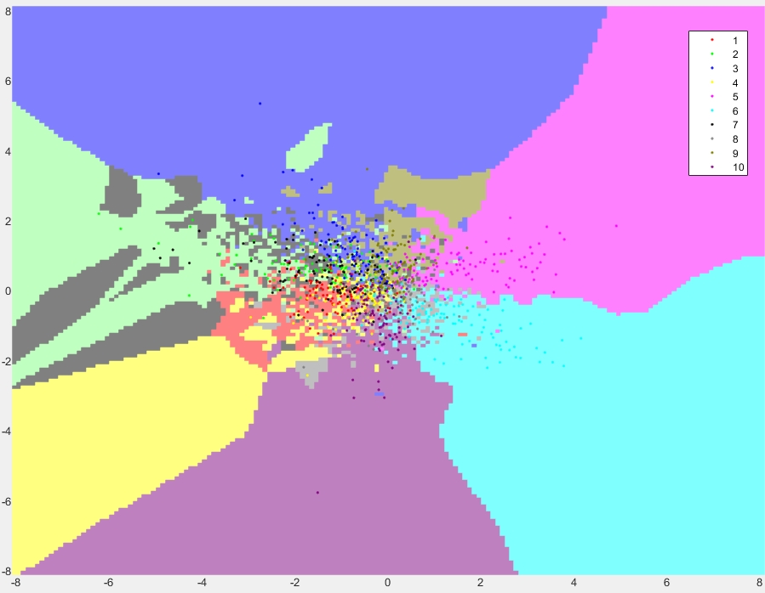

Task 4.3: Gaussian-Full decision boundary:

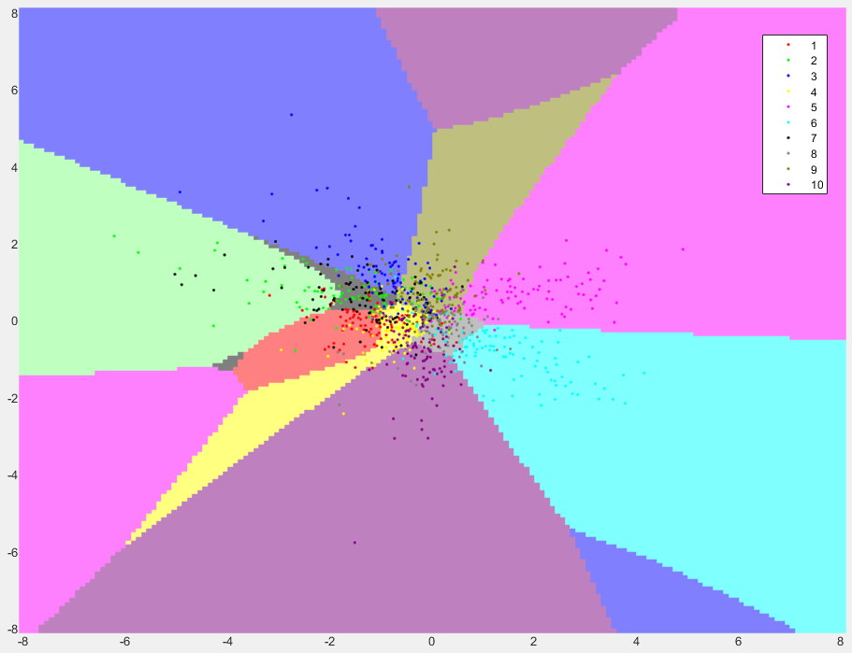

Gaussian lda decision boundaries:

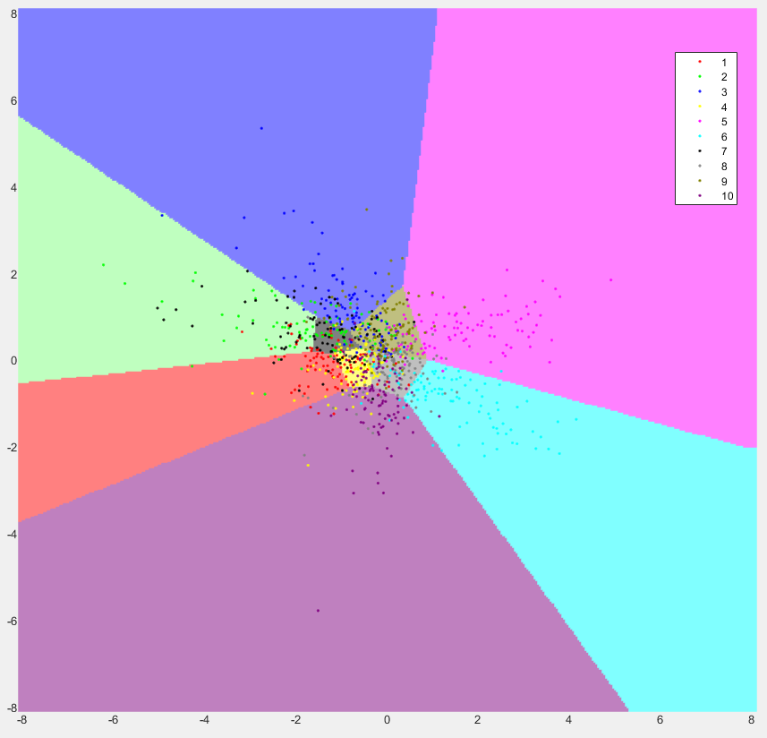

Task 4.4:

From the decision boundary graphs, we can see that the k-nn classification doesn’t generalize the classes from the tests, making it having a ‘messy’ boundary, while both Gaussian method gives clear boundary.

The full Gaussian boundary might be inaccurate when the feature vector is a lot larger than the training data, because there are areas with no data scattered in it.

And the lda boundary have straight line boundaries, it solves the problem from full Gaussian, but makes it less accurate at the center.

From the graph, we can find out that class 2 and 7 (green and black) are not clearly separated, which is also shown in the confusion table, class pairs having the same problem are: 1 and 4(red and yellow), 3 and 9(blue and dark green), this may be the reason that some numbers looks alike when the image isn’t that clear.