AVS ARTS AND SCIENCE COLLEGE,OMALUR

DEPARTMENT OF COMPUTER SCIENCE

HELATH AND WELLNESS

AKASH K

REG NO : C24UG214CSC004

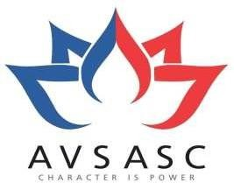

SEMESTERIII

AVSARTSANDSCIENCECOLLEGE(COEDUCATION)
(Affiliated to Periyar University) SALEM - 11 DepartmentofComputerScience
October-2025

Name : ………………………..… Reg No : ……………………..
Year : ………………………….... Semester :……………….……
Practical :……………………………………………

Practical Incharge HOD

Submitted for the Practical Examination held on ………….at

…………………………………………

…………………
Examiner

CONTENT

S NO | TITLE | PAGE NO
1 | INTRODUCTION TO HOLISTIC WELL -BEING | 4
2 | WELLNESS WHEEL EXERCISE (OVER ALL ANALYSIS) | 8
3 | BREAKING BAD HABITS(OVER ALL ANALYSIS) | 12
4 | PHYSICAL WELL –BEING | 16
5 | EMOTIONAL WELL - BEING | 20
6 | SOCIAL WELL - BEING | 27
7 | INTELLECTUAL WELL – BEING | 32
8 | ENVIRONMENTAL WELL – BEING | 37
9 | MENTAL WELL – BEING | 41
10 | SITUTATIONAL AWARNESS (DEVELOPING LIFE CYCLES) | 47
11 | UNDERSTANDING ADDICTION | 51

