# Week 2 Homework:

Create the following geometry using the following dimensions. PDF versions of all drawings are included in the folder called “[Drawings for Homework](https://drive.google.com/open?id=0B_Vi5ZdEzANgLXFPbGhLWmV5TWM)” under the Week 2 folder.

## Exercise #1:

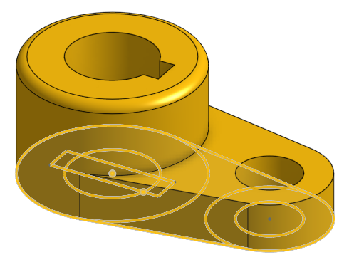

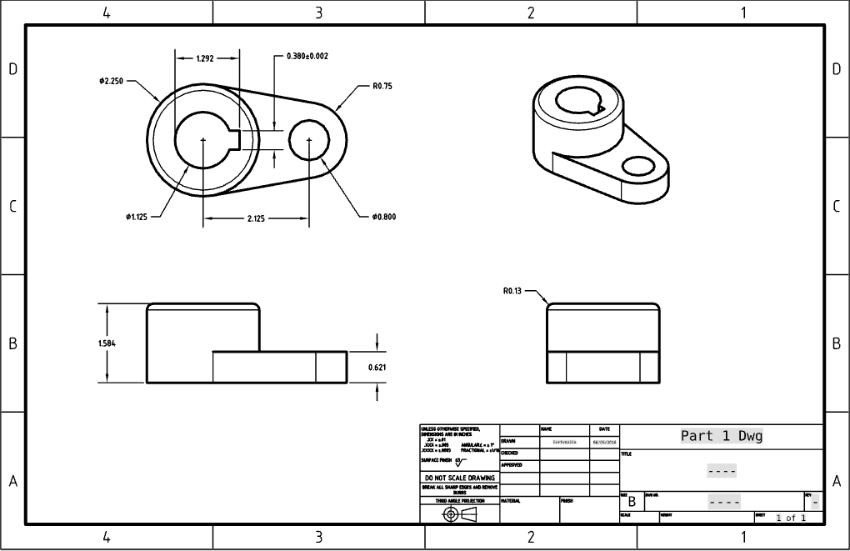

## Exercise #2:

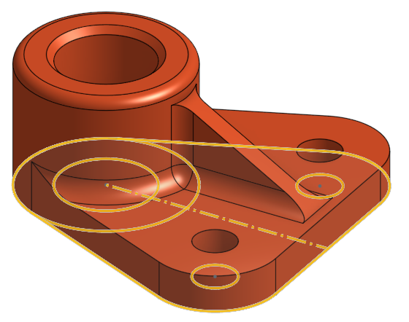 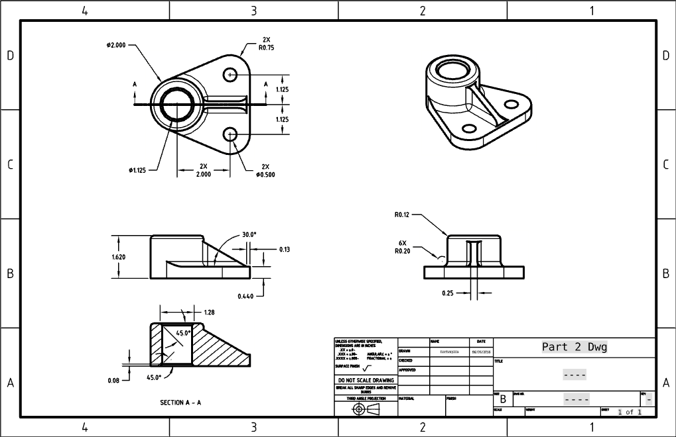

## Exercise #3:

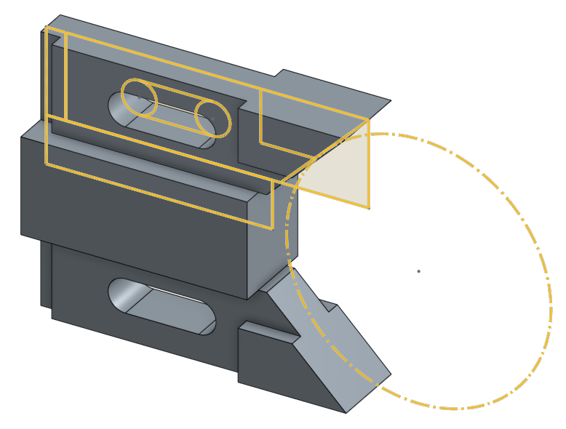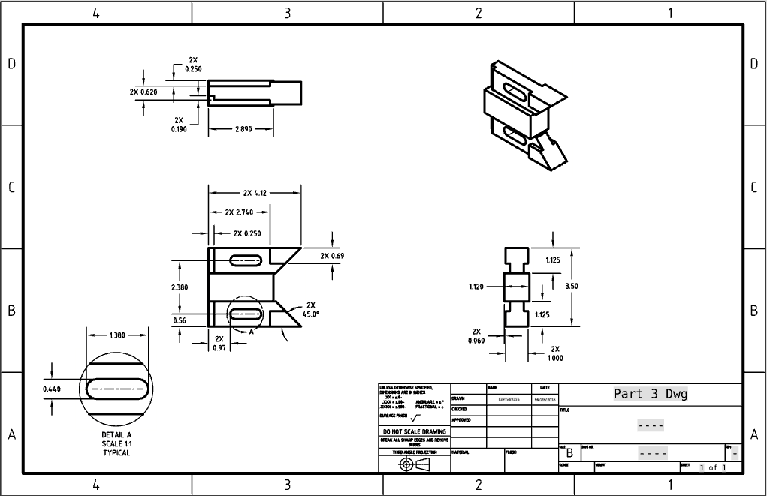

## Exercise #4:

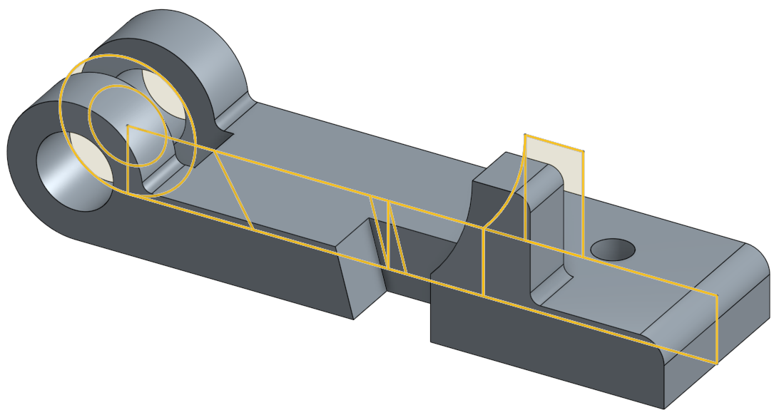 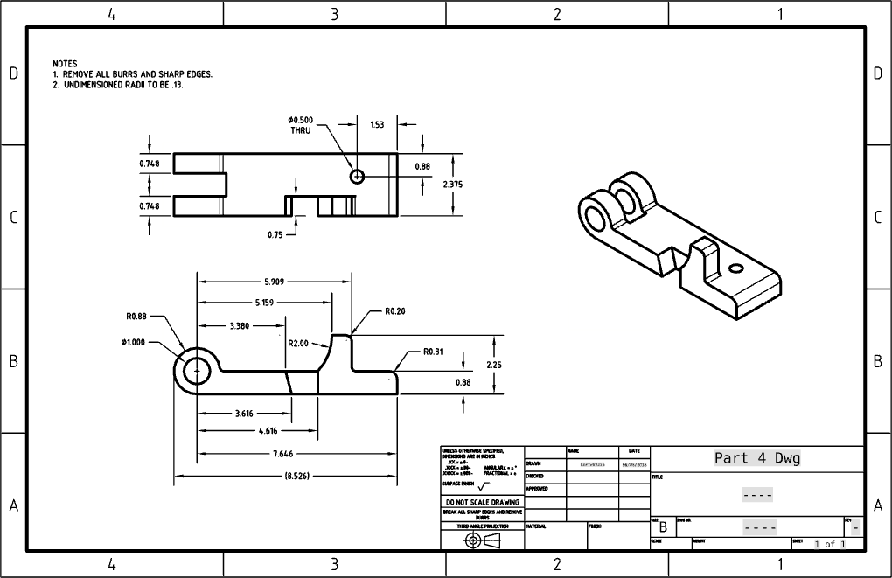

## Exercise #5:

