*Pro Tip: “Pre-selecting” 能減省不少時間.在這情況下, pre-selecting你想繪圖的面(他將會顯示橘色) before clicking the Sketch button will save your mouse a round trip journey from the feature toolbar to the graphic area, and back again. It may not seem like a lot now, but when you create hundreds of parts, each with hundreds of features, that time starts to add up quickly!*

1. We’re going to draw a circle in the middle of this face, and we’re going to utilize **Automatic Inferencing** to do it. Click on the circle tool, now hover over the origin until it turns orange, now slide the mouse up to the middle of the face. Note the yellow dotted line, and the icon for “vertical”. This shows that we’ve “woken up” the origin and enabled snapping to it. Now when we click on the dotted line, the center of the circle will be vertically aligned with the origin. Sketch your circle here, and a vertical constraint will be applied (satisfies Design Requirement B).

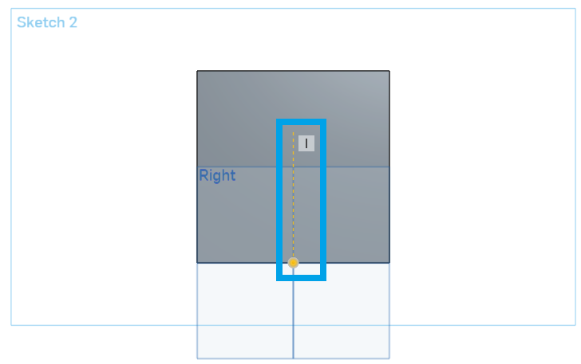

1. 新爭尺寸如下.圓圈應該是黑色,並這草圖現在是完全定義.

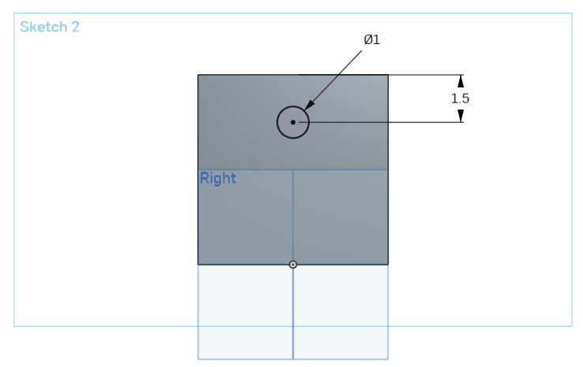

1. 確定草圖.
2. 點擊Extrude工具,並選擇圓形.
3. By default, Onshape assumes you want to create a circular **Boss**, or protruding feature; however, this time we want to create a hole. By default, the Extrude dialog box has the “Add” operation selected, and we need to change it to “Remove” (Note that the direction of the extrude changes automatically as well):

