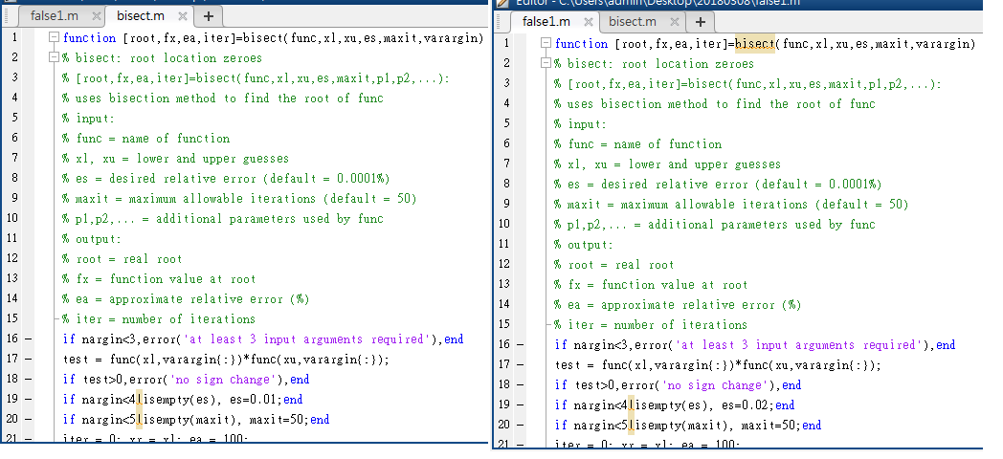

>> [mass fx ea iter]=false1(fm,0.5,2)

xr =

1.6860

xr =

1.5695

xr =

1.5248

xr =

1.5074

xr =

1.5006

xr =

1.4980

xr =

1.4969

xr =

1.4965

xr =

1.4963

mass =

1.4963

fx =

1.2083e-04

ea =

0.0108

iter =

9

>> [mass fx ea iter]=bisect(fm,0.5,2)

mass =

1.4962

fx =

-5.8463e-05

ea =

0.0061

iter =

14