# Configuration:

Default configuration is as follows:

**Client**: BlockChainClient.exe.config

<add key="host" value="localhost"/>

<add key="port" value="12345"/>

<add key="cryptoProvider" value="RLWE"/> <!-- RLWE | ED25519 -->

**Server Node 1**: BlockChainDemo.Console.exe.config

<add key="host" value="localhost"/>

<add key="port" value="12345"/>

<add key="nodeId" value="Node 1"/>

<add key="cryptoProvider" value="RLWE"/> <!-- RLWE | ED25519 -->

<add key="registerNodes" value="localhost:12346"/>

**Server Node 2**: BlockChainDemo.Console.exe.config

<add key="host" value="localhost"/>

<add key="port" value="12346"/>

<add key="nodeId" value="Node 2"/>

<add key="cryptoProvider" value="RLWE"/> <!-- RLWE | ED25519 -->

<add key="registerNodes" value="localhost:12345"/>

Notes on Crypto Providers:

* Crypto providers can be set to “RLWE” or “ED25519”
* All clients and servers must be configured to use the same provider
* The client will use a different wallet file for each crypto provider
* The servers will use a different Block-Chain for each crypto provider

# Running Test Environment

To launch a client and two servers, execute the “run.bat” batch file.

# Server Log and Checkpoint files

The Server nodes store log files in the following folders:

.\ServerNode02\{CryptoProviderName}\logs

These log files can be opened to see entries relating to server activity.

Checkpoint files store server state (ie. block chain + uncommitted transactions) and are stored here:

.\ServerNode02\{CryptoProviderName}\checkpoints

# Client Example commands

## Client : Help

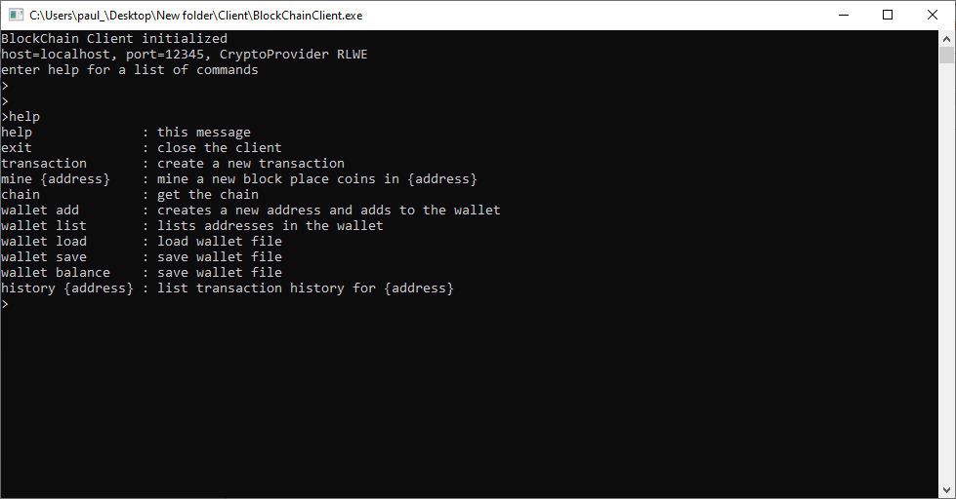

## Client : List Wallet contents:

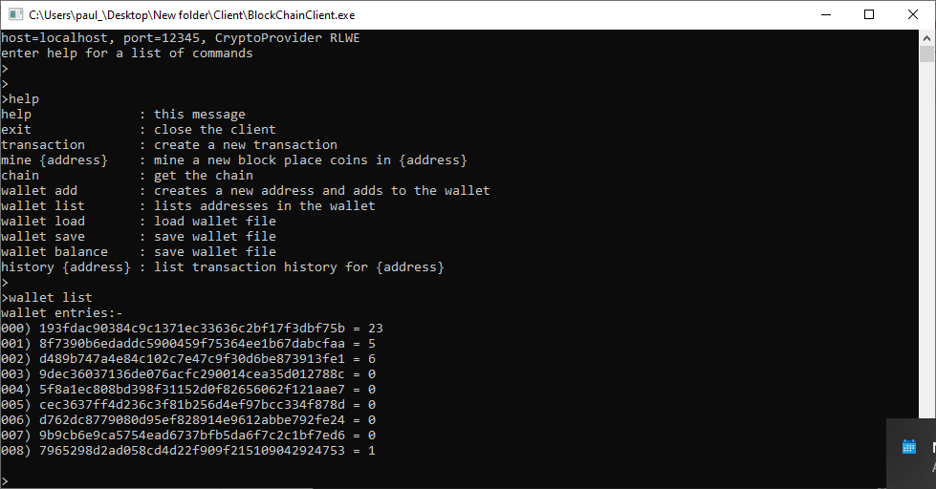

## Client : Create a Transaction (interactive):

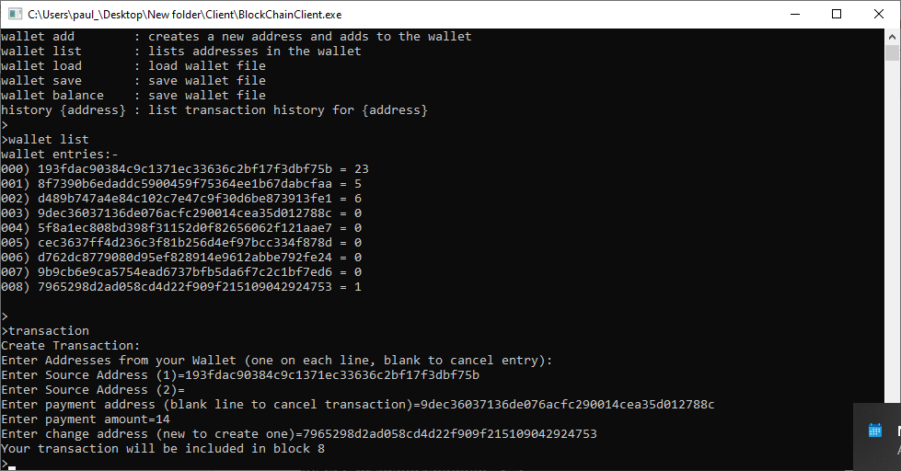

## Client : Wallet List before and after balance:

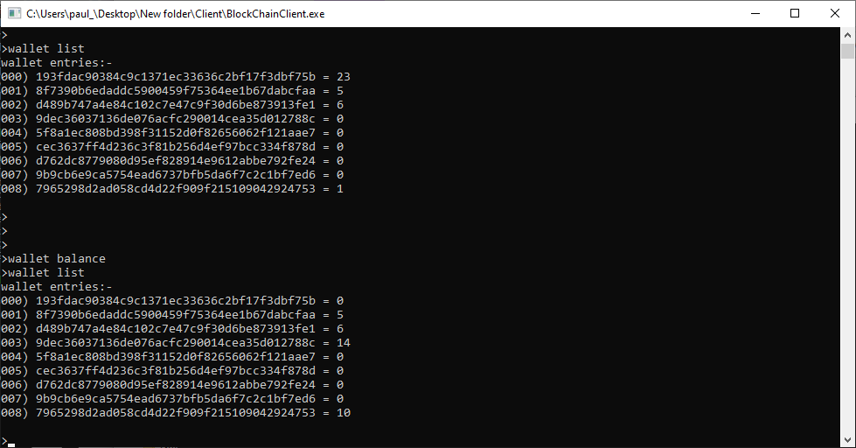

## Client : Mine

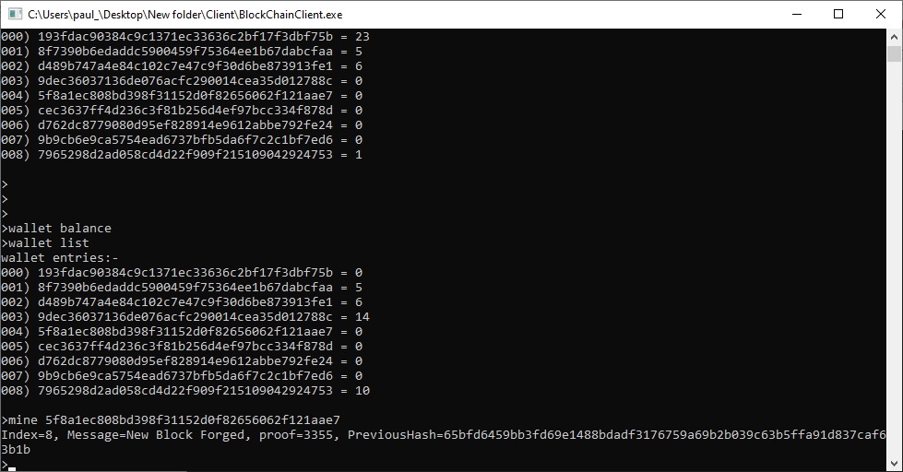

## Client : History

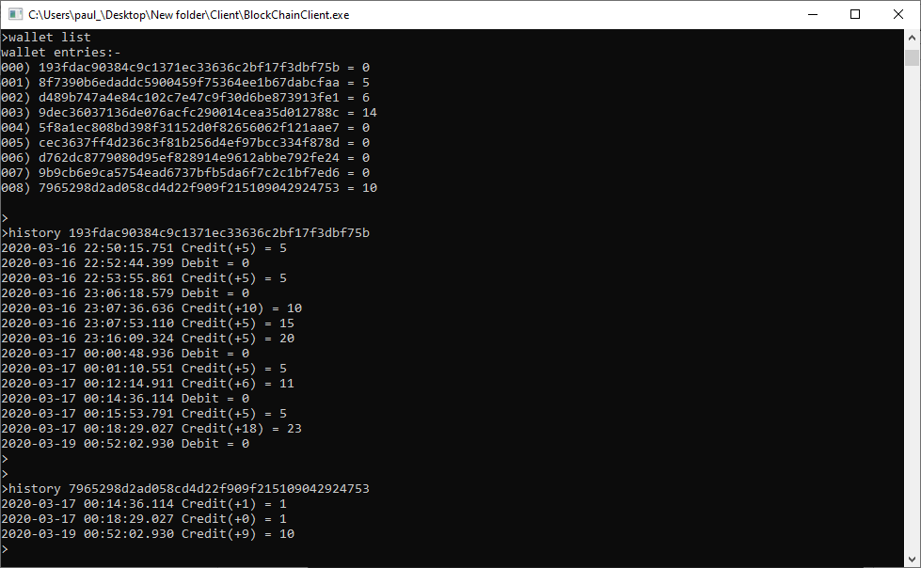

# Server Example commands

# Server Node 01

## Server Node 01 : Help

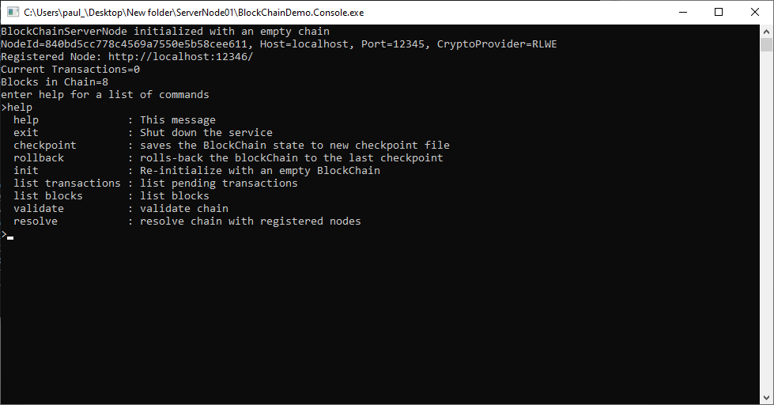

## Server Node 01 : Status

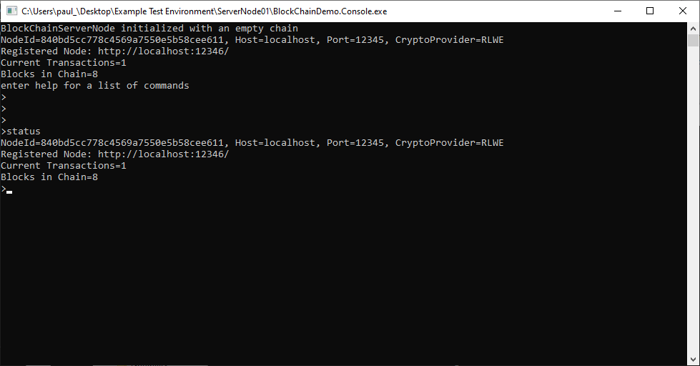

## Server Node 01 : Echo On, output of mine request from client:

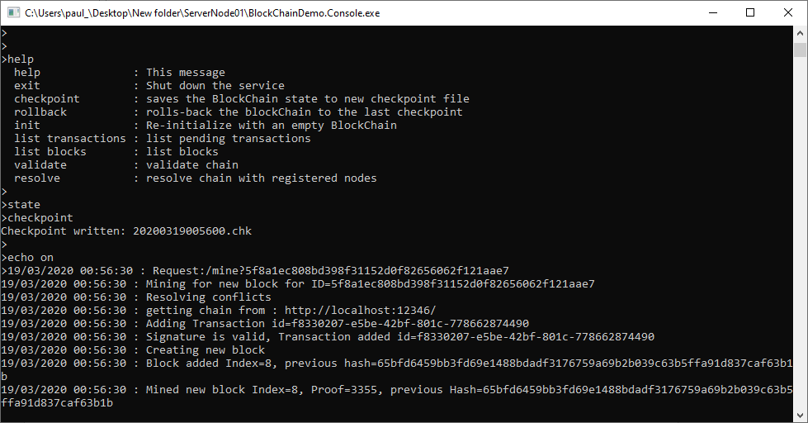

# Server Node 02

## Server 02 : Ouptut from Resolve (ie. Consensus)

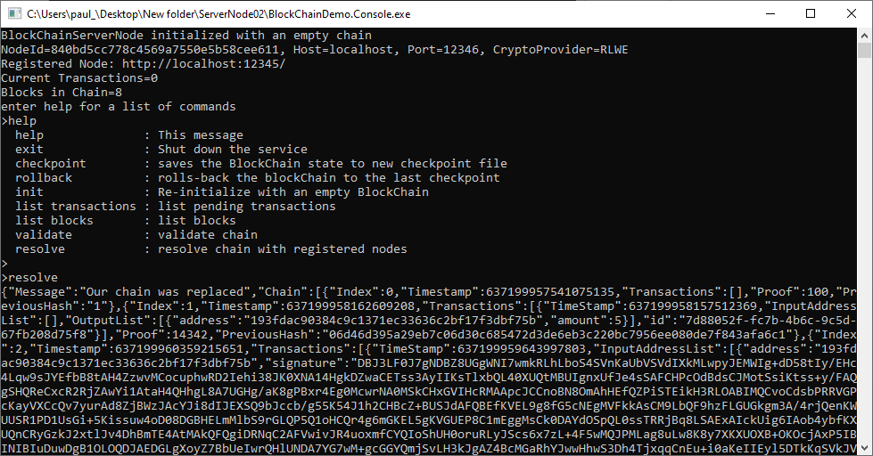

# Example Log Entries

16/03/2020 23:04:11 : Creating new block

16/03/2020 23:04:11 : Block added Index=0, previous hash=1

16/03/2020 23:04:11 : BlockChain Initialized : NodeId=47c2e3e5a38744dc9e401d1fc1934f55

16/03/2020 23:04:11 : Node Registered : http://localhost:12346

16/03/2020 23:04:11 : Web Service Listening on port: 12345

16/03/2020 23:04:11 : Rolling back, loading previous : C:\repos\40448091\eSecurity\assignment\blockchain\BlockChainServerNode\BlockChain.Console\bin\Debug\RLWE\checkpoints\20200316225938.chk

16/03/2020 23:04:12 : Rolling complete

16/03/2020 23:05:28 : Request:/balance

16/03/2020 23:06:18 : Request:/transactions/new

16/03/2020 23:06:18 : Adding Transaction id=378ffffb-ce0d-498f-be78-4e7a6033baea

16/03/2020 23:06:18 : Signature is valid, Transaction added id=378ffffb-ce0d-498f-be78-4e7a6033baea

16/03/2020 23:06:22 : Request:/balance

16/03/2020 23:06:34 : Request:/history?9dec36037136de076acfc290014cea35d012788c

16/03/2020 23:06:43 : Request:/history?193fdac90384c9c1371ec33636c2bf17f3dbf75b

16/03/2020 23:07:36 : Request:/transactions/new

16/03/2020 23:07:36 : Adding Transaction id=b21fe74d-d88b-45d4-bf92-f22392f0ae35

16/03/2020 23:07:36 : Signature is valid, Transaction added id=b21fe74d-d88b-45d4-bf92-f22392f0ae35

16/03/2020 23:07:41 : Request:/balance

16/03/2020 23:07:52 : Request:/mine?193fdac90384c9c1371ec33636c2bf17f3dbf75b

16/03/2020 23:07:52 : Mining for new block for ID=193fdac90384c9c1371ec33636c2bf17f3dbf75b

16/03/2020 23:07:53 : Resolving conflicts

16/03/2020 23:07:53 : getting chain from : http://localhost:12346/

16/03/2020 23:07:53 : Adding Transaction id=1ed8d54a-525a-45d5-86e7-2e940a4d38be

16/03/2020 23:07:53 : Signature is valid, Transaction added id=1ed8d54a-525a-45d5-86e7-2e940a4d38be

16/03/2020 23:07:53 : Creating new block

16/03/2020 23:07:53 : Block added Index=3, previous hash=b1b90e5a139d3f4e79dd09568667fe0eb440aa4d653dbe834692622becb167ce

16/03/2020 23:07:53 : Mined new block Index=3, Proof=45701, previous Hash=b1b90e5a139d3f4e79dd09568667fe0eb440aa4d653dbe834692622becb167ce

# Example Checkpoint file entries

840bd5cc778c4569a7550e5b58cee611|RLWE|0

5

0|637199957541075135|100|1|0

1|637199958162609208|14342|06d46d395a29eb7c06d30c685472d3de6eb3c220bc7956ee080de7f843afa6c1|1

{"TimeStamp":637199958157512369,"InputAddressList":[],"OutputList":[{"address":"193fdac90384c9c1371ec33636c2bf17f3dbf75b","amount":5}],"id":"7d88052f-fc7b-4b6c-9c5d-67fb208d75f8"}

2|637199960359215651|364337|ad437420dc67b2211f11ffdfd68aaeb06e51e5fb4727b53b173136ac053a9d4f|2

{"TimeStamp":637199959643997803,"InputAddressList":[{"address":"193fdac90384c9c1371ec33636c2bf17f3dbf75b","signature":"","base64PublicKey":""}],"OutputList":[{"address":"8f7390b6edaddc5900459f75364ee1b67dabcfaa","amount":4},{"address":"d489b747a4e84c102c7e47c9f30d6be873913fe1","amount":1}],"id":"c87723a8-ad44-4361-90dd-5e2040683aab"}

{"TimeStamp":637199960358616017,"InputAddressList":[],"OutputList":[{"address":"193fdac90384c9c1371ec33636c2bf17f3dbf75b","amount":5}],"id":"ce5d5916-64e2-4707-9afb-4f83ba922caa"}

3|637199968732488290|45701|b1b90e5a139d3f4e79dd09568667fe0eb440aa4d653dbe834692622becb167ce|3

{"TimeStamp":637199967785796485,"InputAddressList":[{"address":"193fdac90384c9c1371ec33636c2bf17f3dbf75b","signature":"","base64PublicKey":""},{"address":"8f7390b6edaddc5900459f75364ee1b67dabcfaa","signature":"","base64PublicKey":""},{"address":"d489b747a4e84c102c7e47c9f30d6be873913fe1","signature":"","base64PublicKey":""}],"OutputList":[{"address":"9dec36037136de076acfc290014cea35d012788c","amount":10},{"address":"5f8a1ec808bd398f31152d0f82656062f121aae7","amount":0}],"id":"378ffffb-ce0d-498f-be78-4e7a6033baea"}

{"TimeStamp":637199968566365429,"InputAddressList":[{"address":"9dec36037136de076acfc290014cea35d012788c","signature":"","base64PublicKey":""}],"OutputList":[{"address":"193fdac90384c9c1371ec33636c2bf17f3dbf75b","amount":10},{"address":"8f7390b6edaddc5900459f75364ee1b67dabcfaa","amount":0}],"id":"b21fe74d-d88b-45d4-bf92-f22392f0ae35"}

{"TimeStamp":637199968731109144,"InputAddressList":[],"OutputList":[{"address":"193fdac90384c9c1371ec33636c2bf17f3dbf75b","amount":5}],"id":"1ed8d54a-525a-45d5-86e7-2e940a4d38be"}

4|637199973693867103|39440|6faaad4a6ef37066113f4e4a771f6ffd010679aa0fa58d1dce21bca3276b2faf|1

{"TimeStamp":637199973693247461,"InputAddressList":[],"OutputList":[{"address":"193fdac90384c9c1371ec33636c2bf17f3dbf75b","amount":5}],"id":"6545cd1c-ea91-4201-9ec9-3f9b6046cf38"}