实验报告

实验项目名称 实验七 基本表的创建、插入、更新和删除
实 验 室 云计算研究中心实验室520
所属课程名称 数 据 库
实 验 日 期 2025.11.20

班 级 24大数据2班
学 号 2024110089
姓 名 倪伟丰

【实验环境】
- Oracle11g及以上
【实验目的】
- 学会基本表的创建；
- 掌握插入记录、更新记录和删除记录的操作。
【实验结果提交方式】
- 实验7-3
按实验要求完成各个实验，并将各命令的执行过程以及执行成功后相应表的结构和数据屏幕复制下来，记录在本实验报告中。
- 将本实验报告存放在“XXXXXXXXXX-7.docx”文件中, 其中“XXXXXXXXXX”是学号，并在教师规定的时间内通过BB系统提交该文件。
【实验7-3的实验结果】
记录各命令的执行过程以及执行成功后相应表的结构或数据。
（注意：自己创建下列题目涉及的表结构，插入的数据可参考7-11至7-22）
前置任务，创建Payment，Ptype，Orders，Order_items表：
drop table Order_items;
drop table Product;
drop table Ptype;
drop table Orders;
drop table Payment;
drop table Customer;

CREATE TABLE Customer (
CNO CHAR(5) PRIMARY KEY,
CNAME NVARCHAR2(50),
COMPANY NVARCHAR2(100),
CITY NVARCHAR2(50),
TEL VARCHAR(20)
);

CREATE TABLE Ptype (
TNO CHAR(1) PRIMARY KEY,
TNAME NVARCHAR2(15)
);

CREATE TABLE Product (
PNO char(4) PRIMARY KEY,
PNAME NVARCHAR2(100),
PRICE NUMBER(7, 2),
TNO CHAR(1),
INVENTORY INT,
FOREIGN KEY (TNO) REFERENCES Ptype(TNO)
);

CREATE TABLE Payment (
PAYMENT_TNO char(1) PRIMARY KEY,
PAYMENT_TYPE NVARCHAR2(50)
);

CREATE TABLE Orders (
ONO CHAR(5) PRIMARY KEY,
ORDER_DATE DATE,
CNO CHAR(5),
FREIGHT INT,
SHIPMENT_DATE DATE,
CITY NVARCHAR2(50),
PAYMENT_TNO char(1),
STATUS NVARCHAR2(20),
FOREIGN KEY (CNO) REFERENCES Customer(CNO),
FOREIGN KEY (PAYMENT_TNO) REFERENCES Payment(PAYMENT_TNO)
);

CREATE TABLE Order_items (
ONO CHAR(5),
PNO char(4),
QTY INT,
DISCOUNT DECIMAL(4, 2),
PRIMARY KEY (ONO, PNO),
FOREIGN KEY (ONO) REFERENCES Orders(ONO),
FOREIGN KEY (PNO) REFERENCES Product(PNO)
);

COMMIT;

- 在Payment和Ptype表中插入数据。
INSERT INTO Ptype VALUES('1', 'Book');
INSERT INTO Ptype VALUES('2', 'CD');
INSERT INTO Ptype VALUES('3', 'Software');

INSERT INTO PAYMENT VALUES('1', 'Cash');
INSERT INTO PAYMENT VALUES('2', 'Check');
INSERT INTO PAYMENT VALUES('3', 'Credit Card');
INSERT INTO PAYMENT VALUES('4', 'Telegraphic Money');
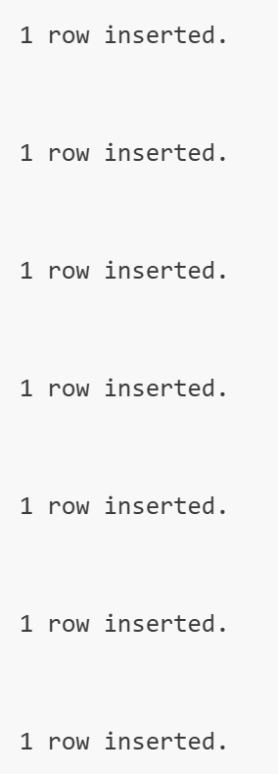

SELECT * FROM Ptype;
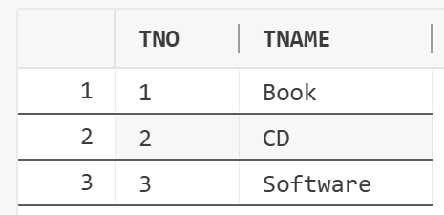
SELECT * FROM PAYMENT;
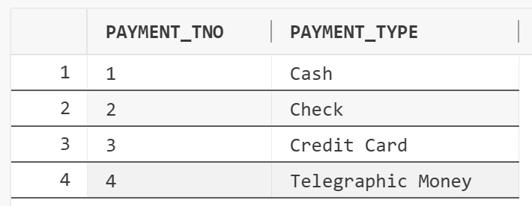
- 利用INSERT语句在Orders表中直接插入5个记录。
INSERT INTO ORDERS(ONO, ORDER_DATE, CNO, FREIGHT, SHIPMENT_DATE, CITY)
SELECT 'O0001', TO_DATE('2014-03-10', 'YYYY-MM-DD'), 'C0001', 8, TO_DATE('2014-03-11', 'YYYY-MM-DD'), 'Beijing' FROM DUAL UNION ALL
SELECT 'O0002', TO_DATE('2014-03-11', 'YYYY-MM-DD'), 'C0002', 8, TO_DATE('2014-03-12', 'YYYY-MM-DD'), 'Shanghai' FROM DUAL UNION ALL
SELECT 'O0003', TO_DATE('2014-03-11', 'YYYY-MM-DD'), 'C0009', 5, TO_DATE('2014-03-12', 'YYYY-MM-DD'), 'Shanghai' FROM DUAL UNION ALL
SELECT 'O0004', TO_DATE('2014-04-13', 'YYYY-MM-DD'), 'C0007', 5, TO_DATE('2014-04-15', 'YYYY-MM-DD'), 'Beijing' FROM DUAL UNION ALL
SELECT 'O0005', TO_DATE('2014-04-14', 'YYYY-MM-DD'), 'C0010', 8, TO_DATE('2014-04-16', 'YYYY-MM-DD'), 'Beijing' FROM DUAL;
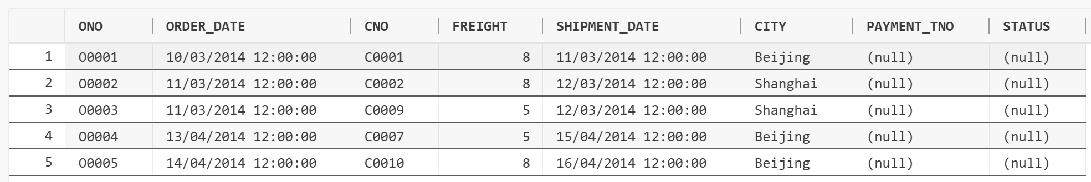
- 利用INSERT语句在Orders表中用交互方式插入3个记录。
INSERT INTO ORDERS(ONO, ORDER_DATE, CNO, FREIGHT, SHIPMENT_DATE, CITY, PAYMENT_TNO, STATUS)
VALUES('&Ono', TO_DATE('&Order_Date', 'YYYY-MM-DD'), '&Cno', &Freight, TO_DATE('&Shipment_Date', 'YYYY-MM-DD'), '&City', '&Payment_Tno', '&Status');
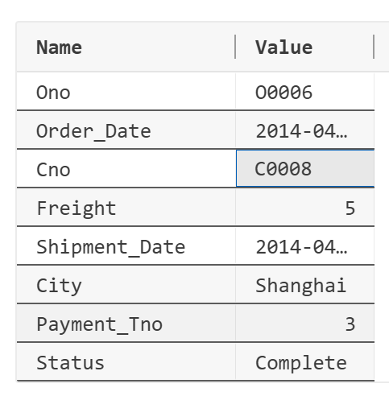
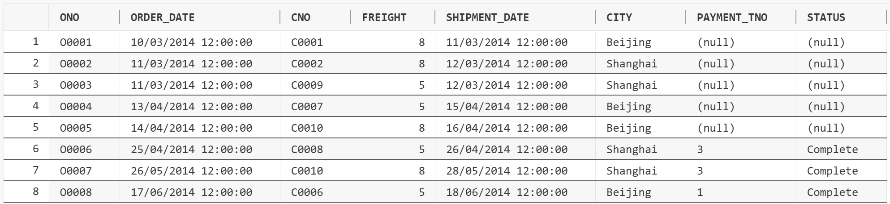
- 设置Orders表前5行数据中的PAYMENT_TNO和STATUS属性的值。
UPDATE ORDERS
SET PAYMENT_TNO = '1', STATUS = 'Complete'
WHERE ONO IN ('O0001', 'O0004', 'O0005');

UPDATE ORDERS
SET PAYMENT_TNO = '2', STATUS = 'Complete'
WHERE ONO IN ('O0002', 'O0003');

SELECT * from ORDERS;
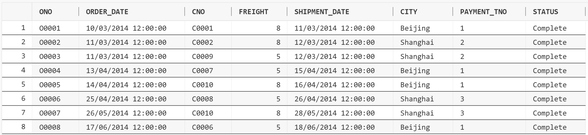
- 在Product和Order_items表中插入数据。
INSERT INTO Product (PNO, PNAME, PRICE, TNO, INVENTORY) VALUES ('1001', 'Advanced Marketing', 20.5, '1', 120);
INSERT INTO Product (PNO, PNAME, PRICE, TNO, INVENTORY) VALUES ('1002', 'Visual Basic Programming', 28, '1', 200);
INSERT INTO Product (PNO, PNAME, PRICE, TNO, INVENTORY) VALUES ('1003', 'Computer Application', 30.55, '1', 80);
INSERT INTO Product (PNO, PNAME, PRICE, TNO, INVENTORY) VALUES ('1004', 'An Introduction to Database Systems', 20, '1', 12);
INSERT INTO Product (PNO, PNAME, PRICE, TNO, INVENTORY) VALUES ('1005', 'Microeconomics', 35.8, '1', 150);
INSERT INTO Product (PNO, PNAME, PRICE, TNO, INVENTORY) VALUES ('2001', 'The Lion King', 35, '2', 150);
INSERT INTO Product (PNO, PNAME, PRICE, TNO, INVENTORY) VALUES ('2002', 'Classic Disney', 25, '2', 20);

INSERT INTO Product (PNO, PNAME, PRICE, TNO, INVENTORY) VALUES ('3001', 'Microsoft Money 2010', 70.5, '3', 300);
INSERT INTO Product (PNO, PNAME, PRICE, TNO, INVENTORY) VALUES ('3002', 'Microsoft Student 2009', 80, '3', 150);
INSERT INTO Product (PNO, PNAME, PRICE, TNO, INVENTORY) VALUES ('3003', 'Norton AntiVirus 2014', 40.9, '3', 250);
INSERT INTO Product (PNO, PNAME, PRICE, TNO, INVENTORY) VALUES ('3004', 'Math Advantage 2007', 30, '3', 10);
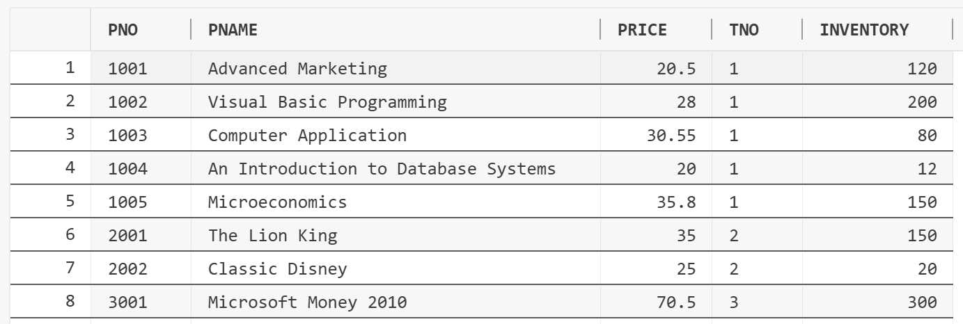
INSERT INTO ORDER_ITEMS (ONO, PNO, QTY, DISCOUNT) VALUES ('O0001', '1001', 5, NULL);
INSERT INTO ORDER_ITEMS (ONO, PNO, QTY, DISCOUNT) VALUES ('O0001', '1002', 1, 0.2);
INSERT INTO ORDER_ITEMS (ONO, PNO, QTY, DISCOUNT) VALUES ('O0001', '1003', 3, 0.3);
INSERT INTO ORDER_ITEMS (ONO, PNO, QTY, DISCOUNT) VALUES ('O0001', '2001', 1, 0.2);
INSERT INTO ORDER_ITEMS (ONO, PNO, QTY, DISCOUNT) VALUES ('O0001', '2002', 1, 0.2);

INSERT INTO ORDER_ITEMS (ONO, PNO, QTY, DISCOUNT) VALUES ('O0002', '1001', 2, 0.0);
INSERT INTO ORDER_ITEMS (ONO, PNO, QTY, DISCOUNT) VALUES ('O0002', '1004', 5, 0.4);
INSERT INTO ORDER_ITEMS (ONO, PNO, QTY, DISCOUNT) VALUES ('O0002', '1005', 1, 0.05);
INSERT INTO ORDER_ITEMS (ONO, PNO, QTY, DISCOUNT) VALUES ('O0002', '3003', 3, 0.3);

INSERT INTO ORDER_ITEMS (ONO, PNO, QTY, DISCOUNT) VALUES ('O0003', '1005', 1, 0.05);
INSERT INTO ORDER_ITEMS (ONO, PNO, QTY, DISCOUNT) VALUES ('O0004', '1005', 1, 0.05);

INSERT INTO ORDER_ITEMS (ONO, PNO, QTY, DISCOUNT) VALUES ('O0005', '1005', 1, 0.05);

INSERT INTO ORDER_ITEMS (ONO, PNO, QTY, DISCOUNT) VALUES ('O0006', '1004', 5, 0.4);
INSERT INTO ORDER_ITEMS (ONO, PNO, QTY, DISCOUNT) VALUES ('O0006', '1005', 1, null);
INSERT INTO ORDER_ITEMS (ONO, PNO, QTY, DISCOUNT) VALUES ('O0006', '2001', 2, 0.3);
INSERT INTO ORDER_ITEMS (ONO, PNO, QTY, DISCOUNT) VALUES ('O0006', '2002', 1, 0.2);
INSERT INTO ORDER_ITEMS (ONO, PNO, QTY, DISCOUNT) VALUES ('O0006', '3003', 2, 0.3);

INSERT INTO ORDER_ITEMS (ONO, PNO, QTY, DISCOUNT) VALUES ('O0007', '1004', 1, 0.4);
INSERT INTO ORDER_ITEMS (ONO, PNO, QTY, DISCOUNT) VALUES ('O0007', '3004', 3, 0.2);

INSERT INTO ORDER_ITEMS (ONO, PNO, QTY, DISCOUNT) VALUES ('O0008', '1002', 1, 0.2);
INSERT INTO ORDER_ITEMS (ONO, PNO, QTY, DISCOUNT) VALUES ('O0008', '2001', 3, 0.3);

INSERT INTO ORDER_ITEMS (ONO, PNO, QTY, DISCOUNT) VALUES ('O0009', '3003', 2, 0.3);
INSERT INTO ORDER_ITEMS (ONO, PNO, QTY, DISCOUNT) VALUES ('O0009', '1001', 1, null);

INSERT INTO ORDER_ITEMS (ONO, PNO, QTY, DISCOUNT) VALUES ('O0010', '1005', 1, 0.05);

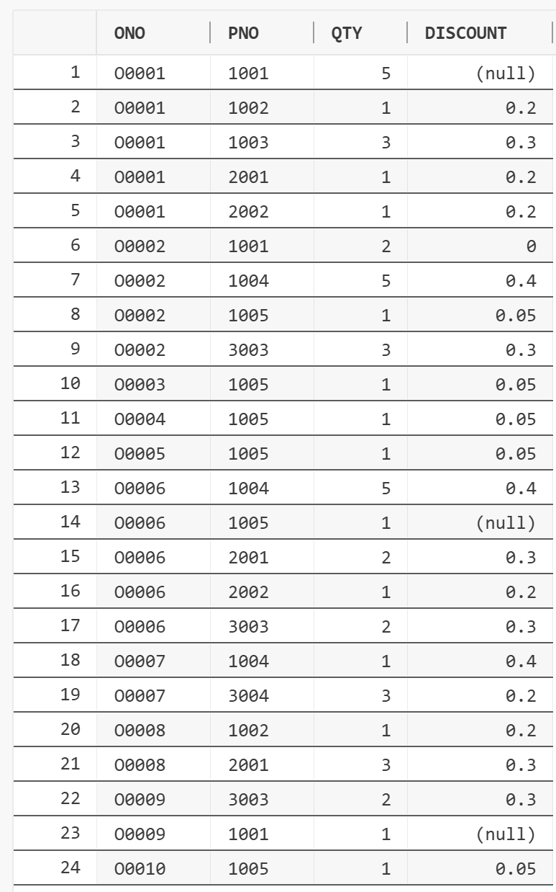
COMMIT;
- 参阅表7-18给出的数据，修改Product表的产品库存。
UPDATE PRODUCT
SET INVENTORY = 110
WHERE PNO = '1001';

UPDATE PRODUCT
SET INVENTORY = 190
WHERE PNO = '1002';

UPDATE PRODUCT
SET INVENTORY = 70
WHERE PNO = '1003';

UPDATE PRODUCT
SET INVENTORY = 2
WHERE PNO = '1004';

UPDATE PRODUCT
SET INVENTORY = 140
WHERE PNO = '1005';
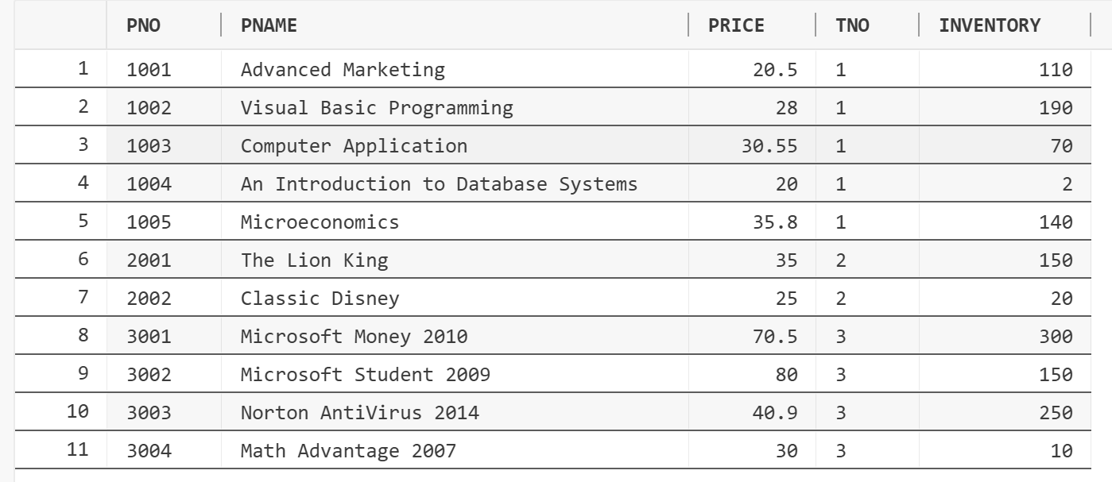
- 删除与 “1001”号产品有关的所有信息。
DELETE
FROM Order_items
where PNO = '1001';
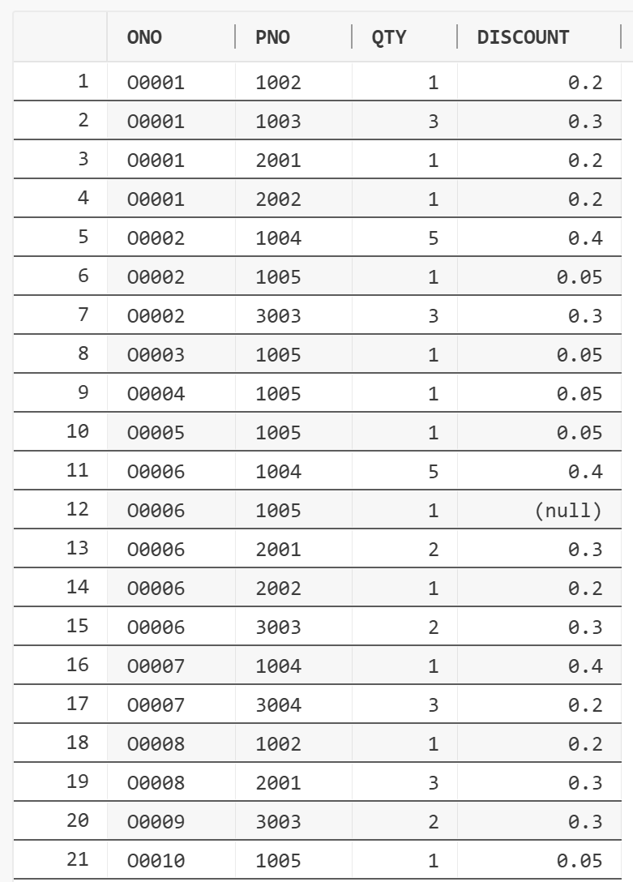
DELETE
from Product
where PNO = '1001';
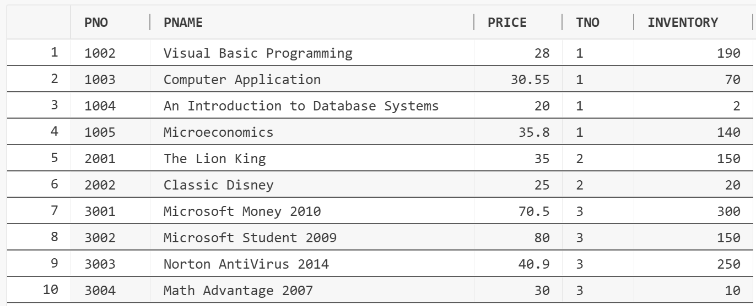
- 使用“CREATE TABLE … AS”语句从Product表创建另一个名称为Product1的表，其中包含所有库存小于100的产品信息。
CREATE TABLE Product1 AS
(
SELECT * FROM Product WHERE INVENTORY < 100
);

SELECT * FROM Product1;

COMMIT;
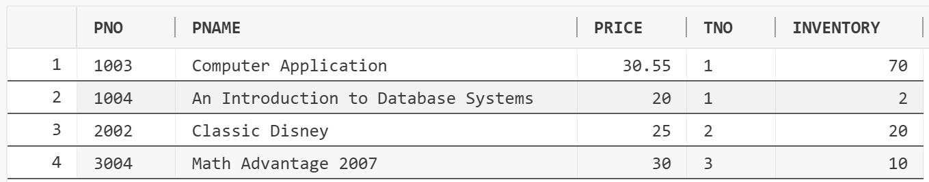
- 将Product1表中库存小于50的产品的库存增加200。
UPDATE PRODUCT1
SET INVENTORY = INVENTORY + 200
WHERE INVENTORY < 50;

SELECT * FROM PRODUCT1;

COMMIT;
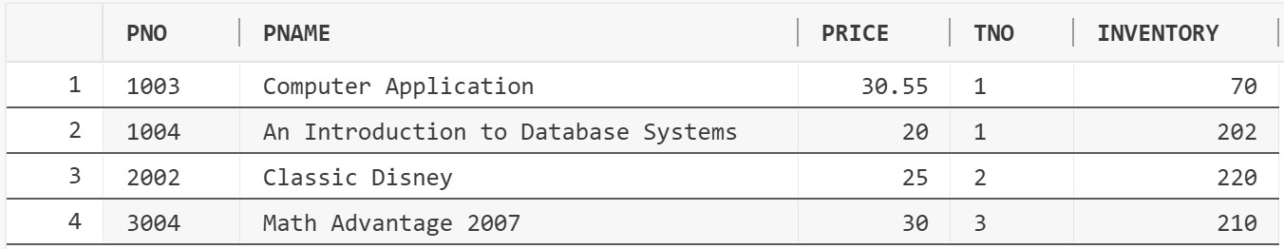
- 将Employee表中所有办事员（CLERK）的薪金提高5%。
UPDATE Employee
SET sal = sal * 1.05
where JOB = 'CLERK';

COMMIT;
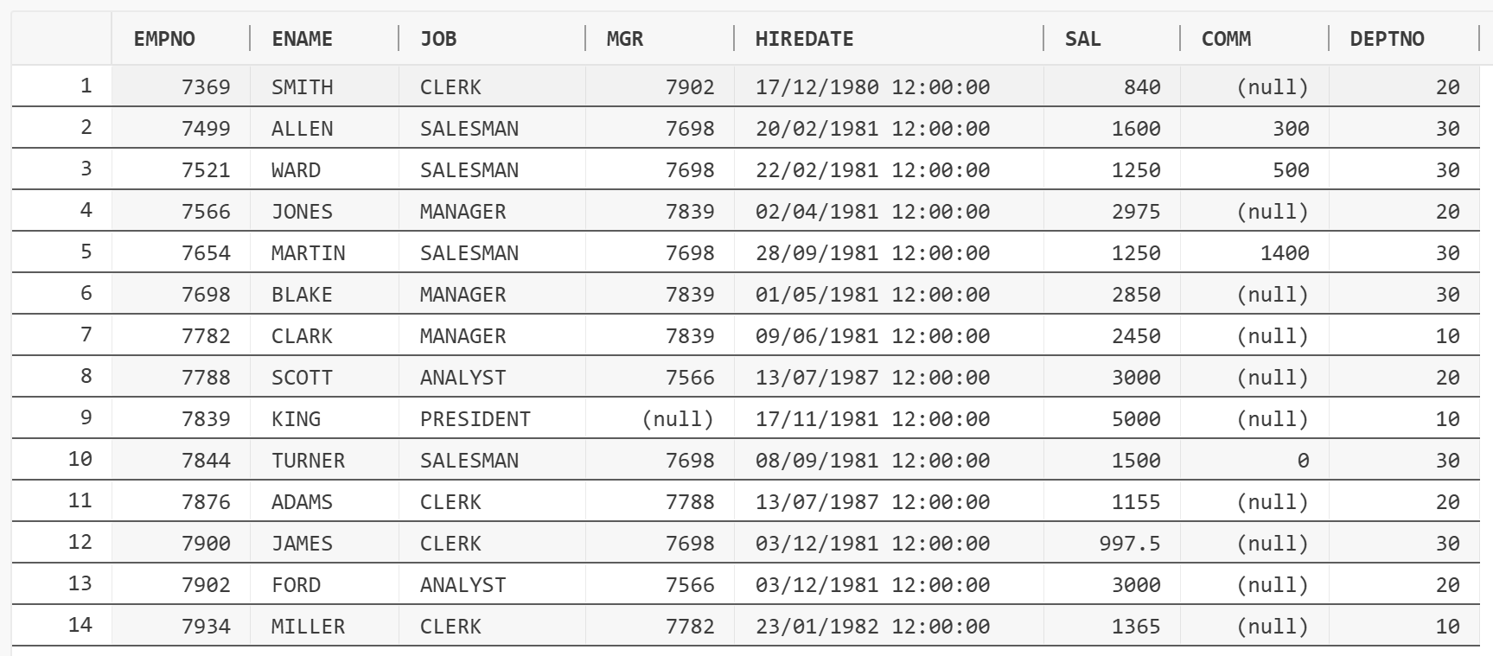
- 将Employee表中部门“30”的销售员（SALESMAN）的薪金增加300元。
UPDATE EMPLOYEE
set sal = sal + 300
where deptno = 30 and job = 'SALESMAN';

COMMIT;

SELECT * FROM EMPLOYEE;
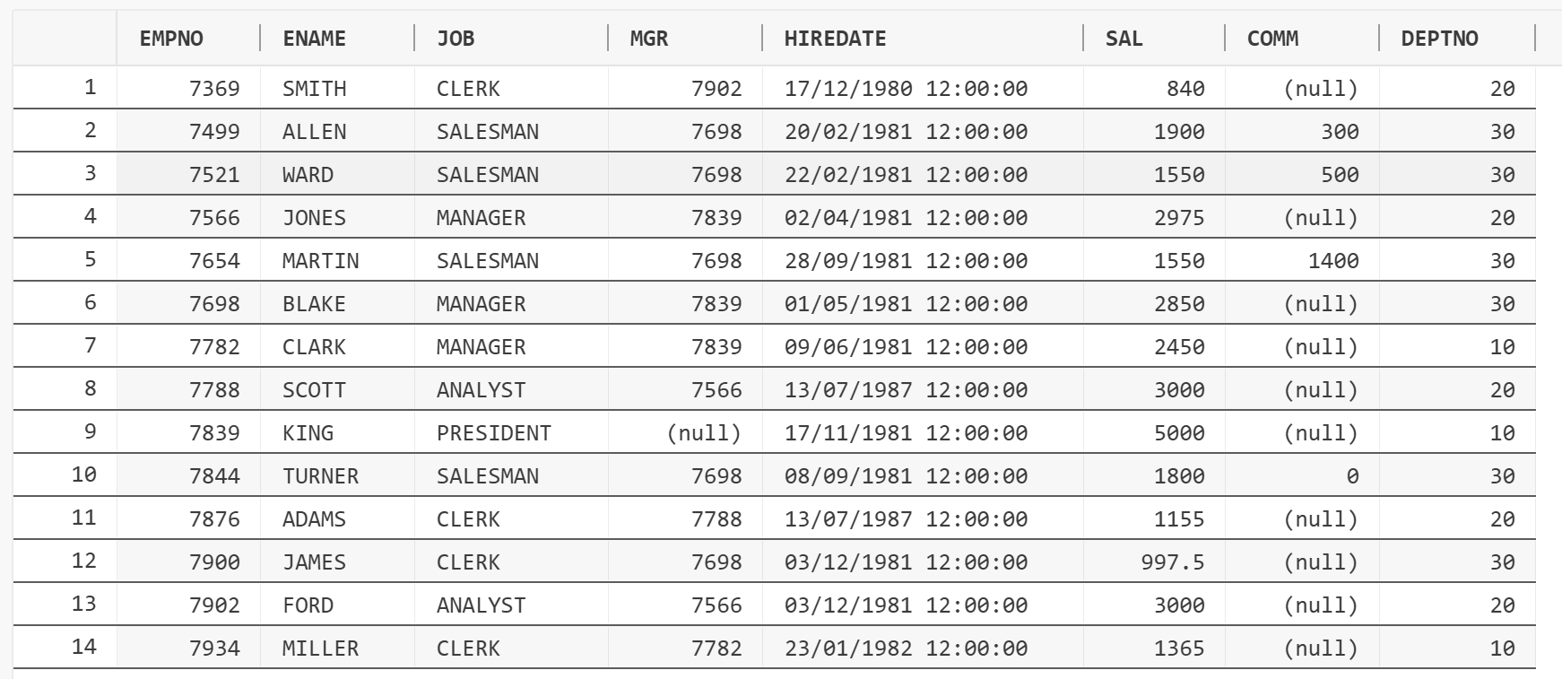
- 在Employee表中将“7369”号雇员从部门“20”转到部门“30”。
UPDATE EMPLOYEE
SET DEPTNO = 30
WHERE EMPNO = 7369;

SELECT * FROM EMPLOYEE;
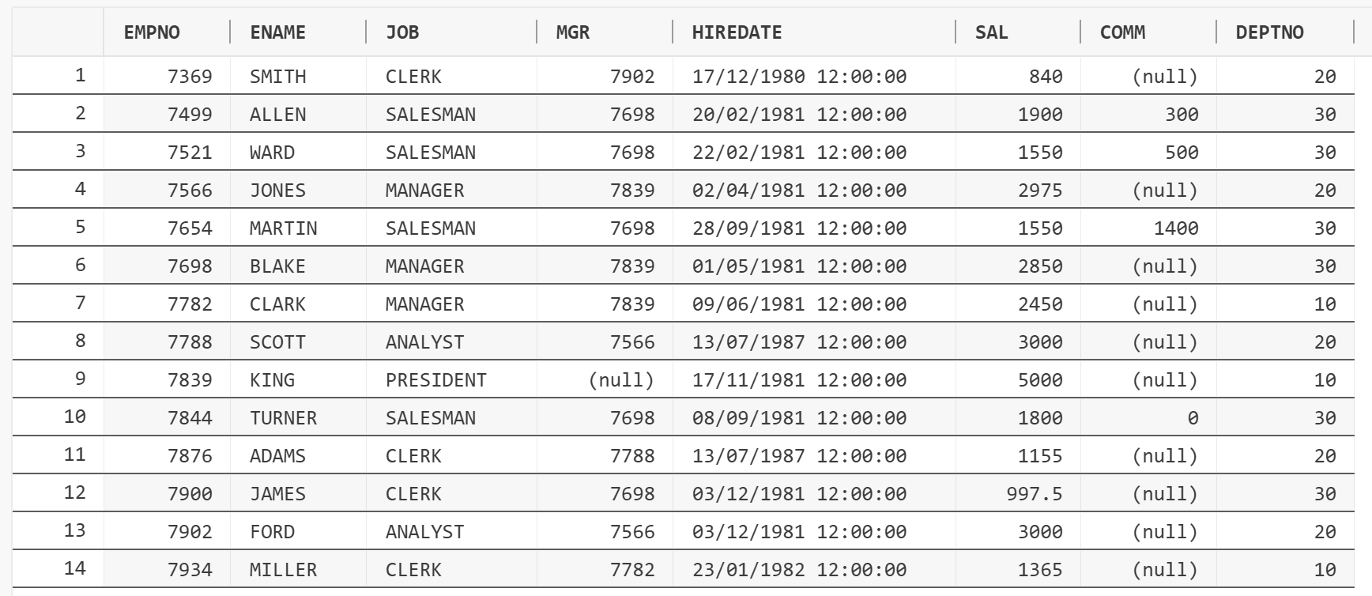
- 在Employee表中，将2000年以前雇佣的职员的薪金提高1000元。
UPDATE EMPLOYEE
SET SAL = SAL + 1000
WHERE EXTRACT(YEAR FROM HIREDATE) < 2000;

select * from EMPLOYEE;

COMMIT;
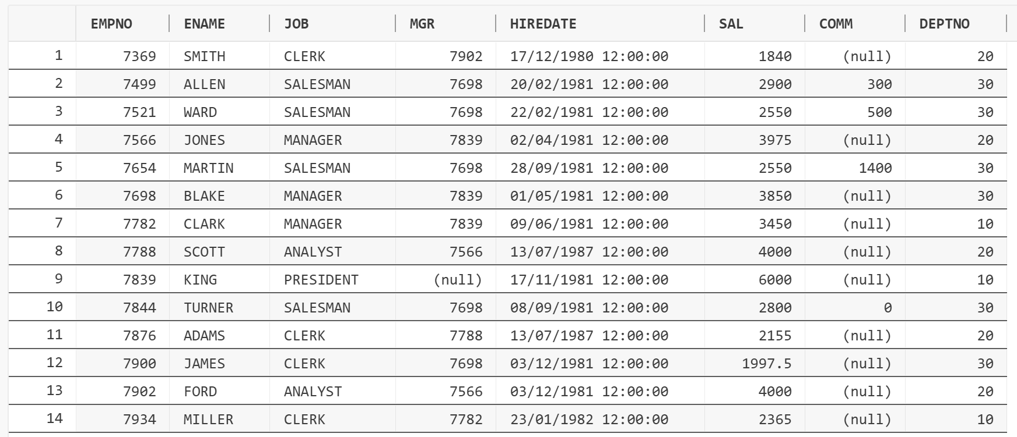
- 在Employee表中删除佣金为0的销售员（SALESMAN）的信息。
DELETE FROM EMPLOYEE
where job = 'SALESMAN' and comm = 0;

SELECT * FROM EMPLOYEE where job = 'SALESMAN';
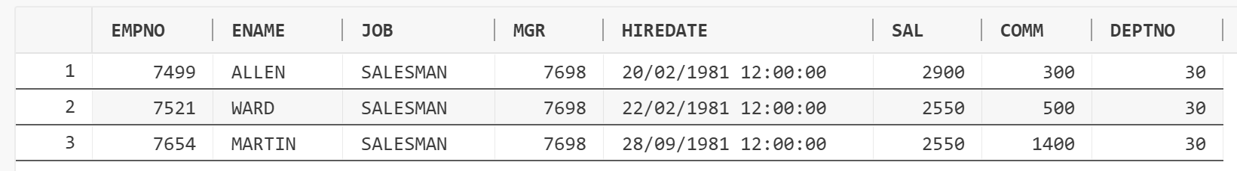
- 删除部门“10”的部门信息，以及其中雇员的信息。
DELETE FROM EMPLOYEE WHERE DEPTNO = 10;

DELETE FROM DEPARTMENT WHERE DEPTNO = 10;

COMMIT;

SELECT * FROM EMPLOYEE;
SELECT * FROM DEPARTMENT;
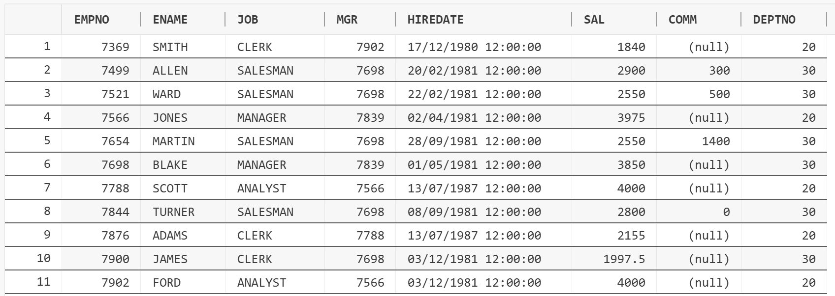
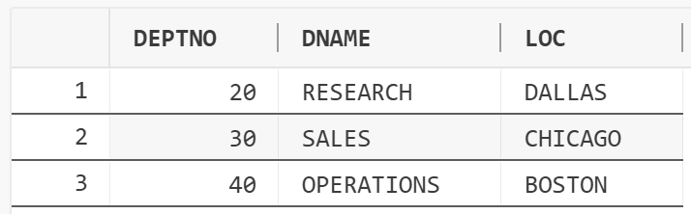
- 删除Employee表中1995年之前雇佣的雇员的信息。
DELETE FROM EMPLOYEE
WHERE EXTRACT(YEAR FROM HIREDATE) < 1995;

SELECT * FROM EMPLOYEE;

COMMIT;
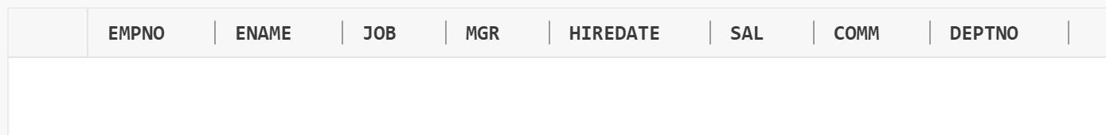
- 查看“user_tables”和“user_tab_columns”视图的内容，了解当前用户中创建了哪些基本表以及表中属性列的相关信息。
SELECT TABLE_NAME, NUM_ROWS, TABLESPACE_NAME FROM USER_TABLES;
SELECT COLUMN_NAME, DATA_TYPE, DATA_LENGTH FROM USER_TAB_COLUMNS;
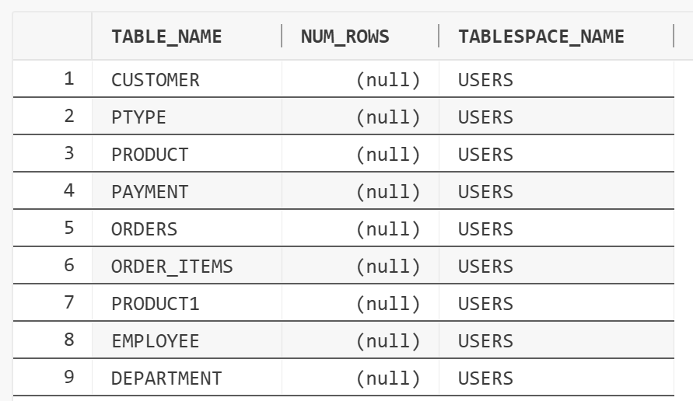

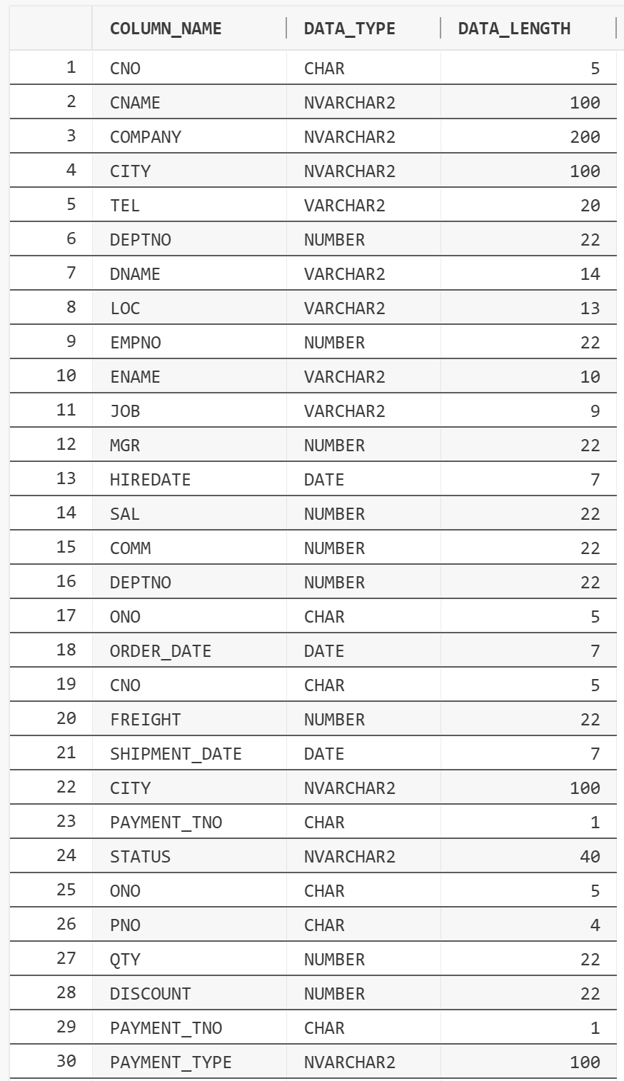
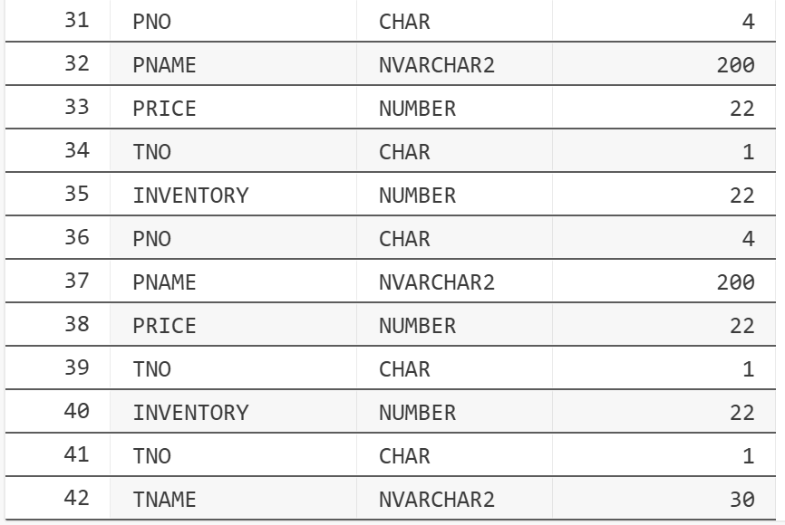
【实验思考】
- 如何用NLS_DATE_FORMAT参数设置默认的日期格式？
- 如何一次在一个基本表中插入多行数据？
- 举例说明如何进行表复制操作？
【思考结果】
将思考结果记录在本实验报告中。
1. 如何用NLS_DATE_FORMAT参数设置默认的日期格式？
ALTER SESSION SET NLS_DATE_FORMAT = 'YYYY-MM-DD HH24:MI:SS';
也可以再获取管理员权限后做系统级别的修改
还可以在Windows系统环境变量中修改

2．如何一次在一个基本表中插入多行数据？

使用INSERT ALL语句
这是 Oracle 特有的语法，适用于大多数版本。注意最后必须包含SELECT * FROM dual。
INSERT ALL
INTO my_table (id, name) VALUES (1, 'Alice')
INTO my_table (id, name) VALUES (2, 'Bob')
INTO my_table (id, name) VALUES (3, 'Charlie')
SELECT * FROM dual;

也可以使用UNION ALL
例如在7-3-2中：
INSERT INTO ORDERS(ONO, ORDER_DATE, CNO, FREIGHT, SHIPMENT_DATE, CITY)
SELECT 'O0001', TO_DATE('2014-03-10', 'YYYY-MM-DD'), 'C0001', 8, TO_DATE('2014-03-11', 'YYYY-MM-DD'), 'Beijing' FROM DUAL UNION ALL
SELECT 'O0002', TO_DATE('2014-03-11', 'YYYY-MM-DD'), 'C0002', 8, TO_DATE('2014-03-12', 'YYYY-MM-DD'), 'Shanghai' FROM DUAL UNION ALL
SELECT 'O0003', TO_DATE('2014-03-11', 'YYYY-MM-DD'), 'C0009', 5, TO_DATE('2014-03-12', 'YYYY-MM-DD'), 'Shanghai' FROM DUAL UNION ALL
SELECT 'O0004', TO_DATE('2014-04-13', 'YYYY-MM-DD'), 'C0007', 5, TO_DATE('2014-04-15', 'YYYY-MM-DD'), 'Beijing' FROM DUAL UNION ALL
SELECT 'O0005', TO_DATE('2014-04-14', 'YYYY-MM-DD'), 'C0010', 8, TO_DATE('2014-04-16', 'YYYY-MM-DD'), 'Beijing' FROM DUAL;

SELECT * from ORDERS;
Commit;

3. 举例说明如何进行表复制操作？
使用CREATE TABLE AS SELECT语句。
比如7-3-8中：
CREATE TABLE Product1 AS
(
SELECT * FROM Product WHERE INVENTORY < 100
);

实验成绩： 批阅老师： 批阅日期：

