Chapter 5
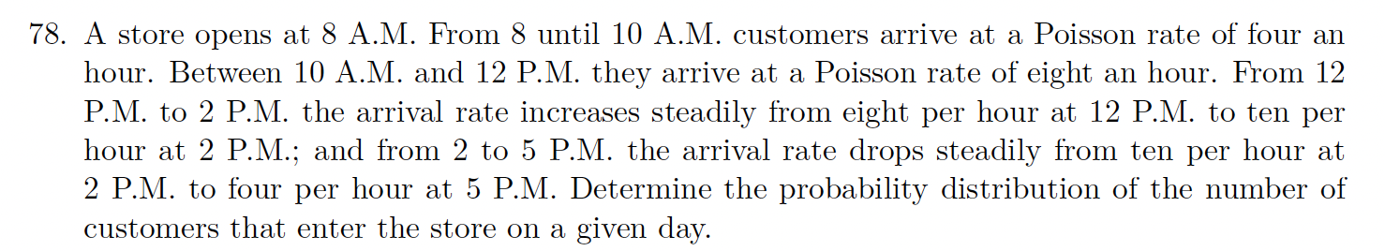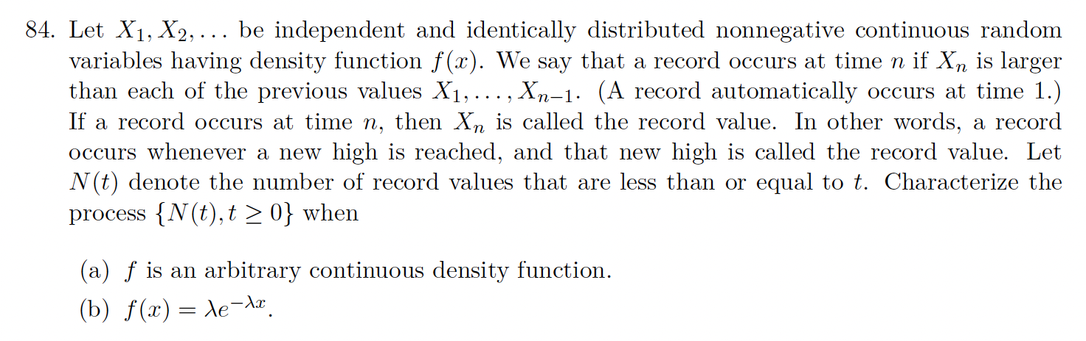
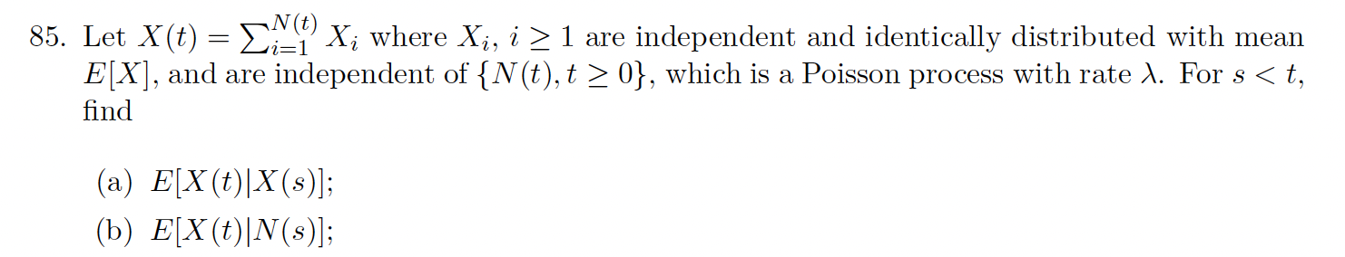

Chapter 6


