Technical Documentation: 3D Object Studio

1. Application Architecture
The 3D Object Studio is a full-stack application built using the MERN stack (MongoDB, Express, React, Node.js) integrated with AWS S3 for object storage.

1.1 Frontend (Client)
- Core Framework: React 18 built with Vite for optimized bundling and hot module replacement.
- State Management: Redux Toolkit is utilized for global state management (Authentication, Model lists, Viewer interaction states).
- 3D Rendering: The application uses vanilla Three.js (three) rather than React-specific wrappers. Rendering logic is encapsulated inside standard JavaScript classes (SceneManager.js, ModelLoader.js) and interfaced with React via custom hooks (useThreeScene.js, useStateSync.js).
- Routing: Client-side routing is handled by react-router-dom, featuring protected routes that verify JWT validity before allowing access to the Dashboard or Viewer.
- Styling & Animation: TailwindCSS handles utility-based styling, while framer-motion drives complex UI animations (like the Loading Overlay).

1.2 Backend (Server)
- Core Framework: Node.js running an Express.js server (express).
- Authentication: Stateless JWT implementation. Short-lived Access Tokens are passed in the response body, while long-lived Refresh Tokens are stored securely in HttpOnly cookies.
- Database ORM: Mongoose connects the application to MongoDB Atlas, enforcing strict schemas for User and Model documents.
- File Processing: The server uses multer configured with memory storage to parse incoming multipart/form-data. Files are streamed directly to AWS S3 using @aws-sdk/lib-storage rather than being saved to the local EC2 disk.

1.3 Deployment Structure
The application is fully containerized using Docker. Both the client and server are built from lightweight node:20-alpine images and orchestrated via docker-compose.yml.

2. Service Interaction Diagram
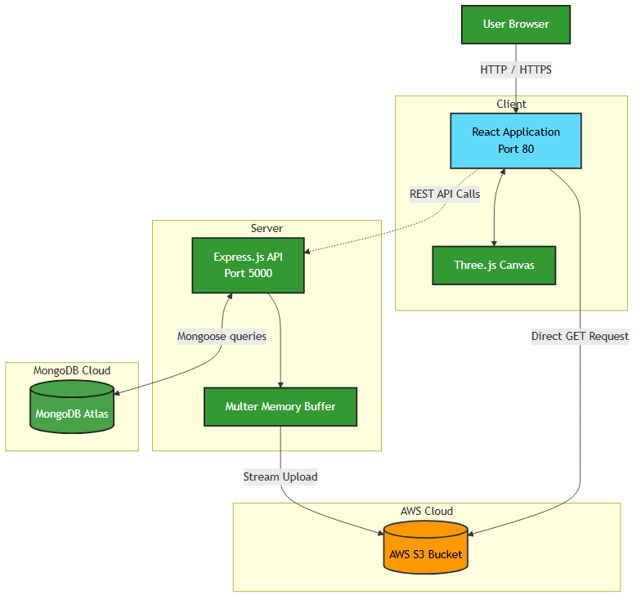
Below is the interaction flow demonstrating how the React frontend, Node.js backend, MongoDB, and AWS services communicate.

3. Optimization Techniques
The project implements several optimizations to guarantee high performance handling of large 3D assets:
1. Route-Based Code Splitting & Lazy Loading:
The application uses React.lazy() and in App.jsx. Heavy views, particularly the ViewerPage containing the Three.js logic, are dynamically imported. This prevents the large Three.js library from bloating the initial JavaScript payload when a user visits the login screen.
2. State Sync Debouncing:
The custom useStateSync.js hook monitors the Three.js interaction state (camera position, zoom, rotation). Instead of sending a PUT request to the server on every frame, it utilizes a 2-second debounce mechanism. The state is only persisted to the database after the user finishes interacting with the model.
3. Direct Memory Streaming to S3:
Instead of the traditional approach of saving uploaded files to the /uploads directory on the server and then moving them to S3, the uploadService.js reads the file directly from Multer's memory buffer and streams it to S3. This eliminates disk I/O bottlenecks and drastically lowers server resource utilization.
4. JWT Rotation:
Refresh tokens are rotated upon use, and old tokens are cleaned up dynamically (user.cleanExpiredTokens()), preventing database bloat and mitigating token reuse attacks.

4. AWS Cloud Setup & Scaling Strategies
The application is currently designed to run on a single EC2 instance via Docker Compose. However, the architecture is entirely stateless, allowing it to easily scale horizontally into the following AWS setup:

4.1 Auto-Scaling (EC2 Auto Scaling Groups)
- Because the Express API stores no session state locally (relying on JWTs) and saves no files locally (streaming to S3), any number of backend servers can run simultaneously.
- An Auto Scaling Group (ASG) can monitor CloudWatch metrics (e.g., CPU utilization > 70%). During traffic spikes, the ASG will dynamically provision new EC2 instances to share the load, and terminate them when traffic subsides to save costs.

4.2 Load Balancing (Application Load Balancer)
- An AWS Application Load Balancer (ALB) serves as the single entry point for all traffic.
- The ALB distributes incoming requests evenly across all available EC2 instances in the Auto Scaling Group.
- It also handles SSL/TLS termination, decrypting HTTPS traffic before passing it to the internal Docker containers.

4.3 Data Persistence & Durability
- MongoDB Atlas (Database): Atlas handles database persistence natively via Replica Sets. Data is mirrored across at least three nodes in different Availability Zones (AZs) to ensure zero downtime during failures.
- AWS S3 (Storage): 3D .glb files are stored in an S3 bucket, which provides 99.999999999% durability across multiple physical facilities.
- Content Delivery (Future Consideration): To optimize delivery of large 3D models globally, an AWS CloudFront distribution can be attached to the S3 bucket to cache the files at edge locations nearest to the end users.

