## Introduction

You have been hired as a security analyst. You were tasked to determine any malicious activity associated with a malware attack.

You will have access to the internet to learn more about the events. You can use websites, such as VirusTotal, to upload and verify threat existence.

The tasks below are designed to provide some guidance through the analysis process.

You will practice and be assessed on the following skills:

* Evaluate event alerts using Squil.
* Use Google search as a tool to obtain intelligence on a potential exploit.
* Use VirusTotal to upload and verify threat existence.

# Instructions

## Gather the Basic Information

In this part, you will review the alerts listed in Security Onion VM and gather basic information for the interested time frame.

### Verify the status of services

* + - 1. Log into Security Onion VM.
      2. Open a terminal window. Enter the **sudo so-status** command to verify that all the services are ready.
      3. When the nsm service is ready, log into Sguil.sud
      4. Download the .pcap file of yours and replay the malware packet capture. Before replaying the packet capture, update IDS rules using the command **sudo rule-update**.

### Gather basic information.

#### Questions:

* + - 1. What is the name of the trojan? Identify the time frame of the attack, including the date and approximate time.

Date: Thu, 19 Aug 2021 19:40:36 GMT

Type your answers here.

* + - 1. List the alerts noted during this time frame associated with the trojan.

ET POLICY PE EXE or DLL Windows file download HTTP  
ET POLICY External IP Lookup api.ipify.org  
ET INFO curl User-Agent Outboard  
ET INFO Dotted Quad Host PDF Request  
ET POLICY HTTP traffic on port 443 (POST)  
ET POLICY OpenSSL Demo CS – Internet Widgits Pty (0)  
ET POLICY OpenSSL Demo CS – Internet Widgits Pty (0)  
.

* + - 1. List the internal IP addresses and external IP addresses involve  
           
         185.244.41.29

Type your answers here.

## Learn about the Exploit

In this part, you will learn more about the exploit.

### Infected host

#### Questions:

* + - 1. Based on the alerts, what is the IP and MAC addresses of the infected computer? Based on the MAC address, what is the vendor of the NIC chipset? (**Hint**: NetworkMiner or internet search

IP: 185.244.41.29  
MAC: 20E52AB693F1  
NIC Vendor: Netgear

Type your answers heggre

* + - 1. Based on the alerts, when (date and time in UTC) and how was the PC infected? (**Hint**: Enter the command **date** in the terminal to determine the time zone for the displayed time

2022-12-24 15:12:04 ers here.

c. How did the malware infect the PC? Use an internet search as necessary.

The user in the 185.244.41.29 PC accessed a malicious domain, and the trojan was used to install the malware.

When executed, trojan reports back to one of several control server IP addresses embedded in it code. The server listens on TCP port 80, and pretends to be an Apache webserver. If the HTTP request contains the correct parameters, one or more executable es will be delivered via HTTP.

awers here.

### Examine the exploit.

#### Questions:

* + - 1. Based on the alerts associated with HTTP GET request, what files were downloaded? List the malicious domains observed and the files downloaded.

Ooiwy.pdf  
Ooiwy.pdf  
Ooiwy.pdf  
Ooiwy.pdf  
Ooiwy.pdf  
Ooiwy.pdf  
Ooiwy.pdf  
Ooiwy.pdf

answers here.

* + - 1. Navigate to [www.virustotal.com](http://www.virustotal.com) input the SHA256 hash to determine if these were detected as malicious files. Record your findings, such as file type and size, other names, and target machine. You can also include any information that is provided by the community posted in VirusTotal.

f25a780095730701efac67e9d5b84bc289afea56d96d8aff8a44af69ae606404

Type your answers here.

* + - 1. Examine other alerts associated with the infected host during this timeframe and record your findings

Type your answer 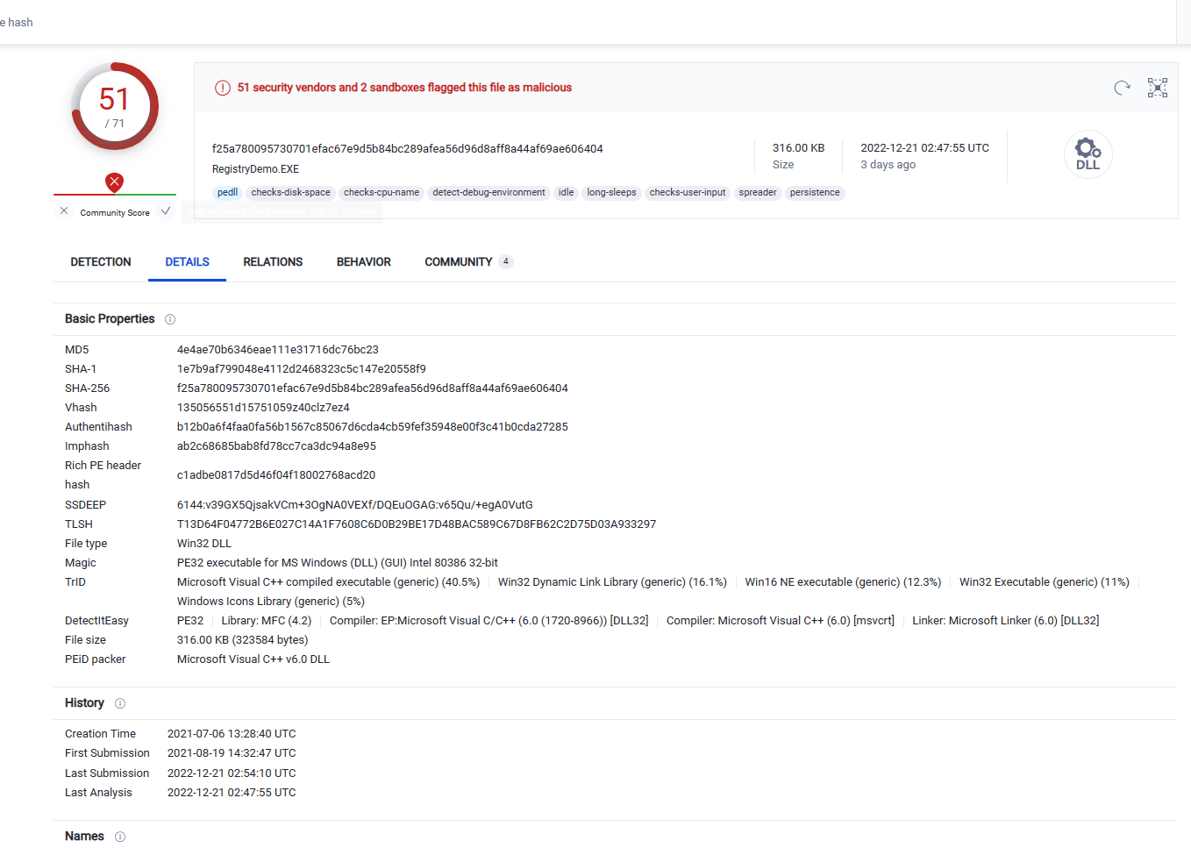 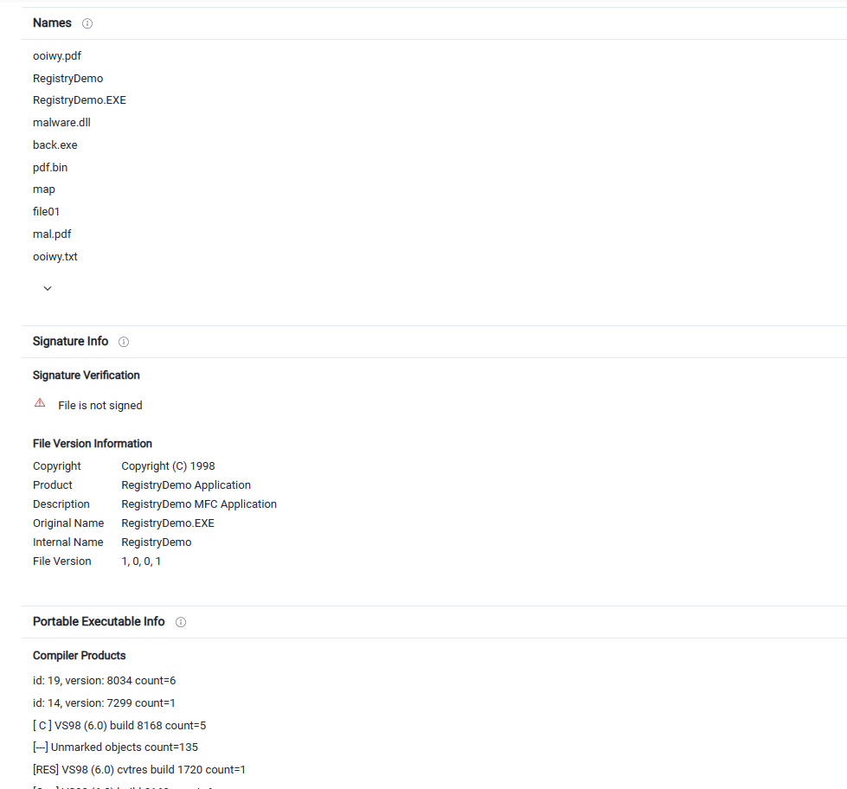 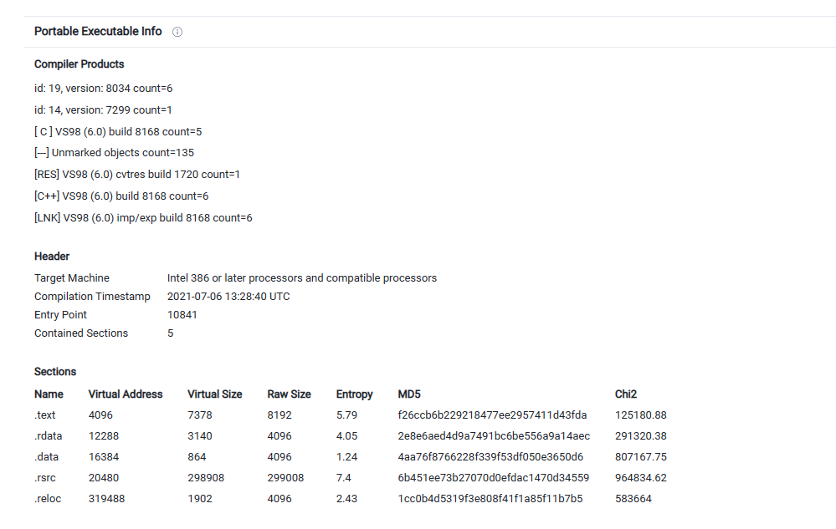 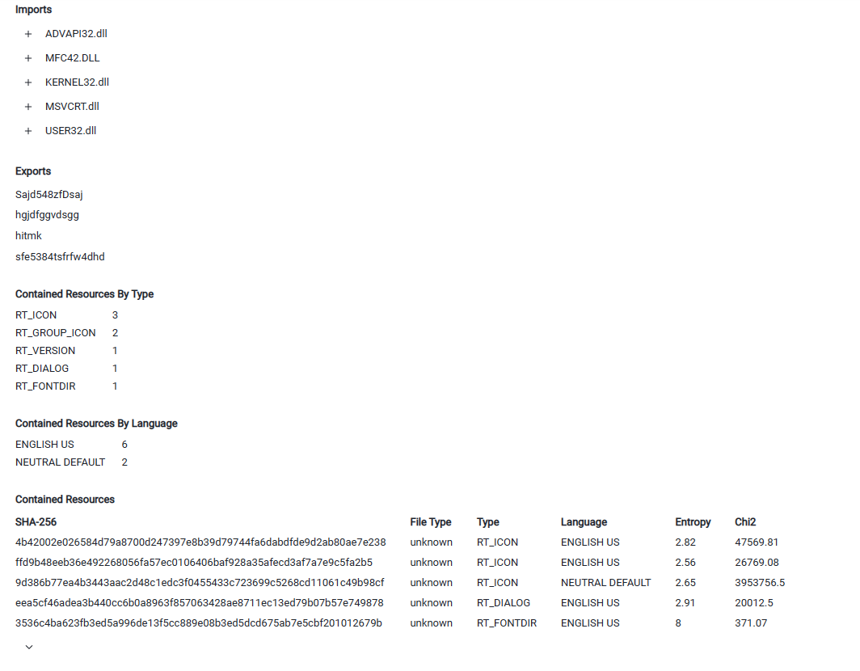s here.

### Report Your Findings

Summarizes your findings based on the information you have gathered from the previous parts, summarize your findings.

A malicious domain for a DNS query, and was infected with the trojan. The trojan pretends to be a pdf. After infection, the trojan downloads various malware. In the examined PC, three malwares were downloaded and installed. These files were checked in virustotal.com, using their SHA256 hash, and verified as malware by most source.document