Name:XIN MING, created:2024-4-23

1：Exporting the data from R as a .csv file using the following commands.

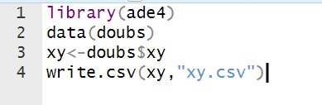

2:open QGIS software, and loading in the data by “Layer-Add Layer-Add Delimited Text Layer...”, with the following settings:

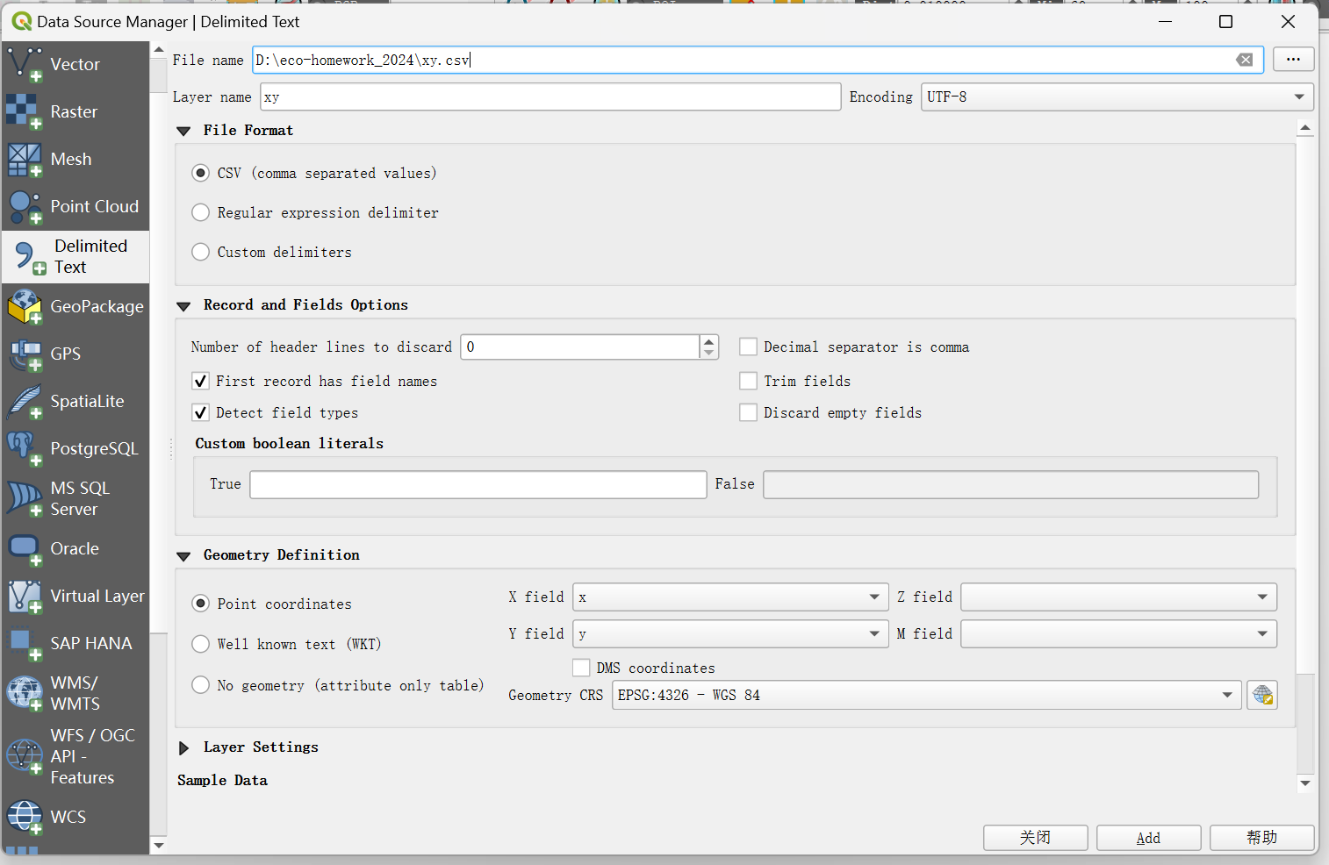

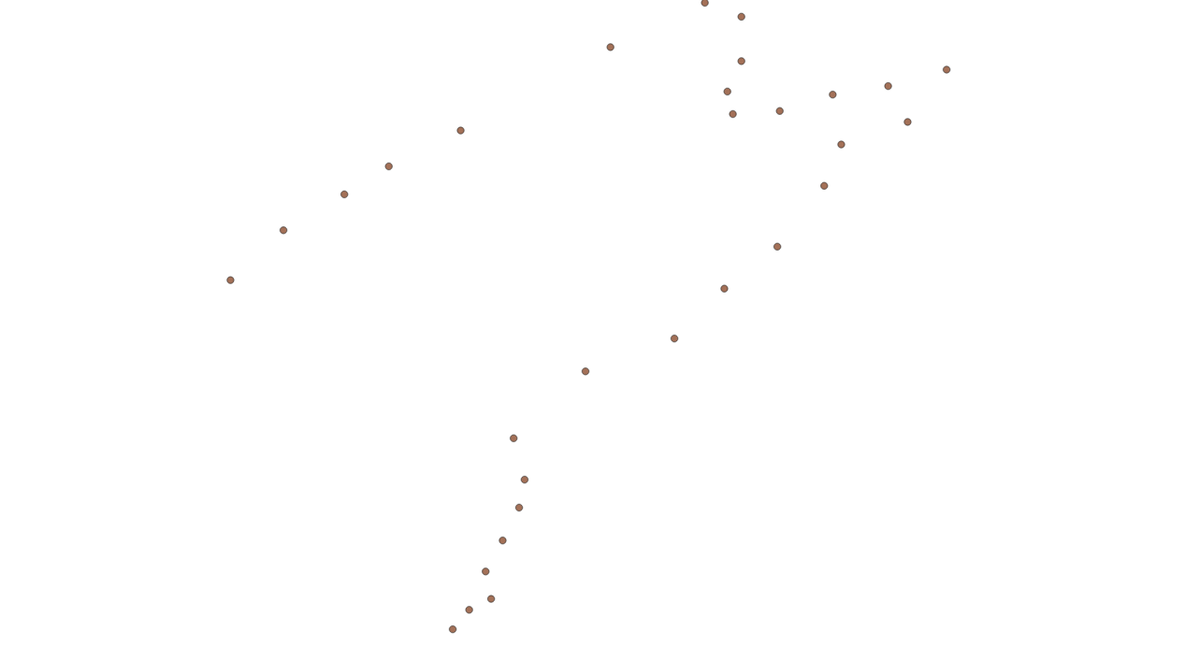

3:export the data points as image by “Project-Import/Export-Export Map to Image” with the following settings:

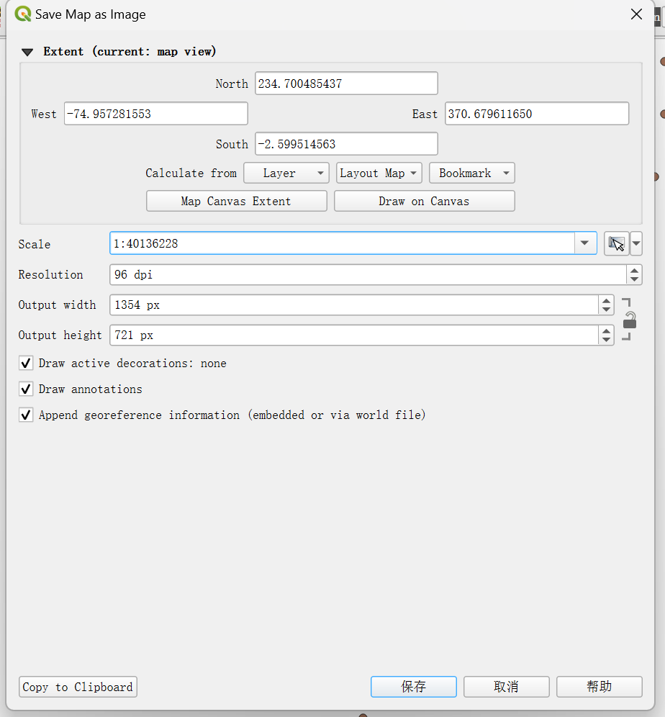

4:loading in the image using the Freehand raster georeferencer, by “AD” button, and deactivate the display of the original data points.

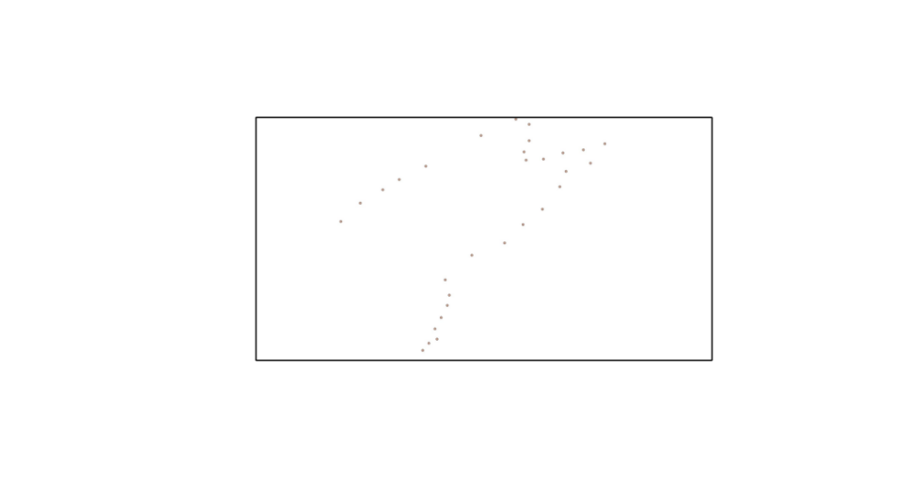

Using the QuickOSM tool to load in the the true image of Doubs river, by using the “” ,with the the following way of searching, and then run the query.

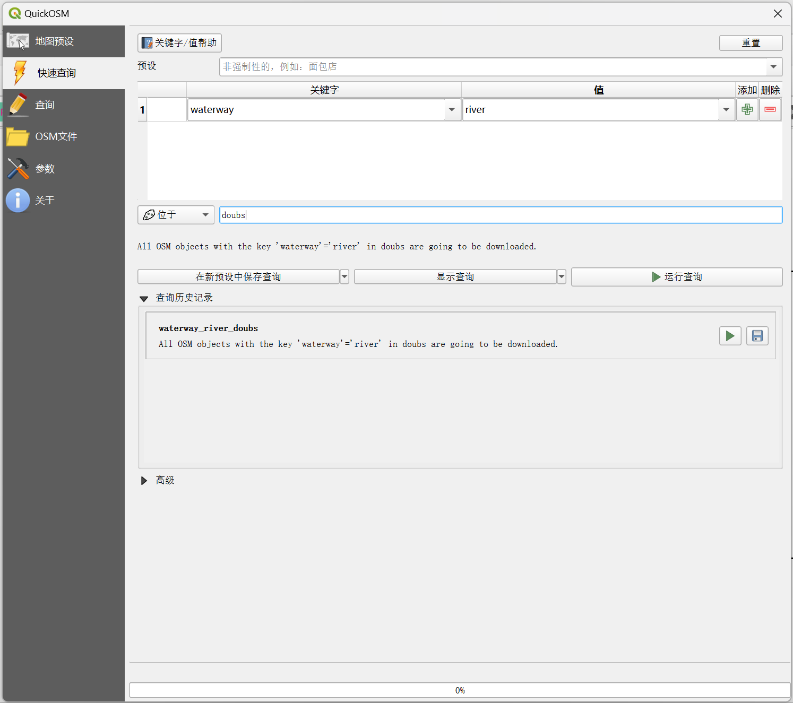

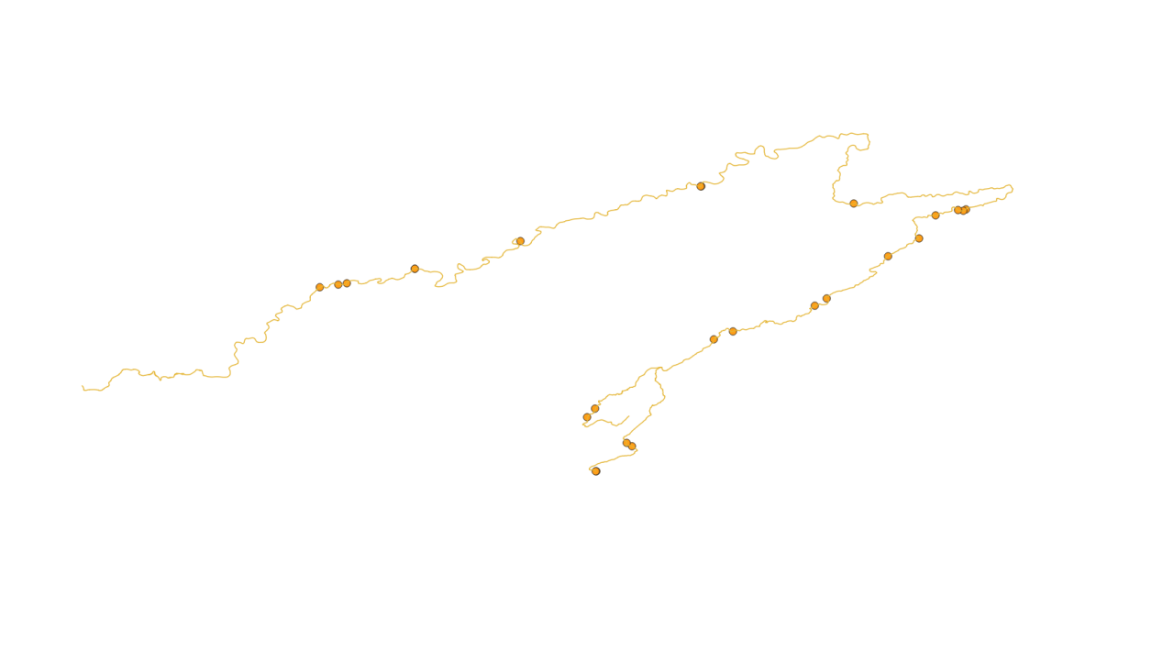

5:Disable the display of the points for “waterway_river_doubs”, then use “SC”,”ADJ”,”RO” and “MO” tools of Freehand raster georeferencer to adjust the raster picture, until there is a fairly good match between the points on the picture and the waterway line

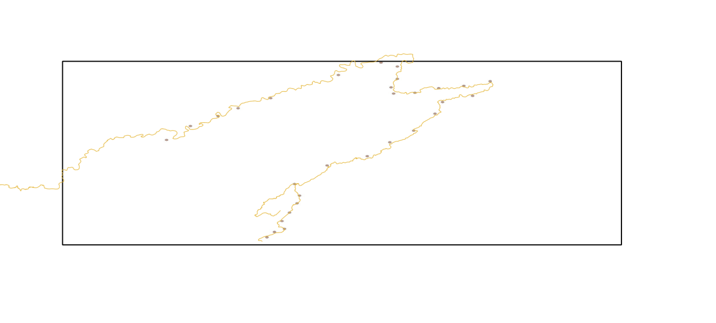

6: Using “Layer-Georeferencer...” to open the Georeferencer panel , then use the “” icon to load in the previously save raster picture.

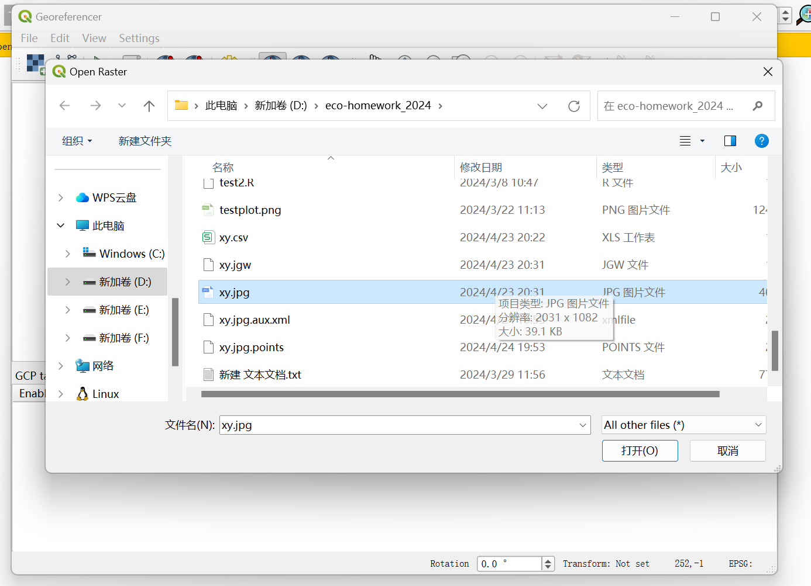

7:after loading, click on the points displayed on the Georeferencer panel, and then click “From Map Canvas” and click on the matching point on the map canvas raster picture. Repreat this step for every point.

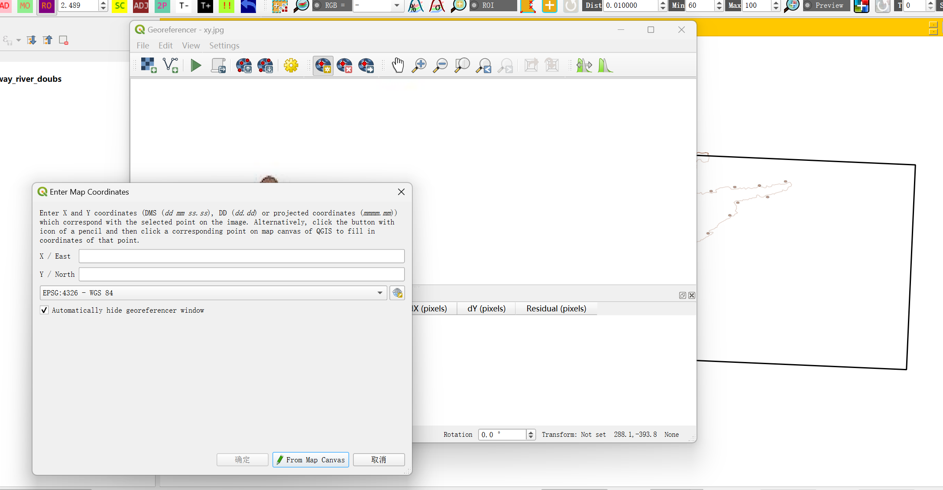

8:Then click on the “” to start the referencing, then in the popped up menu, select saved path.

9:find the file terminating with .points, open it with notebook, and remove the first entry as marked below:

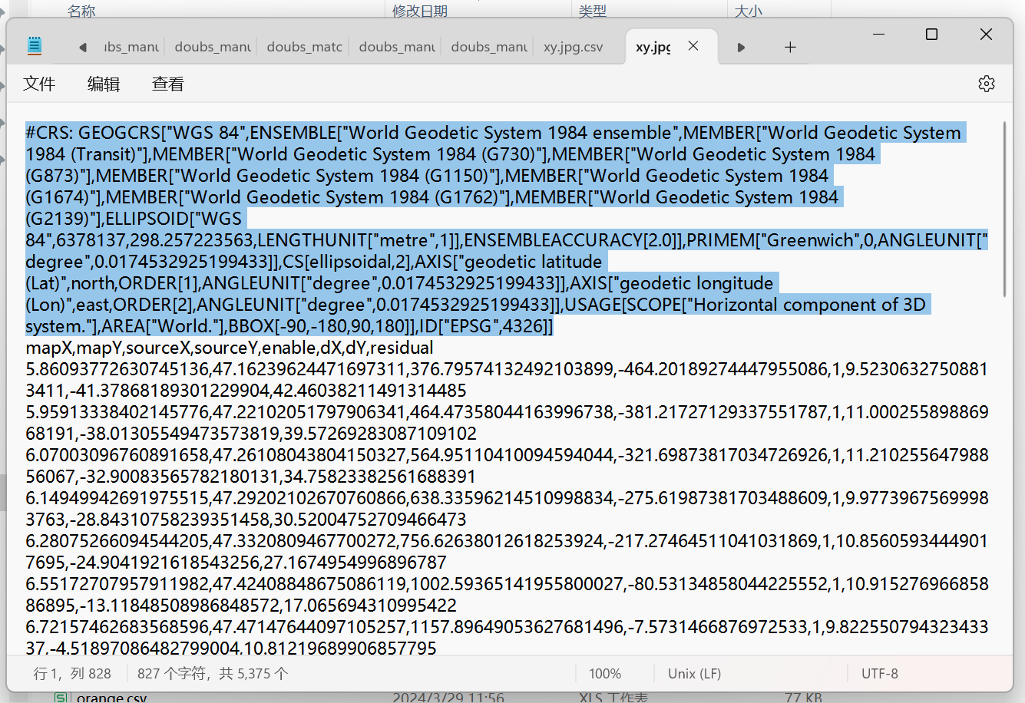

10:Save the resulted file as .csv file, which is ready to be read by R(the saved csv looks like this in Excel)

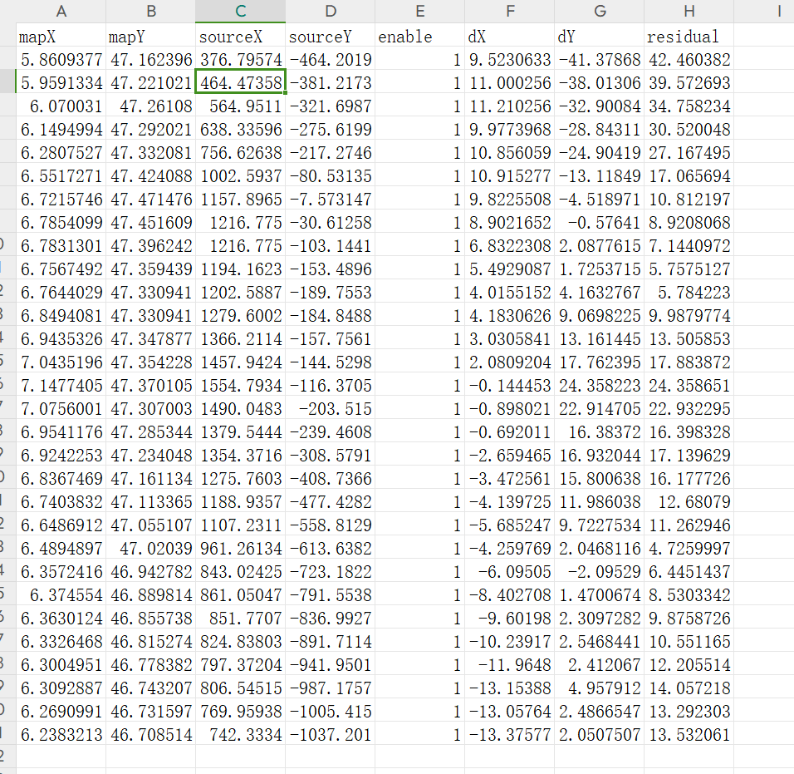

11: coordinate data can be extracted from the file in R with the following command:

