P12. Describe how loops in paths can be detected in BGP.

BGP advertisements contain AS-PATH showing how the AS’s path pass through, so the router can identify a loop if an AS appear twice or more.

P16. Consider the following network. ISP B provides national backbone service to regional ISP A. ISP C provides national backbone service to regional ISP D. Each ISP consists of one AS. B and C peer with each other in two places using BGP. Consider traffic going from A to D. B would prefer to hand that traffic over to C on the West Coast (so that C would have to absorb the cost of carrying the traffic cross-country), while C would prefer to get the traffic via its East Coast peering point with B (so that B would have carried the traffic across the country). What BGP mechanism might C use, so that B would hand over A-to-D traffic at its East Coast peering point? To answer this question, you will need to dig into the BGP specification.

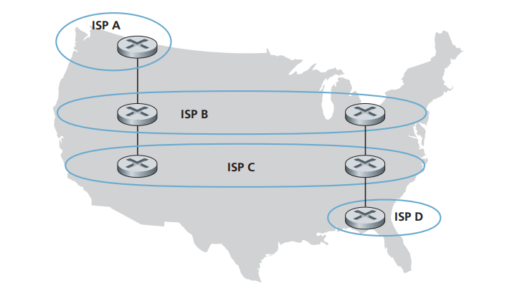

One way for C to force B to hand over all of B’s traffic to D on the east coast is to set the NEXT-HOP attribute for the route “ASB ASC ASD” from ASA to ASD that passes through ASC the IP address of the router on the East Coast. This is to say, only advertise its route to D via its east coast peering point with B.

P20. Suppose ASs X and Z are not directly connected but instead are connected by AS Y. Further suppose that X has a peering agreement with Y, and that Y has a peering agreement with Z. Finally, suppose that Z wants to transit all of Y’s traffic but does not want to transit X’s traffic. Does BGP allow Z to implement this policy?

Yes, BGP allow Z to implement this policy. If Y advertise X that it has no path to Z even though there is a link YZ, the AS X will not send traffic to Z through Y. Meanwhile, Y has a peering with Z so Y will send traffic to Z. Z transit all of Y’s traffic but does not transit X’s traffic.

P22. In Section 5.7, we saw that it was preferable to transport SNMP messages in unreliable UDP datagrams. Why do you think the designers of SNMP chose UDP rather than TCP as the transport protocol of choice for SNMP?

TCP may not recognize heavy traffic and even when SNMP notifications need to be sent, that would not transmit.

The UDP causes less under-network interference and helps to relay information at the correct time.