School of Computer Science, Wuhan University

laboratory report

Course title computer network
Grade 2020
Name 刘骁
Student ID 2020302111248 cooperator
Experimental semester 2 academic year 1 school term
Class hour 1 extracurricular hour 1
Date of writing 2022 year 2 month 27 day

Directory
- Ping a computer -----------------------------P2
- Tracert a server ------------------------------P5

Experiment overview
【Name of the experiment】： Ping a computer

【experimental purpose】：ping a computer

【experimental environment】：Win10’s console

【reference material】：
The detailed annotation of ping instruction:https://blog.csdn.net/hezeyujiang/article/details/79504038?ops_request_misc=%257B%2522request%255Fid%2522%253A%2522164592913416780255271136%2522%252C%2522scm%2522%253A%252220140713.130102334.pc%255Fall.%2522%257D&request_id=164592913416780255271136&biz_id=0&utm_medium=distribute.pc_search_result.none-task-blog-2~all~first_rank_ecpm_v1~rank_v31_ecpm-2-79504038.pc_search_result_cache&utm_term=ping&spm=1018.2226.3001.4187

experiment contect
【Design of experimental scheme】：
- input “cmd” to open console.
- input ipconfig/all, and check network information about the current connection. The result is shown in picture 1.
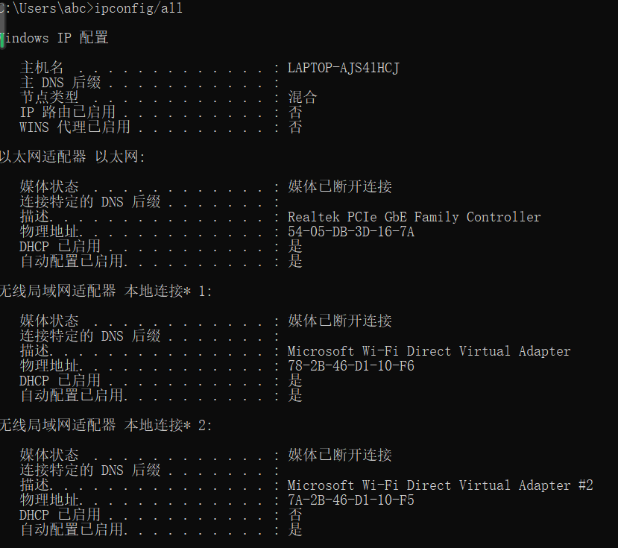
Picture 1
- Input ping another computer’s ip, and wait for the result.

【conclusion】：
The result is shown in picture 2.
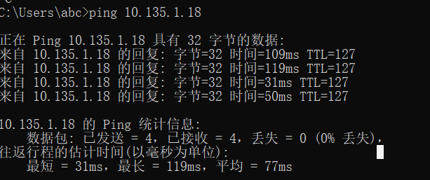
Picture 2

【brief summary】：
This result means that this computer has successfully connected to another computer, which means that it ping the computer successfully.

Instructor’s comments and score
【comment】：

score： signature of instructor：
Date of marking：
Experiment overview
【Name of the experiment】： tracert a server

【experimental purpose】： tracert a server

【experimental environment】：win10’s console

【reference material】：
Annotation of tracert instruction
https://blog.csdn.net/weixin_42674948/article/details/81563929?ops_request_misc=%257B%2522request%255Fid%2522%253A%2522164593112016780271565937%2522%252C%2522scm%2522%253A%252220140713.130102334.pc%255Fall.%2522%257D&request_id=164593112016780271565937&biz_id=0&utm_medium=distribute.pc_search_result.none-task-blog-2~all~first_rank_ecpm_v1~rank_v31_ecpm-2-81563929.pc_search_result_cache&utm_term=tracert&spm=1018.2226.3001.4187

experiment contect
【Design of experimental scheme】：
- input ‘cmd’ to open console.
- Input console the target server’s Ip.

【conclusion】：
The result is shown in picture 3.
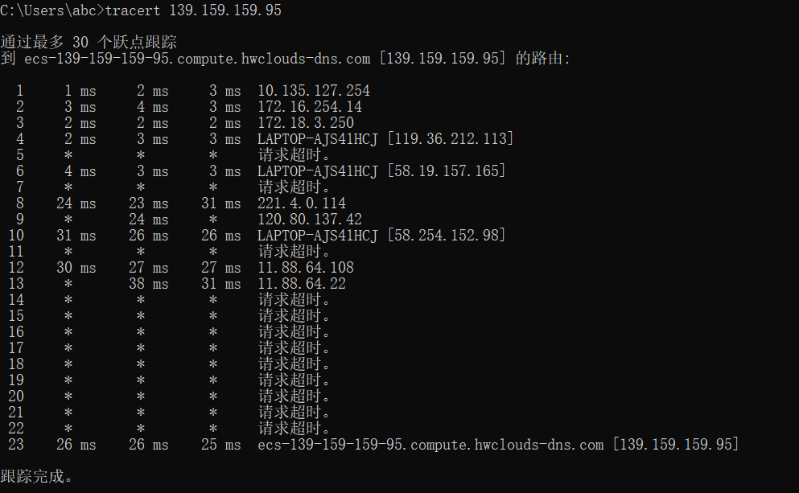
Picture 3

【brief summary】：
The result shown Lists the grouped routing nodes, and its delay in every jump in the IP network.

Instructor’s comments and score
【comment】：

score： signature of instructor：
Date of marking：
附件：
实验报告说明

1．实验项目名称：要用最简练的语言反映实验的内容。要求与实验指导书中相一致。
2．实验目的：目的要明确，要抓住重点，符合实验任务书中的要求。
3．实验环境：实验用的软硬件环境（配置）。
4．实验方案设计（思路、步骤和方法等）：这是实验报告极其重要的内容。包括概要设计、详细设计和核心算法说明及分析，系统开发工具等。应同时提交程序或设计电子版。
对于设计型和综合型实验，在上述内容基础上还应该画出流程图、设计思路和设计方法，再配以相应的文字说明。
对于创新型实验，还应注明其创新点、特色。
5．结论（结果）：即根据实验过程中所见到的现象和测得的数据，做出结论（可以将部分测试结果进行截屏）。
6．小结：对本次实验的心得体会，所遇到的问题及解决方法，其他思考和建议。
7．指导教师评语及成绩：指导教师依据学生的实际报告内容，用简练语言给出本次实验报告的评价和价值。

