Cairo University Advanced Database System

Faculty of Engineering CMON401

# Database Tuning, Optimization & performance analysis

(Phase 1)

|  |  |
| --- | --- |
| **Team Members** | Raghad Khaled  Nada El-Sayed  Menna Ahmed  Donia Abd El-Fatah |

2022

1. System Description

* Operating system => Microsoft Windows 10 pro
* CPU => intel(R) Core(TM) i7-1065G7 CPU @1.30GHZ
* RAM =>8GB
* Hard disk => Size 931.51 GB (1,000,202,273,280 bytes),

Total Cylinders 121,601,

Total Sectors 1,953,520,065

Total Tracks 31,008,255

Tracks/Cylinder 255

Sectors/Track 63

Bytes/Sector 512

1. ER

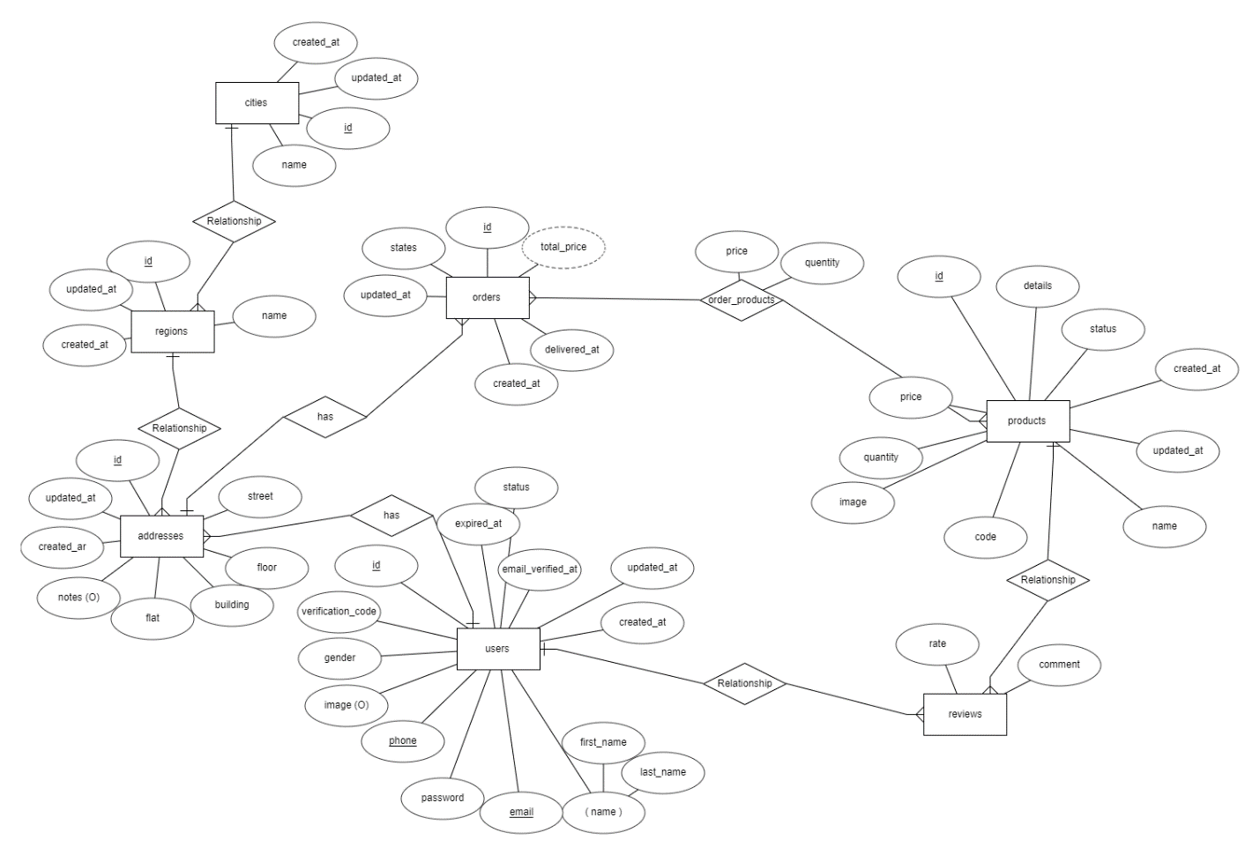

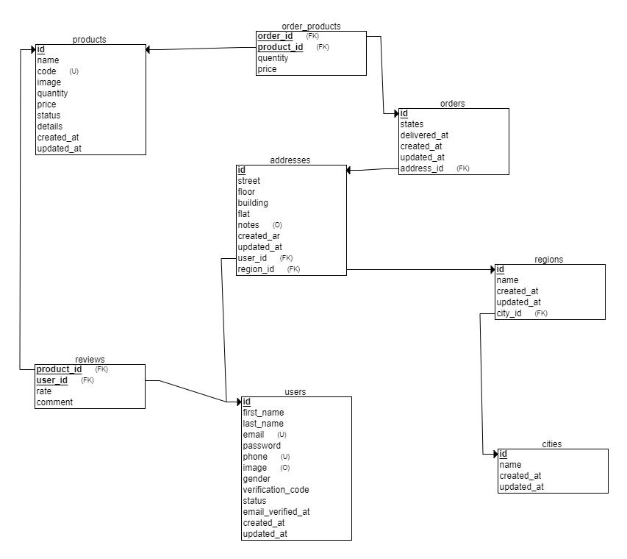

1. Database Report

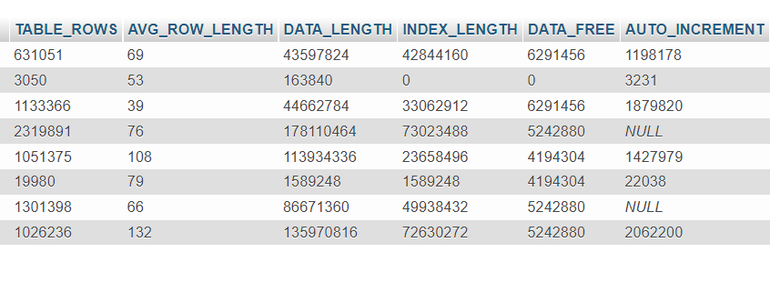

1. Schema implementation on NOSQL

[

{

"name" : "addresses",

"type" : "collection",

"options" : {

},

"info" : {

"readOnly" : false,

"uuid" : UUID("6ba512ac-e208-4f11-aa9f-e0f88c73020f")

},

"idIndex" : {

"v" : 2,

"key" : {

"_id" : 1

},

"name" : "_id_"

}

},

{

"name" : "cities",

"type" : "collection",

"options" : {

},

"info" : {

"readOnly" : false,

"uuid" : UUID("7a34afb4-7d7b-4651-ab3d-da49cb5e5f4b")

},

"idIndex" : {

"v" : 2,

"key" : {

"_id" : 1

},

"name" : "_id_"

}

},

{

"name" : "order_products",

"type" : "collection",

"options" : {

},

"info" : {

"readOnly" : false,

"uuid" : UUID("ed5b9e0a-6046-4e1f-8539-6306a482140c")

},

"idIndex" : {

"v" : 2,

"key" : {

"_id" : 1

},

"name" : "_id_"

}

},

{

"name" : "orders",

"type" : "collection",

"options" : {

},

"info" : {

"readOnly" : false,

"uuid" : UUID("a34ce6a0-f254-4c7d-b12b-8cb7bef5c624")

},

"idIndex" : {

"v" : 2,

"key" : {

"_id" : 1

},

"name" : "_id_"

}

},

{

"name" : "products",

"type" : "collection",

"options" : {

},

"info" : {

"readOnly" : false,

"uuid" : UUID("c8ce25fb-3c00-43f3-bca8-37668ebb660e")

},

"idIndex" : {

"v" : 2,

"key" : {

"_id" : 1

},

"name" : "_id_"

}

},

{

"name" : "regions",

"type" : "collection",

"options" : {

},

"info" : {

"readOnly" : false,

"uuid" : UUID("fe4908df-0b11-4062-9308-99539dbe8480")

},

"idIndex" : {

"v" : 2,

"key" : {

"_id" : 1

},

"name" : "_id_"

}

},

{

"name" : "reviews",

"type" : "collection",

"options" : {

},

"info" : {

"readOnly" : false,

"uuid" : UUID("21043a4a-01bd-4dbb-9878-6ce3006aa7bb")

},

"idIndex" : {

"v" : 2,

"key" : {

"_id" : 1

},

"name" : "_id_"

}

},

{

"name" : "users",

"type" : "collection",

"options" : {

},

"info" : {

"readOnly" : false,

"uuid" : UUID("decb2df1-d808-4cb5-b247-e4631ba6c99e")

},

"idIndex" : {

"v" : 2,

"key" : {

"_id" : 1

},

"name" : "_id_"

}

}

]