**California Roll Recipe**

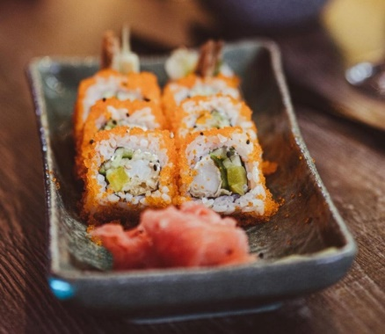

**Ingredients**

* 2 cups sushi rice
* 2 1/2 cups water
* 1/4 cup rice vinegar
* 1 tablespoon sugar
* 1 teaspoon salt
* 1 avocado, sliced
* 1/2 cucumber, seeded and sliced
* 8 crab sticks
* 4 sheets of nori seaweed
* Toasted sesame seeds, for garnish
* Wasabi and soy sauce, for serving

**Directions**

1. Rinse the sushi rice several times until the water runs clear. Drain the rice and put it in a medium saucepan with the water. Bring to a boil over high heat, then reduce the heat to low and cover the pot with a tight-fitting lid. Cook for 15-20 minutes, or until the rice is tender and all the water has been absorbed.
2. In a small saucepan, combine the rice vinegar, sugar, and salt. Heat over low heat until the sugar has dissolved.
3. When the rice is done, transfer it to a large mixing bowl. Pour the vinegar mixture over the rice and stir gently to combine. Allow the rice to cool to room temperature.
4. Cut the crab sticks into thin strips. Cut the avocado in half, remove the pit, and slice the flesh thinly. Cut the cucumber in half lengthwise, remove the seeds, and slice thinly.
5. Place a sheet of nori seaweed on a sushi mat, shiny side down. Spread a layer of sushi rice over the nori, leaving a 1-inch border at the top.
6. Arrange the crab, avocado, and cucumber in a horizontal line across the center of the rice.
7. Using the mat to help you, roll the sushi tightly, starting at the bottom and rolling towards the top. Use a little water to moisten the border of the nori to seal the roll.
8. Repeat the process with the remaining ingredients to make 4 rolls.
9. Cut each roll into 8 pieces using a sharp, wet knife. Garnish with toasted sesame seeds and serve with wasabi and soy sauce on the side.