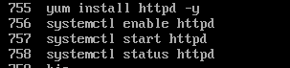

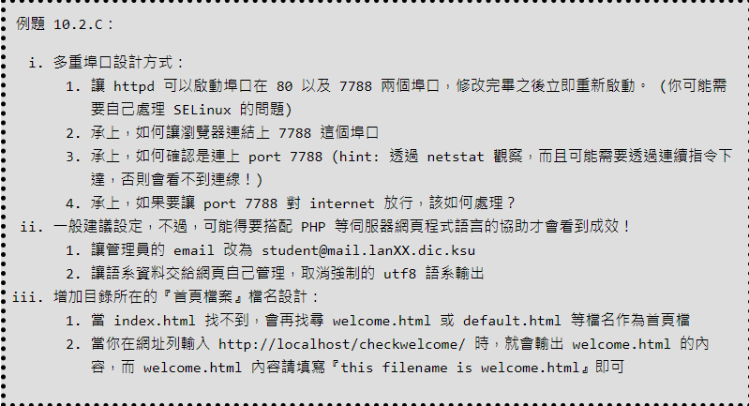

vim /etc/httpd/conf/httpd.conf



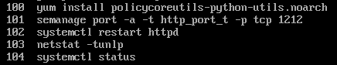

curl http://localhost:7788

vim firewall.sh

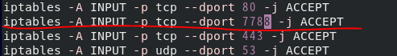

sh firewall.sh

iptables-save -t filter

vim /etc/httpd/conf/httpd.conf



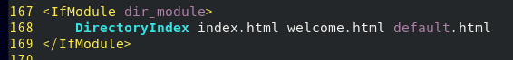



systemctl restart httpd

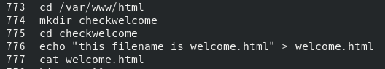

瀏覽器輸入: http://server.checkwelcome

httpd -V

httpd -t -D DUMP_MODULES " | grep mpm

cd /etc/httpd/conf.d

vim mpm.conf

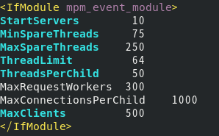

測試語法正確: apachectl configtest

systemctl restart httpd

vim userdir.conf

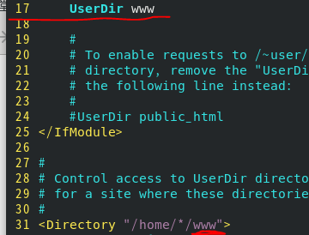

systemctl restart

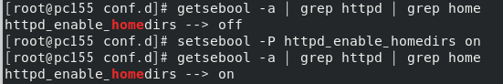

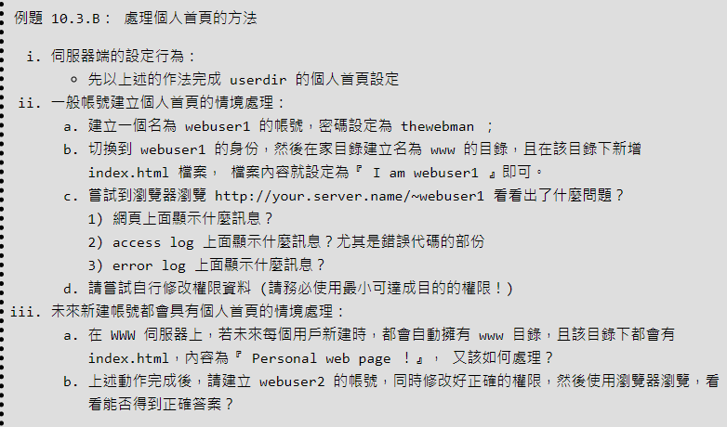

useradd webuser1

echo thewebman | passwd --stdin webuser1

su webuser1

(進到webuser1)

cd ~

mkdir www

cd www

echo "I am webuser1" > index.html



瀏覽器: http://server/~webuser1

exit(回到root)

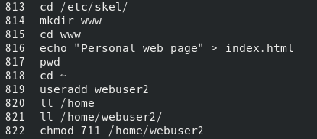

瀏覽器: http://server/~webuser2

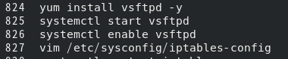



vim firewall.sh



sh firewall.sh

systemctl restart iptables

iptables-save -t filter

瀏覽器: ftp://server



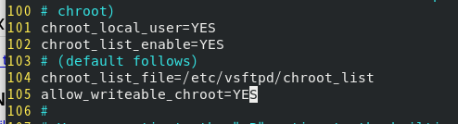

瀏覽器: ftp://webuser1@server/

systemctl restart vsftpd

vim /etc/httpd/conf/httpd.conf

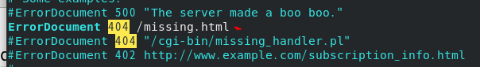

systemctl restart httpd

cd /var/www/html/

vim missing.html

(建造首頁)

cd /var/www/html/

vim index.html



systemctl restart httpd

瀏覽器: http://server/dsfidjfojfosfj (後面隨便打)

(點 home會回到首頁)

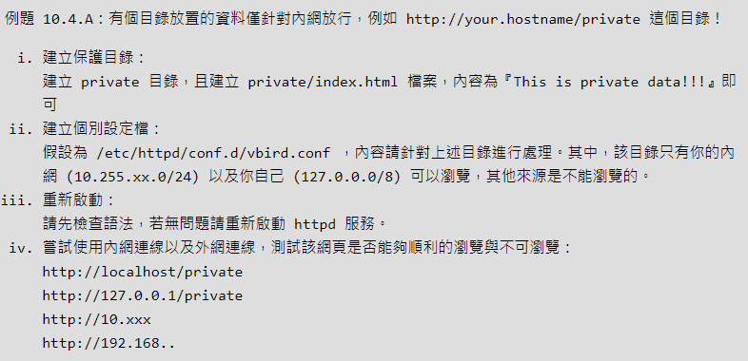

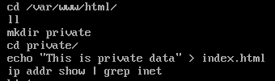

瀏覽器: server/private/

cd /etc/httpd/conf.d

vim cheris.conf (設定自己的設定檔，根據要修改的檔案更改黨名)

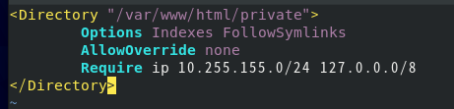

apachectl configtest

systemctl restart httpd

瀏覽器:測試他人是否能瀏覽你自己 : 自己IP/private/

* **建立使用密碼保護的瀏覽目錄**

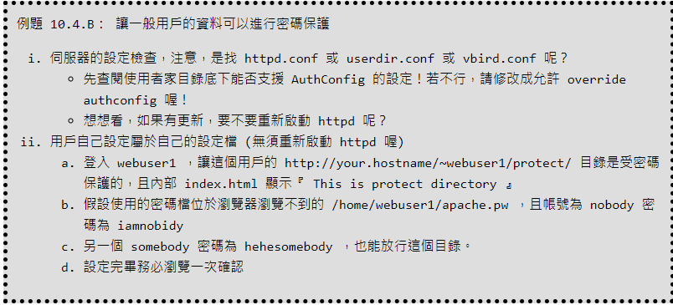

su - webuser1

vim /etc/httpd/conf/httpd.conf

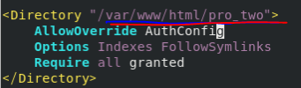紅線為題目的檔案位置

systemctl restart httpd

cd www/protect/

vim .htaccess

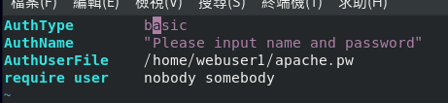

htpasswd -c abache.pw nobody/somebody

(?還未能測試連線)

(root@server)

setsebool -P httpd_read_user_content 1

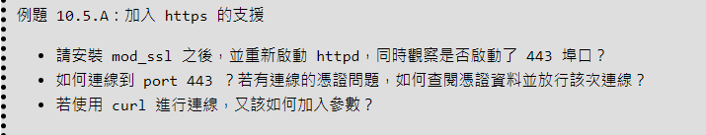

yum install mod_ssl

netstat -tlunp | grep http

systemctl restart httpd

curl https://localhost

man curl

curl -k <https://localhost>

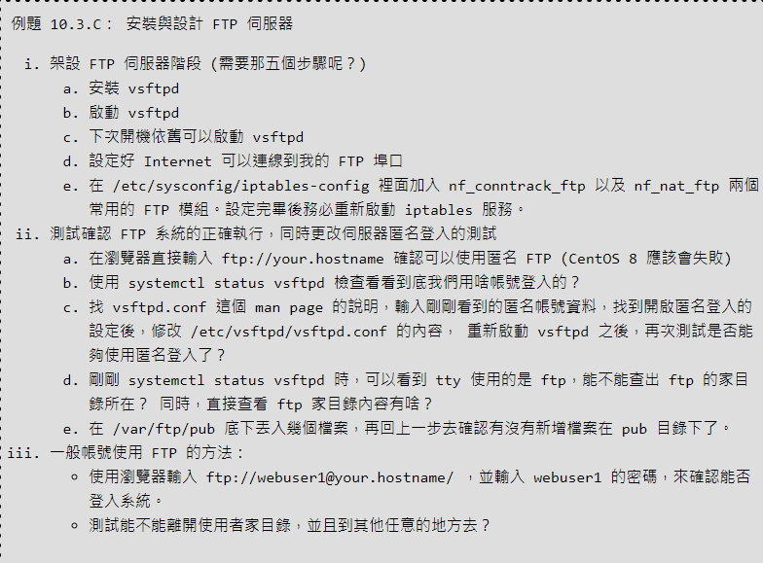

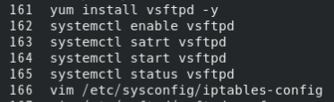



vim firewall.sh



sh firewall.sh

vim /etc/vsftpd/vsftpd.conf



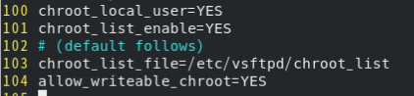

systemctl restart vsftpd.service

瀏覽器: ftp://your.hostname

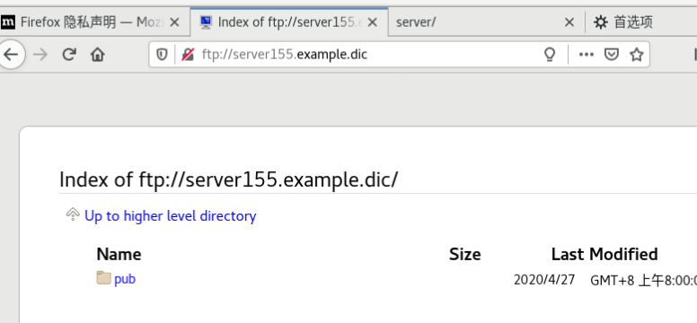

-------------------

FTP

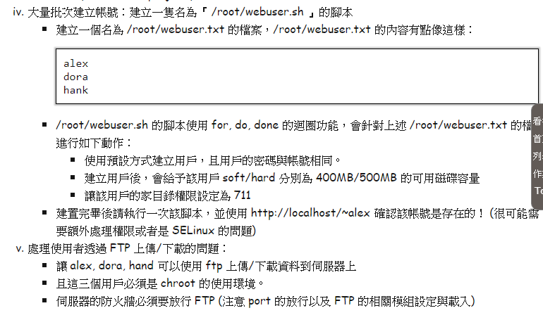

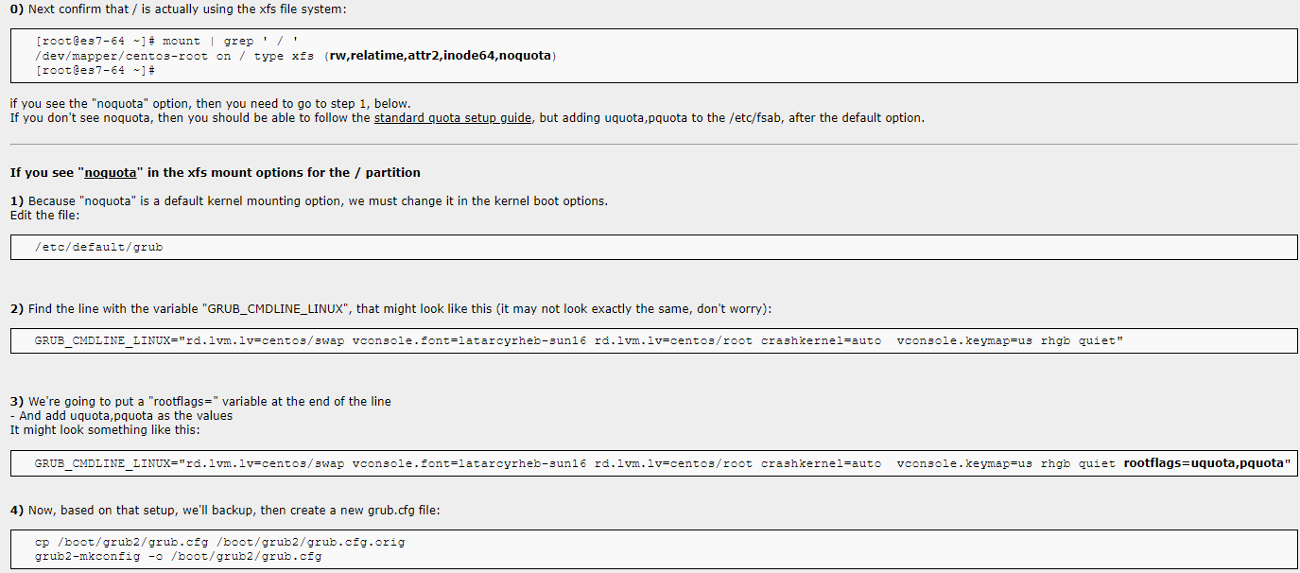

vim /root/webuser.sh

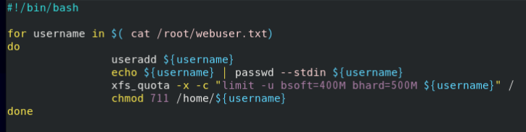

sh webuser.sh

**?xfs_quota -x -c “report -ubih” /**

**?setsebool -P httpd_enable_homedirs=1**

**?restorecon -Rv /home/\***

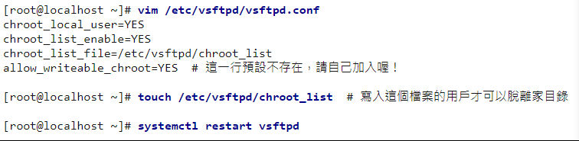

瀏覽器:ftp://alex@server155.example.dic