A(server)

nmcli connection delete

nmcli connection add con-name ens3 ifname ens3 type ethernet connection.autoconnect yes ipv4.method manual ipv4.address 172.18.255.*/24 ipv4.gateway 172.18.255.254 ipv4.dns 172.16.200.254,168.95.1.1

nmcli connection add con-name team0 ifname team0 type team config ‘{“runner”:{“name”:”activebackup”}}’

nmcli connection modify team0 ipv4.method manual ipv4.address 172.19.155.254/24

nmcl I connection add con-name ens7 ifname ens7 type team-slave master team0

nmcli connection add con-name ens8 ifname ens8 type team-slave master team0

nmcli connection up ens3 team0

teamdctl team0 state

hostnamectl set-hostname server155.example.dic

vim /etc/hosts

* 1. server*.example.dic 172.18.255.* 別名為 server*
  2. server254.example.dic 172.18.255.254 別名為 server254
  3. server.lan*.example.dic 172.19.*.254 別名為 server
  4. client.lan*.example.dic 172.19.*.1 別名為 client

B(server)

vim /etc/yum.repos.d/CentOS-AppStream.repo

<http://ftp.ksu.edu.tw/FTP/CentOS/8/AppStream/x86_64/os/>

vim /etc/yum.repos.d/CentOS-Base.repo

<http://ftp.ksu.edu.tw/FTP/CentOS/8/BaseOS/x86_64/os/>

vim /etc/yum.repos.d/CentOS-Extras.repo

<http://ftp.ksu.edu.tw/FTP/CentOS/8/extras/x86_64/os/>

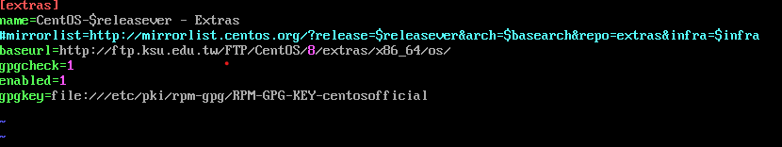

yum clean all

yum update

yum –enablerepo=PowerTools install links

yum install vim-enhanced bash-completion net-tools mailx wget bind-utils kernel-tools kernel-modules

vim /etc/crontab

0 3 * * * root /bin/yum update -y

vim /etc/selinux/config

SELINUX=enforcing

getenforce

reboot

C(server)

systemctl disable firewall.service

systemctl stop firewall.service

yum install iptables* -y

systemctl start iptables.service

systemctl enable iptables.service

systemctl status iptables.service

vim firewall.sh

iptables -F

iptables -X

iptables -Z

iptables -P INPUT DROP

iptables -P OUTPUT ACCEPT

iptables -P FORWARD ACCEPT

iptables -A INPUT -m state --state RELATED,ESTABLISHED -j ACCEPT

iptables -A INPUT -i lo -j ACCEPT

iptables -A INPUT -p icmp -j ACCEPT

iptables -A INPUT -s 172.19.155.0/24 -j ACCEPT

iptables -A INPUT –s 172.18.255.0/24 –j ACCEPT

iptables -A INPUT -p tcp --dport 80 -j ACCEPT

iptables-save > /etc/sysconfig/iptables

systemctl restart ipteables.service

iptables-save

D

cat /proc/sys/net/ipv4/ip_forwardㄊ

vim /etc/sysctl.conf

net.ipv4.ip_forward=1

sysctl -p

cat /proc/sys/net/ipv4/ip_forward

vim firewall.sh

iptables -t nat -F

iptables -t nat -X

iptables -t nat -Z

iptables -t nat -A POSTROUTING -s 172.19.155.1/24 -o ens3 -j MASQUERADE

vim /etc/sysconfig/iptables-config

IPTABLES_MODULES="nf_nat_ftp nf_conntrack_ftp"

E(server)

yum install setroubleshoot-* -y

vim /etc/ssh/sshd_config

Port 22

Port 3131

semanage port –a –t ssh_port_t –p tcp 3131

systemctl restart sshd

systemctl status sshd

vim firewall.sh

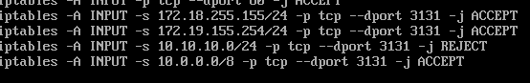

sh firewall.sh

systemctl restart iptables.service

groupadd nosshgrp

useradd –G nosshgrp localuser1/2/3

echo “123hehe” | passwd --stdin localuser1/2/3

vim /etc/ssh/sshd_config

PermitRootLogin no

DenyGroups nosshgrp

systemctl restart sshd

vim firewall.sh

iptables -t nat -A PREROUTING -p tcp --dport 4455 -j REDIRECT --to 22

F(server)

yum install rsync –y

--先設定無須密碼登入root

ssh-keygen

ssh-copy-id –i /root/.ssh/id_rsa.pub root@client

ssh root@client (測試是否需要密碼)

vim /etc/ssh/sshd_config

Ciphers chacha20-poly1305@openssh.com

mkdir /root/bin

vim /root/bin/backup.sh

rsync –e ‘ssh -c chacha20-poly1305@openssh.com’ –rtlv /etc /home /root /var/spool/mail root@client:/backups/

sh /root/bin/backup.sh

vim /etc/crontab

0 3 * * * root sh /root/bin/backup.sh

G

yum install gnome-session gnome-classic-session gnome-terminal tigervnc-server -y

(student)

vncserver :7

netstat -tlunp

cp /usr/lib/systemd/system/vncserver@.service /etc/systemd/system

vim /etc/systemd/system/vncserver@.service

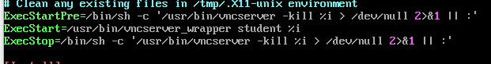

systemctl start vncserver@:7.service

systemctl enable vncserver@:7.service

(client)

B

systemctl enable firewalld

firewall-cmd --set-default-zone=work

firewall-cmd –permanent –add-service=http

firewall-cmd –permanent –add-service=ssh

firewall-cmd –permanent –add-service=dhcp

firewall-cmd --permanent --add-rich-rule=’rule family=”ipv4” source address=”172.19.155.0/24” accept’

firewall-cmd –reload

firewall-cmd –list-all

sudo useradd admin

sudo passwd admin

visudo

root ALL=(ALL) ALL

admin ALL=(ALL) NOPASSWD:ALL

(寫腳本，並在client-student下傳遞金鑰)

ssh-keygen

ssh-copy-id –i /home/student/.ssh/id_rsa.pub admin@server