(root@clien



port number 43

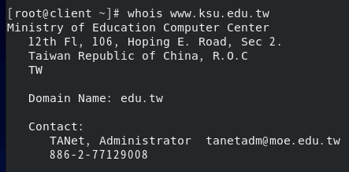

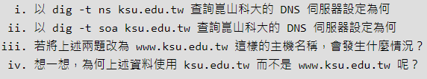

dig –t ns ksu.edu.tw

dig –t soa ksu.edu.tw

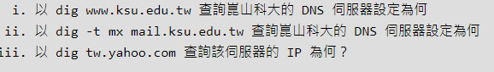

i.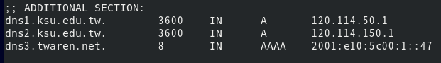

ii.

iii. 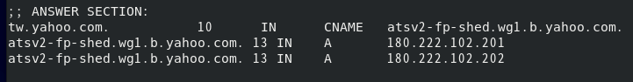ip兩個輪流,不知道哪個

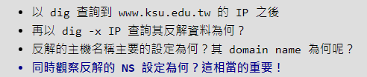

1.

(X)dig –x 120.114.100.65 //因dns是反解IP 要反過來輸入IP

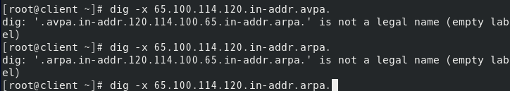

(進到root@server)

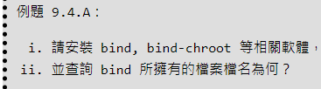

yum install  bind bind-chroot –y

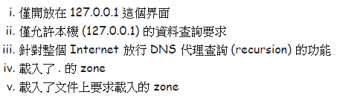

vim /etc/named.conf

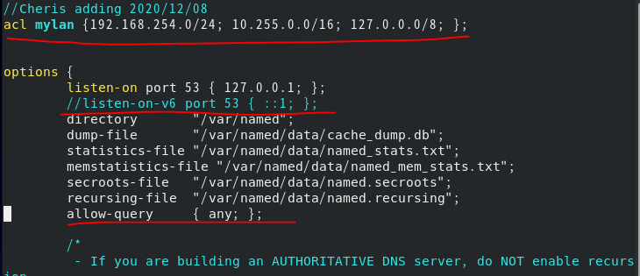

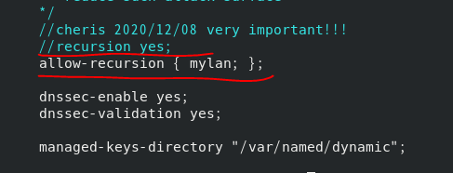更改不對所有人待查放行，只針對特定mylan

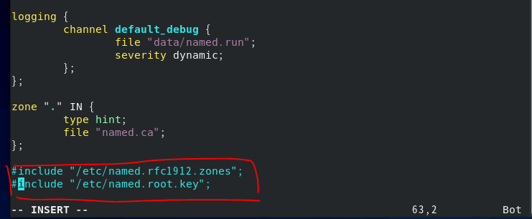

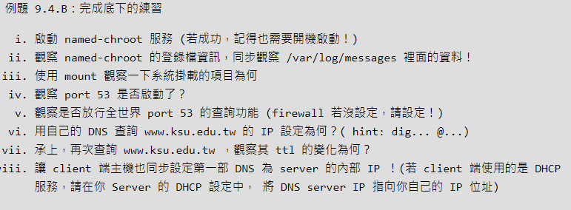

systemctl start named-chroot

systemctl enable named-chroot

vim /var/log/messages

mount

netstat –tulnp | grep named

vim firewall.sh

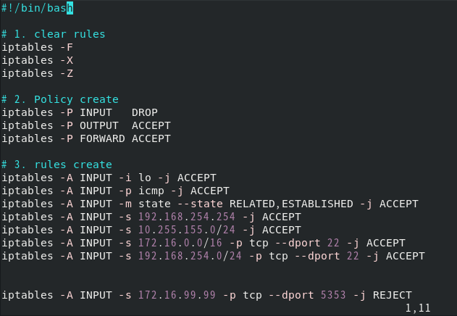

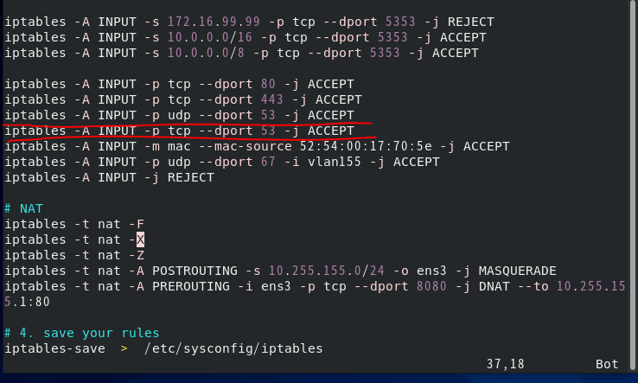

sh firewall.sh

systemctl restart iptables

iptables-save

dig [www.ksu.edu.tw](http://www.ksu.edu.tw)

vim /etc/dhcp/dhcpd.conf

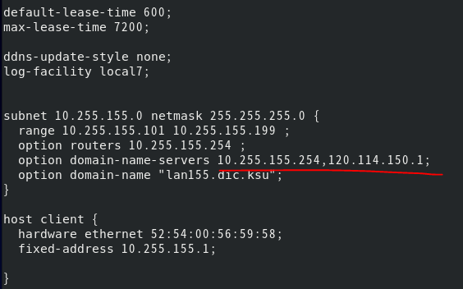

systemctl restart dhcpd

(root@client)

su –

cat /etc/resolv.conf

nmcli connection up vlan155

cat /etc/resolv.conf

dig dic.vbird.tw

netstat –tulnp | grep named

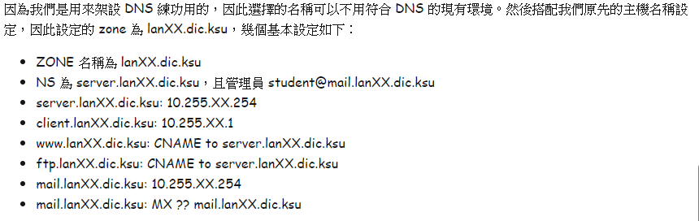

9.5： DNS 正解設定

vim /etc/named.conf

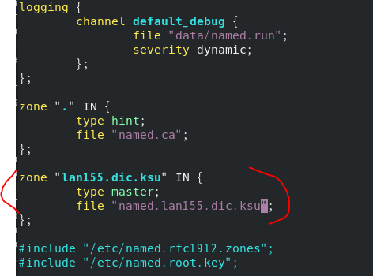

.

cd /var/named

cat named.localhost

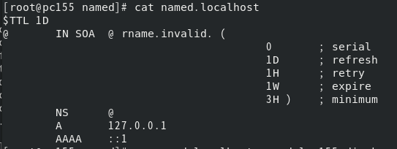

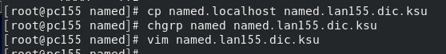

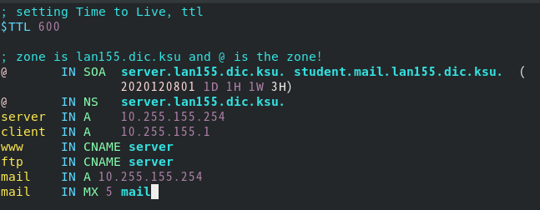

systemctl restart named-chroot

systemctl status named-chroot //檢查錯誤

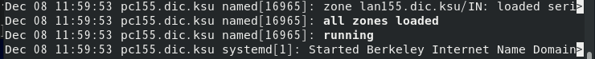

dig server.lan155.dic.ksu //查詢正解

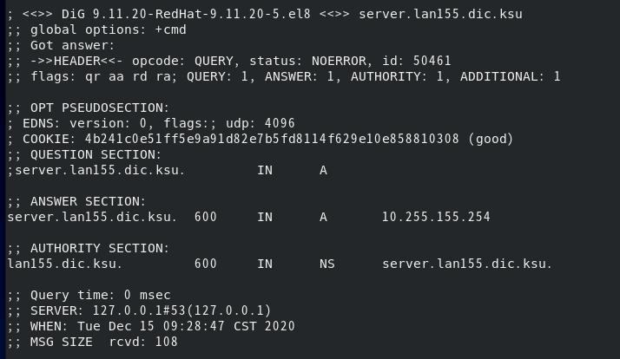

9.6： DNS 反解設定

vim /etc/named.conf

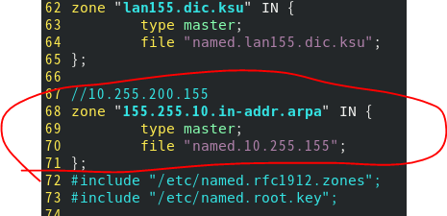

cp named.lan155.dic.ksu named.10.255.155

chgrp named named.10.255.155

vim named.10.255.155

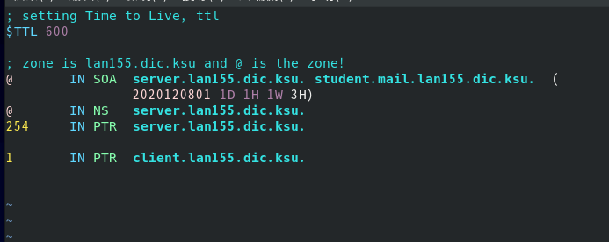

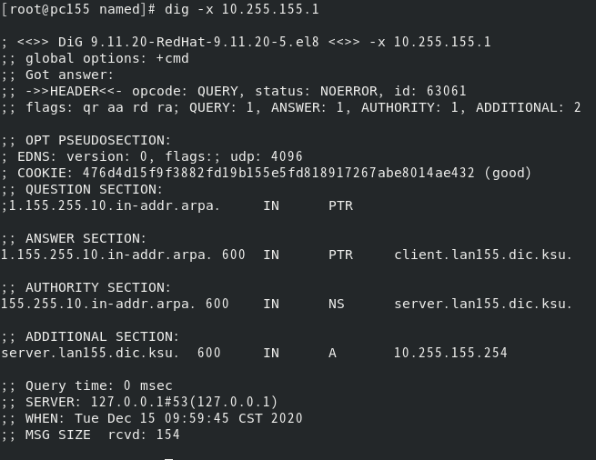

9.7： Master/Slave 的設

(server)以下要設定才能讓client通過  
vim /etc/named.conf

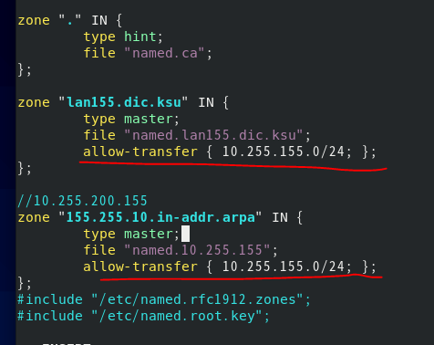

vim named.lan155.dic.ksu

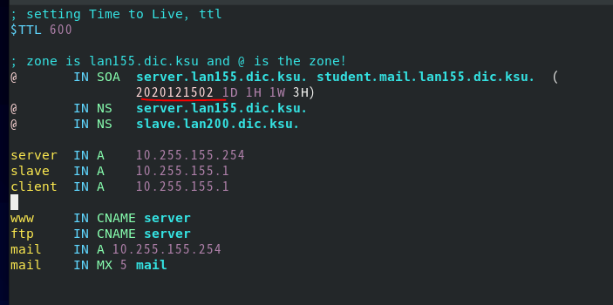

vim named.10.255.155

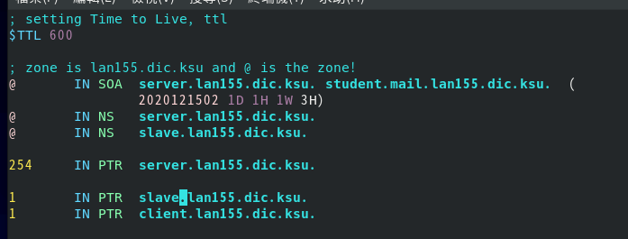

systemctl restart named-chroot

systemctl status named-chroot

* **Slave DNS Server 的設定：**

以下到client@root:

yum install bind bind-chroot

vim /etc/named.conf

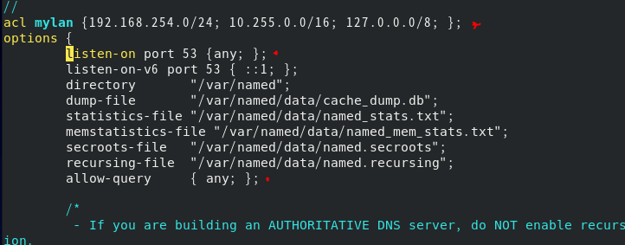

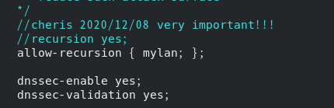

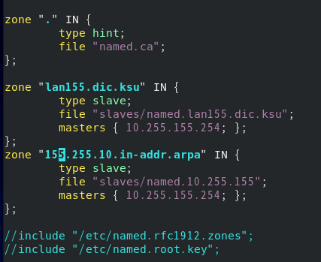

systemctl start named-chroot

systemctl enable named-chroot

systemctl restart named-chroot

systemctl status named-chroot

firewall-cmd --list-all

firewall-cmd --add-service=dns

firewall-cmd --add-serivce=dns --permanent

firewall-cmd --reload

firewall-cmd --list-all

nmcli connection modify vlan155 ipv4.dns 127.0.0.1,120.114.150.1

nmcli connection modify vlan155 ipv4.ignore-auto-dns yes

nmcli connection up vlan155

ll /var/named/slaves/

最後dig看有沒有成功

查詢反解 dig -x