關閉firewalld防火牆: systemctl stop firewalld.service

設定開機不啟動firewalld防火牆:systemctl disable firewalld.service

設定防火牆

Vlans

清除team0設定

nmcli connection modify team0 ipv4.method disavled ipv4.addresses ‘’ ipv6.method link-local ipv6.address ‘’

nmcli connection add con-name vlan155 ifname vlan155 type vlan dev team0 id 155

nmcli connection modify vlan155 802-3-ethernet.mtu 1400s ipv4.addresses 172.19.155.254/24

1. 讓核心支援 IP 轉遞的功能，並且每次重新開機都可以自動生效

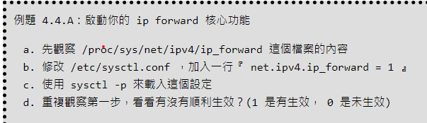

讓你的 server 會多一個路由，當發現到 172.19.250.0/24 的封包目標時，將它導向到 172.18.255.250 這部伺服器。

DHCP設定:

[root@localhost ~]# **yum install dhcp-server**

[root@localhost ~]# **vim /etc/dhcp/dhcpd.conf**

[root@localhost ~]# **systemctl start dhcpd**

[root@localhost ~]# **systemctl enable dhcpd**

[root@localhost ~]# **systemctl status dhcpd**

yum install dhcp-server -ys

vim /etc/dhcp/dhcpd.conf

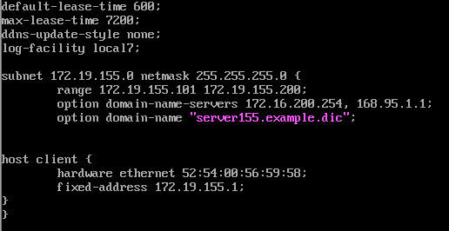

iptables -A INPUT -p udp --dport 67 -i vlan200 -j ACCEPT

systemctl restart dhcpd.service

firewall

查詢 rich rule (man firewalld.richlanguage)，確認來自本機同一個 LAN 網段的封包，通通給予放行。

firewall-cmd --permanent --add-rich-rule=’rule family=”ipv4” source address=”172.19.155.0” accept’

firewall-cmd --reload

firewall-cmd --list-all