**第一題　加密法**

字元的加密法有很多，假若吾人欲使用互斥邏輯運算進行加密，其作法如下：將每個字元的最右邊 (即最小的) 3個位元進行反轉 (即1變0，0變1)，再將反轉後的字元視為其加密後的密碼。例如：

N→01001**110**

↓

I ←01001**001**

亦即N加密後成為I。

請寫一個程式，可以將輸入的字串，使用以上方法加密後，並輸出加密後的密碼。

**輸入範例：**　　　　　　　　　　　　　　　　**輸出範例：**

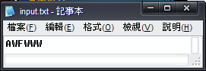　　　　　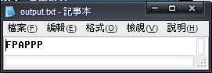

**程式碼：**

Imports System.IO

Public Class Form1

Dim fr As New FileInfo("input.txt")

Dim fw As New FileInfo("output.txt")

Dim sw As StreamWriter = fw.CreateText

Dim str As String

Dim io(,), n(), a As Integer

Private Sub Form1_Load(ByVal sender As System.Object, ByVal e As System.EventArgs) Handles MyBase.Load

If fr.Exists = False Then

MsgBox("未找到input.txt檔，程式即將結束執行。")

End

ElseIf fw.Exists = False Then

fw.Create()

End If

Dim sr As StreamReader = fr.OpenText

str = sr.ReadLine

ReDim io(Len(str) - 1, 8), n(7)

For i = 0 To Len(str) - 1

io(i, 0) = Asc(Microsoft.VisualBasic.Mid(str, i + 1, 1))

Do

n(i) += 1

If n(i) > 3 Then

If io(i, 0) Mod 2 = 0 Then

io(i, n(i)) = 0

Else : io(i, n(i)) = 1

End If

ElseIf n(i) <= 3 Then

If io(i, 0) Mod 2 = 1 Then

io(i, n(i)) = 0

Else : io(i, n(i)) = 1

End If

End If

io(i, 0) = io(i, 0) \ 2

Loop Until io(i, 0) = 1

io(i, n(i) + 1) = 1

io(i, 0) = 0

Next

For i = 0 To Len(str) - 1

For k = 1 To n(i) + 1

io(i, 0) += 2 ^ (k - 1) * io(i, k)

Next

sw.Write(Chr(io(i, 0)))

Next

sw.Flush() : sw.Close()

End

End Sub

End Class

**第二題　質因數分解**

將一正整數分解成質數的乘積，稱之為質因數分解。請寫一個程式，輸入一正整數 (此整數在3~1000之間)，輸出其質因數分解的結果。

**輸入範例：　　　　　　　　　　　　　　　　　輸出範例：**

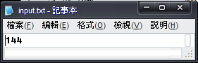　　　　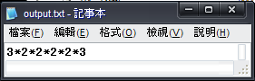

**程式碼：**

Imports System.IO

Public Class Form1

Dim fr As New FileInfo("input.txt")

Dim fw As New FileInfo("output.txt")

Dim sw As StreamWriter = fw.CreateText

Dim a(1), n, aa As Integer

Private Sub Form1_Load(ByVal sender As System.Object, ByVal e As System.EventArgs) Handles MyBase.Load

If fr.Exists = False Then

MsgBox("未找到input.txt檔，程式即將結束執行。")

End

ElseIf fw.Exists = False Then

fw.Create()

End If

Dim sr As StreamReader = fr.OpenText

a(0) = sr.ReadLine

aa = a(0)

Do

For i = 2 To aa

If a(0) > i Then

If a(0) Mod i = 0 Then

a(0) = a(0) / i

n += 1

ReDim Preserve a(n)

a(n) = i

Exit For

End If

End If

If i = aa Then

Exit Do

End If

Next

Loop

For i = 0 To n

sw.Write(a(i))

If i <> n Then sw.Write("*")

Next

sw.Flush() : sw.Close()

End

End Sub

End Class

**第三題　聯立方程式**

在本題中，請設計一個解聯立方程式的程式。輸入資料為六個參數，依序為、、、、、及。所有輸入參數皆為-100到+100間的整數。求聯立方程式的解，即求出、的值。

**輸入範例：　　　　　　　　　　　　　　　　　　輸出範例：**

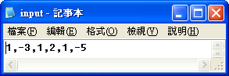　　　　　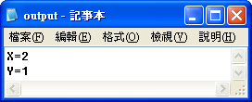

**程式碼：**

Imports System.IO

Public Class Form1

Dim fr As New FileInfo("input.txt")

Dim fw As New FileInfo("output.txt")

Dim sw As StreamWriter = fw.CreateText

Dim ii(1, 2), a, b As Short

Dim inn, aa As String

Private Sub Form1_Load(ByVal sender As System.Object, ByVal e As System.EventArgs) Handles MyBase.Load

If fr.Exists = False Then

MsgBox("input.txt不存在，程式即將結束執行。")

End

ElseIf fw.Exists = False Then

fw.Create()

End If

Dim sr As StreamReader = fr.OpenText

inn = sr.ReadLine

For i = 1 To Len(inn)

If Microsoft.VisualBasic.Mid(inn, i, 1) <> "," Then

aa &= Microsoft.VisualBasic.Mid(inn, i, 1)

Else

ii(a, b) = Val(aa)

aa = ""

b += 1

If b = 3 Then a += 1 : b = 0

End If

Next

ii(1, 2) = Val(aa)

a = ii(0, 0) : b = ii(1, 0)

If ii(0, 0) * b = ii(1, 0) * a Then

b = -((ii(0, 2) * b - ii(1, 2) * a) / (ii(0, 1) * b - ii(1, 1) * a))

ElseIf ii(0, 0) * b <> ii(1, 0) * a Then

b = -((ii(0, 2) * b + ii(1, 2) * a) / (ii(0, 1) * b + ii(1, 1) * a))

End If

a = -((ii(0, 2) + b * ii(0, 1)) / ii(0, 0))

sw.WriteLine("X=" & a & vbNewLine & "Y=" & b)

sw.Flush() : sw.Close()

End

End Sub

End Class

**第四題　統計**

請設計一個程式，輸入為一串數值資料，每個數值的範圍大於等於1且小於等於100。這個程式會計算出輸入數值的平均數、標準差、中位數、及眾數，並輸出這些的結果。

提示：平均數＝ *i*

變異數＝ (*Xi* －)2

中位數＝ [*X*()+*X* ()]

其中：*X*(k)表示將*Xi*由小而大排序後，第k 個位置的數。

眾 數＝ 出現次數最多的數。

**輸入範例(0表示結束)：　　　　　　　　　　　　輸出範例：**

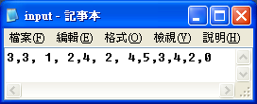　　　　　　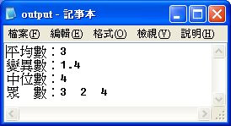

**程式碼：**

Imports System.IO

Public Class Form1

Dim fr As New FileInfo("input.txt")

Dim fw As New FileInfo("output.txt")

Dim sw As StreamWriter = fw.CreateText

Dim ii(1), nn(), a, x, z As Short '輸入數 多少數

Dim inn, aa As String

Private Sub Form1_Load(ByVal sender As System.Object, ByVal e As System.EventArgs) Handles MyBase.Load

If fr.Exists = False Then

MsgBox("input.txt不存在，程式即將結束執行。")

End

ElseIf fw.Exists = False Then

fw.Create()

End If

Dim sr As StreamReader = fr.OpenText

inn = sr.ReadLine

For i = 1 To Len(inn) '取數

If Microsoft.VisualBasic.Mid(inn, i, 1) = "," Then

If aa = "0" Then Exit For

ii(a) = Val(aa)

aa = ""

a += 1

ReDim Preserve ii(a)

ElseIf Microsoft.VisualBasic.Mid(inn, i, 1) <> "," Then

aa &= Microsoft.VisualBasic.Mid(inn, i, 1)

End If

Next

For i = 0 To a - 1 '計算平均數

x += ii(i)

Next

sw.WriteLine("平均數：" & Format(x / a), "###.0#")

For i = 0 To a - 1 '計算變異數

z += (ii(i) - (x / a)) ^ 2

Next

sw.WriteLine("變異數：" & Microsoft.VisualBasic.Left(z / (a - 1), 4))

If a Mod 2 = 1 Then '計算中位數

sw.WriteLine("中位數：" & ii(a \ 2 + 1))

ElseIf a Mod 2 = 0 Then

sw.WriteLine("中位數：" & (ii(a / 2) + ii(a / 2 + 1)) / 2)

End If

ReDim Preserve nn(a - 1)

For i = 0 To a - 1 '計算眾數

For j = 0 To a - 1

If ii(i) = ii(j) Then

nn(i) += 1

End If

Next

Next

sw.Write("眾　數：")

For i = 0 To a - 1

For j = 0 To a - 1

If i <> j And ii(i) = ii(j) Then

ii(j) = 0

nn(j) = 0

End If

Next

Next

For i = 0 To a - 1

For j = 0 To a - 1

If nn(i) < nn(j) Then

Exit For

ElseIf j = a - 1 Then

sw.Write(ii(i) & Space(2))

End If

Next

Next

sw.Flush() : sw.Close()

End

End Sub

End Class

**第五題　字串重組**

請輸入兩組字串，每組長度為八個字元。請注意，字串必須是由A、B、C、D、E、F、G、H這些英文字母所組合而成的，且每個英文字母在一個字串中限制只能出現一次。請設計一個程式，利用這兩組輸入的字串，組合另一個新的字串輸出。組合的法則為：新字串的前三個字元是從第一組輸入字串的前三個字元而來，後五個字元則是由第二組輸入字串從頭依序遞補上來的。遞補的條件為：遞補的字元必須跟第一組的前三個字元不相同。

**輸入範例：　　　　　　　　　　　　　　　　輸出範例：**

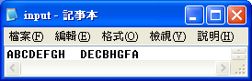　　　　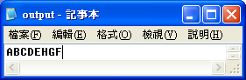

**程式碼：**

Imports System.IO

Public Class Form1

Dim fr As New FileInfo("input.txt")

Dim fw As New FileInfo("output.txt")

Dim sw As StreamWriter = fw.CreateText

Dim a, aa(2), bb(7), ans As String

Dim n As Byte

Private Sub Form1_Load(ByVal sender As System.Object, ByVal e As System.EventArgs) Handles MyBase.Load

If fr.Exists = False Then

MsgBox("未找到input.txt檔，程式即將結束執行")

End

ElseIf fw.Exists = False Then

fw.Create()

End If

Dim sr As StreamReader = fr.OpenText

a = sr.ReadLine

For i = 0 To 2

aa(i) = Microsoft.VisualBasic.Mid(a, i + 1, 1)

ans &= aa(i)

Next

For i = Len(a) - 7 To Len(a)

bb(i + 7 - Len(a)) = Microsoft.VisualBasic.Mid(a, i, 1)

Next

For i = 1 To 8

For j = 1 To 3

If bb(i - 1) = aa(j - 1) Then Exit For

If j = 3 Then

ans &= bb(i - 1)

n += 1

If n >= 5 Then GoTo 1

End If

Next

Next

1: sw.WriteLine(ans)

sw.Flush() : sw.Close()

End

End Sub

End Class

**第六題　求係數**

求`(x+1)*n*之各項係數（限制條件為1 ≤ *n* ≤ 50，*n*為一個正整數）。

**輸入範例：　　　　　　　　　　　　　　　　　輸出範例：**

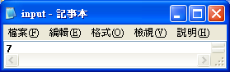　　　　　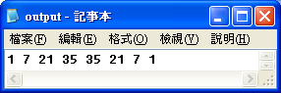

**程式碼：**

Imports System.IO

Public Class Form1

Dim fr As New FileInfo("input.txt")

Dim fw As New FileInfo("output.txt")

Dim sw As StreamWriter = fw.CreateText

Dim ii, a, b As Integer '結果 輸入數

Private Sub Form1_Load(ByVal sender As System.Object, ByVal e As System.EventArgs) Handles MyBase.Load

If fr.Exists = False Then

MsgBox("未找到input.txt檔，程式即將結束執行。")

End

ElseIf fw.Exists = False Then

fw.Create()

End If

Dim sr As StreamReader = fr.OpenText

ii = Val(sr.ReadLine)

a = 1

For i = 1 To ii

a *= i

Next

For i = 0 To ii

b = 1

For j = 1 To i

b *= j

Next

For k = 1 To ii - i

b *= k

Next

sw.Write(a / b & " ")

Next

sw.Flush() : sw.Close()

End

End Sub

End Class

**第七題　9*9乘法表**

請利用迴圈的方式設計一個程式，先輸出如下圖所示之9*9乘法表。

|  |  |  |  |  |  |  |  |  |
| --- | --- | --- | --- | --- | --- | --- | --- | --- |
| 1 | 2 | 3 | 4 | 5 | 6 | 7 | 8 | 9 |
| 2 | 4 | 6 | 8 | 10 | 12 | 14 | 16 | 18 |
| 3 | 6 | 9 | 12 | 15 | 18 | 21 | 24 | 27 |
| 4 | 8 | 12 | 16 | 20 | 24 | 28 | 32 | 36 |
| 5 | 10 | 15 | 20 | 25 | 30 | 35 | 40 | 45 |
| 6 | 12 | 18 | 24 | 30 | 36 | 42 | 48 | 54 |
| 7 | 14 | 21 | 28 | 35 | 42 | 49 | 56 | 63 |
| 8 | 16 | 24 | 32 | 40 | 48 | 56 | 64 | 72 |
| 9 | 18 | 27 | 36 | 45 | 54 | 63 | 72 | 81 |
|  |  |  |  |  |  |  |  |  |

請注意對齊位置。接著，再利用條件判斷的方式，限制9*9乘法表中部分資料的列印方式，輸出如下圖所示之結果。

|  |  |  |  |  |  |  |  |  |
| --- | --- | --- | --- | --- | --- | --- | --- | --- |
| 1 | 2 | 3 | 4 | 5 | 6 | 7 | 8 | 9 |
| 2 | 4 | 6 | 8 |  | 12 | 14 | 16 | 18 |
| 3 | 6 | 9 |  |  |  | 21 | 24 | 27 |
| 4 | 8 |  |  |  |  |  | 32 | 36 |
| 5 |  |  |  |  |  |  |  | 45 |
| 6 | 12 |  |  |  |  |  | 48 | 54 |
| 7 | 14 | 21 |  |  |  | 49 | 56 | 63 |
| 8 | 16 | 24 | 32 |  | 48 | 56 | 64 | 72 |
| 9 | 18 | 27 | 36 | 45 | 54 | 63 | 72 | 81 |

**輸出範例：**

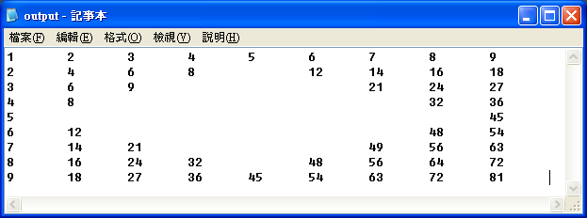

**程式碼：**

Imports System.IO

Public Class Form1

Dim fw As New FileInfo("output.txt")

Dim sw As StreamWriter = fw.CreateText

Dim a(8, 8) As String

Dim z As Byte

Private Sub Form1_Load(ByVal sender As System.Object, ByVal e As System.EventArgs) Handles MyBase.Load

If fw.Exists = False Then

fw.Create()

End If

For i = 1 To 9

For j = 1 To 9

a(i - 1, j - 1) = i * j & vbTab

Next

Next

For i = 1 To 4

For j = 5 - i To 3 + i

a(i, j) = "" & vbTab

Next

Next

For i = 5 To 8

For j = i - 3 To 11 - i

a(i, j) = "" & vbTab

Next

Next

For i = 1 To 9

For j = 1 To 9

sw.Write(a(i - 1, j - 1))

Next

sw.Write(vbNewLine)

Next

sw.Flush() : sw.Close()

End

End Sub

End Class