**13週VB作業**

1寫一個 VB專案，讓使用者輸入一個正整數N(N>1)，輸出所有小於等於N的質數。

2.費氏數列公式為:A(n)=A(n-1)+A(n-2)，A(0)=0，A(1)=1，n>1。

寫一個 VB專案，可以讓使用者輸入一個正整數X(X>1)，輸出所有值小於X的費氏數列元素。

3. 製作一程式計算 1^3+3^3+5^3+...+ 99^3=?

4.輸入一個N，印出三角形的星星：如下圖所示！

********

*** ***

** **

* *

** **

*** ***

********

5.輸入一個N，印出呈現四方形的數字：若N=3則如下圖所示！(60分)

1 1 1 1 1 1

1 2 2 2 2 1

1 2 3 3 2 1

1 2 3 3 2 1

1 2 2 2 2 1

1 1 1 1 1 1

**第一題**

**輸入範例：**

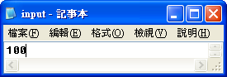

**輸出範例：**

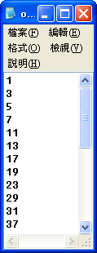 　　　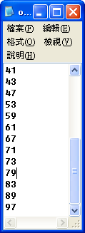

**程式碼：**

Imports System.IO

Public Class Form1

Dim fr As New FileInfo("input.txt")

Dim fw As New FileInfo("output.txt")

Dim sw As StreamWriter = fw.CreateText

Dim a, b As Integer 'a=原數

Private Sub Form1_Load(ByVal sender As System.Object, ByVal e As System.EventArgs) Handles MyBase.Load

If fr.Exists = False Then

MsgBox("未找到input.txt檔，程式即將結束執行")

End

ElseIf fw.Exists = False Then

fw.Create()

End If

Dim sr As StreamReader = fr.OpenText

a = Val(sr.ReadLine)

If a <= 1 Then

MsgBox("請輸入大於1的數，程式即將結束執行")

End

End If

sw.WriteLine("1")

For j = 2 To a

For i = 2 To (j - 1)

b = j Mod i

If b = 0 Then

Exit For

End If

Next

If b <> 0 Then

sw.WriteLine(j)

End If

Next

sw.Flush() : sw.Close()

End

End Sub

**第二題**

**輸入範例：　　　　　　　　　　　　　　　　　輸出範例：**

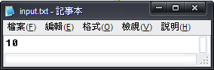　　　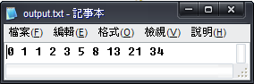

**程式碼：**

Imports System.IO

Public Class Form1

Dim fr As New FileInfo("input.txt")

Dim fw As New FileInfo("output.txt")

Dim sw As StreamWriter = fw.CreateText

Dim a, b, c, d As Integer

Private Sub Form1_Load(ByVal sender As System.Object, ByVal e As System.EventArgs) Handles MyBase.Load

If fr.Exists = False Then

MsgBox("未找到input.txt檔，程式即將結束執行")

End

ElseIf fw.Exists = False Then

fw.Create()

End If

Dim sr As StreamReader = fr.OpenText

a = Val(sr.ReadLine)

c = 1

For i = 1 To a

sw.Write(b & " ")

d = b

b = c + b

c = d

If b > a Then Exit For

Next

sw.Flush() : sw.Close()

End

End Sub

End Class

**第三題**

**輸出範例：**

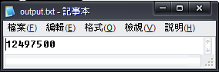

**程式碼：**

Imports System.IO

Public Class Form1

Dim fw As New FileInfo("output.txt")

Dim sw As StreamWriter = fw.CreateText

Dim a As Integer

Private Sub Form1_Load(ByVal sender As System.Object, ByVal e As System.EventArgs) Handles MyBase.Load

If fw.Exists = False Then

fw.Create()

End If

For i = 1 To 99 Step 2

a += i ^ 3

Next

sw.WriteLine(a)

sw.Flush() : sw.Close()

End

End Sub

End Class

**第四題**

**輸入範例：　　　　　　　　　　　　　　　　　輸出範例：**

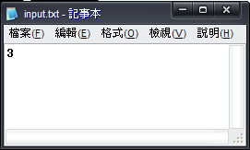 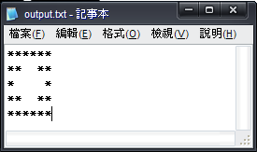

**程式碼：**

Imports System.IO

Public Class Form1

Dim fw As New FileInfo("output.txt")

Dim fr As New FileInfo("input.txt")

Dim sw As StreamWriter = fw.CreateText

Dim ans As String

Dim a As Integer

Private Sub Form1_Load(ByVal sender As System.Object, ByVal e As System.EventArgs) Handles MyBase.Load

If fr.Exists = False Then

MsgBox("未找到input.txt檔，程式即將結束執行")

End

ElseIf fw.Exists = False Then

fw.Create()

End If

Dim sr As StreamReader = fr.OpenText

a = Val(sr.ReadLine)

For k = a To 1 Step -1

For i = 1 To k

ans &= "*"

Next

ans &= Space((a - k) * 2)

For i = 1 To k

ans &= "*"

Next

ans &= vbNewLine

Next

For k = 2 To a

For i = 1 To k

ans &= "*"

Next

ans &= Space((a - k) * 2)

For i = 1 To k

ans &= "*"

Next

ans &= vbNewLine

Next

sw.WriteLine(ans) : sw.Flush() : sw.Close() : End

End Sub

End Class

**第五題**

**輸入範例：　　　　　　　　　　　　　　　　　輸出範例：**

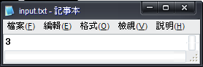 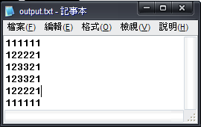

**程式碼：**

Imports System.IO

Public Class Form1

Dim fr As New FileInfo("input.txt")

Dim fw As New FileInfo("output.txt")

Dim sw As StreamWriter = fw.CreateText

Dim n As Integer

Dim ans As String

Private Sub Form1_Load(ByVal sender As System.Object, ByVal e As System.EventArgs) Handles MyBase.Load

If fr.Exists = False Then

MsgBox("未找到input.txt檔，程式即將結束執行")

End

ElseIf fw.Exists = False Then

fw.Create()

End If

Dim sr As StreamReader = fr.OpenText

n = sr.ReadLine

For i = 1 To n

For k = 1 To i

ans &= k

Next

For z = 1 To n - i

ans &= i

Next

　　　　 For z = n - i To 1 Step -1

ans &= i

Next

For k = i To 1 Step -1

ans &= k

Next

ans &= vbCrLf

Next

For i = n To 1 Step -1

For k = 1 To i

ans &= k

Next

For z = 1 To n - i

ans &= i

Next

For z = n - i To 1 Step -1

ans &= i

Next

For k = i To 1 Step -1

ans &= k

Next

ans &= vbCrLf

Next

sw.WriteLine(ans)

sw.Flush() : sw.Close()

End

End Sub

End Class