**第一、二、三、四、五題**

**輸入前：**

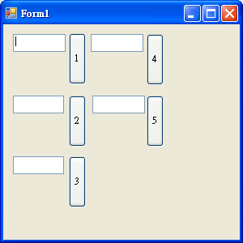

**輸入後：**

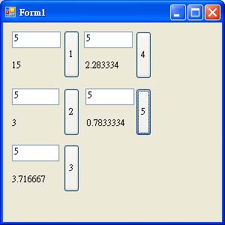

**程式碼：**

Public Class Form1

Dim a, b, c As Single

Private Sub Button1_Click(ByVal sender As System.Object, ByVal e As System.EventArgs) Handles Button1.Click

a = 0

For i = 1 To Val(T1.Text)

a += i

Next

l1.text = a

End Sub

Private Sub Button2_Click(ByVal sender As System.Object, ByVal e As System.EventArgs) Handles Button2.Click

a = 0 : b = 0

For i = 1 To Val(T2.Text) Step 2

a += i

Next

For i = 2 To Val(T2.Text) Step 2

b -= i

Next

L2.Text = a + b

End Sub

Private Sub Button3_Click(ByVal sender As System.Object, ByVal e As System.EventArgs) Handles Button3.Click

a = 1

For i = 2 To Val(T3.Text)

a += (i - 1) / i

Next

L3.Text = a

End Sub

Private Sub Button4_Click(ByVal sender As System.Object, ByVal e As System.EventArgs) Handles Button4.Click

a = 0

For i = 1 To Val(T3.Text)

a += 1 / i

Next

l4.text = a

End Sub

Private Sub Button5_Click(ByVal sender As System.Object, ByVal e As System.EventArgs) Handles Button5.Click

a = 0 : b = 0

For i = 1 To Val(T2.Text) Step 2

a += 1 / i

Next

For i = 2 To Val(T2.Text) Step 2

b -= 1 / i

Next

L5.Text = a + b

End Sub

End Class

**第六題**

**輸入範例：**

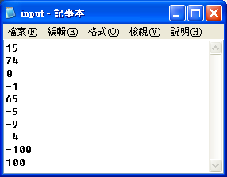

**輸出範例：**

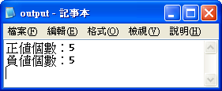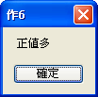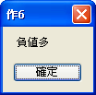(3種結果)

**程式碼：**

Imports System.IO

Public Class Form1

Dim fr As New FileInfo("input.txt")

Dim fw As New FileInfo("output.txt")

Dim sw As StreamWriter = fw.CreateText

Dim ii(9), a, b As Long

Private Sub Form1_Load(ByVal sender As System.Object, ByVal e As System.EventArgs) Handles MyBase.Load

If fr.Exists = False Then

MsgBox("未找到input.txt檔，程式即將結束執行。")

End

ElseIf fw.Exists = False Then

fw.Create()

End If

Dim sr As StreamReader = fr.OpenText

For i = 0 To 9

ii(i) = sr.ReadLine

If ii(i) >= 0 Then

a += 1

ElseIf ii(i) < 0 Then

b += 1

End If

Next

sw.WriteLine("正值個數：" & a)

sw.WriteLine("負值個數：" & b)

If a > b Then

MsgBox("正值多")

ElseIf a < b Then

MsgBox("負值多")

ElseIf a = b Then

MsgBox("正負一值樣多")

End If

sw.Flush() : sw.Close()

End

End Sub

End Class

**第七題**

**輸出範例：**

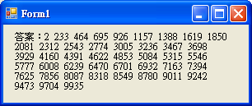

**程式碼：**

Public Class Form1

Private Sub Form1_Load(ByVal sender As System.Object, ByVal e As System.EventArgs) Handles MyBase.Load

For i = 1 To 10000

If i Mod 7 = 2 And i Mod 11 = 2 And i Mod 3 = 2 Then

Label1.Text &= i & " "

End If

Next

End Sub

End Class

**第八題**

**輸入範例：　　　　　　　　　　　　　　　　　　輸出範例：**

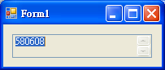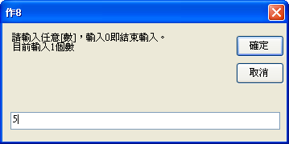（其中之ㄧ）

**程式碼：**

Public Class Form1

Dim ii(1), n, a As Long

Private Sub Form1_Load(ByVal sender As System.Object, ByVal e As System.EventArgs) Handles MyBase.Load

a = 1

Do

ii(n) = Val(InputBox("請輸入任意[數]，輸入0即結束輸入。" & vbNewLine & "目前輸入" & n + 1 & "個數"))

n += 1

ReDim Preserve ii(n)

Loop Until ii(n - 1) = 0

For i = 0 To n - 2

a *= ii(i)

Next

TextBox1.Text = a

End Sub

End Class

**第九題**

**輸出結果：**

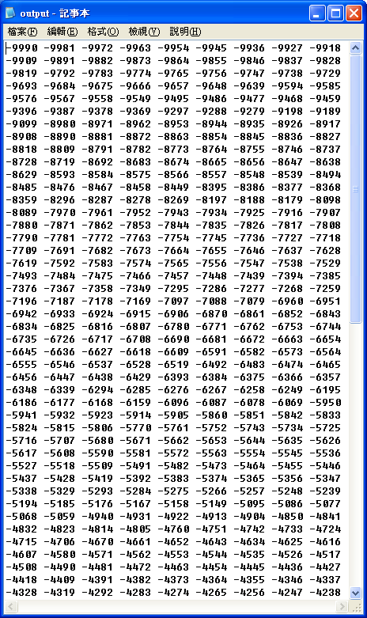 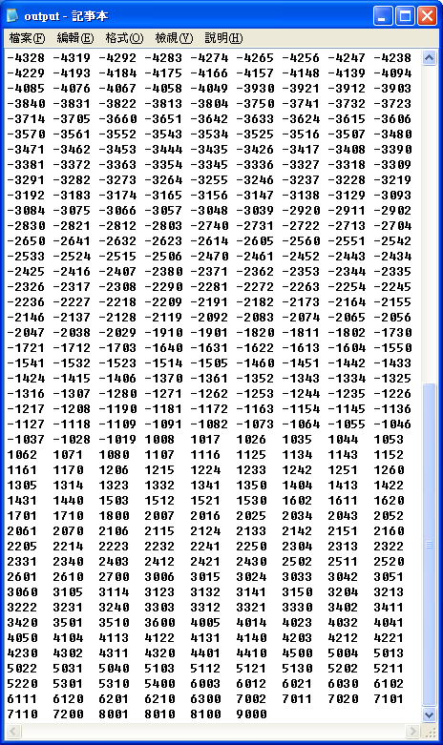

**程式碼：**

Imports System.IO

Public Class Form1

Dim fw As New FileInfo("output.txt")

Dim sw As StreamWriter = fw.CreateText

Dim a, n As Long

Dim ss As String

Private Sub Form1_Load(ByVal sender As System.Object, ByVal e As System.EventArgs) Handles MyBase.Load

If fw.Exists = False Then

fw.Create()

End If

n = 1

For i = -9990 To 9000

a = 0 : ss = ""

For j = 1 To 4

If i < 0 And Len(CStr(i)) = 5 Then

If j = 1 Then

ss &= Microsoft.VisualBasic.Mid(i, j, 2)

a += Val(ss)

Else

a += Microsoft.VisualBasic.Mid(i, j + 1, 1)

End If

ElseIf i >= 0 And Len(CStr(i)) = 4 Then

a += Microsoft.VisualBasic.Mid(i, j, 1)

End If

Next

If a = 9 Then sw.Write(i & " ") : n += 1

If n Mod 10 = 0 Then sw.Write(vbCrLf) : n = 1

Next

sw.Flush() : sw.Close() : End

End Sub

End Class

**第十題**

**輸入範例：**

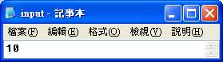

**輸出範例：**

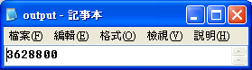

**程式碼：**

Imports System.IO

Public Class Form1

Dim fr As New FileInfo("input.txt")

Dim fw As New FileInfo("output.txt")

Dim sw As StreamWriter = fw.CreateText

Dim ii, aa As Integer

Private Sub Form1_Load(ByVal sender As System.Object, ByVal e As System.EventArgs) Handles MyBase.Load

If fr.Exists = False Then

MsgBox("未找到input.txt檔，程式即將結束執行。")

End

ElseIf fw.Exists = False Then

fw.Create()

End If

Dim sr As StreamReader = fr.OpenText

ii = sr.ReadLine

aa = 1

sw.Write(zz(ii))

sw.Flush() : sw.Close()

End

End Sub

Function zz(ByVal a As Integer)

If a = 1 Then

Return aa

Else

aa *= a

Return zz(a - 1)

End If

End Function

End Class