**第一題**

**輸出範例：**

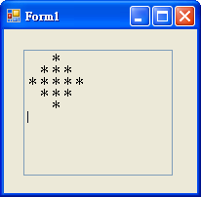

**程式碼：**

Public Class Form1

Private Sub Form1_Load(ByVal sender As System.Object, ByVal e As System.EventArgs) Handles MyBase.Load

For j = 1 To 5 Step 2

T1.Text &= Space((5 - j) * 2)

For i = 1 To j

T1.Text &= "＊"

Next

T1.Text &= vbNewLine

Next

For j = 3 To 1 Step -2

T1.Text &= Space((5 - j) * 2)

For i = 1 To j

T1.Text &= "＊"

Next

T1.Text &= vbNewLine

Next

End Sub

End Class

**第二題**

**輸出範例：**

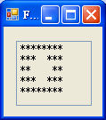

**程式碼：**

Public Class Form1

Private Sub Form1_Load(ByVal sender As System.Object, ByVal e As System.EventArgs) Handles MyBase.Load

For i = 4 To 2 Step -1

For j = 1 To i * 2

T1.Text &= "*"

If i = j Then

T1.Text &= Space((4 - i) * 4)

End If

Next

T1.Text &= vbCrLf

Next

For i = 3 To 4

For j = 1 To i * 2

T1.Text &= "*"

If i = j Then

T1.Text &= Space((4 - i) * 4)

End If

Next

T1.Text &= vbCrLf

Next

End Sub

End Class

**第三題**

**輸入範例：　　　　　　　　　　　　　　　　 　輸出範例：**

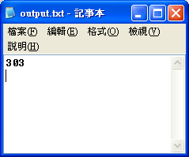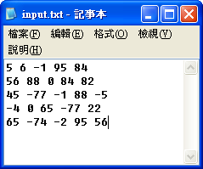

**程式碼：**

Imports System.IO

Public Class Form1

Dim fr As New FileInfo("input.txt")

Dim fw As New FileInfo("output.txt")

Dim sw As StreamWriter = fw.CreateText

Dim gg(25), n As Long

Dim a, b As String

Private Sub Form1_Load(ByVal sender As System.Object, ByVal e As System.EventArgs) Handles MyBase.Load

If fr.Exists = False Then

MsgBox("未找到input.txt檔，程式即將結束執行")

End

ElseIf fw.Exists = False Then

fw.Create()

End If

Dim sr As StreamReader = fr.OpenText

For i = 1 To 5

a = sr.ReadLine & " "

For j = 1 To Len(a)

If Microsoft.VisualBasic.Mid(a, j, 1) <> " " Then

b &= Microsoft.VisualBasic.Mid(a, j, 1)

ElseIf Microsoft.VisualBasic.Mid(a, j, 1) = " " Then

gg(n) = Val(b) : n += 1 : b = ""

End If

Next

Next

gg(n) = gg(0) + gg(4) + gg(6) + gg(8) + gg(12) * 2 + gg(16) + gg(18) + gg(20) + gg(24)

sw.WriteLine(gg(n))

sw.Flush() : sw.Close() : End

End Sub

End Class

**第四題**

**輸出範例：**

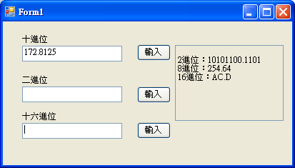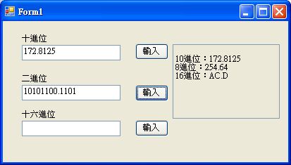

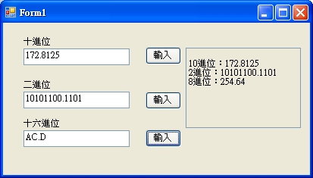

**程式碼：**

Public Class Form1

Dim i1, n, aa, a, b As Integer

Dim i2, bb As Single

Dim s1, e1(), e2() As String

Dim z() As Byte = {2, 8, 16}

Dim v() As String = {"A", "B", "C", "D", "E", "F"}

Private Sub Button1_Click(ByVal sender As System.Object, ByVal e As System.EventArgs) Handles Button1.Click

Tii.Text = "" : i1 = Fix(Val(T1.Text)) '取數

If Val(T1.Text) > i1 Then

For i = 1 To Len(T1.Text)

If Microsoft.VisualBasic.Mid(T1.Text, i, 1) = "." Then

i2 = "0." & Microsoft.VisualBasic.Mid(T1.Text, i + 1, Len(T1.Text))

Exit For

End If

Next

End If

For j = 0 To 2 '2、8、16進位

aa = i1 : s1 = "" '(整數部分)

Tii.Text &= vbCrLf & z(j) & "進位："

If i1 > z(j) - 1 Then

Do

If aa Mod z(j) > 9 Then

s1 &= v(aa Mod z(j) - 10)

Else

s1 &= aa Mod z(j)

End If

aa = aa \ z(j)

Loop Until aa = 0

For i = Len(s1) To 1 Step -1

Tii.Text &= Microsoft.VisualBasic.Mid(s1, i, 1)

Next

Else

Tii.Text &= i1

End If

'(小數部分)

If i2 > 0 Then

bb = i2 : Tii.Text &= "."

Do

If Fix(bb * z(j)) > 9 Then

Tii.Text &= v(Fix(bb * z(j)) - 10)

Else

Tii.Text &= Fix(bb * z(j))

End If

bb = bb * z(j)

For i = 1 To Len(CStr(bb))

If Microsoft.VisualBasic.Mid(CStr(bb), i, 1) = "." Then

bb = "0." & Microsoft.VisualBasic.Mid(CStr(bb), i + 1, Len(CStr(bb)))

Exit For

End If

Next

Loop Until bb = Fix(bb)

End If

Next

End Sub

Private Sub Button2_Click(ByVal sender As System.Object, ByVal e As System.EventArgs) Handles Button2.Click

i1 = Fix(Val(T2.Text)) : i2 = 0 : n = Len(CStr(i1)) - 1 : aa = 0 '取數

'十進位

For i = 1 To Len(CStr(i1))

aa += Val(Microsoft.VisualBasic.Mid(CStr(i1), i, 1)) * 2 ^ n

n -= 1

Next

i1 = aa

If Val(T2.Text) > i1 Then

For i = 1 To Len(T2.Text)

If Microsoft.VisualBasic.Mid(T2.Text, i, 1) = "." Then

For j = i + 1 To Len(T2.Text)

i2 += Val(Microsoft.VisualBasic.Mid(T2.Text, j, 1)) * 2 ^ n

n -= 1

Next

Exit For

End If

Next

End If

Tii.Text = vbCrLf & "10進位：" & i1 + i2

For j = 1 To 2 '8、16進位

aa = i1 : s1 = "" '(整數部分)

Tii.Text &= vbCrLf & z(j) & "進位："

If i1 > z(j) - 1 Then

Do

If aa Mod z(j) > 9 Then

s1 &= v(aa Mod z(j) - 10)

Else

s1 &= aa Mod z(j)

End If

aa = aa \ z(j)

Loop Until aa = 0

For i = Len(s1) To 1 Step -1

Tii.Text &= Microsoft.VisualBasic.Mid(s1, i, 1)

Next

Else

Tii.Text &= i1

End If

'(小數部分)

If i2 > 0 Then

bb = i2 : Tii.Text &= "."

Do

If Fix(bb * z(j)) > 9 Then

Tii.Text &= v(Fix(bb * z(j)) - 10)

Else

Tii.Text &= Fix(bb * z(j))

End If

bb = bb * z(j)

For i = 1 To Len(CStr(bb))

If Microsoft.VisualBasic.Mid(CStr(bb), i, 1) = "." Then

bb = "0." & Microsoft.VisualBasic.Mid(CStr(bb), i + 1, Len(CStr(bb)))

Exit For

End If

Next

Loop Until bb = Fix(bb)

End If

Next

End Sub

Private Sub Button3_Click(ByVal sender As System.Object, ByVal e As System.EventArgs) Handles Button3.Click

'取數+轉十進位

i1 = 0 : n = 0 : a = 0 : i2 = 0 : b = 0

For i = 1 To Len(T3.Text) '計算整數部分有幾位

If Microsoft.VisualBasic.Mid(T3.Text, i, 1) = "." Then

Exit For

End If

n += 1

Next

If n = Len(T3.Text) Then

ReDim e1(n - 1)

For i = 1 To n '整數部分(16進位)帶入陣列

e1(i - 1) = Microsoft.VisualBasic.Mid(T3.Text, i, 1)

Next

For i = 1 To n '整數部分轉阿拉伯數字

For j = 0 To 5

If e1(i - 1) = v(j) Then

e1(i - 1) = j + 10

End If

Next

Next

Else

ReDim e1(n - 1), e2(Len(T3.Text) - n - 2)

For i = 1 To n '整數部分(16進位)帶入陣列

e1(i - 1) = Microsoft.VisualBasic.Mid(T3.Text, i, 1)

Next

For i = n + 2 To Len(T3.Text) '小數部分(16進位)帶入陣列

e2(a) = Microsoft.VisualBasic.Mid(T3.Text, i, 1)

a += 1

Next

For i = 1 To n '整數部分轉阿拉伯數字

For j = 0 To 5

If e1(i - 1) = v(j) Then

e1(i - 1) = j + 10

End If

Next

Next

For i = 1 To a '小數部分轉阿拉伯數字

For j = 0 To 5

If e2(i - 1) = v(j) Then

e2(i - 1) = j + 10

End If

Next

Next

End If

'轉10進位

For i = n - 1 To 0 Step -1

i1 += e1(i) * 16 ^ b

b += 1

Next

If a > 0 Then

b = -1

For i = 0 To a - 1

i2 += e2(i) * 16 ^ b

b -= 1

Next

End If

Tii.Text = vbCrLf & "10進位：" & i1 + i2

For j = 0 To 1 '2、8進位

aa = i1 : s1 = "" '(整數部分)

Tii.Text &= vbCrLf & z(j) & "進位："

If i1 > z(j) - 1 Then

Do

s1 &= aa Mod z(j)

aa = aa \ z(j)

Loop Until aa = 0

For i = Len(s1) To 1 Step -1

Tii.Text &= Microsoft.VisualBasic.Mid(s1, i, 1)

Next

Else

Tii.Text &= i1

End If

'(小數部分)

If i2 > 0 Then

bb = i2 : Tii.Text &= "."

Do

Tii.Text &= Fix(bb * z(j))

bb = bb * z(j)

For i = 1 To Len(CStr(bb))

If Microsoft.VisualBasic.Mid(CStr(bb), i, 1) = "." Then

bb = "0." & Microsoft.VisualBasic.Mid(CStr(bb), i + 1, Len(CStr(bb)))

Exit For

End If

Next

Loop Until bb = Fix(bb)

End If

Next

End Sub

End Class

**第五題**

**輸入範例：　　　　　　　　　　　　　　　　　　　輸出範例：**

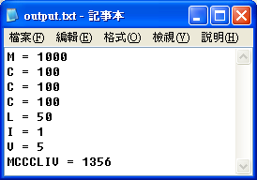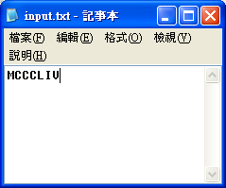

**程式碼：**

Imports System.IO

Public Class Form1

Dim fr As New FileInfo("input.txt")

Dim fw As New FileInfo("output.txt")

Dim sw As StreamWriter = fw.CreateText

Dim st1() As String = {"I", "V", "X", "L", "C", "D", "M"}

Dim st2() As Integer = {1, 5, 10, 50, 100, 500, 1000}

Dim ss As String

Dim aa As integer

Private Sub Form1_Load(ByVal sender As System.Object, ByVal e As System.EventArgs) Handles MyBase.Load

If fr.Exists = False Then

MsgBox("未找到input.txt檔，程式!即將結束執行。")

End

ElseIf fw.Exists = False Then

fw.Create()

End If

Dim sr As StreamReader = fr.OpenText

ss = sr.ReadLine

For i = 1 To Len(ss)

For j = 1 To 7

If Microsoft.VisualBasic.Mid(ss, i, 1) = st1(j - 1) Then

sw.WriteLine(st1(j - 1) & " = " & st2(j - 1))

aa += st2(j - 1)

End If

Next

Next

sw.Write(ss & " = " & aa)

sw.Flush() : sw.Close() : End

End Sub

End Class

**第六題**

**輸入範例：　　　　　　　　　　　　　　　　　　　輸出範例：**

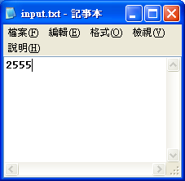 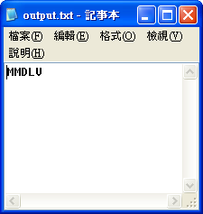

**程式碼：**

Imports System.IO

Public Class Form1

Dim fr As New FileInfo("input.txt")

Dim fw As New FileInfo("output.txt")

Dim sw As StreamWriter = fw.CreateText

Dim st1() As String = {"I", "V", "X", "L", "C", "D", "M"}

Dim st2() As Integer = {1, 5, 10, 50, 100, 500, 1000}

Dim ss, a As Integer

Private Sub Form1_Load(ByVal sender As System.Object, ByVal e As System.EventArgs) Handles MyBase.Load

If fr.Exists = False Then

MsgBox("未找到input.txt檔，程式!即將結束執行。")

End

ElseIf fw.Exists = False Then

fw.Create()

End If

Dim sr As StreamReader = fr.OpenText

ss = sr.ReadLine

For i = 6 To 0 Step -1

a = ss \ st2(i)

For j = 1 To a

sw.Write(st1(i))

Next

ss = ss - a * st2(i)

Next

sw.Flush() : sw.Close() : End

End Sub

End Class

**第七題**

**輸入範例：**

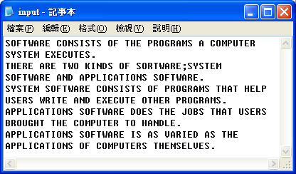

**輸出範例：**

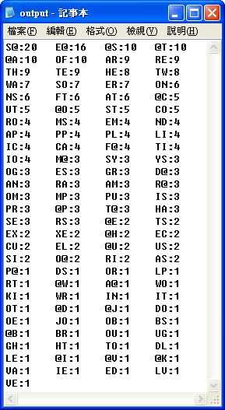

**程式碼：**

Imports System.IO

Public Class Form1

Dim fr As New FileInfo("input.txt")

Dim fw As New FileInfo("output.txt")

Dim sw As StreamWriter = fw.CreateText

Dim abc(0), ii, aa, bb As String

Dim a111(0), n, a As Integer

Private Sub Form1_Load(ByVal sender As System.Object, ByVal e As System.EventArgs) Handles MyBase.Load

If fr.Exists = False Then

MsgBox("未找到input.txt檔")

End

ElseIf fw.Exists = False Then

fw.Create()

End If

Dim sr As StreamReader = fr.OpenText

ii = Trim(sr.ReadLine)

Do

For i = 1 To Len(ii) - 1 '取頭尾

aa = "" : bb = ""

If i = 1 Then

aa = "@" & Microsoft.VisualBasic.Mid(ii, i, 1) & ":"

ElseIf i = Len(ii) - 1 Then

If Asc(Microsoft.VisualBasic.Mid(ii, i + 1, 1)) <= 90 And Asc(Microsoft.VisualBasic.Mid(ii, i + 1, 1)) >= 65 Then

bb = Microsoft.VisualBasic.Mid(ii, i + 1, 1) & "@" & ":"

Else : bb = Microsoft.VisualBasic.Mid(ii, i, 1) & "@" & ":"

End If

ElseIf Asc(Microsoft.VisualBasic.Mid(ii, i, 1)) > 90 Or Asc(Microsoft.VisualBasic.Mid(ii, i, 1)) < 65 Then

aa = "@" & Microsoft.VisualBasic.Mid(ii, i + 1, 1) & ":"

bb = Microsoft.VisualBasic.Mid(ii, i - 1, 1) & "@" & ":"

End If

For j = 0 To n

If aa = abc(j) And aa <> "" Then

a111(j) += 1 : Exit For

ElseIf j = n And aa <> "" Then

n += 1

ReDim Preserve abc(n), a111(n)

abc(n) = aa : a111(n) += 1

End If

Next

For j = 0 To n

If bb = abc(j) And bb <> "" Then

a111(j) += 1 : Exit For

ElseIf j = n And bb <> "" Then

n += 1

ReDim Preserve abc(n), a111(n)

abc(n) = bb : a111(n) += 1

End If

Next

Next

For i = 1 To Len(ii) - 1 '取任兩個

aa = "" : bb = ""

If (Asc(Microsoft.VisualBasic.Mid(ii, i, 1)) <= 90 And Asc(Microsoft.VisualBasic.Mid(ii, i, 1)) >= 65) _

And (Asc(Microsoft.VisualBasic.Mid(ii, i + 1, 1)) <= 90 And Asc(Microsoft.VisualBasic.Mid(ii, i + 1, 1)) >= 65) Then

aa = Microsoft.VisualBasic.Mid(ii, i, 2) & ":"

For j = 0 To n

If aa = abc(j) And aa <> "" Then

a111(j) += 1 : Exit For

ElseIf j = n And aa <> "" Then

n += 1

ReDim Preserve abc(n), a111(n)

abc(n) = aa : a111(n) += 1

End If

Next

End If

Next

ii = Trim(sr.ReadLine)

Loop Until ii = ""

For i = 0 To n

For j = 0 To n

If a111(i) > a111(j) Then

a = a111(i) : a111(i) = a111(j) : a111(j) = a

bb = abc(i) : abc(i) = abc(j) : abc(j) = bb

End If

Next

Next

For i = 1 To n

sw.Write(abc(i - 1) & a111(i - 1) & vbTab)

If i Mod 4 = 0 Then sw.Write(vbCrLf)

Next

sw.Flush() : sw.Close() : End

End Sub

End Class

**第八題**

**輸入範例：**

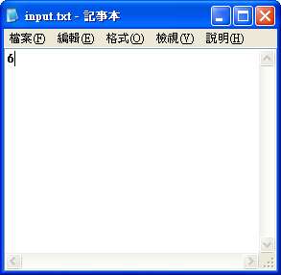

**輸出範例：**

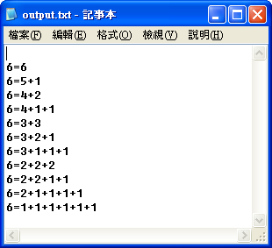

**程式碼：**

Imports System.IO

Public Class Form1

Dim fr As New FileInfo("input.txt")

Dim fw As New FileInfo("output.txt")

Dim sw As StreamWriter = fw.CreateText

Dim ii, n, zz(3), a, b As Integer

Dim aa As String

Private Sub Form1_Load(ByVal sender As System.Object, ByVal e As System.EventArgs) Handles MyBase.Load

If fr.Exists = False Then

MsgBox("未D?找±a到Liinput.txt檔E，A程g式!即±Y將ÓN結g2束±o執Xo行a。C")

End

ElseIf fw.Exists = False Then

fw.Create()

End If

Dim sr As StreamReader = fr.OpenText

ii = sr.ReadLine

Dim ee(ii * 4, ii - 1) As Integer

For i = 1 To ii

ee(a, i - 1) = 1

Next

zz(a) = ii

a += 1

For i = 2 To ii - 2

ee(a, b) = i

For j = 1 To ii - i

b += 1

ee(a, b) = 1

Next

ReDim Preserve zz(a)

zz(a) = b + 1

b = 0

Do

For j = 1 To zz(a) - 1

For l = zz(a) - 1 To 2 Step -1

If ee(a, l) < ee(a, 0) And ee(a, l) <> 0 Then

n = l : Exit For

End If

Next

If ee(a, n) + ee(a, j) <= ee(a, 0) And ee(a, j) <> 0 And j <> n Then

a += 1

For k = 0 To zz(a - 1)

If k <> n And k <> j Then

ee(a, k) = ee(a - 1, k)

ElseIf k = n Then

ee(a, k) = ee(a - 1, n) + ee(a - 1, j)

End If

Next

ReDim Preserve zz(a)

zz(a) = zz(a - 1)

End If

Next

For k = 1 To ii - 1 '判斷此算是裡面是否有1

If ee(a, k) = 1 Then '有的話則繼續該數運算

Exit For '沒有的話則跳至下一數

ElseIf k = ii - 1 And ee(a, k) <> 1 Then

Exit Do

End If

Next

Loop

a += 1

Next

ReDim Preserve zz(a + 1):zz(a) = 2

ee(a, 0) = ii - 1 : ee(a, 1) = 1

a += 1:ee(a, 0) = ii:zz(a) = 1

For i = 0 To a

For j = 0 To ii - 1

For k = 0 To ii - 1

If ee(i, j) > ee(i, k) Then

n = ee(i, j)

ee(i, j) = ee(i, k)

ee(i, k) = n

End If

Next

Next

Next

For i = a To 0 Step -1

sw.Write(vbCrLf & ii & "=")

For j = 0 To zz(i) - 1

If ee(i, j) <> 0 Then

If j <> 0 And ee(i, j) <> 0 Then

sw.Write("+")

End If

sw.Write(ee(i, j))

End If

Next

Next

sw.Flush() : sw.Close() : End

End Sub

End Class

**第十題**

**輸入範例：　　　　　　　　　　　　　　　　　　 　輸出範例：**

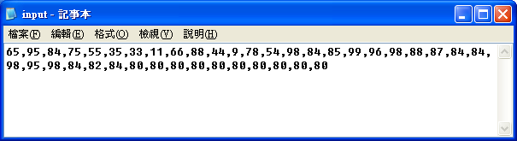 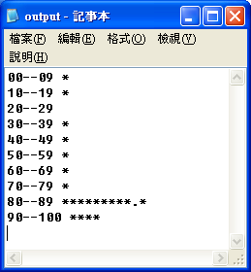

**程式碼：**

Imports System.IO

Public Class Form1

Dim fr As New FileInfo("input.txt")

Dim fw As New FileInfo("output.txt")

Dim sw As StreamWriter = fw.CreateText

Dim zz() As String = {"00--09 ", "10--19 ", "20--29 ", "30--39 ", "40--49 ", "50--59 ", "60--69 ", "70--79 ", "80--89 ", "90--100 "}

Dim ii, bb(9), a As String

Dim aa(9) As Integer

Private Sub Form1_Load(ByVal sender As System.Object, ByVal e As System.EventArgs) Handles MyBase.Load

If fr.Exists = False Then

MsgBox("未找到input.txt檔")

End

ElseIf fw.Exists = False Then

fw.Create()

End If

Dim sr As StreamReader = fr.OpenText

ii = Trim(sr.ReadLine)

Do

For i = 1 To Len(ii)

If Microsoft.VisualBasic.Mid(ii, i, 1) <> "," Then

a &= Microsoft.VisualBasic.Mid(ii, i, 1)

ElseIf Microsoft.VisualBasic.Mid(ii, i, 1) = "," Or i = Len(ii) Then

If a = "999" Then Exit Do

Select Case Val(a)

Case 0 To 9

aa(0) += 1

Case 10 To 19

aa(1) += 1

Case 20 To 29

aa(2) += 1

Case 30 To 39

aa(3) += 1

Case 40 To 49

aa(4) += 1

Case 50 To 59

aa(5) += 1

Case 60 To 69

aa(6) += 1

Case 70 To 79

aa(7) += 1

Case 80 To 89

aa(8) += 1

Case 90 To 100

aa(9) += 1

End Select

a = ""

End If

Next

ii = Trim(sr.ReadLine)

Loop Until ii = ""

For i = 0 To 9

If aa(i) Mod 2 = 1 Then aa(i) += 1

Next

For i = 0 To 9

For j = 1 To aa(i) / 2

If j Mod 10 = 0 Then zz(i) &= "."

zz(i) &= "*"

Next

Next

For i = 0 To 9

sw.WriteLine(zz(i))

Next

sw.Flush() : sw.Close() : End

End Sub

End Class

**第十一題**

**輸入範例： 　　　　 　　　　　　　 輸出範例：**

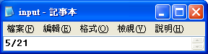 　　　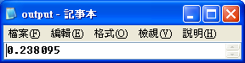

程式碼：

Imports System.IO

Public Class Form1

Dim fr As New FileInfo("input.txt")

Dim fw As New FileInfo("output.txt")

Dim sw As StreamWriter = fw.CreateText

Dim ix As Double

Dim n, ii(1), b As Integer

Dim a As String

Private Sub Form1_Load(ByVal sender As System.Object, ByVal e As System.EventArgs) Handles MyBase.Load

If fr.Exists = False Then

MsgBox("未找到input.txt檔")

End

ElseIf fw.Exists = False Then

fw.Create()

End If

Dim sr As StreamReader = fr.OpenText

a = sr.ReadLine

For i = 1 To Len(a) '帶入數

If Microsoft.VisualBasic.Mid(a, i, 1) <> "/" Then

ii(n) &= Microsoft.VisualBasic.Mid(a, i, 1)

Else : n += 1

End If

Next

ix = ii(0) / ii(1)

For i = 1 To Len(CStr(ix)) '找出她的小數有幾位

If Microsoft.VisualBasic.Mid(ix, i, 1) = "." Then

n = Len(CStr(ix)) - i : Exit For

End If

Next

For i = 3 To Len(CStr(ix))

If Microsoft.VisualBasic.Mid(ix, i, 1) = Microsoft.VisualBasic.Mid(ix, i + 1, 1) Then

b += 1

If b >= 6 Then

sw.Write(Microsoft.VisualBasic.Left(ix, 8))

GoTo 1

End If

End If

Next

If n > 6 Then

a = Microsoft.VisualBasic.Mid(ix, Len(CStr(ix)) - n + 1, 2)

For i = Len(CStr(ix)) - n + 3 To n

If Microsoft.VisualBasic.Mid(ix, i, 2) = a Then

sw.Write(Microsoft.VisualBasic.Left(ix, i - 1))

Exit For

End If

Next

ElseIf n <= 6 Then

sw.Write(ix)

End If

1: sw.Flush() : sw.Close() : End

End Sub

End Class