ENSF-381: Full Stack Web Development Laboratory
Lab04

GitHub Link:
https://github.com/407-Proxy/ENSF381

Group Information:
Mazin Mazin 30243457
Azlan Qamar 30241636

Exercise 1:


Exercise 2:

Screenshot from Step 9:
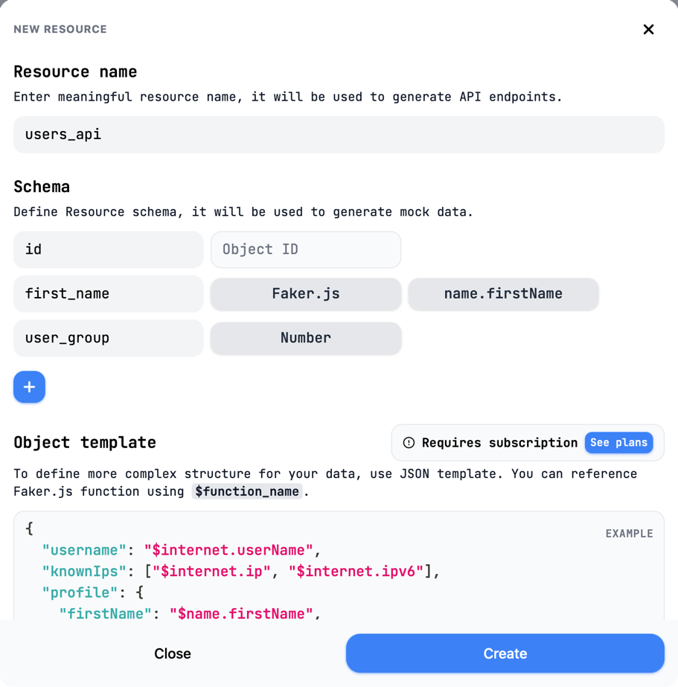

Screenshot from Step 12:
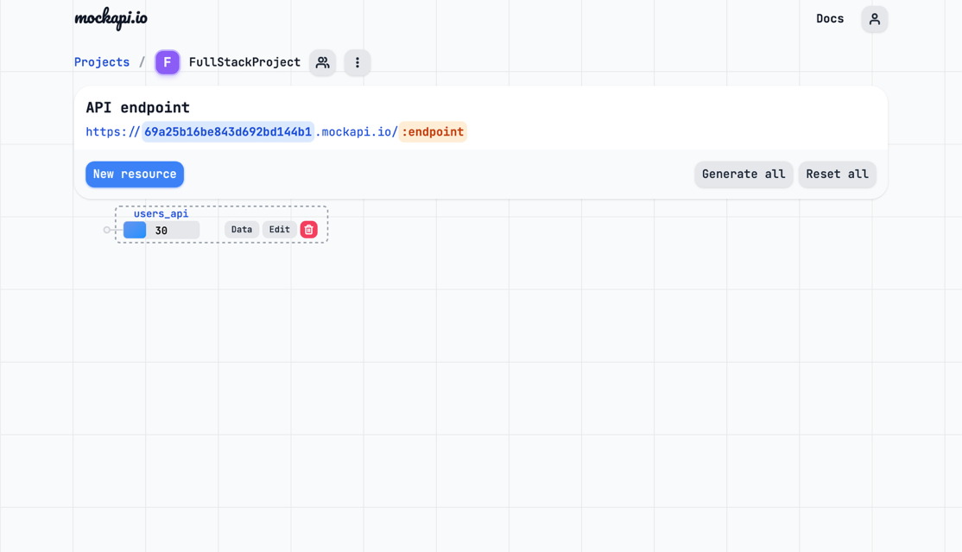

Screenshot from Step 14:
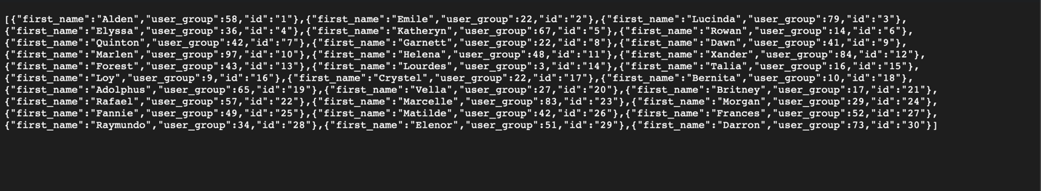

Exercise 3:

Screenshot A:
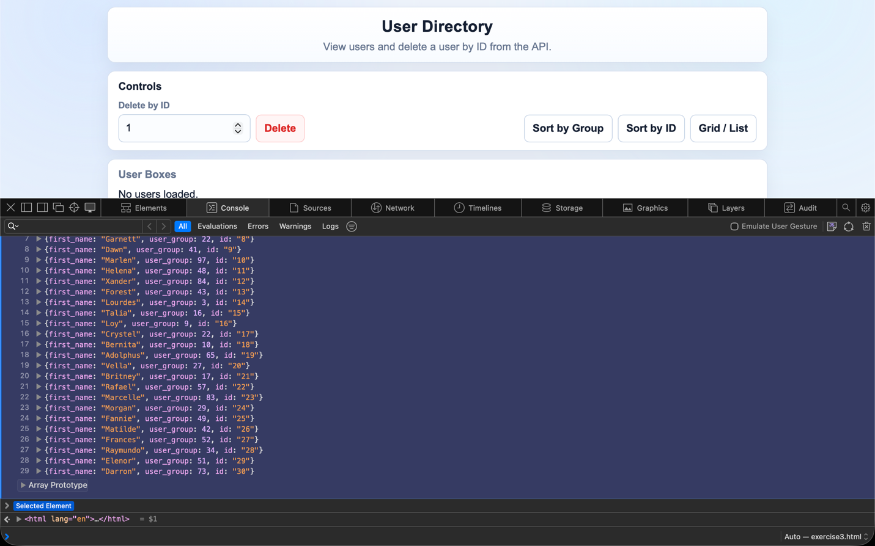
Screenshot B:
