ENSF-381: Full Stack Web Development Laboratory
Lab01

Section: L01

Github Repository: https://github.com/407-Proxy/ENSF381

407-Proxy is just an organization we made.

Group information:
Azlan Qamar 30241636
Mazin Mazin 30243457

Exercise 1:

- The HTML element used for “Faculties” is: h3

- Screenshot of the Faculties section highlighted in the Developer Tools:

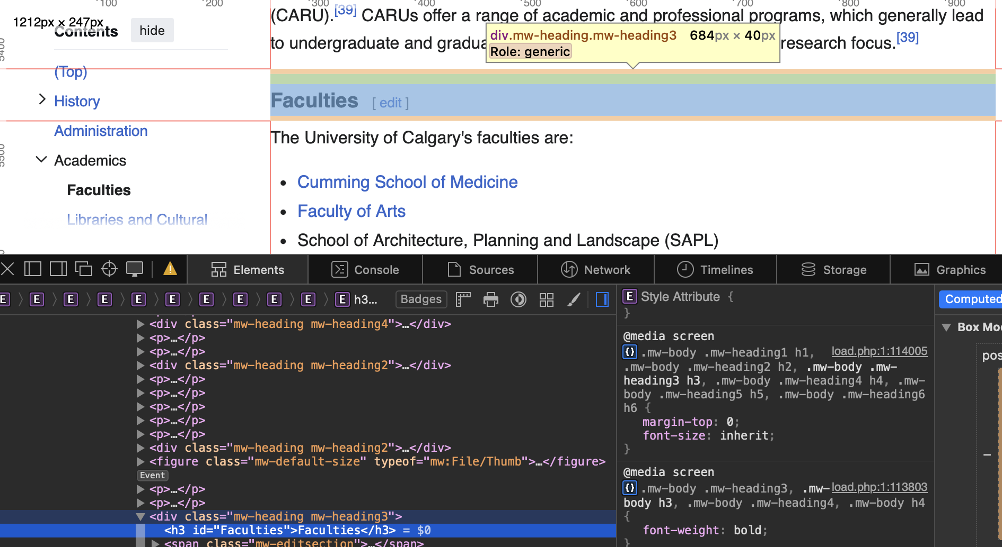

Exercise 2:
Output Screenshot:



Exercise 3
Your answer to Question 4.1:

When you set a table to a fixed width (e.g., 150px), the table always stays that exact size no matter the screen size. This can cause layout issues on smaller screens because the table won’t shrink, so it may overflow or require horizontal scrolling. It’s not very responsive.

When you set a table width to a percentage (e.g., 100%), the table scales relative to its container. This makes the layout more flexible since the table grows or shrinks with the screen size, which improves responsiveness and works better across different devices.

Output Screenshot:


