ENSF-381: Full Stack Web Development Laboratory
Lab04

GitHub Link: https://github.com/407-Proxy/ENSF381

Group information:
Azlan Qamar: 30241636
Mazin Mazin: 30243457

Exercise 1 Output:
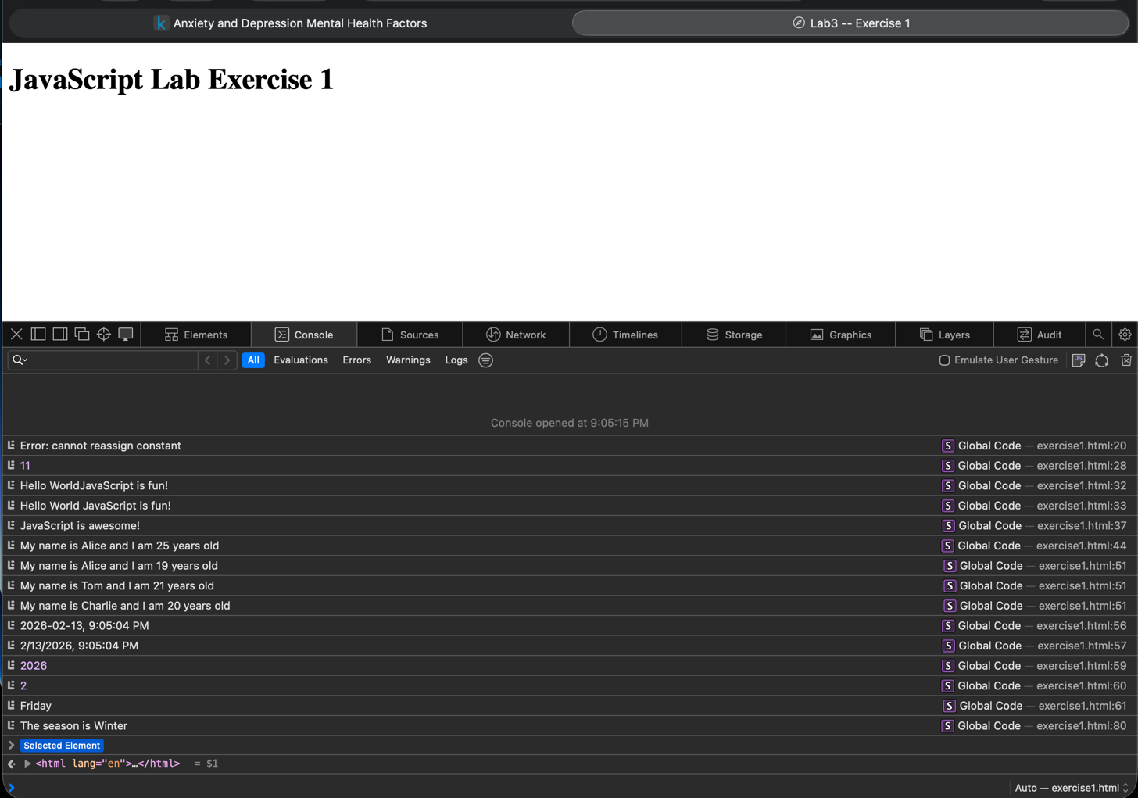

Exercise 2 Output:
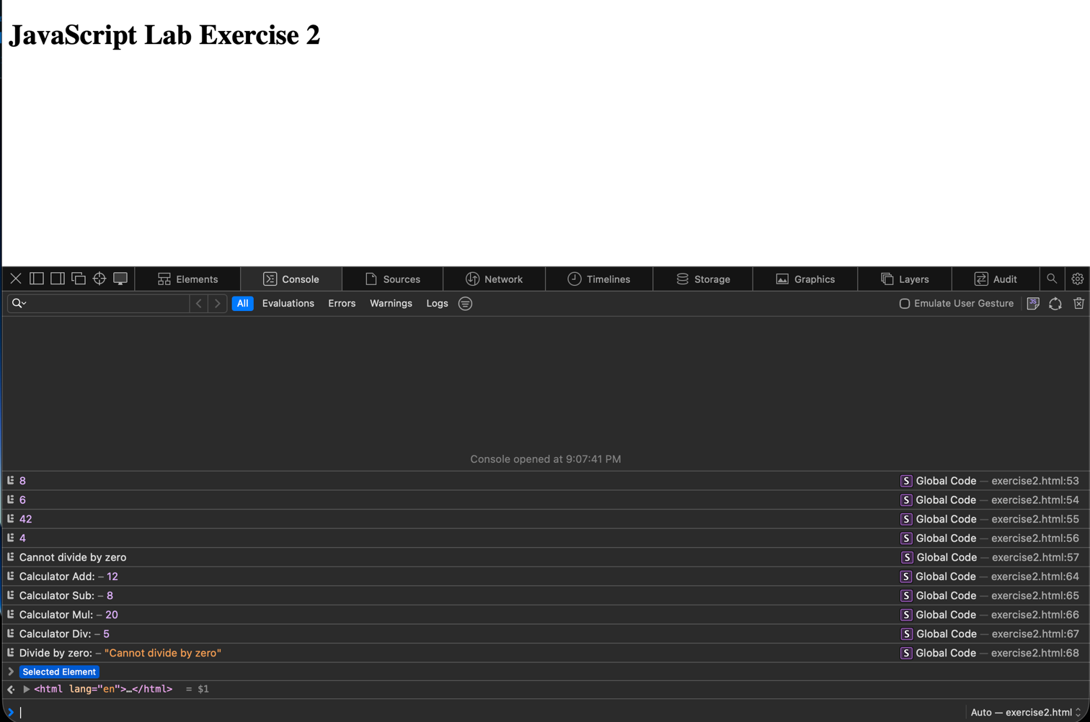

Exercise 3 Output:
