**1th Week Homework**

1.ping another computer

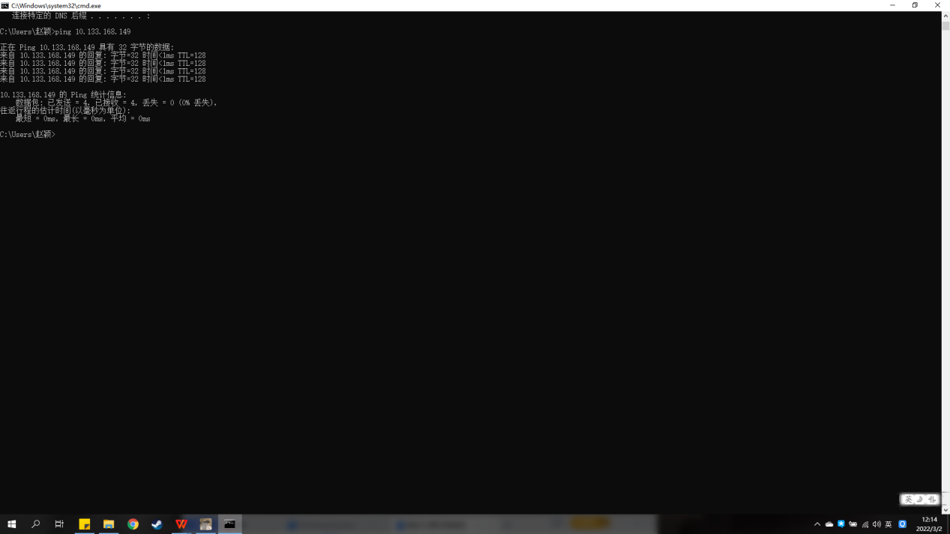2.Tracert another computer

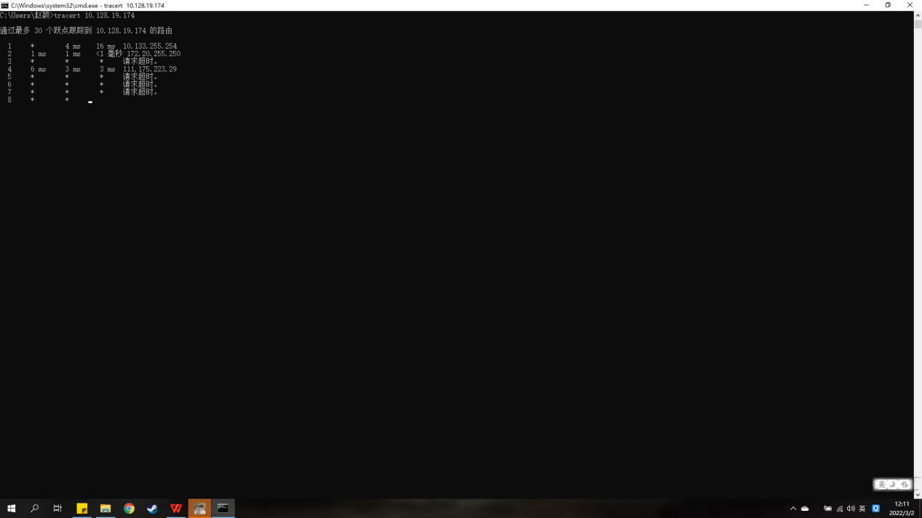

**2th week Homework**

Chapter 1 Problems

P5

A)

Time to push through the three tollbooths =12*10*3=360s=0.1h

Time to propagate=175km/100km*h-1=1.75h

T=1.85h;

B)

T=12*8*3sec+1.75h=1.84h;

P7

D=Dproc+Dqueue+Dtrans+Dprop

Assume Dqueue=0;

Dproc=56*8bit/64kbps=7msec

Dtrans=56*8bit/2*10Mbps=0.224msec

Dprop=10msec

So D=17.224msec

P26

S/R=20000km

R=s/20000km=2.5*108/(1*107)=12.5bps

**3th week Homework**

Telnet an address

Telnet mail.hust.edu.cn 25



P6

A)

In RFC2616,the specification says:Either the client or the server can indicate to the other of closing the persistent connection.

B)

HTTP doer not provide encryption service

C)

No,a single-user should not maintain more than 2 connections.

D)

Yes,the reason is:the request may be in progress but bot send to the other side,but meanwhile the side wants to close the connection.

P12

**Server code:**

from socket import *  
serverPort=12001  
serverSocket=socket(AF_INET,SOCK_STREAM)  
serverSocket.bind(('',serverPort))  
serverSocket.listen(1)  
while True:  
 connectionSocket,addr=serverSocket.accept()  
 sentence=connectionSocket.recv(1024).decode()  
 print(sentence)  
 connectionSocket.close()

**Client code:**

from socket import *  
serverName ='Server'  
serverPort=12001  
clientSocket=socket(AF_INET,SOCK_STREAM)  
clientSocket.connect((serverName,serverPort))  
  
sentence=("GET")  
clientSocket.send(sentence.encode())