**实验一**

1.

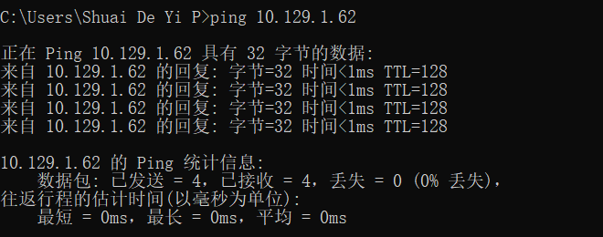

2.

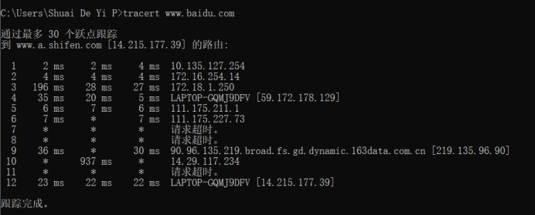

**实验二**

***What is the difference between a host and an end system? List several differ- ent types of end systems. Is a Web server an end system?***

A host and an end system are terms that are used interchangeably meaning thata host is an end system.

The types of application programs that run are web browser programs,web server programs,and e-mail readers and senders.So a web server is an system.

**实验三**

***The word protocol is often used to describe diplomatic relations. How does Wikipedia describe diplomatic protocol?***

Diplomatic protocol is commonly described as a set of international courtesy rules. These well-established and time-honored rules have made it easier for nations and people to live and work together. Part of protocol has always been the acknowledgment of the hierarchical standing of all present. Protocol rules are based on the principles of civility.

**实验四**

***Why are standards important for protocols?***

Only by establishing a set of standards can people create products that can be called and communicated with each other on the agreement.

**实验五**

***Obtain the HTTP/1.1 specification (RFC 2616). Answer the following questions:***

1. ***Explain the mechanism used for signaling between the client and server to indicate that a persistent connection is being closed. Can the client, the server, or both signal the close of a connection?***

If the connect header of the request does not contain the "close" tag, the HTTP / 1.1 server can assume that the HTTP / 1.1 client wants to maintain a long-term connection. If the server wants to close the connection immediately after sending the response, it should include a "close" in the sent connector field.

HTTP / 1.1 clients may want to keep the connection open, but this must be based on whether the server response contains the connection header field and whether the header field contains "close". If the client does not want to maintain the connection for more requests, it should send a header field with a value of "close".

If the client with the "close" request is the last one sent by the server.

So, the client and the server can signal the close of a connection.

1. ***What encryption services are provided by HTTP?***

HTTP dosen’t provide envryption services.It is HTTPS that provides SSL envryption services.

1. ***Can a client open three or more simultaneous connections with a given server?***

No,but a client can open more simultaneous connections with more than one server.

***4.Either a server or a client may close a transport connection between them if either one detects the connection has been idle for some time. Is it possible that one side starts closing a connection while the other side is transmitting data via this connection? Explain.***

It is impossible that one side starts closing a connection while the other side is transmitting data via this connection.Because after the connection is established, if you want to transmit data, the client will send a request to the server every time. After receiving the request, the server will give the corresponding response information. The client will receive the information returned by the server, and then the client will disconnect from the server. If the connection has been disconnected, the request cannot be sent.

**实验六**

***Problem :***

***Write a simple TCP program for a server that accepts lines of input from a cli ent and prints the lines onto the server’s standard output. (You can do this by modifying the TCPServer.py program in the text.) Compile and execute your program. On any other machine that contains a Web browser, set the proxy server in the browser to the host that is running your server program; also con- figure the port number appropriately. Your browser should now send its GET request messages to your server, and your server should display the messages on its standard output. Use this platform to determine whether your browser generates conditional GET messages for objects that are locally cached.***

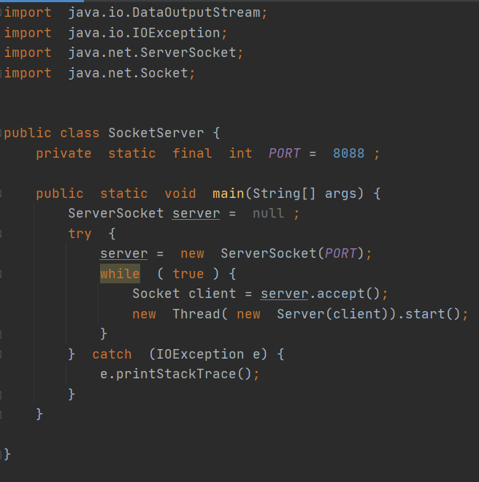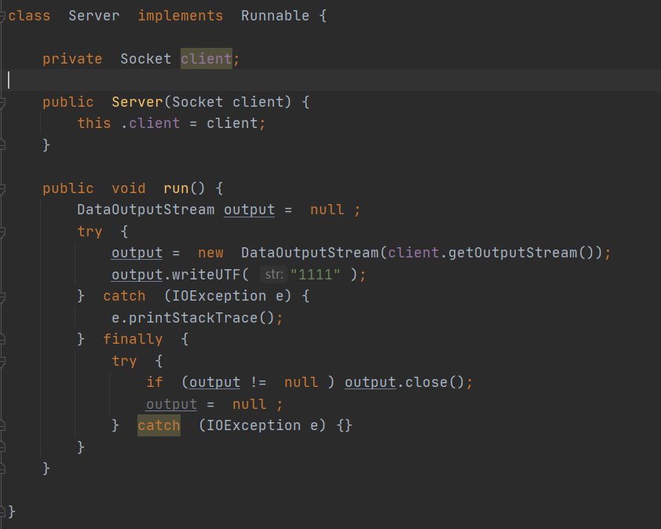

客户端

