2D rank finding problem

[intro]

$$Q:Given a sequence of points P=\left\{p_{1},p_{2},…,p_{n}\right\}$$

$$p_{i}=\left(x_{i},y_{i}\right) ∀i=1,2,…,n$$

$$Define p_{i} donimates p_{j}$$

$$iff p_{i}>p_{j}$$

$$,or equivalently x_{i}>x_{j} and y_{i}>y_{i}.$$

$$Find how many points are donimated by the point p_{i}?$$

[method]

$$\left[method 1\right]$$

$$Straightforward algorithm:$$

$$\left[time complexity\right]$$

$$O\left(n^{2}\right)$$

$$\left[method 2\right]$$

$$Divide-and-conquer algorithm$$

$$\left[time complexity\right]$$

$$O\left(n{\left(\lg{n}\right)}^{2}\right)$$

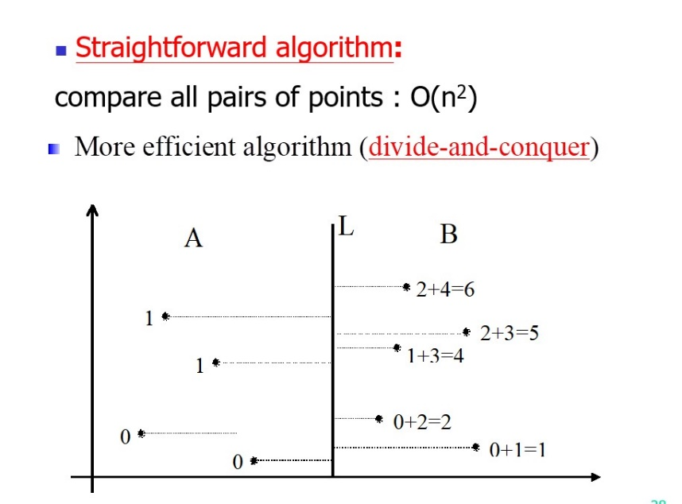

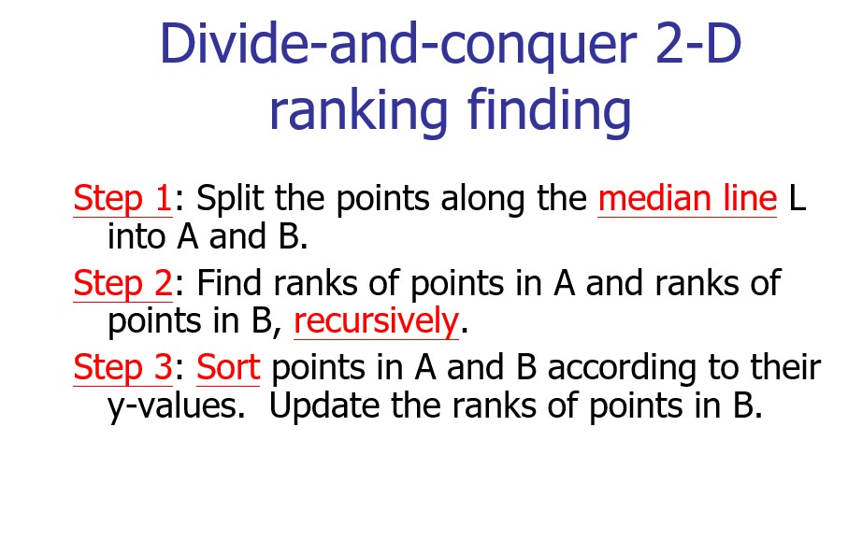

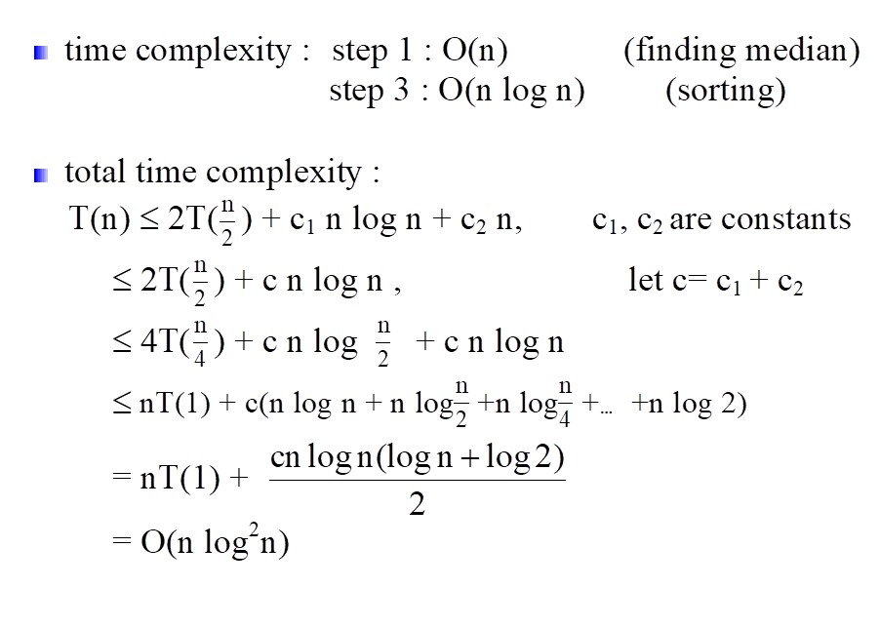

[ref]

See the ppt in algorithm CH5 for class

which talks about divide and conquer