Answer algorithm CH18

[CH18]

[CH18-1]

Ex18-1-1

Q: Why don’t we allow a minimum degree of t=1 in a B-tree?

A: If a minimum degree of t=1 occurs, some nodes will have no key and so the tree is NOT a B-tree.

Ex18-1-2

Q: t=? for this figure

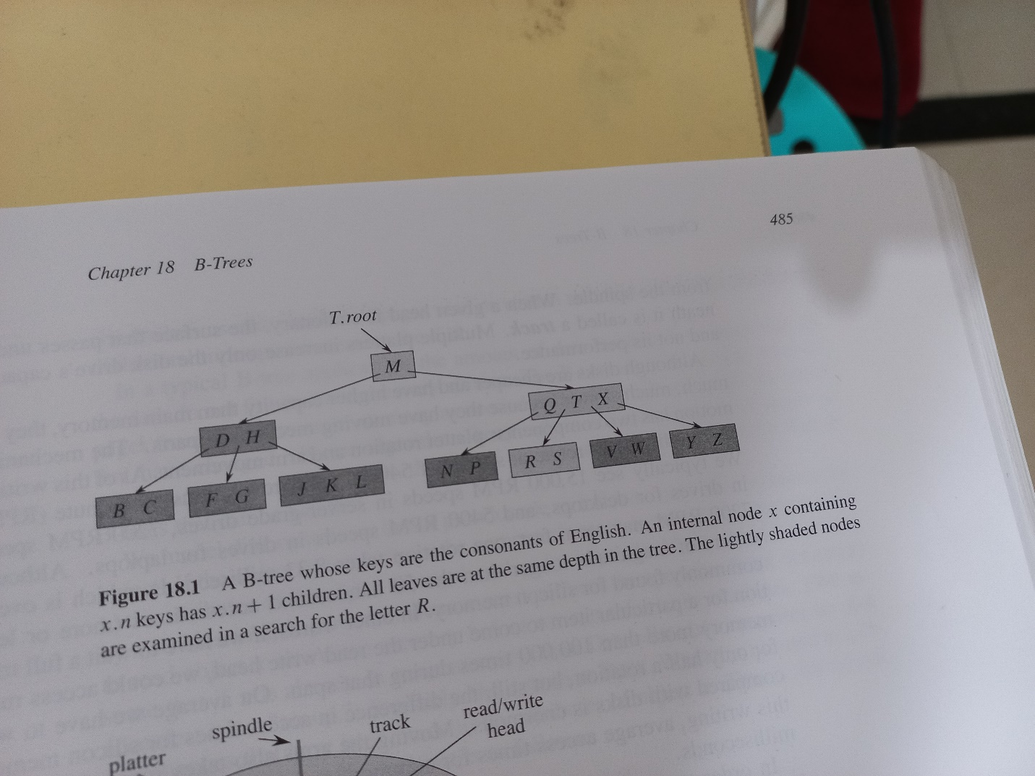

A:t=2

Ex18-1-3

Q: Show all legal B-trees of minimum degree t=2 that represents {1,2,3,4,5}

A:

Ex18-1-4

A: 2t-1

Ex18-1-5

A:

[CH18-2]