Answers of Exercises in Algorithm

[CH1]

[CH1-1]

Ex1-1-1

Ex1-1-2

Ex1-1-3

Ex1-1-4

Ex1-1-5

[CH1-2]

Ex1-2-1

1. Smallest step of Bubble sort. Use Heap sort

Ex1-2-2

Ex1-2-3

[Problem]

1-1

Issue:How to solve a equation by hand.

|  |  |  |  |  |  |  |
| --- | --- | --- | --- | --- | --- | --- |
|  |  | 1s | 1min | 1h | 1d | 1mo |
|  | |  |  |  |  |  |
|  | |  |  |  |  |  |
|  | |  |  |  |  |  |
|  | |  |  |  |  |  |
|  | |  |  |  |  |  |
|  | |  |  |  |  |  |
|  | |  |  |  |  |  |
|  | |  |  |  |  |  |

|  |  |  |  |
| --- | --- | --- | --- |
|  |  | 1y | 1century |
|  | |  |  |
|  | |  |  |
|  | |  |  |
|  | |  |  |
|  | |  |  |
|  | |  |  |
|  | |  |  |
|  | |  |  |

[CH2]

[CH2-2]

Ex2-2-1

Ex2-2-2

It needs to run first n-1 elements instead of all n elements because the last element does NOT have to compare with others.

Best case:

Worst case :

Ex2-2-3

Best case:

Worst case

Average case:

Ex2-2-4

I am not sure to answer.

[CH2-3]

Ex2-3-1

Skip

Ex2-3-2

I don’t understand what is the meaning of the word sentinel.

Sentinel

Ex2-3-3

Ex2-3-4

The worst case occurs at comparing all previous elements for each elements.

Ex2-3-5

Ex2-3-6

Ex2-3-7

[problem]

2-1

1. In each loop, the comparisons are
2. A

2-2

2-3

(a)

(b)

Naïve polynomial evaluation

Pseudo code:

total=0;

for i=n down to 0

p=1

//x^p

for j=0 to i

p=p*x

total=total+p

worst case:

Time complexity: Horner’s rule<naïve

(c)

(d) I don’t understand the meaning.

[CH3]

[CH3-1]

Ex3-1-1

Ex3-1-2

Ex3-1-3

Ex3-1-4

Ex3-1-5

Ex3-1-6

Ex3-1-7

Ex3-1-8

[CH3-2]

Ex3-2-1

(a)Since f(n), g(n) are monotonically increasing functions,

for all m>n and for all m>n.

for all m>n

Hence, is a monotonically increasing function.

(b)Since f(n), g(n) are monotonically increasing functions,

for all m>n and for all m>n.

for all m>n.

Hence, is a monotonically increasing function.

(c) Since f(n), g(n) are monotonically increasing functions,

for all m>n and for all m>n.

And since for all n,

Then we conclude that for all m>n.

By the conclusion we know that,

Then we combines four inequalities.

for all m>n.

We get

for all m>n.

is a monotonically increasing function.

Ex3-2-2

Proof of equation (3.16) are proved at other doc.

Ex3-2-3

Ex3-2-4

Ex3-2-5

Ex3-2-6

Show that golden ratio and its conjugate are the roots of the equation

The roots of

are

Ex3-2-7

Proof of are proved in wiki.

[Fibonacci number - Wikipedia](https://en.wikipedia.org/wiki/Fibonacci_number)

Ex3-2-8

Show that implies

By definition,

To show the equality.

Tip: Try using newton’s method.

[Problem]

3-1

(a)Since

Therefore,

Similarly,

(b)similar to above.

(c)Combine these two inequalities (a),(b).

(d) similar to above.

(e) similar to above.

3-2

3-3

No answer

3-4

(a)No

It is impossible that

for all g(n) and f(n) unless .

(b)No

It is impossible that

for all g(n) and f(n) unless .

(c)No

(d)

(e)No

For ,we can not prove that

(f)Yes

Is this true?

(g)Yes

For all , we can know that

(h)No

3-5

3-6

[CH4]

[CH4-1]

[CH4-3]

Ex4-3-1

Q:Show

We can use recursion tree or expand the recurrence to solve it.

Ex4-3-2

Q:Show

We can use recursion tree or expand the recurrence to solve it.

Ex4-3-3

Ex4-3-6

Ex4-3-7

Ex4-3-8

Ex4-3-9

[CH4-4]

Ex4-4-1

Ex4-4-2

Ex4-4-4

Ex4-4-5

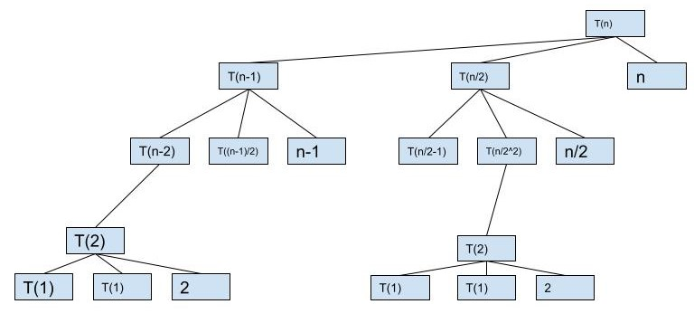

[Introduction to Algorithms Exercises (efanzh.org)](https://efanzh.org/2018/10/05/introduction-to-algorithms-exercises.html#the-substitution-method-for-solving-recurrences)

Ex4-4-6

Ex4-4-7

Ex4-4-8

Ex4-4-9

[sectbyfn (mit.edu)](http://mitp-content-server.mit.edu:18180/books/content/sectbyfn?collid=books_pres_0&id=8030&fn=Intro_to_Algo_Selected_Solutions.pdf)

[CH4-5]

Ex4-5-1

Ex4-5-2

Ex4-5-3

Ex4-5-4

[Introduction to Algorithms Exercises (efanzh.org)](https://efanzh.org/2018/10/05/introduction-to-algorithms-exercises.html#the-substitution-method-for-solving-recurrences)

Ex4-5-5

[CH4-6]

Ex4-6-1

Ex4-6-2

Ex4-6-3

[Problem]

4-1

(a)

(b)

(c)

(d)

(e)

(f)

(g)

And

4-2

(a)

(b)

4-3

4-2

4-3

4-4

4-5

4-6

[CH5]

[CH5-1]

[CH5-2]

Ex5-2-3

Ex5-2-4

|  |  |  |  |
| --- | --- | --- | --- |
|  |  |  |  |
|  |  |  |  |
|  |  |  |
| … | … | … |
|  |  |  |
|  | | | |

Ex5-2-5

[CH5-3]

Ex5-3-3

Ex5-3-4

[CH5-4]

Ex5-4-1

Ex5-4-2

Ex5-4-4

Ex5-4-5

Ex5-4-6

[Problem]

5-1

[CH6]

[CH6-1]

Ex6-1-1

I am not sure.

1. h:height. inf
2. inf

Ex6-1-2

Ex6-1-3

Ex6-1-4

Ex6-1-5

Ex6-1-6

Ex6-1-7

[CH6-2]

Ex6-2-1

Ex6-2-2

Ex6-2-3

Ex6-2-4

Ex6-2-5

[CH6-3]

Ex6-3-1

Ex6-3-2

Ex6-3-3

Ex6-4-1

Ex6-4-2

Ex6-4-3

Ex6-4-4

Ex6-4-5

[CH6-5]

Ex6-5-1

Ex6-5-2

Ex6-5-3

Ex6-5-4

[Problem]

6-1

1. Yes

6-2

(a)d-ary tree with an array

(b)d-ary heap tree with n elements, represent height h in terms of n and d.

(c)

Max-Heapify(A,i)

{

parent=i;

lb=d*i-(d-2);

rb=d*i+1;

largest=parent;

for (j=lb;j<=rb;j++)

{

curr=A[j];

if(curr>=A.heap_size)

{return;}

if(largest>curr)

{largest=curr;}

}

if(largest!=parent)

{

exchange A[parent] with A[largest];

Max-heapify(A,largest);

}

return;

}

Heap_Extract_Max(A)

{

if (A.heap_size<1)

{error}

M=A[1];

A[1]=A[A.heap_size]

A.heap_size=A.heap_size-1;

Max_heapify(A,1);

return max;

}

Time complexity:

(d)

Max_Heap_insert(A,key)

{

A.heap_size=A.heap_size-1;

A[A.heap_size]=-∞;

Heap_Increase_key(A,A.heap_size,key);

}

Heap_increase_key(A,i,key)

{

if(key<A[i])

{error}

A[i]=key;

while (i>1 and A[parent(i)]<A[i])

{

exchange A[i] with A[parent(i)];

i=parent(i);

}

}

Time complexity:

6-3

[CH7]

[CH7-1]

Ex7-1-3

[CH8]

[CH8-1]

Ex8-1-1

Ex8-1-2

Ex8-1-3

Q:

1. Show that there is no comparison sort whose running time is linear for at least half n! inputs of length n.
2. What about the fraction of of the inputs of length n?
3. What about the fraction ?

A:

Take a quick review at comparison sort.

Comparison sort is a method which sort elements by comparison of any two elements. Insertion sort and quick sort are kind of comparison sort.

Let’s start with (a).

You can visit the website as below for more details about answer and comparison sort.

[Comparison sort - Wikipedia](https://en.wikipedia.org/wiki/Comparison_sort)

Since each comparison of two element only has 2 outcomes (> or <), the outcomes would not be more than if we suppose the algorithm always completes after steps.

Thus,

And

Combine these two inequalities, we can get

Therefore,

Since , which no comparison sort whose running time is linear (it can be expressed as y=mx+b)

Hence, (a) is proved.

(b)

I am not sure that meaning of the question. Is the meaning of the question? I suppose the meaning is that.

And

We can get which can not be linear.

(c)

I am not sure that meaning of the question. Is the meaning of the question? I suppose the meaning is that.

By the inequality we mentioned above, we can get

It is can not be linear.

Ex8-1-4

The website as below may give you idea. (the hyperlink is same as the previous one in previous exercise.)

[Comparison sort - Wikipedia](https://en.wikipedia.org/wiki/Comparison_sort)

Merge sort must spend at least for n inputs.

[CH8-2]

Ex8-2-1

Ex8-2-2

[CH8-3]

Ex8-3-3

[CH9]

[CH9-1]

[CH9-2]

[CH9-3]

Ex9-3-7

[algorithms - Find k closest numbers to the median - Computer Science Stack Exchange](https://cs.stackexchange.com/questions/145854/find-k-closest-numbers-to-the-median)

[K'th Smallest/Largest Element in Unsorted Array | Set 3 (Worst Case Linear Time) - GeeksforGeeks](https://www.geeksforgeeks.org/kth-smallestlargest-element-unsorted-array-set-3-worst-case-linear-time/)

[QuickSelect Algorithm - Bing video](https://www.bing.com/videos/search?q=quickselect+algorithm&&view=detail&mid=58251520BEDC8962D10358251520BEDC8962D103&&FORM=VRDGAR&ru=%2Fvideos%2Fsearch%3Fq%3Dquickselect%2Balgorithm%26FORM%3DHDRSC3)

Ex9-3-8

[Median of two sorted arrays of same size - GeeksforGeeks](https://www.geeksforgeeks.org/median-of-two-sorted-arrays/#:~:text=6%29%20If%20size%20of%20the%20two%20arrays%20is,ar2%20%5B0%5D%29%20%2B%20min%20%28ar1%20%5B1%5D%2C%20ar2%20%5B1%5D%29%29%2F2.)

[Problem]

9-1

(a)

(b)

(c)

9-2

[CH10]

[CH10-1]

Ex10-1-1

Initially,

S.top=0

|  |  |  |  |  |  |  |
| --- | --- | --- | --- | --- | --- | --- |
|  | 1 | 2 | 3 | 4 | 5 | 6 |
| S |  |  |  |  |  |  |

Push (S,4)

S.top=1

|  |  |  |  |  |  |  |
| --- | --- | --- | --- | --- | --- | --- |
|  | 1 | 2 | 3 | 4 | 5 | 6 |
| S | 4 |  |  |  |  |  |

Push(S,1)

S.top=2

|  |  |  |  |  |  |  |
| --- | --- | --- | --- | --- | --- | --- |
|  | 1 | 2 | 3 | 4 | 5 | 6 |
| S | 4 | 1 |  |  |  |  |

Push(S,3)

S.top=3

|  |  |  |  |  |  |  |
| --- | --- | --- | --- | --- | --- | --- |
|  | 1 | 2 | 3 | 4 | 5 | 6 |
| S | 4 | 1 | 3 |  |  |  |

Pop(S)

S.top=2

|  |  |  |  |  |  |  |
| --- | --- | --- | --- | --- | --- | --- |
|  | 1 | 2 | 3 | 4 | 5 | 6 |
| S | 4 | 1 |  |  |  |  |

Push(S,8)

S.top=3

|  |  |  |  |  |  |  |
| --- | --- | --- | --- | --- | --- | --- |
|  | 1 | 2 | 3 | 4 | 5 | 6 |
| S | 4 | 1 | 8 |  |  |  |

Pop(S)

S.top=2

|  |  |  |  |  |  |  |
| --- | --- | --- | --- | --- | --- | --- |
|  | 1 | 2 | 3 | 4 | 5 | 6 |
| S | 4 | 1 |  |  |  |  |

Ex10-1-2

Ex10-1-3

Initially,

Q.head=1

Q.tail=1

|  |  |  |  |  |  |  |
| --- | --- | --- | --- | --- | --- | --- |
|  | 1 | 2 | 3 | 4 | 5 | 6 |
| Q |  |  |  |  |  |  |

Enqueue(Q,4)

Q.head=1

Q.tail=2

|  |  |  |  |  |  |  |
| --- | --- | --- | --- | --- | --- | --- |
|  | 1 | 2 | 3 | 4 | 5 | 6 |
| Q | 4 |  |  |  |  |  |

Enqueue(Q,2)

Q.head=1

Q.tail=3

|  |  |  |  |  |  |  |
| --- | --- | --- | --- | --- | --- | --- |
|  | 1 | 2 | 3 | 4 | 5 | 6 |
| Q | 4 | 1 |  |  |  |  |

Enqueue(Q,3)

Q.head=1

Q.tail=4

|  |  |  |  |  |  |  |
| --- | --- | --- | --- | --- | --- | --- |
|  | 1 | 2 | 3 | 4 | 5 | 6 |
| Q | 4 | 1 | 3 |  |  |  |

Dequeue(Q)

Q.head=2

Q.tail=4

|  |  |  |  |  |  |  |
| --- | --- | --- | --- | --- | --- | --- |
|  | 1 | 2 | 3 | 4 | 5 | 6 |
| Q | 4 | 1 | 3 |  |  |  |

Enqueue(Q,8)

Q.head=2

Q.tail=5

|  |  |  |  |  |  |  |
| --- | --- | --- | --- | --- | --- | --- |
|  | 1 | 2 | 3 | 4 | 5 | 6 |
| Q | 4 | 1 | 3 | 8 |  |  |

Dequeue(Q)

Q.head=3

Q.tail=5

|  |  |  |  |  |  |  |
| --- | --- | --- | --- | --- | --- | --- |
|  | 1 | 2 | 3 | 4 | 5 | 6 |
| Q | 4 | 1 | 3 | 8 |  |  |

Ex10-1-4

Detect underflow and overflow of a queue.

(a)Detect underflow

Dequeue(Q,x)

{

if(Q.head==Q.length)

{

Throw ;

Return;

}

x=Q[Q.head];

Q.head=Q.head+1;

Return x;

}

(b)Detect overflow

Enqueue(Q,x)

{

if(Q.tail==Q.length)

{

Throw ;

Return;

}

Q[Q.tail]=x;

Q.tail= Q.tail+1;

}

Ex10-1-5

Ex10-1-6

We can combine them together. As follows.

|  |  |  |  |  |  |
| --- | --- | --- | --- | --- | --- |
|  | 1 | 2 |  | 1 | 2 |
| A | X | x2 | B | y | y2 |
|  | A.top |  |  | B.top |  |

|  |  |  |  |  |  |
| --- | --- | --- | --- | --- | --- |
|  | 1 | 2 | 3 | 4 |  |
| C | x2 | X | y | y2 |  |
|  | C.head |  |  | C.tail |  |

Initially, it should be.

Init(C,A,B)

{

C.length=A.length+B.length;

C.head=A.length;

C.tail=C.head;

}

Enqueue to C at end when insert an element in stack B.

EnqueueB(C,elem)

{

if(C.tail==C.length)

{

Throw;

Return;

}

C[C.tail]=elem;

C.tail=C.tail+1;

Return;

}

Enqueue to C at front when insert an element in stack A.

EnqueueA(C,elem)

{

if(C.head=1)

{

Throw;

Return;

}

C[C.head]=elem;

C.head=C.head-1;

Return;

}

Dequeue at end when pop an element in stack B.

DequeueB(C)

{

if(C.tail==C.head)

{

Throw;

Return;

}

X=C[C.tail];

C.tail=C.tail-1;

Return X;

}

Dequeue at front when pop an element in stack A.

DequeueA(C)

{

if(C.tail==C.head)

{

Throw;

Return;

}

X=C[C.head];

C.head=C.head-1;

Return X;

}

[CH10-2]

[CH10-3]

Ex10-3-4

[Problem 10]

10-1

|  |  |  |  |  |
| --- | --- | --- | --- | --- |
|  |  |  |  |  |
|  |  |  |  |  |
|  |  |  |  |  |
|  |  |  |  |  |
|  |  |  |  |  |
|  |  |  |  |  |
|  |  |  |  |  |
|  |  |  |  |  |

10-2

[CH11]

[CH11-1]

Ex11-1-1

Ex11-1-2

Ex11-1-3

Ex11-1-4

[CH11-2]

Ex11-2-1

Ex11-2-2

After insert key 5,28,19,15,20,33,12,17,10

|  |  |  |  |  |  |  |  |  |  |
| --- | --- | --- | --- | --- | --- | --- | --- | --- | --- |
| Index | 1 | 2 | 3 | 4 | 5 | 6 | 7 | 8 | 0 |
| Key | 28  ->19  ->10 | 20 | 12 | NIL | 5 | 15  ->33 | NIL | 17 | NIL |

Ex11-2-3

Ex11-2-4

Ex11-2-5

keys: n

hash table size: m

universe of keys : |U|

Show that if the worst-case searching time is

In hash by chaining (for solving collision), The hash table is an array with linked list.

The best situation occurs when it hashes perfect. Each linked list has nearly same linked node.

Since the hash table has m slots(from question), each linked list must have at least n linked nodes, even though in the best situation.

In linked list, we have to search one by one, so it takes Θ(n) time.

We can know that it takes Θ(n) time for searching of hashing with chaining.

[CH11-3]

Ex11-3-1

Compare each linked node in linked list with strcmp, which behaves similar to comparing 1st char of the two strings then go through next if nth chars of two strings are same.

Ex11-3-2

For a string

We can represent a matrix as a digit using unicode conversion ,then combing the matrix into a big number as follows.

which

Ex11-3-3

Hash function:

Then we know that

Hence, any string meet the above condition will hash to the same value.

Ex11-3-4

Given

Compute the key for 61,62,63,64,65

(1)When k=61,

(2)When k=62,

(3)When k=63,

(4)When k=64,

(5)When k=65,

Ex11-3-5

[CH11-4]

Ex11-4-1

Insert the keys 10,22,31,4,15,28,17,88,59

1. linear probing.
2. quadratic probing.
3. double hashing.
4. linear probing.

|  |  |  |  |  |  |  |  |  |  |
| --- | --- | --- | --- | --- | --- | --- | --- | --- | --- |
| key | 10 | 22 | 31 | 4 | 15 | 28 | 17 | 88 | 59 |
| value | 0 | 2 | 1 | 8 | 9 | 1 | 3 | 8 | 2 |

1. quadratic probing.

|  |  |  |  |  |  |  |  |  |  |
| --- | --- | --- | --- | --- | --- | --- | --- | --- | --- |
| key | 10 | 22 | 31 | 4 | 15 | 28 | 17 | 88 | 59 |
| value | 3 | 3 | 6 | 1 | 7 | 10 | 6 | 2 | 3 |

1. double hashing.

|  |  |  |  |  |  |  |  |  |  |
| --- | --- | --- | --- | --- | --- | --- | --- | --- | --- |
| key | 10 | 22 | 31 | 4 | 15 | 28 | 17 | 88 | 59 |
| value | 0 | 6 | 4 | 2 | 1 | 5 | 7 | 6 | 6 |

Ex11-4-2

Ex11-4-3

1. case 1: an unsuccessful search.
2. case 2: a successful search

|  |  |  |
| --- | --- | --- |
|  | Successful | Unsuccessful |
| ¾ |  | 4 |
| 7/8 |  | 8 |

Ex11-4-4

Ex11-4-5

[Problem]

11-1

11-2

[CH12]

[CH12-1]

Ex12-1-1

For the set of {1,4,5,10,16,17,21}

Draw binary search tree of height 2,3,4,5,6.

[depth]

[pf]

Since it is a kind of binary tree, it must have at most 2 childs.

The largest number of n which indicates the number of node of the tree must satisfy the condition in depth d.

1. height 2

impossible since there are 7 nodes.

1. height 3

10

17

4

21

16

1

5

1. height 4

4

1

10

17

5

21

16

1. height 5

4

1

10

5

16

21

17

1. height 6

4

21

17

16

10

5

1

Ex12-1-2

|  |  |  |
| --- | --- | --- |
|  | Binary search tree | Min-heap tree |
| Same | L is the left child of P and R is the right child of P. | |
| difference | May NOT be a complete binary tree. | Must be a complete binary tree. |
| Time complexity | and |  |

[ref]

[Difference between Binary Search Tree and Binary Heap - GeeksforGeeks](https://www.geeksforgeeks.org/difference-between-binary-search-tree-and-binary-heap/#:~:text=The%20Min-Heap%2C%20on%20the%20other%20hand%2C%20is%20the,The%20BST%20is%20ordered%2C%20while%20Heap%20is%20not.)

Ex12-1-3

With array representation, see BST_array.txt text file.

Ex12-1-4

See the “Binary_search_tree” document file (my note).

Ex12-1-5

1. Yes
2. Yes

[CH12-2]

Ex12-2-1

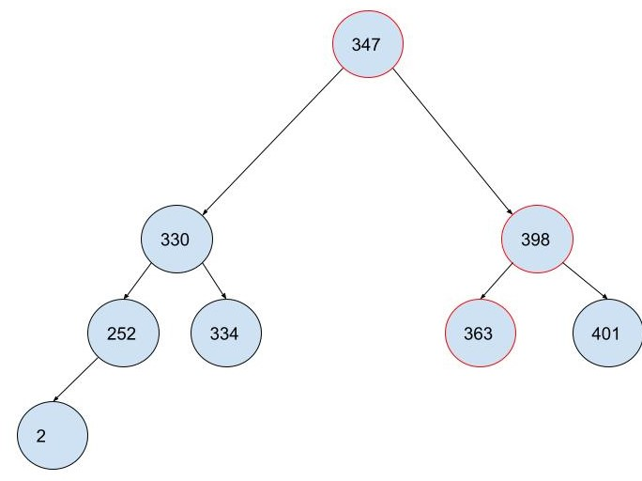

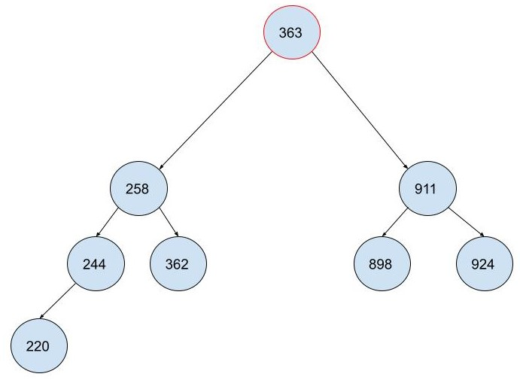

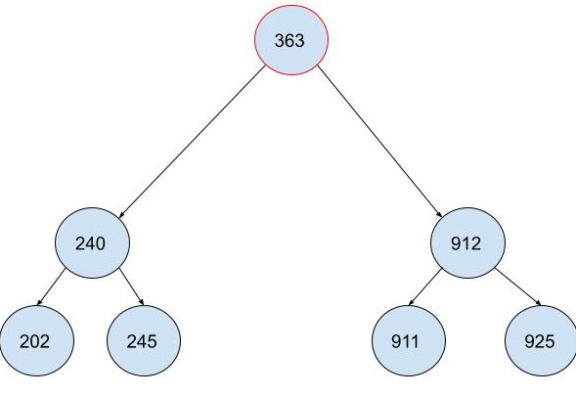

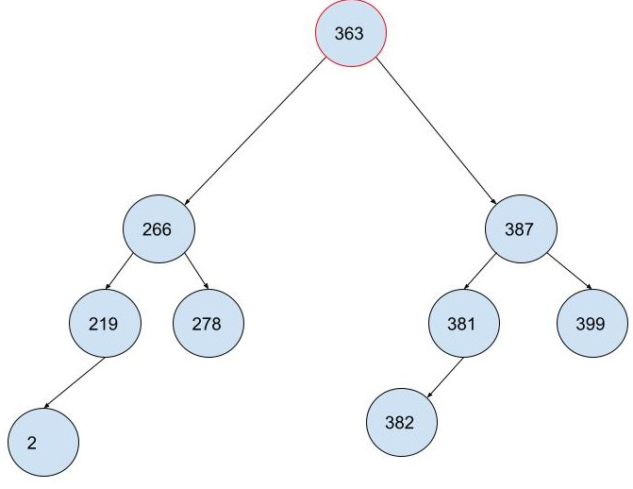

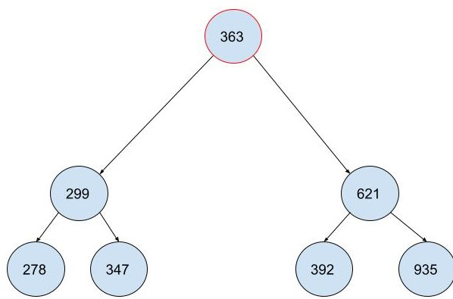

Ex12-2-4

Ex12-2-5

[CH12-3]

Ex12-3-4

Ex12-3-5

[CH12-4]

Ex12-4-1

Ex12-4-2

Ex12-4-3

Ex12-4-4

Hence

[Problem]

12-1

12-2

12-3

(a.1)Yes

(a.2)Q: Show that expected value of P(T) is O(n lg n).

(b)No

(c)

(d)

(e)

(f)

12-4

Let be number of different binary tree with n nodes.

1. Q: Show that

A:

(1)When n=0 which means empty tree,

(2)When n=1 which means tree with root node, .

It satisfy the condition.

(3)For , suppose that

We can know that

And the solution can be

|  |  |  |  |
| --- | --- | --- | --- |
| L |  | R |  |
| 0 |  | n-1 |  |
| 1 |  | n-2 |  |
| … |  | … |  |
| n-1 |  | 0 |  |

We add all possible solution and get

1. Since ,
2. Show that

By (a), we know that

Let’s Started with

(d)

[CH13]

[CH13-1]

Ex13-1-1

Skip since it asks us to draw tree.

Ex13-1-2

Skip same above.

Ex13-1-3

Ex13-1-4

[sectbyfn (mit.edu)](http://mitp-content-server.mit.edu:18180/books/content/sectbyfn?collid=books_pres_0&id=8030&fn=Intro_to_Algo_Selected_Solutions.pdf)

Ex13-1-5

[sectbyfn (mit.edu)](http://mitp-content-server.mit.edu:18180/books/content/sectbyfn?collid=books_pres_0&id=8030&fn=Intro_to_Algo_Selected_Solutions.pdf)

Ex13-1-6

Ex13-1-7

[CH13-2]

Ex13-2-1

Skip

Ex13-2-2

Ex13-2-3

|  |  |
| --- | --- |
|  |  |
|  |  |
|  |  |
|  |  |

|  |  |
| --- | --- |
|  |  |
|  |  |
|  |  |
|  |  |

Ex13-2-4

Ex13-2-5

[CH13-3]

Ex13-3-1

Ex13-3-2

[CH13-4]

Ex13-4-1

Ex13-4-2

Ex13-4-3

Ex13-4-4

Ex13-4-5

Ex13-4-6

Ex13-4-7

[Problem]

13-3

[CH14]

[CH14-1]

Ex14-1-1

Ex14-

[CH15]

[CH15-4]

Ex15-4-1

Q: Determine an LCS of

<1,0,0,1,0,1,0,1> and <0,1,0,1,1,0,1,1,0>

A:

Process

|  |  |  |  |  |  |  |  |  |  |
| --- | --- | --- | --- | --- | --- | --- | --- | --- | --- |
|  |  |  |  |  |  |  |  |  |  |
|  |  |  |  |  |  |  |  |  |  |
|  |  |  |  |  |  |  |  |  |  |
|  |  |  |  |  |  |  |  |  |  |
|  |  |  |  |  |  |  |  |  |  |
|  |  |  |  |  |  |  |  |  |  |
|  |  |  |  |  |  |  |  |  |  |
|  |  |  |  |  |  |  |  |  |  |
|  |  |  |  |  |  |  |  |  |  |
|  |  |  |  |  |  |  |  |  |  |
|  |  |  |  |  |  |  |  |  |  |

|  |  |  |  |  |  |  |  |  |  |
| --- | --- | --- | --- | --- | --- | --- | --- | --- | --- |
|  |  |  |  |  |  |  |  |  |  |
|  |  |  |  |  |  |  |  |  |  |
|  |  |  |  |  |  |  |  |  |  |
|  |  |  |  |  |  |  |  |  |  |
|  |  |  |  |  |  |  |  |  |  |
|  |  |  |  |  |  |  |  |  |  |
|  |  |  |  |  |  |  |  |  |  |
|  |  |  |  |  |  |  |  |  |  |
|  |  |  |  |  |  |  |  |  |  |
|  |  |  |  |  |  |  |  |  |  |
|  |  |  |  |  |  |  |  |  |  |

Ex15-4-4

Q: How to compute length of LCS

(a)In 2*min(m,n) entries, in O(1) space

(b)In min(m,n) entries, in O(1) space

[CH16]

Ex16-2-2

Ex16-2-3

Ex16-2-4

Ex16-2-5

Ex12-2-6

Ex16-2-7

[CH16-3]

Ex16-3-1

Ex16-3-2

Ex16-3-3

Ex16-3-4

Ex16-3-5

Ex16-3-6

Ex16-3-7

Ex16-3-8

[CH17]

[CH17-1]

Ex17-1-1

Ex17-1-2

Ex17-1-3

[CH17-2]

Ex17-2-1

Ex17-2-2

[CH17-3]

Ex17-3-1

Ex17-3-2

Ex17-3-3

Ex17-3-4

Ex17-3-5

[CH17-4]

Ex17-4-1

[Problem]

17-1

17-2

17-3

[CH18]

[CH18-1]

Ex18-1-1

Ex18-1-2

Ex18-1-3

Ex18-1-4

Ex18-1-5

[CH18-2]

Ex18-2-4

Ex18-2-5

skip

Ex18-2-6

Ex18-2-7

[CH18-3]

[Problem]

[CH21]

[CH21-1]

Ex21-1-1

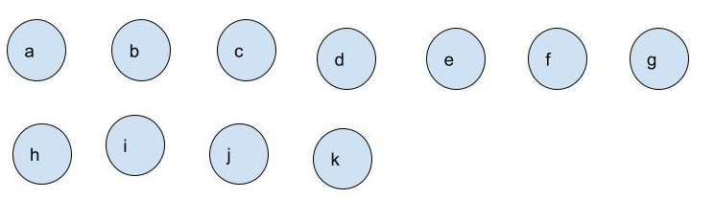

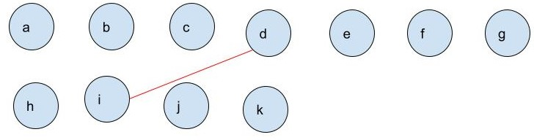

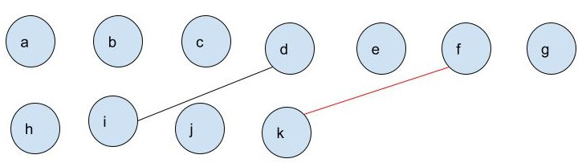

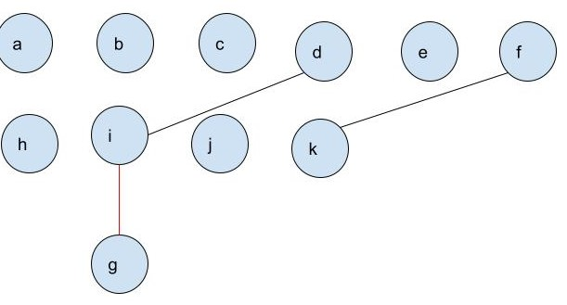

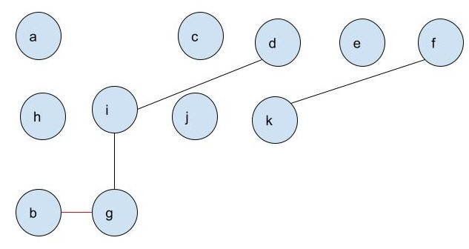

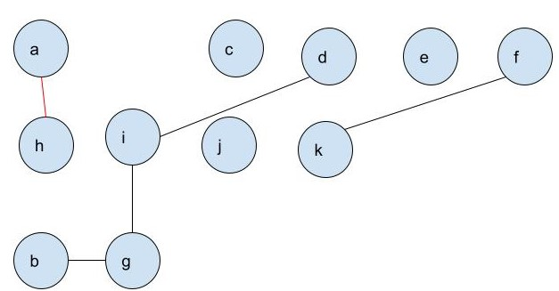

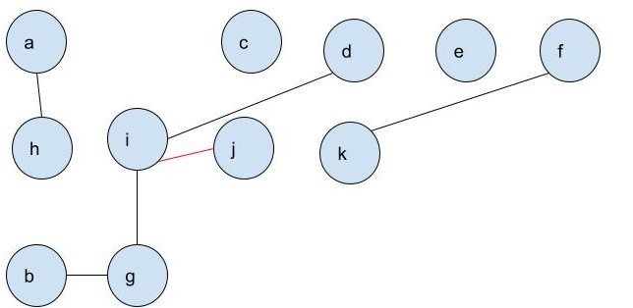

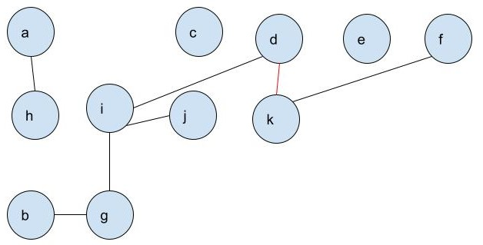

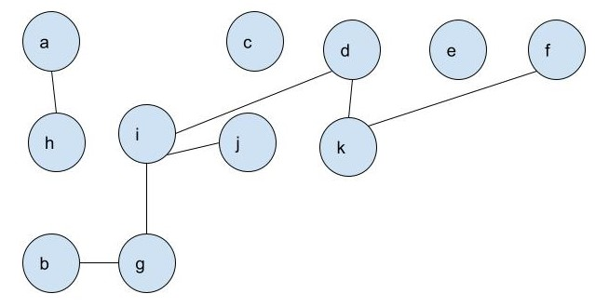

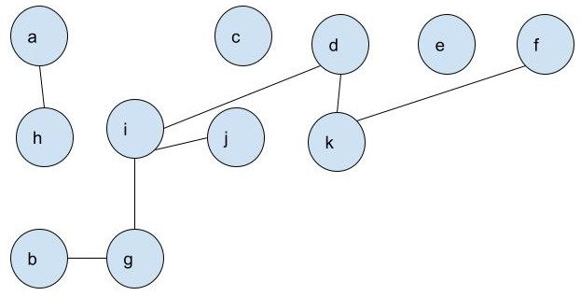

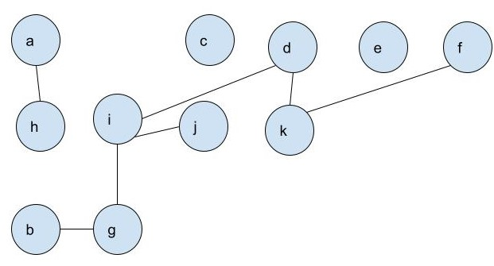

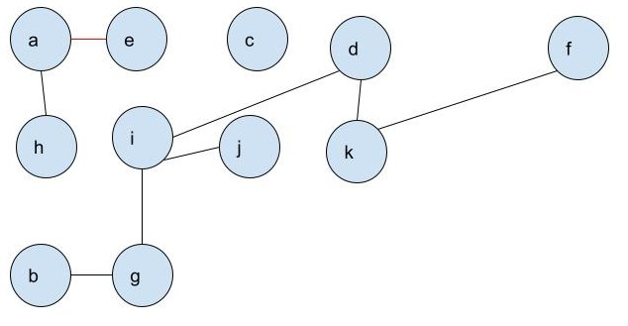

Ex21-1-2

Ex21-1-3

[CH21-2]

Ex21-2-1

Ex21-2-2

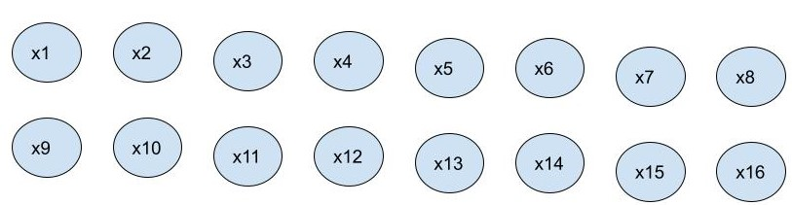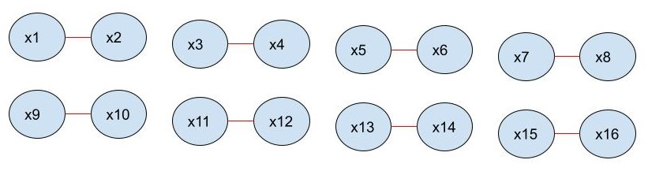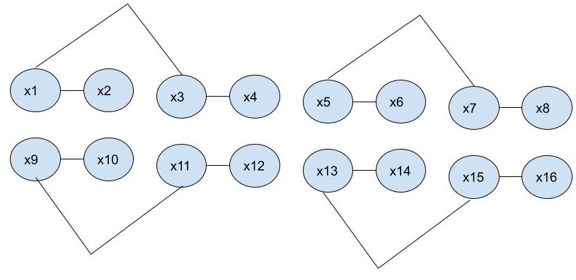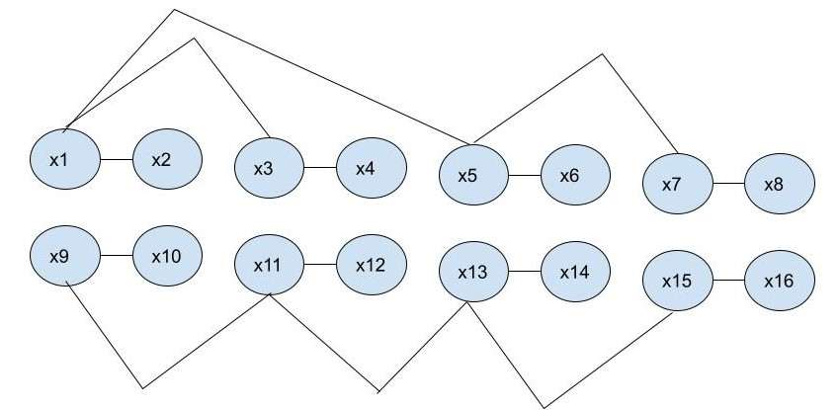

[CH21-3]

Ex21-3-1

Ex21-3-2

FIND-SET(x)

{

while(x!=x.p){x=x.p;}

return x;

}

[CH22]

[CH22-1]

Ex22-1-1

adjacency list

1. indegree: |E|
2. outdegree: |E|

Ex22-1-2

Give an adjacency-list representation of complete binary tree with binary heap on 7 vertices.

[info]

1. complete binary tree
2. binary heap tree
3. 7 vertices

[tip]

1. complete binary tree:

nodes whose depth n-1 are non-leaf nodes.

1. Binary heap: Assume binary min heap.

The node is greater than or equal to all of its descendants.

[graph]

1

2

3

6

5

7

4

[adjacency list]

|  |  |  |  |  |  |
| --- | --- | --- | --- | --- | --- |
| 1 | -> | 2 | -> | 3 | / |
| 2 | -> | 4 | -> | 5 | / |
| 3 | -> | 6 | -> | 7 | / |
| 4 | -> | NIL | / |  |  |
| 5 | -> | NIL | / |  |  |
| 6 | -> | NIL | / |  |  |
| 7 | -> | NIL | / |  |  |

Ex22-1-3

Analyze running times of your algorithm for adjacency matrix and adjacency list of transposed graph.

Transposed graph

[Example]

(a)

(b)

Ex22-1-4

For undirected graph with adjacency-list representation,

1. Self-loop remove:

It can be done by comparing any element and first element of each list with same value.

1. Multiple edges replaced by single edge:

It can be done by comparing any two element with same value for each list.

Ex22-1-5

1. Adjacency list:

Add the head nodes of all elements of the list at the end of the list for each list.

1. Adjacency matrix:
2. For each row to find all vertices with nonzero value and put them into set V’. The purpose is that find adjacency edge of all vertices. You can search all elements of its column.
3. Then for all vertices of V’, to find all vertices with nonzero value and put them into set V’’. The purpose is that find adjacency edge of all vertices of V’. You can search all elements of its column.
4. Then V’’ is a vertex set whose elements have a square path (

)

1. Let’s Done.

Ex22-1-6

For a universal sink graph, adjacency matrix looks like this

Ex22-1-7

[sectbyfn (mit.edu)](http://mitp-content-server.mit.edu:18180/books/content/sectbyfn?collid=books_pres_0&id=8030&fn=Intro_to_Algo_Selected_Solutions.pdf)

Ex22-1-8

[CH22-2]

Ex22-2-1

Fig 22.2.(a) in textbook (p590)

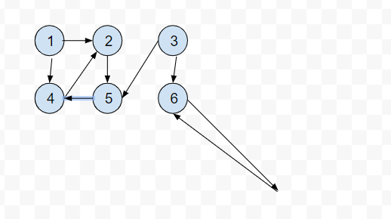

|  |  |  |  |  |  |  |
| --- | --- | --- | --- | --- | --- | --- |
|  |  |  |  |  |  |  |
|  |  |  |  |  |  |  |
|  |  |  |  |  |  |  |
|  |  |  |  |  |  |  |

|  |  |  |  |  |  |  |
| --- | --- | --- | --- | --- | --- | --- |
|  |  |  |  |  |  |  |
|  |  |  |  |  |  |  |
|  |  |  |  |  |  |  |
|  |  |  |  |  |  |  |

|  |  |  |  |  |  |  |
| --- | --- | --- | --- | --- | --- | --- |
|  |  |  |  |  |  |  |
|  |  |  |  |  |  |  |
|  |  |  |  |  |  |  |
|  |  |  |  |  |  |  |

Result:

|  |  |  |  |  |  |  |
| --- | --- | --- | --- | --- | --- | --- |
|  |  |  |  |  |  |  |
|  |  |  |  |  |  |  |
|  |  |  |  |  |  |  |
|  |  |  |  |  |  |  |

Ex22-2-2

Fig 22.3 in textbook (p596)

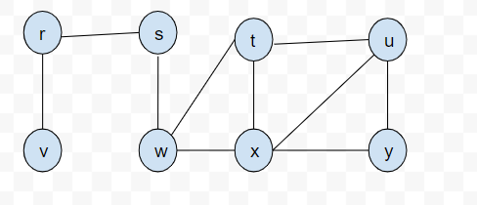

|  |  |  |  |  |  |  |  |  |
| --- | --- | --- | --- | --- | --- | --- | --- | --- |
|  |  |  |  |  |  |  |  |  |
|  |  |  |  |  |  |  |  |  |
|  |  |  |  |  |  |  |  |  |
|  |  |  |  |  |  |  |  |  |

|  |  |  |  |  |  |  |  |  |
| --- | --- | --- | --- | --- | --- | --- | --- | --- |
|  |  |  |  |  |  |  |  |  |
|  |  |  |  |  |  |  |  |  |
|  |  |  |  |  |  |  |  |  |
|  |  |  |  |  |  |  |  |  |

|  |  |  |  |  |  |  |  |  |
| --- | --- | --- | --- | --- | --- | --- | --- | --- |
|  |  |  |  |  |  |  |  |  |
|  |  |  |  |  |  |  |  |  |
|  |  |  |  |  |  |  |  |  |
|  |  |  |  |  |  |  |  |  |

|  |  |  |  |  |  |  |  |  |
| --- | --- | --- | --- | --- | --- | --- | --- | --- |
|  |  |  |  |  |  |  |  |  |
|  |  |  |  |  |  |  |  |  |
|  |  |  |  |  |  |  |  |  |
|  |  |  |  |  |  |  |  |  |

|  |  |  |  |  |  |  |  |  |
| --- | --- | --- | --- | --- | --- | --- | --- | --- |
|  |  |  |  |  |  |  |  |  |
|  |  |  |  |  |  |  |  |  |
|  |  |  |  |  |  |  |  |  |
|  |  |  |  |  |  |  |  |  |

Result:

|  |  |  |  |  |  |  |  |  |
| --- | --- | --- | --- | --- | --- | --- | --- | --- |
|  |  |  |  |  |  |  |  |  |
|  |  |  |  |  |  |  |  |  |
|  |  |  |  |  |  |  |  |  |
|  |  |  |  |  |  |  |  |  |

Ex22-2-3

Ex22-2-4

Ex22-2-5

Ex22-2-6

Ex22-2-7

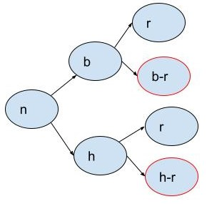

Ex22-2-8

Ex22-2-9

[CH22-3]

Ex22-3-1

Ex22-3-2

Ex22-3-3

Ex22-3-4

Ex22-3-5

(a)

(b)

.

(c)

[CH22-4]

Ex22-4-4

[CH22-5]

Ex22-5-1

Ex22-5-2

Ex22-5-4

Ex22-5-6

[Problem]

22-1

22-2

22-3

22-4

[CH23]

[CH23-1]

Ex23-1-1

Ex23-1-2

Ex23-1-3

Ex23-1-4

Ex23-1-5

Ex23-1-8

The

Ex23-1-10

[CH23-2]

Ex23-2-1

Ex23-2-2

Ex23-2-4

Ex23-2-5

Ex23-2-6

[Problem]

23-1

[CH24]

[CH24-1]

Ex24-1-6

[CH24-2]

[CH24-3]

Ex24-3-4

Ex24-3-5

Ex24-3-6

Ex24-3-7

Ex24-3-10

[CH24-4]

[CH24-5]

Ex24-5-7

Ex24-5-8

[Problem]

24-1

24-2

24-3

24-4

24-5

24-6

[CH25]

[CH25-1]

Ex25-1-1

Ex25-1-2

[CH25-2]

Ex25-2-1

|  |  |  |  |  |  |  |
| --- | --- | --- | --- | --- | --- | --- |
|  | | | | | | |
|  |  |  |  |  |  |  |
|  |  |  |  |  |  |  |
|  |  |  |  |  |  |  |
|  |  |  |  |  |  |  |
|  |  |  |  |  |  |  |
|  |  |  |  |  |  |  |
|  |  |  |  |  |  |  |
|  | | | | | | |
|  |  |  |  |  |  |  |
|  |  |  |  |  |  |  |
|  |  |  |  |  |  |  |
|  |  |  |  |  |  |  |
|  |  |  |  |  |  |  |
|  |  |  |  |  |  |  |
|  |  |  |  |  |  |  |

|  |  |  |  |  |  |  |
| --- | --- | --- | --- | --- | --- | --- |
|  | | | | | | |
|  |  |  |  |  |  |  |
|  |  |  |  |  |  |  |
|  |  |  |  |  |  |  |
|  |  |  |  |  |  |  |
|  |  |  |  |  |  |  |
|  |  |  |  |  |  |  |
|  |  |  |  |  |  |  |
|  | | | | | | |
|  |  |  |  |  |  |  |
|  |  |  |  |  |  |  |
|  |  |  |  |  |  |  |
|  |  |  |  |  |  |  |
|  |  |  |  |  |  |  |
|  |  |  |  |  |  |  |
|  |  |  |  |  |  |  |

|  |  |  |  |  |  |  |
| --- | --- | --- | --- | --- | --- | --- |
|  | | | | | | |
|  |  |  |  |  |  |  |
|  |  |  |  |  |  |  |
|  |  |  |  |  |  |  |
|  |  |  |  |  |  |  |
|  |  |  |  |  |  |  |
|  |  |  |  |  |  |  |
|  |  |  |  |  |  |  |
|  | | | | | | |
|  |  |  |  |  |  |  |
|  |  |  |  |  |  |  |
|  |  |  |  |  |  |  |
|  |  |  |  |  |  |  |
|  |  |  |  |  |  |  |
|  |  |  |  |  |  |  |
|  |  |  |  |  |  |  |

|  |  |  |  |  |  |  |
| --- | --- | --- | --- | --- | --- | --- |
|  | | | | | | |
|  |  |  |  |  |  |  |
|  |  |  |  |  |  |  |
|  |  |  |  |  |  |  |
|  |  |  |  |  |  |  |
|  |  |  |  |  |  |  |
|  |  |  |  |  |  |  |
|  |  |  |  |  |  |  |
|  | | | | | | |
|  |  |  |  |  |  |  |
|  |  |  |  |  |  |  |
|  |  |  |  |  |  |  |
|  |  |  |  |  |  |  |
|  |  |  |  |  |  |  |
|  |  |  |  |  |  |  |
|  |  |  |  |  |  |  |

|  |  |  |  |  |  |  |
| --- | --- | --- | --- | --- | --- | --- |
|  | | | | | | |
|  |  |  |  |  |  |  |
|  |  |  |  |  |  |  |
|  |  |  |  |  |  |  |
|  |  |  |  |  |  |  |
|  |  |  |  |  |  |  |
|  |  |  |  |  |  |  |
|  |  |  |  |  |  |  |
|  | | | | | | |
|  |  |  |  |  |  |  |
|  |  |  |  |  |  |  |
|  |  |  |  |  |  |  |
|  |  |  |  |  |  |  |
|  |  |  |  |  |  |  |
|  |  |  |  |  |  |  |
|  |  |  |  |  |  |  |

|  |  |  |  |  |  |  |
| --- | --- | --- | --- | --- | --- | --- |
|  | | | | | | |
|  |  |  |  |  |  |  |
|  |  |  |  |  |  |  |
|  |  |  |  |  |  |  |
|  |  |  |  |  |  |  |
|  |  |  |  |  |  |  |
|  |  |  |  |  |  |  |
|  |  |  |  |  |  |  |
|  | | | | | | |
|  |  |  |  |  |  |  |
|  |  |  |  |  |  |  |
|  |  |  |  |  |  |  |
|  |  |  |  |  |  |  |
|  |  |  |  |  |  |  |
|  |  |  |  |  |  |  |
|  |  |  |  |  |  |  |

|  |  |  |  |  |  |  |
| --- | --- | --- | --- | --- | --- | --- |
|  | | | | | | |
|  |  |  |  |  |  |  |
|  |  |  |  |  |  |  |
|  |  |  |  |  |  |  |
|  |  |  |  |  |  |  |
|  |  |  |  |  |  |  |
|  |  |  |  |  |  |  |
|  |  |  |  |  |  |  |
|  | | | | | | |
|  |  |  |  |  |  |  |
|  |  |  |  |  |  |  |
|  |  |  |  |  |  |  |
|  |  |  |  |  |  |  |
|  |  |  |  |  |  |  |
|  |  |  |  |  |  |  |
|  |  |  |  |  |  |  |

Ex25-2-3

Ex25-2-4

Ex25-2-5

Ex25-2-6

[CH25-3]

Ex25-3-1

Ex25-3-2

Ex25-3-3

Ex25-3-4

Ex25-3-5

Ex25-3-6

[Problem]

25-1

25-2

[CH26]

[CH26-1]

Ex26-1-1

Ex26-1-2

Ex26-1-3

[CH26-2]

Ex26-2-2

[Ch26.pdf (rutgers.edu)](https://sites.math.rutgers.edu/~ajl213/CLRS/Ch26.pdf)

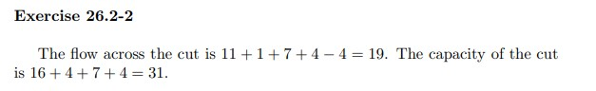

|  |  |
| --- | --- |
|  | |
|  |  |
|  |  |
|  |  |
|  |  |
|  |  |
|  |  |
|  |  |
|  |  |
|  |  |
|  |  |

|  |  |
| --- | --- |
|  | |
|  | |
|  |  |
|  |  |
|  |  |
|  |  |
|  |  |
|  |  |
|  |  |
|  |  |
|  |  |
|  |  |
|  | |
|  |  |
|  |  |
|  |  |

|  |  |
| --- | --- |
|  | |
|  | |
|  | |
|  | |
|  |  |
|  |  |
|  |  |
|  |  |
|  |  |
|  |  |
|  |  |
|  |  |
|  |  |
|  |  |
|  | |
|  |  |
|  |  |
|  |  |

|  |  |
| --- | --- |
|  | |
|  | |
|  | |
|  | |
|  |  |
|  |  |
|  |  |
|  |  |
|  |  |
|  |  |
|  |  |
|  |  |
|  |  |
|  |  |
|  | |
|  |  |
|  |  |
|  |  |

|  |  |  |  |
| --- | --- | --- | --- |
|  | | | |
|  | | | |
|  | | | |
|  | |  | |
|  |  |  |  |
|  |  |  |  |
|  |  |  |  |
|  |  |  |  |
|  |  |  |  |
|  |  |  |  |
|  |  |  |  |
|  |  |  |  |
|  |  |  |  |
|  |  |  |  |
|  | | | |
|  |  | | |
|  |  | | |
|  |  | | |

|  |  |  |  |
| --- | --- | --- | --- |
|  | | | |
|  | | | |
|  | | | |
|  | |  | |
|  |  |  |  |
|  |  |  |  |
|  |  |  |  |
|  |  |  |  |
|  |  |  |  |
|  |  |  |  |
|  |  |  |  |
|  |  |  |  |
|  |  |  |  |
|  |  |  |  |
|  | | | |
|  |  | | |
|  |  | | |
|  |  | | |

|  |  |  |  |
| --- | --- | --- | --- |
|  | | | |
|  | | | |
|  | | | |
|  | |  | |
|  |  |  |  |
|  |  |  |  |
|  |  |  |  |
|  |  |  |  |
|  |  |  |  |
|  |  |  |  |
|  |  |  |  |
|  |  |  |  |
|  |  |  |  |
|  |  |  |  |
|  | | | |
|  |  | | |
|  |  | | |
|  |  | | |

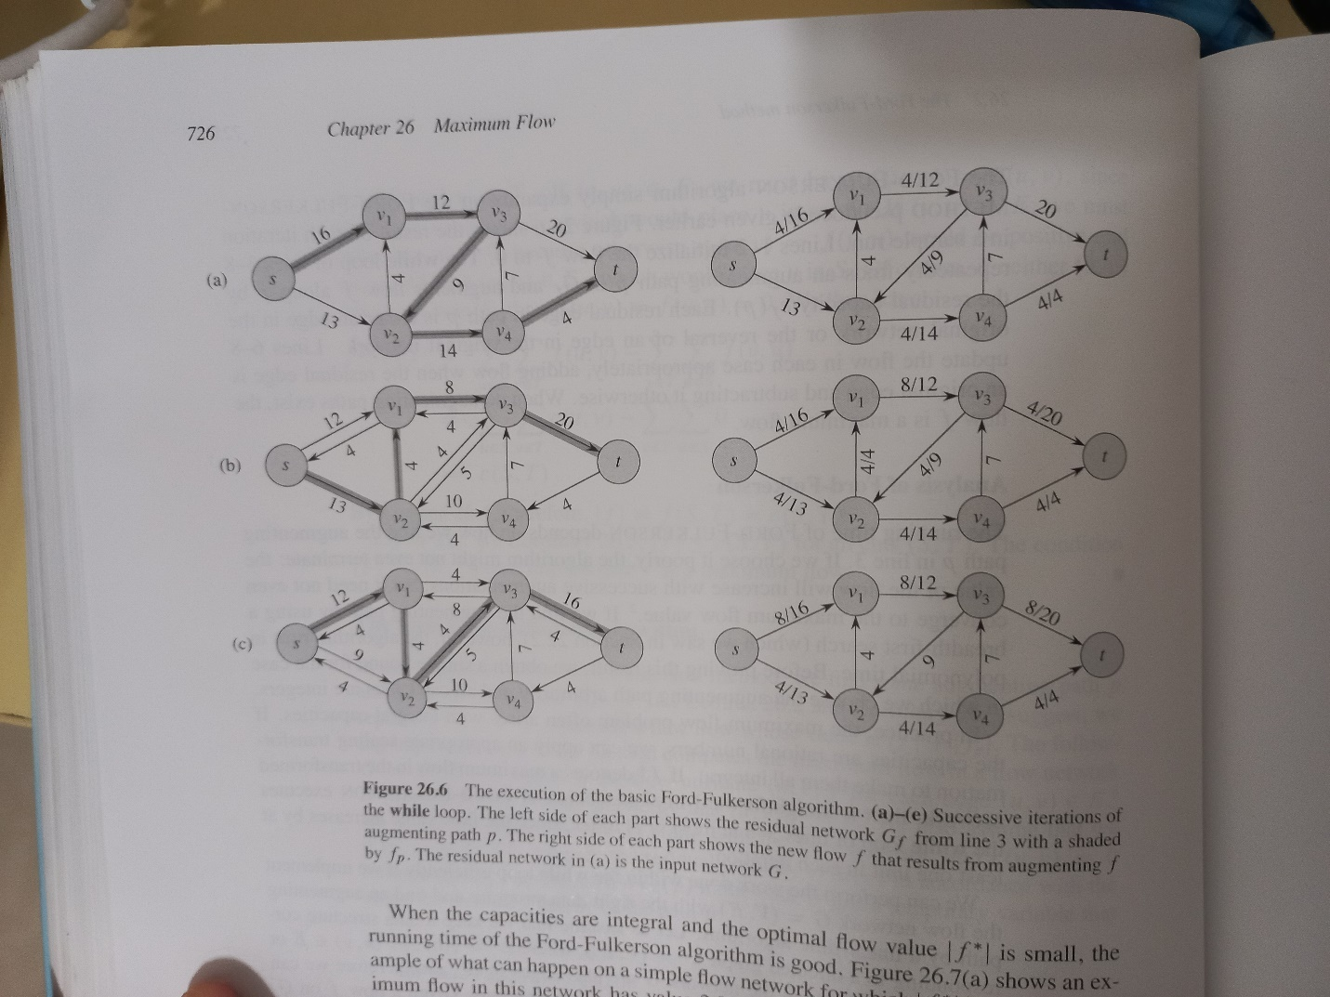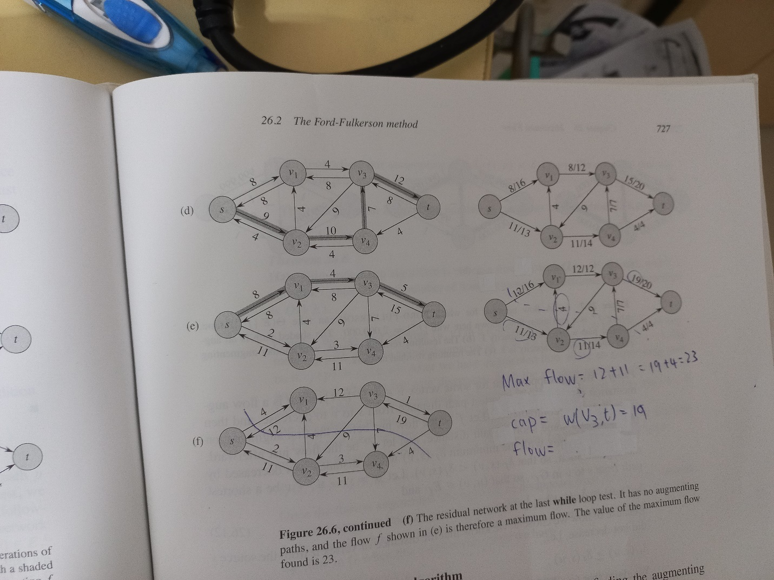

Ex26-2-3

Ex26-2-4

Ex26-2-9

[CH27]

[CH28]

[CH28-1]

Ex28-1-1

Ex28-1-2

Ex28-1-3

Ex28-1-4

Ex28-1-5

[CH29]

[CH30]

[CH30-1]

Ex30-1-1

Ex30-1-2

Ex30-1-3

Ex30-1-4

Ex30-1-5

Ex30-1-6

Ex30-1-7

[CH30-2]

[CH30-3]

Ex30-3-1

|  |  |  |  |  |  |  |  |  |  |
| --- | --- | --- | --- | --- | --- | --- | --- | --- | --- |
|  |  |  |  |  |  |  |  |  |  |
|  |  |  |  |  |  |  |  |  |  |
|  |  |  |  |  |  |  |  |  |  |
|  |  |  |  |  |  |  |  |  |  |
|  |  |  |  |  |  |  |  |  |  |

|  |  |  |  |  |  |  |  |  |  |
| --- | --- | --- | --- | --- | --- | --- | --- | --- | --- |
|  |  |  |  |  |  |  |  |  |  |
|  |  |  |  |  |  |  |  |  |  |
|  |  |  |  |  |  |  |  |  |  |
|  |  |  |  |  |  |  |  |  |  |
|  |  |  |  |  |  |  |  |  |  |

|  |  |  |  |  |  |  |  |  |  |
| --- | --- | --- | --- | --- | --- | --- | --- | --- | --- |
|  |  |  |  |  |  |  |  |  |  |
|  |  |  |  |  |  |  |  |  |  |
|  |  |  |  |  |  |  |  |  |  |
|  |  |  |  |  |  |  |  |  |  |
|  |  |  |  |  |  |  |  |  |  |

|  |  |  |  |  |  |  |  |  |  |
| --- | --- | --- | --- | --- | --- | --- | --- | --- | --- |
|  |  |  |  |  |  |  |  |  |  |
|  |  |  |  |  |  |  |  |  |  |
|  |  |  |  |  |  |  |  |  |  |
|  |  |  |  |  |  |  |  |  |  |
|  |  |  |  |  |  |  |  |  |  |

|  |  |  |  |  |  |  |  |  |  |
| --- | --- | --- | --- | --- | --- | --- | --- | --- | --- |
|  |  |  |  |  |  |  |  |  |  |
|  |  |  |  |  |  |  |  |  |  |
|  |  |  |  |  |  |  |  |  |  |
|  |  |  |  |  |  |  |  |  |  |
|  |  |  |  |  |  |  |  |  |  |

|  |  |  |  |  |  |  |  |  |  |
| --- | --- | --- | --- | --- | --- | --- | --- | --- | --- |
|  |  |  |  |  |  |  |  |  |  |
|  |  |  |  |  |  |  |  |  |  |
|  |  |  |  |  |  |  |  |  |  |
|  |  |  |  |  |  |  |  |  |  |
|  |  |  |  |  |  |  |  |  |  |

|  |  |  |  |  |  |  |  |  |  |
| --- | --- | --- | --- | --- | --- | --- | --- | --- | --- |
|  |  |  |  |  |  |  |  |  |  |
|  |  |  |  |  |  |  |  |  |  |
|  |  |  |  |  |  |  |  |  |  |
|  |  |  |  |  |  |  |  |  |  |
|  |  |  |  |  |  |  |  |  |  |

C

|  |  |  |  |  |  |  |  |  |  |
| --- | --- | --- | --- | --- | --- | --- | --- | --- | --- |
|  |  |  |  |  |  |  |  |  |  |
|  |  |  |  |  |  |  |  |  |  |
|  |  |  |  |  |  |  |  |  |  |
|  |  |  |  |  |  |  |  |  |  |
|  |  |  |  |  |  |  |  |  |  |

|  |  |  |  |  |  |  |  |  |  |
| --- | --- | --- | --- | --- | --- | --- | --- | --- | --- |
|  |  |  |  |  |  |  |  |  |  |
|  |  |  |  |  |  |  |  |  |  |
|  |  |  |  |  |  |  |  |  |  |
|  |  |  |  |  |  |  |  |  |  |
|  |  |  |  |  |  |  |  |  |  |

|  |  |  |  |  |  |  |  |  |  |
| --- | --- | --- | --- | --- | --- | --- | --- | --- | --- |
|  |  |  |  |  |  |  |  |  |  |
|  |  |  |  |  |  |  |  |  |  |
|  |  |  |  |  |  |  |  |  |  |
|  |  |  |  |  |  |  |  |  |  |
|  |  |  |  |  |  |  |  |  |  |

|  |  |  |  |  |  |  |  |  |  |
| --- | --- | --- | --- | --- | --- | --- | --- | --- | --- |
|  |  |  |  |  |  |  |  |  |  |
|  |  |  |  |  |  |  |  |  |  |
|  |  |  |  |  |  |  |  |  |  |
|  |  |  |  |  |  |  |  |  |  |
|  |  |  |  |  |  |  |  |  |  |

|  |  |  |  |  |  |  |  |  |  |
| --- | --- | --- | --- | --- | --- | --- | --- | --- | --- |
|  |  |  |  |  |  |  |  |  |  |
|  |  |  |  |  |  |  |  |  |  |
|  |  |  |  |  |  |  |  |  |  |
|  |  |  |  |  |  |  |  |  |  |
|  |  |  |  |  |  |  |  |  |  |

C

|  |  |  |  |  |  |  |  |  |  |
| --- | --- | --- | --- | --- | --- | --- | --- | --- | --- |
|  |  |  |  |  |  |  |  |  |  |
|  |  |  |  |  |  |  |  |  |  |
|  |  |  |  |  |  |  |  |  |  |
|  |  |  |  |  |  |  |  |  |  |
|  |  |  |  |  |  |  |  |  |  |

|  |  |  |  |  |  |  |  |  |  |
| --- | --- | --- | --- | --- | --- | --- | --- | --- | --- |
|  |  |  |  |  |  |  |  |  |  |
|  |  |  |  |  |  |  |  |  |  |
|  |  |  |  |  |  |  |  |  |  |
|  |  |  |  |  |  |  |  |  |  |
|  |  |  |  |  |  |  |  |  |  |

|  |  |  |  |  |  |  |  |  |  |
| --- | --- | --- | --- | --- | --- | --- | --- | --- | --- |
|  |  |  |  |  |  |  |  |  |  |
|  |  |  |  |  |  |  |  |  |  |
|  |  |  |  |  |  |  |  |  |  |
|  |  |  |  |  |  |  |  |  |  |
|  |  |  |  |  |  |  |  |  |  |

|  |  |  |  |  |  |  |  |  |  |
| --- | --- | --- | --- | --- | --- | --- | --- | --- | --- |
|  |  |  |  |  |  |  |  |  |  |
|  |  |  |  |  |  |  |  |  |  |
|  |  |  |  |  |  |  |  |  |  |
|  |  |  |  |  |  |  |  |  |  |
|  |  |  |  |  |  |  |  |  |  |

|  |  |  |  |  |  |  |  |  |  |
| --- | --- | --- | --- | --- | --- | --- | --- | --- | --- |
|  |  |  |  |  |  |  |  |  |  |
|  |  |  |  |  |  |  |  |  |  |
|  |  |  |  |  |  |  |  |  |  |
|  |  |  |  |  |  |  |  |  |  |
|  |  |  |  |  |  |  |  |  |  |

C

|  |  |  |  |  |  |  |  |  |  |
| --- | --- | --- | --- | --- | --- | --- | --- | --- | --- |
|  |  |  |  |  |  |  |  |  |  |
|  |  |  |  |  |  |  |  |  |  |
|  |  |  |  |  |  |  |  |  |  |
|  |  |  |  |  |  |  |  |  |  |
|  |  |  |  |  |  |  |  |  |  |

|  |  |  |  |  |  |  |  |  |  |
| --- | --- | --- | --- | --- | --- | --- | --- | --- | --- |
|  |  |  |  |  |  |  |  |  |  |
|  |  |  |  |  |  |  |  |  |  |
|  |  |  |  |  |  |  |  |  |  |
|  |  |  |  |  |  |  |  |  |  |
|  |  |  |  |  |  |  |  |  |  |

|  |  |  |  |  |  |  |  |  |  |
| --- | --- | --- | --- | --- | --- | --- | --- | --- | --- |
|  |  |  |  |  |  |  |  |  |  |
|  |  |  |  |  |  |  |  |  |  |
|  |  |  |  |  |  |  |  |  |  |
|  |  |  |  |  |  |  |  |  |  |
|  |  |  |  |  |  |  |  |  |  |

Wrong answer

Ex30-3-2

Ex30-3-3

Ex30-3-4

[Problem]

30-2

[CH31]

[CH31-1]

Ex31-1-1

Ex31-1-2

[Ch31.pdf (rutgers.edu)](https://sites.math.rutgers.edu/~ajl213/CLRS/Ch31.pdf)

Ex31-1-3

Ex31-1-4

Ex31-1-5

Ex31-1-6

[Ch31.pdf (rutgers.edu)](https://sites.math.rutgers.edu/~ajl213/CLRS/Ch31.pdf)

Ex31-1-7

[Ch31.pdf (rutgers.edu)](https://sites.math.rutgers.edu/~ajl213/CLRS/Ch31.pdf)

Ex31-1-8

[Ch31.pdf (rutgers.edu)](https://sites.math.rutgers.edu/~ajl213/CLRS/Ch31.pdf)

Ex31-1-9

[Ch31.pdf (rutgers.edu)](https://sites.math.rutgers.edu/~ajl213/CLRS/Ch31.pdf)

Ex31-1-10

[Ch31.pdf (rutgers.edu)](https://sites.math.rutgers.edu/~ajl213/CLRS/Ch31.pdf)

Ex31-1-11

[Ch31.pdf (rutgers.edu)](https://sites.math.rutgers.edu/~ajl213/CLRS/Ch31.pdf)

Ex31-1-12

[Ch31.pdf (rutgers.edu)](https://sites.math.rutgers.edu/~ajl213/CLRS/Ch31.pdf)

Ex31-1-13

[Ch31.pdf (rutgers.edu)](https://sites.math.rutgers.edu/~ajl213/CLRS/Ch31.pdf)

[CH31-2]

Ex31-2-1

Ex31-2-3

Ex31-2-9

[CH31-3]

Ex31-3-2

Ex31-3-3

Ex31-3-4

Ex31-3-5

[CH31-4]

Ex31-4-1

Ex31-4-2

Ex31-4-3

Ex31-4-4

[CH31-5]

Ex31-5-1

Ex31-5-2

[CH31-6]

[CH31-7]

Ex31-7-1

[Ch31.pdf (rutgers.edu)](https://sites.math.rutgers.edu/~ajl213/CLRS/Ch31.pdf)

Ex31-7-2

Ex31-7-3

[Ch31.pdf (rutgers.edu)](https://sites.math.rutgers.edu/~ajl213/CLRS/Ch31.pdf)

[CH31-8]

Ex31-8-1

Ex31-8-2

[Ch31.pdf (rutgers.edu)](https://sites.math.rutgers.edu/~ajl213/CLRS/Ch31.pdf)

Ex31-8-3

[Ch31.pdf (rutgers.edu)](https://sites.math.rutgers.edu/~ajl213/CLRS/Ch31.pdf)

[CH31-9]

[Problem 31]

31-2

31-3

31-4

[CH32]

[CH32-1]

Ex32-1-1

|  |  |  |  |  |  |  |
| --- | --- | --- | --- | --- | --- | --- |
|  |  |  |  |  |  |  |
|  |  |  |  |  |  |  |
|  |  |  |  |
|  |  |  |  |  |  |  |
|  |  |  |  |
|  |  |  |  |  |  |  |
|  |  |  |  |
|  |  |  |  |  |  |  |
|  |  |  |  |
|  |  |  |  |  |  |  |
|  |  |  |  |
|  |  |  |  |  |  |  |
|  |  |  |  |
|  |  |  |  |  |  |  |
|  |  |  |  |
|  |  |  |  |  |  |  |
|  |  |  |  |
|  |  |  |  |  |  |  |
|  |  |  |  |
|  |  |  |  |  |  |  |
|  |  |  |  |
|  |  |  |  |  |  |  |
|  |  |  |  |
|  |  |  |  |  |  |  |
|  |  |  |  |

Ex32-1-2

[Ch32.pdf (rutgers.edu)](https://sites.math.rutgers.edu/~ajl213/CLRS/Ch32.pdf)

Ex32-1-3

[Ch32.pdf (rutgers.edu)](https://sites.math.rutgers.edu/~ajl213/CLRS/Ch32.pdf)

Ex32-1-4

[CH33]

[CH33-1]

Ex33-1-1s

Ex33-1-2

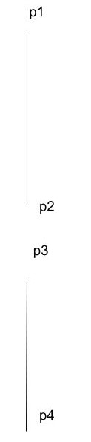

Ex33-1-3

Ex33-1-4

Ex33-1-5

[Ch33.pdf (rutgers.edu)](https://sites.math.rutgers.edu/~ajl213/CLRS/Ch33.pdf)

Ex33-1-6

[Ch33.pdf (rutgers.edu)](https://sites.math.rutgers.edu/~ajl213/CLRS/Ch33.pdf)

Ex33-1-7

[Ch33.pdf (rutgers.edu)](https://sites.math.rutgers.edu/~ajl213/CLRS/Ch33.pdf)

Ex33-1-8

[Ch33.pdf (rutgers.edu)](https://sites.math.rutgers.edu/~ajl213/CLRS/Ch33.pdf)

[CH33-2]

Ex33-2-1

Ex33-2-4

Ex33-2-5

Ex33-2-6

Ex33-2-7

[Ch33.pdf (rutgers.edu)](https://sites.math.rutgers.edu/~ajl213/CLRS/Ch33.pdf)

Ex33-2-8

Ex33-2-9

[CH34]

[CH34-1]

Ex34-1-1

Ex34-1-2

Ex34-1-3

Ex34-1-4

Ex34-1-5

Ex34-1-6

[CH34-2]

Ex34-2-1

Ex34-2-2

Ex34-2-3

Ex34-2-4

Ex34-2-5

Ex34-2-6

Ex34-2-7

Ex34-2-8

Ex34-2-9

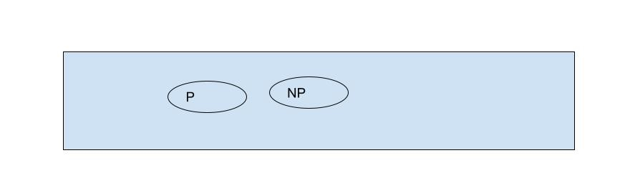

[Ch34.pdf (rutgers.edu)](https://sites.math.rutgers.edu/~ajl213/CLRS/Ch34.pdf)

Ex34-2-10

Ex34-2-11

[CH34-3]

Ex34-3-1

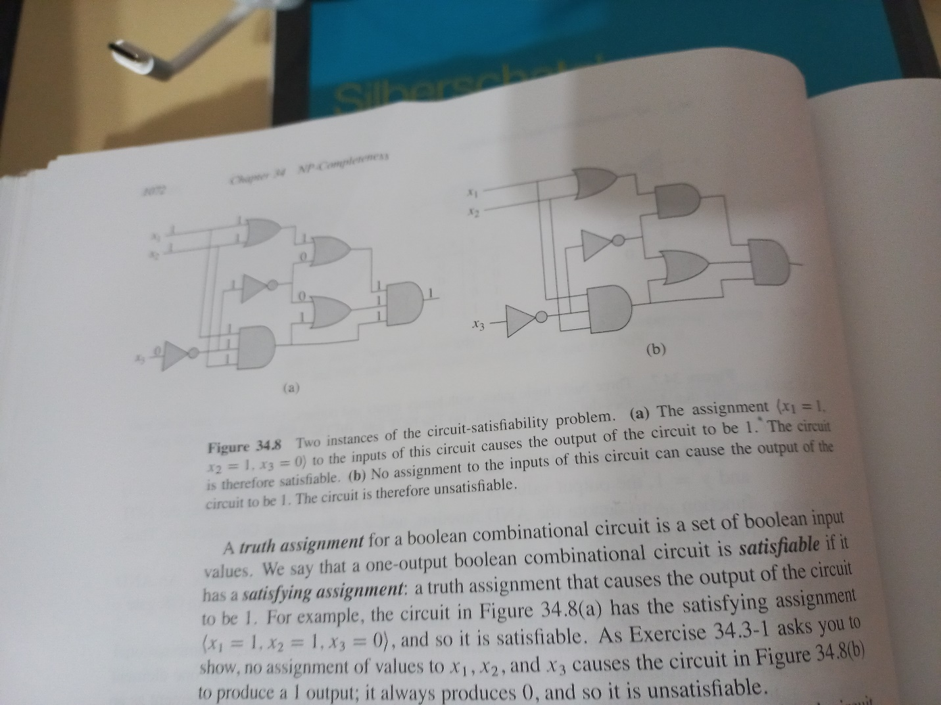

Ex34-3-2

Ex34-3-3

Ex34-3-4

Ex34-3-5

Ex34-3-6

[Ch34.pdf (rutgers.edu)](https://sites.math.rutgers.edu/~ajl213/CLRS/Ch34.pdf)

Ex34-3-7

Ex34-3-8

[CH34-4]

Ex34-4-1

Ex34-4-2

Ex34-4-3

Ex34-4-4

Ex34-4-5

[Ch34.pdf (rutgers.edu)](https://sites.math.rutgers.edu/~ajl213/CLRS/Ch34.pdf)

Ex34-4-6

Ex34-4-7

[CH34-5]

Ex34-5-1

Ex34-5-2

Ex34-5-3

Ex34-5-4

Ex34-5-5

Ex34-5-6

Ex34-5-7

Ex34-5-8

[Problem]

Ex34-1

Ex34-2

Ex34-3

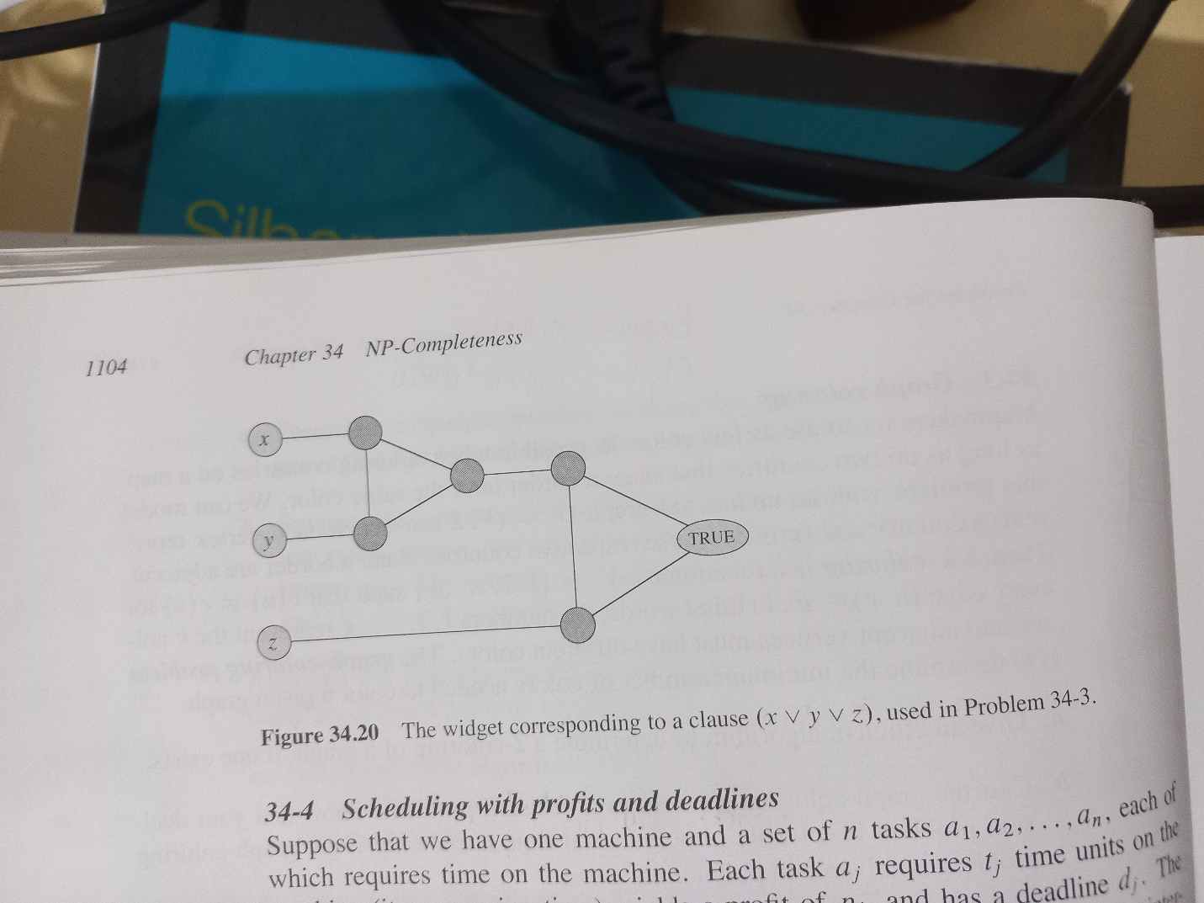

[Ch34.pdf (rutgers.edu)](https://sites.math.rutgers.edu/~ajl213/CLRS/Ch34.pdf)

|  |  |  |  |  |  |  |  |
| --- | --- | --- | --- | --- | --- | --- | --- |
|  | | |  | | | | |
|  |  |  |  |  |  |  |  |
|  |  |  |  |  |  |  |  |
|  |  |  |  |  |  |  |  |
|  |  |  |  |  |  |  |  |
|  |  |  |  |  |  |  |  |
|  |  |  |  |  |  |  |  |

Ex34-4

[CH35]

[CH35-1]

Ex35-1-1

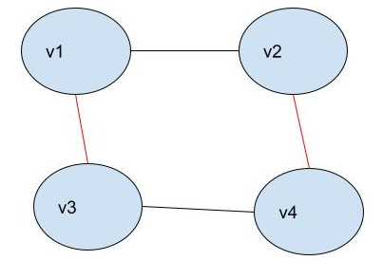

Ex35-1-2

Ex35-1-3

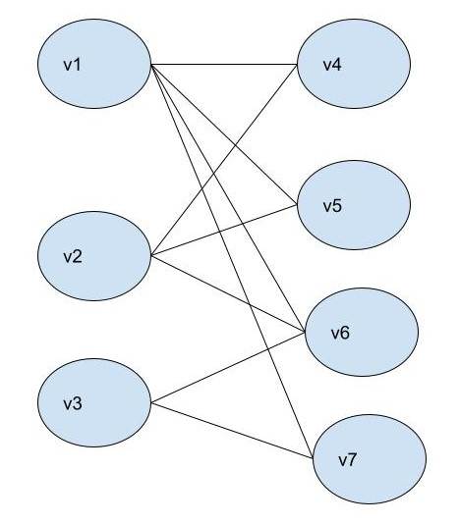

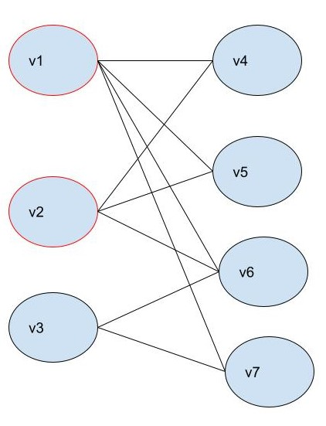

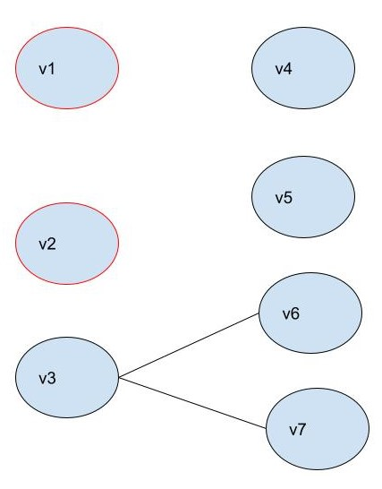

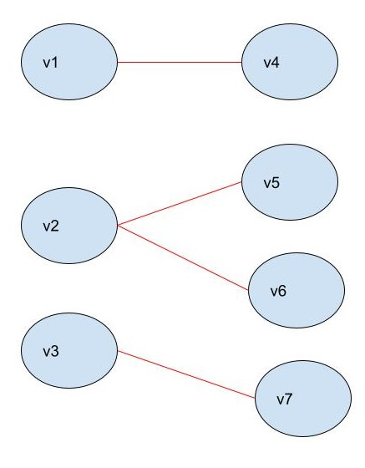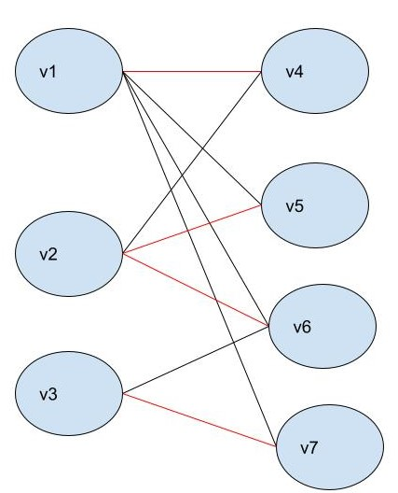

Ex35-1-4

Ex35-1-5

[CH35-2]

Ex35-2-1

Ex35-2-2

Ex35-2-3

Ex35-2-4

Ex35-2-5

[CH35-3]

Ex35-3-1

Ex35-3-2

[Ch35.pdf (rutgers.edu)](https://sites.math.rutgers.edu/~ajl213/CLRS/Ch35.pdf)

Ex35-3-3

Ex35-3-4

Ex35-3-5

[CH35-4]

Ex35-4-1

Ex35-4-2

Ex35-4-3

Ex35-4-4

[CH35-5]

Ex35-5-1

Ex35-5-2

Ex35-5-3

Ex35-5-4

Ex35-5-5

[Problem]

Ex35-1

Ex35-2

Ex35-3

Ex35-4

Ex35-5

Ex35-6

Ex35-7

[Appendix A]

[A-1]

ExA-1-1

ExA-1-2

Another method

ExA-1-3

ExA-1-4

ExA-1-5

ExA-1-6

Prove

Hence proved.

ExA-1-7

ExA-1-8

[A-2]

ExA-2-1

ExA-2-2

ExA-2-3

ExA-2-4

ExA-2-5

Since

[Problem]

A-1

1. Since
2. Since

(c)Since

[Appendix B]

[B.1]

ExB-1-1

Draw Venn diagrams to illustrate the first of the distribute laws

Draw by yourself.

ExB-1-2

Prove the generalization of DeMorgon’s laws.

(a)

(b)

We use mathematical induction to prove them.

1. Let

For base case: When n=2, S(2) is always true as follows.

For induction case: When n=k S(k) is true, n=k+1 S(k+1) must also be true. In other words, we have to prove S(k)=>S(k+1). That is, we have to prove the following

.

NOTE that we must derive S(k+1) from S(k).

By DeMorgan’s law.

Hence proved.

1. Let

For base case: When n=2, S(2) is always true.

For induction case: When n=k is true, n=k+1 must be also true.

By DeMorgan’s law.

Hence proved.

ExB-1-3

We use mathematical induction to prove it.

Let

For base case: When n=2, it is always true.

For induction case: When n=k is true, n=k+1 must be also true.

ExB-1-4

Show that set of odd natural numbers are countable.

Since set of natural numbers are countable,

We suppose that set of odd natural numbers are NOT countable and thus set of even natural numbers are NOT countable. Then we get set of natural numbers are NOT countable. It make a contradiction. And I can ensure that I did any wrong in process. The only possible is my assumption is wrong, which yields set of odd natural numbers are countable.

Hence proved.

ExB-1-5

Show that the power has elements.

That is, show

By definition of power set,

we can observe that power set of A consists of empty set and all elements of A.

Each element in A has two choices, it is in power of A or not.

Thus, we can get

Hence proved.

ExB-1-6

Skip

[B-2]

ExB-2-1

Prove that subset relation “belongs to” on all subsets of Z is a partial order but not total order.

[pf]

We have to prove it is

1. A partial order
2. NOT a total relation

For 1st part,

(1.1) a R a always true, so reflexivity holds.

(1.2) a R b and b R a => a=b , so anti-symmetry holds.

(1.3)a R b and b R c => a R c, so transitivity holds.

Hence it is a partial order.

For the 2nd part,

3 belongs to {3,5} but 3,5 does NOT belong to {3}. Hence, it is NOT a total relation.

Hence proved.

ExB-2-2

ExB-2-3

Example of (a) (b) (c)

1. reflexive + symmetric – transitive
2. reflexive + transitive – symmetric
3. symmetric + transitive – reflexive

(a)

(b)

(c)I have no idea.

ExB-2-4

Since R is an equivalence relation, R must be reflexive, symmetric and transitive.

If R is also antisymmetric, the equivalence class of S must be singleton.

ExB-2-5

No

By definition of transitivity.

[B-3]

ExB-3-1

(a)a function is a injection iff distinct keys will generate distinct values.

Thus,

(b)a function is a surjection is its codomain are corresponded to its domain.

Thus

ExB-3-2

NO.

The function is NOT bijective since it is NOT a surjection (we can not find a value to satisfy f(n)=0)

Yes.

The function is bijective.

ExB-3-3

ExB-3-4

Give a bijection from to.

[B-4]

ExB-4-1

Q: For a graph G=(V,E), show that

A: an edge must connect two vertices u and v.

Sum all edges up and you can prove it.

ExB-4-2

ExB-4-3

Q: For any connected, undirected graph G=(V,E), show that

A:

Since it is connected, each vertices are must have at least 2 degrees except that 2 different vertices must have at least 1 degree. Thus,

*Hence,*

Hence proved.

ExB-4-4

ExB-4-5

Skip

ExB-4-6

[ref]

[Hypergraph & its representation | Discrete Mathematics - GeeksforGeeks](https://www.geeksforgeeks.org/hypergraph-its-representation-discrete-mathematics/)

ExB-5-1

Skip

ExB-5-2

1. Since there is a vertex such that there exists a unique path from to every vertex , it is connected and it is not a multi-edge graph.
2. The problems gives us it is acyclic.
3. Hence undirected version of G forms a tree.

ExB-5-3

(a)We use mathematical induction to prove it.

For base case: When n=2, it is true.

For induction case: when n=k is true. n=k+1 must be true.

(1)When we append one child to a leaf node, it does NOT matter. Ok!

(2)Suppose we have L leaf node and N non-leaf node.

Then we have the equation,

After we append two children to a leaf node,

We have N+1 non-leaf node and L-1+2=L+1 leaf node, which satisfies the equation after simplifying.

(3)And if we append it to a non-leaf node, we can consider it as we remove the non-leaf node which also satisfies the equation.

Hence proved.

(b)

we can build a full binary tree with a tree which has only root node by append the two children to every leaf node until we expected. (We use (a)-(2).) And it is also satisfies the equation.

Hence proved.

Another proof is to count non-leaf node and leaf node.

For a binary tree with depth d,

We have leaf nodes and

non-leaf nodes.

It also satisfies the equation.

Hence proved.

ExB-5-4

Let

(1)For base case: When n=1, S(1) is always true.

When n=2, S(2) is always true.

1. For induction case:

Case 1: append nodes to leaf nodes with largest depth.

Suppose there are nodes in the origin tree and we append nodes to leaf nodes with largest depth to create a new tree with nodes,

we can know that

We have to show the inequality.

Let’s started.

(2)

*(3)*

1. *Since f(x)=lg(x) is strict monotonically decreasing*

1. *combine (2) and (3) together, we can get*

ExB-5-5

ExB-5-6

ExB-5-7

[Problem B]

B-1

B-2

B-3

[Appendix C]

[C-1]

ExC-1-1

ExC-1-2

(a)n-input 1-ouput

(b)n-input m-output

ExC-1-3

ExC-1-4

Q: select three distinct numbers

from the set {1,2,..,99}

which sum is even?

A:

There are four cases:

Odd+odd+even

Odd+even+odd

Even+odd+odd

Even+even+even

The set O={1,3,5,…,99} |O|=50.

The set E={2,4,6,…,98} |E|=49.

Poss(Odd,odd,even): 50*49*49= 120,050

Poss(Odd,even,odd): 50*49*49= 120,050

Poss(even, odd,odd): 49*50*49= 120,050

Poss(even,even,even): 49*48*47= 110,544

Answer=4.70694e+5=470694

ExC-1-5

Q:Prove the identity

ExC-1-6

ExC-1-7

ExC-1-8

Q: Create a Pascal’s triangle.

A: skip

ExC-1-9

ExC-1-10

ExC-1-11

ExC-1-12

ExC-1-13

Prove that

ExC-1-14

(a)Show that

(b)What’s its maximum value?

(a)

ExC-1-15

[C-2]

ExC-2-1

|  |  |
| --- | --- |
| Head | Pr |
| 0 | 1/2 |
| 1 | 1/2 |

|  |  |
| --- | --- |
| Head | Pr |
| 0 | 1/4 |
| 1 | 1/2 |
| 2 | 1/4 |

ExC-2-2

Prove Boole’s inequality.

See my article.

ExC-2-3

ExC-2-4

Hence proved.

ExC-2-5

ExC-2-6

ExC-2-7

ExC-2-8

ExC-2-9

ExC-2-10

Q:

In prisoners X, Y, Z, there are exact 2 prisoners must be executed and the other 1 will be free.

Prisoner X knows that prisoner Y will be executed.

Is the chance of prisoner X free equal to 1/2?

A:

No. The chance of prison X for free is still 1/3.

Because the guard randomly picks the prisoner before one tells prisoner X and one do NOT pick again after one tells the prisoner X.

[C-3]

ExC-3-1

Table about a dice.

|  |  |
| --- | --- |
| Value | Pr |
| 1 | 1/6 |
| 2 | 1/6 |
| 3 | 1/6 |
| 4 | 1/6 |
| 5 | 1/6 |
| 6 | 1/6 |

(a)Table of sum of two dices.

|  |  |  |  |  |
| --- | --- | --- | --- | --- |
| Sum | Pr |  |  | Value=sum*Pr |
| 1 | 0 | NIL | NIL | 0 |
| 2 | 1/36 | 1 | 1 | 2/36 |
| 3 | 2/36 | 1 | 2 | 6/36 |
| 2 | 1 |
| 4 | 3/36 | 1 | 3 | 12/36 |
| 2 | 2 |
| 3 | 1 |
| 5 | 4/36 | 1 | 4 | 20/36 |
| 2 | 3 |
| 3 | 2 |
| 4 | 1 |
| 6 | 5/36 | 1 | 5 | 30/36 |
| 2 | 4 |
| 3 | 3 |
| 4 | 2 |
| 5 | 1 |
| 7 | 6/36 | 1 | 6 | 42/36 |
| 2 | 5 |
| 3 | 4 |
| 4 | 3 |
| 5 | 2 |
| 6 | 1 |
| 8 | 5/36 | 2 | 6 | 40/36 |
| 3 | 5 |
| 4 | 4 |
| 5 | 3 |
| 6 | 2 |
| 9 | 4/36 | 3 | 6 | 36/36 |
| 4 | 5 |
| 5 | 4 |
| 6 | 3 |
| 10 | 3/36 | 4 | 6 | 30/36 |
| 5 | 5 |
| 6 | 4 |
| 11 | 2/36 | 5 | 6 | 22/36 |
| 6 | 5 |
| 12 | 1/36 | 6 | 6 | 12/36 |
| 13 | 0 | NIL | NIL | 0 |
| Total |  | | | 252/36 |

ExC-3-2

ExC-3-3

ExC-3-4

Q: Is it true? For any nonnegative random variable X and Y

A:

Since X and Y is nonnegative,

And since

We can know

Hence proved.

ExC-3-5

ExC-3-6

Prove that the Markov’s inequality.

ExC-3-7

Q: Prove that

A:

Hence proved.

ExC-3-8

ExC-3-9

Q:Prove that for any random variable X that takes on only the values 0 and 1, we have

A: Suppose that X is random variable and P is the probability of X. We can represent them as

Then, the expected value of X is

And we square the X, we can find that is same as

since and .

And we subtract X from 1, we can find that is same as since and .

By the identity of Variance,

We can get

Hence proved.

ExC-3-10

Q: Prove that

A:

[Appendix D]

[D-1]

ExD-1-1

ExD-1-2

ExD-1-3

ExD-1-4

[D-2]

ExD-2-1

Q: Prove that matrix inverses are unique. That is, is B and C are inverses of A, then B=C.

A:

[method 1]

Let’s suppose B and C are inverses of A.

Then

[method 2]

ExD-2-2

Q: (a)

Prove that determinant of lower and upper triangular matrix is equal to the product of its diagonal elements?

(b)Prove that inverse of lower-triangular matrix is lower-triangular matrix.

A: (a)Let L be lower triangular matrix.

Then determinant of L is

Hence proved.

(b)

Since

Then

Hence is also a lower-triangular matrix if it exists.

In this question, I just prove for lower-triangular matrix. However, I can use similar methods to prove for upper-triangular matrix.

Hence proved.

ExD-2-3

Q: Prove that if P is a permutation matrix, then P is invertible, its inverse is and is a permutation matrix.

A:

Since P is permutation matrix, we can know that there exactly exist 1 in any row or column of P.

Thus, determinant of P is equal to product of nonzero elements.

ExD-2-4

Q:

AB=I

A’ is obtained from A by adding row i to row j where ,

B’ is obtained from subtracting column i from column j.

Prove that B’=A’.

A:

Since

Since A’ is obtained from A by adding row i to row j where, ,

On the other hand,

Since B’ is obtained from subtracting column i from column j where ,

Hence proved.

ExD-2-5

ExD-2-6

Q: (a)

.

(b)If B is m*n matrix then is symmetric.

A:(a)

Hence proved.

Hence proved.

ExD-2-7

ExD-2-8

[ref]

[linear algebra - Proofs about Matrix Rank - Mathematics Stack Exchange](https://math.stackexchange.com/questions/935253/proofs-about-matrix-rank)

[Problem]

D-1

See my article.

D-2