Approximation Subset sum problem

[intro]

$$Given a sequence X=\left\{x_{1},x_{2},…,x_{n}\right\} and a target value t$$

$$where x_{i}≥0 for ∀i=1,2,…,n and t≥0.$$

$$Find an approximation solution.$$

$$Find a subset S=\left\{s:s∈X\right\} such that$$

$$\sum_{s∈S}{s}≤t is maximum.$$

$$i.e. Find a subset S=\left\{s:s∈X\right\} such that$$

$$t≥\sum_{s∈S}{s}>\sum_{s^{'}∈S^{'}}{s^{'}},∀S≠S^{'}∈X.$$

[method]

$$1.Approximation algorithm:$$

$$See the following figure of pseudo code and examples.$$

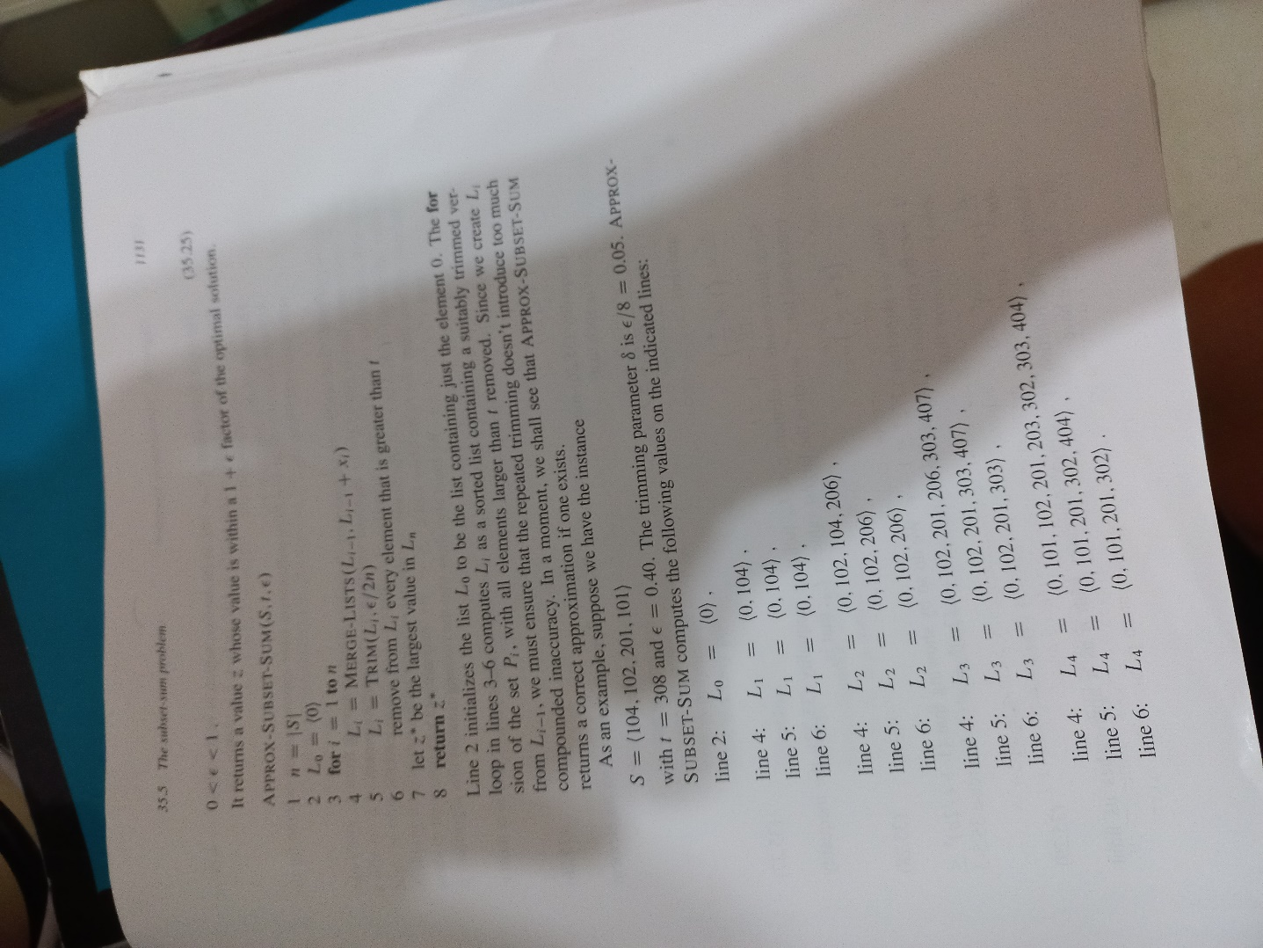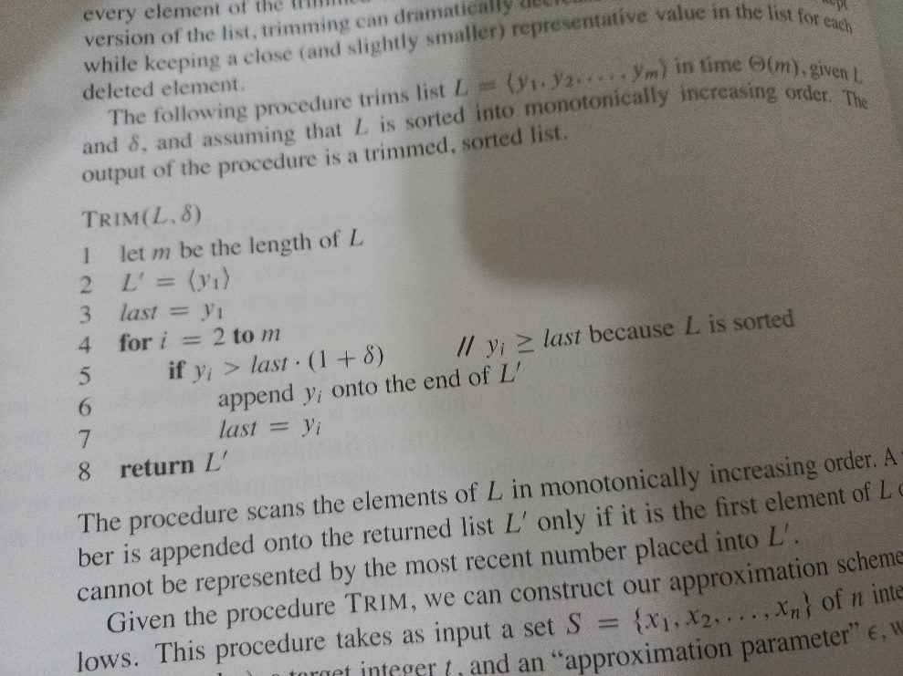

[theorem]

$$1. refer Theorem 35.8 on the page 1132$$

$$in CH11 in algorithm textbook.$$

$$APPROX-SUBSET-SUM is a fully polynomial-time$$

$$approximation scheme for the subset sum problem.$$

$$\left[pf\right]$$

$$The operations of trimming L_{i} in line 5 and removing from$$

$$L_{i} every element that is greater than t to maintain$$

$$the property that every element of L_{i} is also$$

$$a member of P_{i}. Therefore, the value z^{*} returned in line 8$$

$$is indeed the sum of some subset of S.$$

$$Let y^{*}∈P_{n} donate an optimal solution to$$

$$the subset-sum problem.$$

$$Then, from line 6, we know that z^{*}≤y^{*}.$$

$$By inequality \left(35.1\right), we need to show that$$

$$\frac{y^{*}}{z^{*}}≤1+ϵ.$$

$$We must also show that$$

$$the running time of this algorithm is polynomial$$

$$in both \frac{1}{ϵ} and the size of input.$$

$$For every element y in P_{i} that is at most t,$$

$$there exists an element z∈L_{i} such that$$

$$\frac{y}{{\left(1+\frac{ϵ}{2n}\right)}^{i}}≤z≤y.(35.26)$$

$$The claim leaves as Ex35-5-2$$

$$Since inequality \left(35.26\right) must hold for y^{*}∈P_{n},$$

$$there exists an element z∈L_{n} such that$$

$$\frac{y^{*}}{{\left(1+\frac{ϵ}{2n}\right)}^{n}}≤z≤y^{*}.$$

$$Thus,$$

$$\frac{y^{*}}{z}≤{\left(1+\frac{ϵ}{2n}\right)}^{n} (35.27)$$

$$Since there exists an element z∈L_{n} fullfilling the$$

$$inequality \left(35.27\right),$$

$$the inequality must hold for z^{*}, which is the largest value$$

$$in L_{n}. That is,$$

$$\frac{y^{*}}{z^{*}}≤{\left(1+\frac{ϵ}{2n}\right)}^{n} \left(35.28\right)$$

$$Now, we have to show that$$

$${\left(1+\frac{ϵ}{2n}\right)}^{n}≤1+ϵ.$$

$$By equation \left(3.14\right), we have that$$

$$\lim_{n→∞}{{\left(1+\frac{ϵ}{2n}\right)}^{n}}=e^{\frac{ϵ}{2}}$$

$$We can take differentiate at both sides.$$

$$We have that$$

$$\frac{d}{dn}\left[{\left(1+\frac{ϵ}{2n}\right)}^{n}\right]>0 \left(35.29\right)$$

$$We leave it as ex35-5-3$$

$$Therefore, the function$$

$$f\left(n\right)={\left(1+\frac{ϵ}{2n}\right)}^{n} increases with n approaches$$

$$its limit of e^{\frac{ϵ}{2}}, and we have that$$

$${\left(1+\frac{ϵ}{2n}\right)}^{n}≤e^{\frac{ϵ}{2}}$$

$$≤1+\frac{ϵ}{2}+{\left(\frac{ϵ}{2}\right)}^{2}$$

$$≤1+ϵ$$

$$Combing the inequalities completes the analysis of$$

$$the approximation ratio.$$

$$To show that APPROX-SUBSET-SUM$$

$$is a fully polynomial-time scheme,$$

$$we derive a bound on the length of L_{i}.$$

$$After trimming, successive element z and z^{'}$$

$$of L_{i} must have the relationship that$$

$$\frac{z^{'}}{z}>1+\frac{ϵ}{2n}$$

$$They must differ by a factor at least of 1+\frac{ϵ}{2n}.$$

$$Therefore, each list contains the value 0,$$

$$possibly to the value 1, and up to the additional value$$

$$\left\lfloor \log_{1+\frac{ϵ}{2n}}{t}\right\rfloor$$

$$The number of elements in each L_{i} is at most$$

$$\log_{1+\frac{ϵ}{2n}}{t}+2=\frac{\ln{t}}{\ln\left(1+\frac{ϵ}{2n}\right)}+2$$

$$≤\left(\frac{2n}{ϵ}\right)\left(1+\frac{ϵ}{2n}\right)\left(\ln{t}\right)+2 (by eq \left(3.17\right)$$

$$See the following derviation)$$

$$≤\frac{3n\ln{t}}{ϵ}+2$$

$$We can conclude that$$

$$APPROX-SUBSET-SUM is a polynomial-time$$

$$algorithm.$$

$$\frac{x}{1+x}≤\ln\left(1+x\right)≤x ,∀x≥-1$$

$$=>\frac{1}{x}≤\frac{1}{\ln\left(1+x\right)}≤\frac{1}{\frac{x}{1+x}}=\frac{1+x}{x}$$

$$Since\frac{ϵ}{2n}>-1,$$

$$\frac{1}{\ln\left(1+\frac{ϵ}{2n}\right)}≤\frac{1+\frac{ϵ}{2n}}{\frac{ϵ}{2n}}=\left(2n\right)\left(\frac{1+\frac{ϵ}{2n}}{ϵ}\right)$$

$$=>\frac{\ln{t}}{\ln\left(1+\frac{ϵ}{2n}\right)}+2≤\left(2n\right)\left(\frac{1+\frac{ϵ}{2n}}{ϵ}\right)\left(\ln{t}\right)+2$$

[ref]