Approximation algorithm

[term]

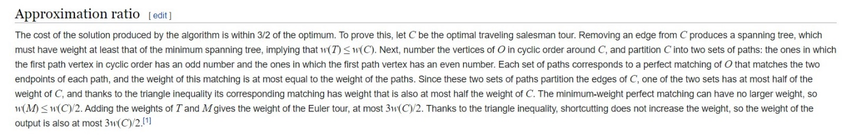

1. Approximation ratio:

$$Let C is a optimal solution and w is weight.$$

$$Approximation ratio r of the algorithm for the problem$$

$$means that$$

$$If the optimal solution of the problem$$

$$can be always solved in$$

$$r*w\left(C\right).$$

$$We can say that$$

$$\left(1\right)Approximation ratio r of the algorithm for the problem$$

$$\left(2\right)The problem is r-approximation algorithm$$

[ref]

[Christofides algorithm - Wikipedia](https://en.wikipedia.org/wiki/Christofides_algorithm)

[approx_algs.pdf (cornell.edu)](http://www.cs.cornell.edu/courses/cs6820/2013fa/handouts/approx_algs.pdf)