Change making problem

[intro]

$$A country has k distinct integer denominations$$

$$A=\left\{a_{1},a_{2},…,a_{k}\right\} in increasing order.$$

$$How to use minimum coins to make a change N$$

$$where N is a positive integer and N≥a_{1}?$$

[method]

$$\left[method 1\right]$$

$$recursive$$

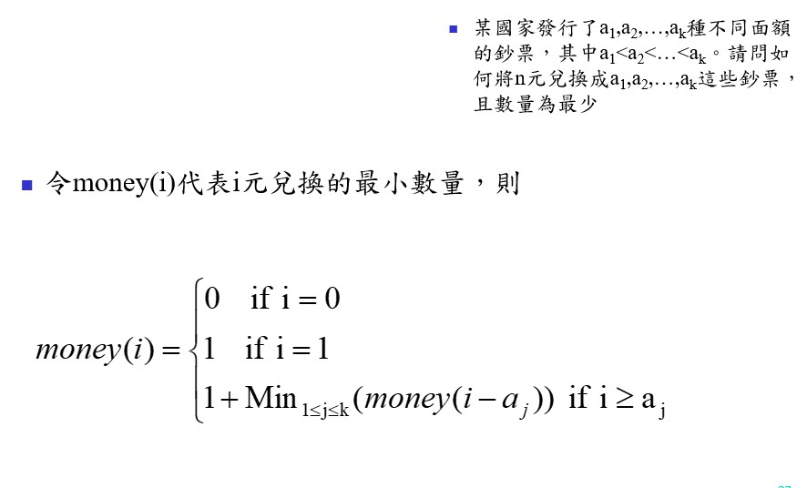

$$\left[method 2\right]$$

$$dynamic programming$$

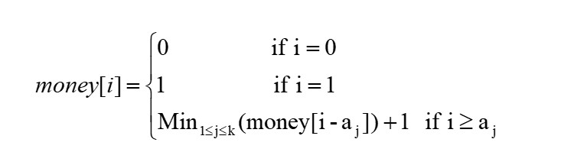

[code]

$$See python code change-making-problem.py$$

$$via the following website.$$

[ref]

[Change-making problem - Wikipedia](https://en.wikipedia.org/wiki/Change-making_problem)