Chip test problem

[intro]

$$A chip must be categorized into a good chip or a bad chip.$$

$$When two chips are placed into a chip tester,$$

$$they can test each other.$$

$$A good chip always tell the truth of another tested chip.$$

$$A bad chip may either tell the truth$$

$$or tell a lie.$$

$$Suppose we have 2n chips and$$

$$there are at least n good chips.$$

$$Can we use a chip tester at most O\left(n\right) times$$

$$to find a good chip?$$

$$The answer is yes.$$

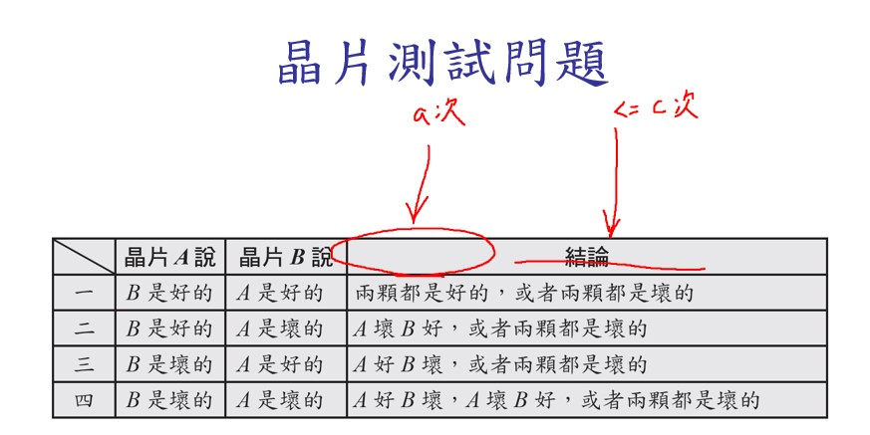

$$Let^{'}s consider four possibles of a test of two chips.$$

|  |  |  |  |
| --- | --- | --- | --- |
| $$case$$ | $$Chip A says$$ | $$Chip B says$$ | $$Conclusion$$ |
| $$1$$ | $$B is good.$$ | $$A is good.$$ | $$either two goods$$ $$or two bads.$$ |
| $$2$$ | $$B is good.$$ | $$A is bad.$$ | $$A is bad.$$ |
| $$3$$ | $$B is bad.$$ | $$A is good.$$ | $$B is bad.$$ |
| $$4$$ | $$B is bad.$$ | $$A is bad.$$ | $$at least 1 bad.$$ |

$$\left[pf\right]$$

$$Case 1:$$

$$Suppose A is good=>A tells a truth$$

$$=>B is good=>YA‼!$$

$$Suppose A is bad=>B tells a lie=>B is bad=>YA‼!$$

$$Case 2:$$

$$Prove by contradiction.$$

$$Suppose A is good=>A tells a truth$$

$$=>B is good=>B tells a truth=>A is bad$$

$$=>contradiction.$$

$$Case 3:$$

$$Similar to case 2.$$

$$Prove by contradiction.$$

$$Suppose B is good=>B tells a truth$$

$$=>A is good=>A tells a truth=>B is bad$$

$$=>contradiction.$$

$$Case 4:$$

$$Prove by contradiction.$$

$$Suppose A is good and B is good=>A tells a truth$$

$$=>B is bad$$

$$=>contradiction.$$

$$The other three possibles may occur in this case.$$

[method]

$$Suppose C=a set of good chips, C=∅.$$

$$(1)If n=1,$$

$$then it must be good.$$

$$(2)Otherwise,$$

$$we split the chips into C_{1} and C_{2}$$

$$with smallest different size.$$

$$(3)Next, we pick one chip from c_{1} called A and$$

$$one from c_{2} called B.$$

$$(4)If A says B is good and B says A is good,$$

$$then C=C∪\left\{A\right\}.$$

$$(5)Go to step \left(1\right).$$

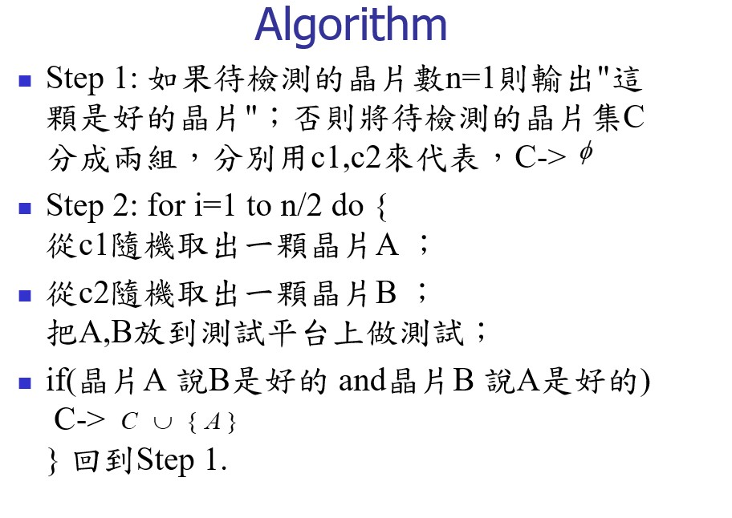

[analysis]

$$time complexity:$$

$$recurrence:T\left(n\right)=T\left(\frac{n}{2}\right)+cn$$

[ref]