Closest pair of points problem

[intro]

$$Given a set of points. Find the pair which has a smallest distance.$$

$$\left(usually use Euclidean distance as the standard\right)$$

[review]

$$\left(1\right)Euclidean distance:$$

$$Euclidean distance of points p_{1}\left(x_{1},y_{1}\right) and p_{2}\left(x_{2},y_{2}\right) is$$

$$\overline{p_{1}p_{2}}=\sqrt{{\left(x_{1}-x_{2}\right)}^{2}+{\left(y_{1}-y_{2}\right)}^{2}}$$

[concept]

$$For divide-and-conquer method.$$

$$Fig 1 is the correctness of it.$$

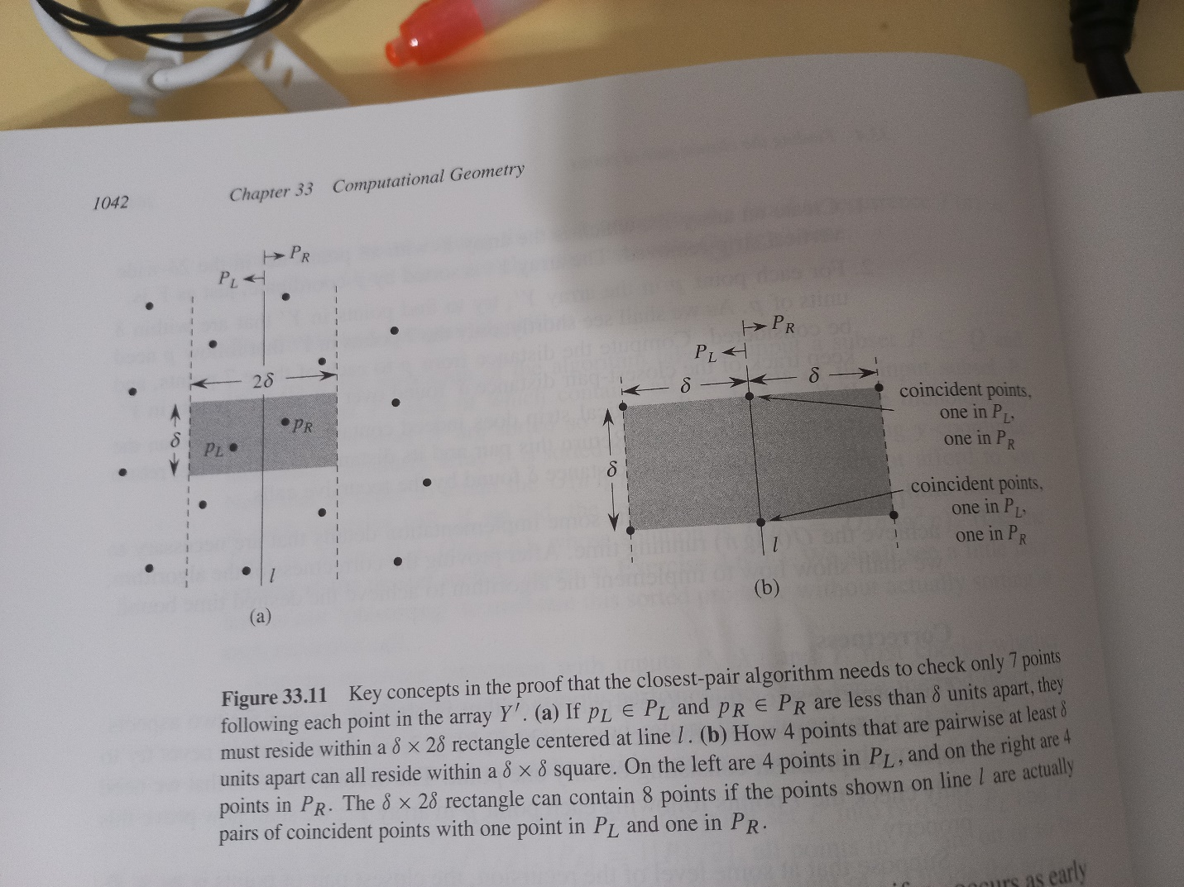

$$Fig 2 is the key concepts of it.$$

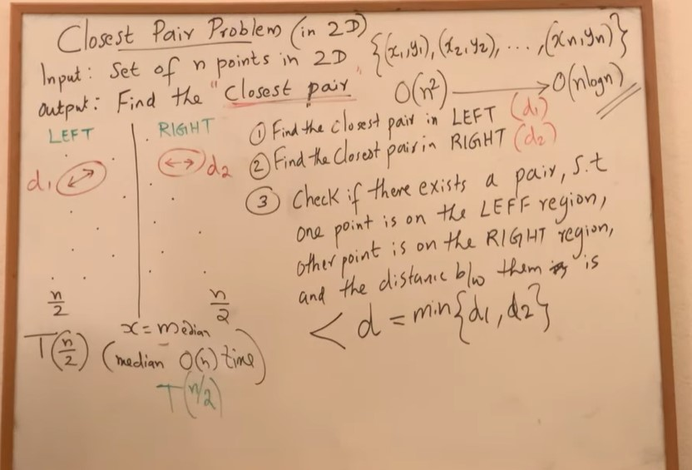

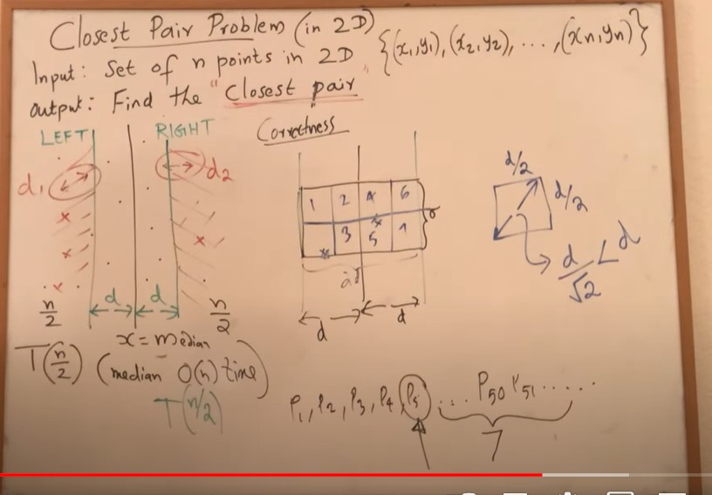

[analysis]

$$\left(1\right)brute-force algorithm:$$

$$total O(n^{2})$$

$$\left(2\right)divide-and-conquer algorithm:$$

$$total O\left(n \lg{n}\right)$$

[pf]

$$\left(1\right)For brute-force algorithm:$$

$$We have to find \left({n \atop 2}\right) possibilites.$$

$$\left(2\right)For divide-and-conquer algorithm:$$

$$Let T\left(n\right) be the time complexity of the problem for n points.$$

$$We have the recurrence relation.$$

$$T\left(n\right)=T\left(\frac{n}{2}\right)+T\left(\frac{n}{2}\right)+O\left(n\right)$$

$$=>T\left(n\right)=O(\lg{n})$$

[method]

$$\left(1\right)brute-force algorithm:$$

$$find all possibilities.$$

$$\left(2\right)divide-and-conquer algorithm:$$

$$It can take 3 parts.$$

$$\left(1\right)divide:$$

$$split it into 2 regions left and right.$$

$$\left(2\right)conquer:find smallest distance.$$

$$let d_{L} be smallest distance in left region and$$

$$d_{R} be smallest distance in right region.$$

$$\left(3\right)check:$$

$$check the situation occurs.$$

$$An point in left region called p_{L} and$$

$$the other point in right region p_{R}.$$

$$Is the distance of p_{L} and p_{R} smaller than$$

$$the minimum of d_{L} and d_{R}.$$

$$\left(2.1\right)Divide:$$

$$Slice it into 2 parts P_{L} and P_{R} such that$$

$$\left|P_{L}\right|=\left\lceil \frac{\left|P\right|}{2}\right\rceil and \left|P_{R}\right|=\left\lfloor \frac{\left|P\right|}{2}\right\rfloor$$

$$,and all points in P_{L} are left on or to the line l.$$

$$All points in P_{R} are right on or to the line r.$$

$$Divide array X into X_{L} and X_{R}$$

$$sorted by monotonically increasing x-coordinate.$$

$$Divide array Y into Y_{L}and Y_{R}.$$

$$orted by monotonically increasing y-coordinate.$$

$$\left(2.2\right)Conquer:$$

$$Having divided P into P_{L} and P_{R}.$$

$$Make two recursive calls.$$

$$Let the two recursive calls return δ_{L} and δ_{R} respectively.$$

$$then let δ=\min\left(δ_{L},δ_{R}\right)$$

$$\left(2.3\right)Combine:$$

$$The closest pair is either the pair with distance δ$$

$$found by one of the recursive calls,$$

$$or it is the points with one point in P_{L} and the other in P_{R}$$

$$whose distance is less than δ.$$

$$Observe that if a pair of points has distance less than δ,$$

$$then both points of the pair must be within δ units in l.$$

$$To find a such pair, if one exists, we do the following:$$

$$\left(2.3.1\right)Create an array Y^{'}, which is the array Y$$

$$with all points NOT$$

$$in the 2δ-wide vertical strip removed.$$

$$The array Y^{'} is sorted by y-coordinate, just as Y is.$$

$$\left(2.3.2\right)For each point p in the array Y^{'},$$

$$try to find points in Y^{'} that are within δ units of p.$$

$$\left(2.3.3\right)If δ^{'}<δ,$$

$$then the vertical strip does indeed contains$$

$$a closer pair than the recursive calls found. And return δ^{'}.$$

$$Otherwise, return the closest pair and its distance δ$$

$$found by the recursive calls.$$

$$Return\min\left(δ^{'},δ\right).$$

|  |  |  |
| --- | --- | --- |
| $$method$$ | $$brute-force$$ | $$divide-and-conquer$$ |
| $$analysis$$ $$(time complexity)$$ | $$O(n^{2})$$ | $$O(n\lg{n})$$ |
|  |  |  |
|  |  |  |
|  |  |  |

[ref]

[Closest pair of points problem - Wikipedia](https://en.wikipedia.org/wiki/Closest_pair_of_points_problem)

[2.5 - Closest Pair of Points using Divide and Conquer algorithm in O(n log n) time. - YouTube](https://www.youtube.com/watch?v=kCLGVat2SHk&t=11s)

$$algorithm textbook CH33-4 p1039$$