Ford Fulkerson algorithm

[abbr]

FFA

[intro]

It is an algorithm that solves a maximum flow in a flow network.

[analysis]

Time complexity:

$$O\left(\left|E\right|*f\right)$$

$$where \left|E\right| is number of edges and f is a flow graph.$$

[analogy]

$$1. It is similar to water flow.$$

[E.g.]

The original flow graph.

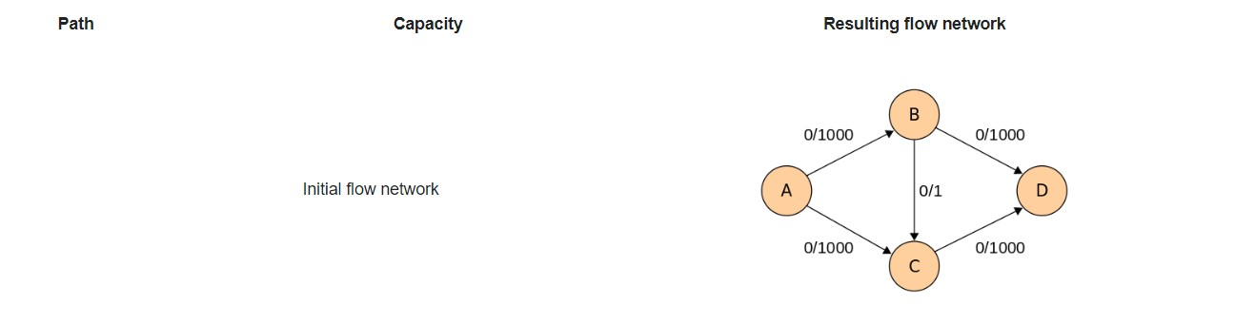

After 1st round

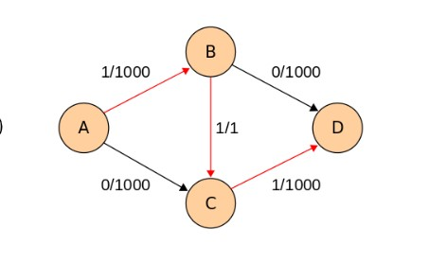

[step]

$$1. initialize:$$

$$initialize all flow function as zero$$

$$f\left(u,v\right)=0 ∀all edges \left(u,v\right)$$

$$2. find min:$$

$$find c_{f}\left(p\right)=\min\left\{c_{f}\left(u,v\right):\left(u,v\right)∈p\right\}$$

$$3. update:$$

$$update the value ∀\left(u,v\right)∈p$$

$$In the edge f\left(u,v\right), it will send flow along the path.$$

$$f\left(u,v\right)=f\left(u,v\right)+c_{f}\left(p\right)$$

$$Conversely, in the edge f\left(v,u\right), it will return the flow later.$$

$$f\left(v,u\right)=f\left(v,u\right)-c_{f}(p)$$

[pseudo code]

**Algorithm** Ford–Fulkerson

**Inputs** Given a Network {\displaystyle G=(V,E)} with flow capacity *c*, a source node *s*, and a sink node *t*

**Output** Compute a flow *f* from *s* to *t* of maximum value

1. {\displaystyle f(u,v)\leftarrow 0} for all edges {\displaystyle (u,v)}
2. While there is a path *p* from *s* to *t* in {\displaystyle G_{f}}, such that {\displaystyle c_{f}(u,v)>0} for all edges {\displaystyle (u,v)\in p}:
   1. Find {\displaystyle c_{f}(p)=\min\{c_{f}(u,v):(u,v)\in p\}}
   2. For each edge {\displaystyle (u,v)\in p}
      1. {\displaystyle f(u,v)\leftarrow f(u,v)+c_{f}(p)} (*Send flow along the path*)
      2. {\displaystyle f(v,u)\leftarrow f(v,u)-c_{f}(p)} (*The flow might be "returned" later*)

[ref]

Document:

my note (maximum-flow)

website

[Ford–Fulkerson algorithm - Wikipedia](https://en.wikipedia.org/wiki/Ford%E2%80%93Fulkerson_algorithm)