Grid multiplication method

[intro]

$$It can mulitply two real numbers.$$

$$This method splits a number into$$

$$many constant time 10-base power numbers.$$

$$Then we mulitply them and make a grid, summing them.$$

$$Since it draws a grid,$$

$$it is called grid multiplication method.$$

[E.g.]

$$34*13=\left(30+4\right)*\left(10+3\right)$$

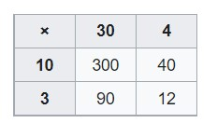

[analysis]

$$Time complexity:O\left(n^{2}\right)$$

$$recurrence:T\left(n\right)=4T\left(\frac{n}{2}\right)+n$$

$$T\left(1\right)=1$$

[pseudo code]

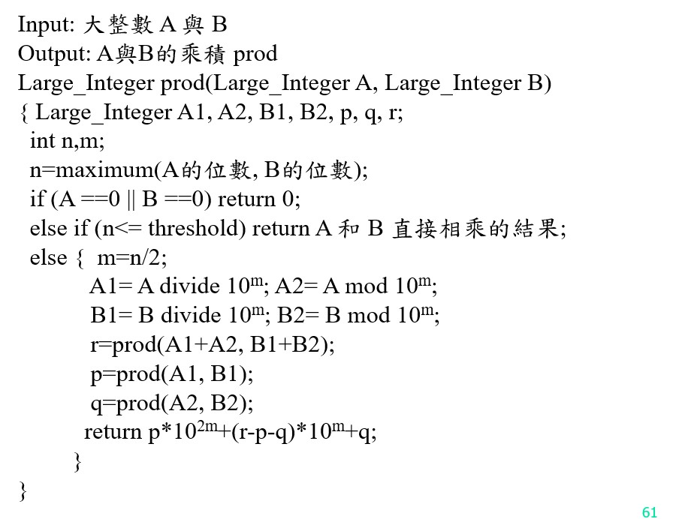

[ref]

[Multiplication algorithm - Wikipedia](https://en.wikipedia.org/wiki/Multiplication_algorithm)