Karatsuba multiplication

[intro]

$$It is a kind of divide-and-conquer algorithm$$

$$and it uses the concept of reforming mathematics.$$

$$It behaves similarly as Strassen^{'}s algorithm.$$

[step]

$$Given two m-based input$$

$$X=x_{1}*m+x_{2},Y=y_{1}*m+y_{2}$$

$$\left(1\right)F=x_{1}*y_{1}$$

$$\left(2\right)G=x_{2}*y_{2}$$

$$\left(3\right)H=\left(x_{1}+x_{2}\right)*\left(y_{1}+y_{2}\right)$$

$$\left(4\right)K=H-F-G=x_{1}*y_{2}+x_{2}*y_{1}$$

$$\left(5\right)X*Y=F*m^{2}+K*m+G$$

[proof]

$$First prove that$$

$$K=H-F-G=x_{1}*y_{2}+x_{2}*y_{1}$$

$$K=H-F-G$$

$$=\left(x_{1}+x_{2}\right)*\left(y_{1}+y_{2}\right)-x_{1}*y_{1}-x_{2}*y_{2}$$

$$=\left(x_{1}*y_{1}+x_{1}*y_{2}+x_{2}*y_{1}+x_{2}*y_{2}\right)-x_{1}*y_{1}-x_{2}*y_{2}$$

$$=x_{1}*y_{2}+x_{2}*y_{1}$$

$$X*Y=\left(x_{1}*m+x_{2}\right)*\left(y_{1}*m+y_{2}\right)$$

$$=\left(x_{1}y_{1}\right)*m^{2}+\left(x_{1}y_{2}+x_{2}y_{1}\right)*m+x_{2}y_{2}$$

$$=F*m^{2}+K*m+G$$

$$Hence proved.$$

[time complexity]

$$Running time:O\left(n^{\lg{3}}\right)≈O\left(n^{1.585}\right)$$

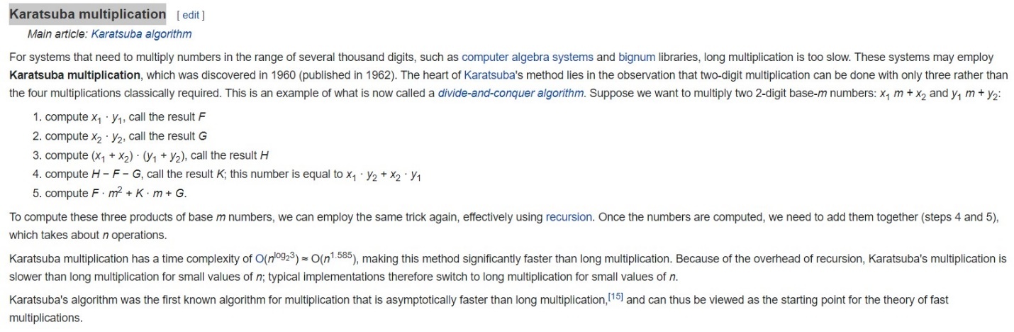

[ref]

[Multiplication algorithm - Wikipedia](https://en.wikipedia.org/wiki/Multiplication_algorithm)