Lattice multiplication method

[intro]

[step]

$$\left(1\right)Draw a grid and split each box of the grid into$$

$$two parititions-$$

$$upperleft and rightdown .$$

$$\left(2\right)Multiply the ith row and jth column as a number n.$$

$$\left(3\right)Place the last digit of n \left(n\%10\right) to$$

$$right-down pieces.$$

$$\left(4\right)Place other digits \left(\frac{n}{10}\right) to left-up pieces.$$

$$\left(5\right)Sum up them diagonal and$$

$$don^{'}t forget carry it.$$

[E.g.]

$$345*12=4140$$

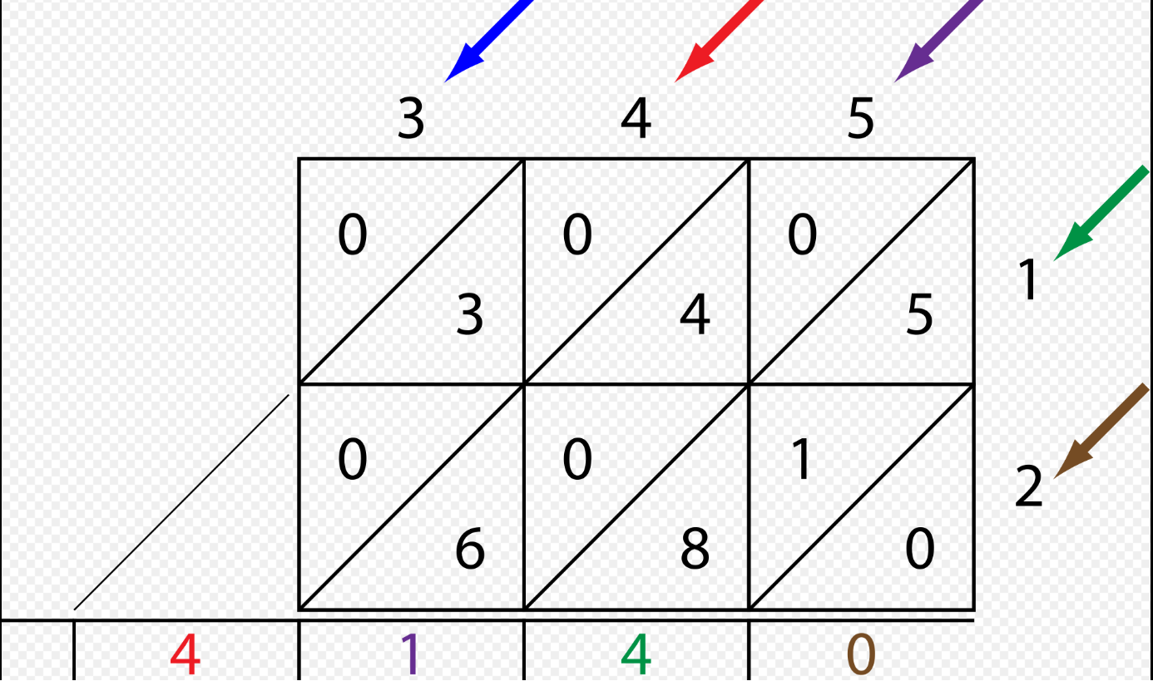

[ref]

[Multiplication algorithm - Wikipedia](https://en.wikipedia.org/wiki/Multiplication_algorithm)