NP-Completeness

[term]

A problem can be one of these.

1. P:
$$Polynomial time. O\left(n^{k}\right)∀k∈R.$$

2. NP:
$$Not Polynomial time. NOT O(n^{k})∀k∈R$$

3. NPC:
$$NP-complete.$$

$$Check solution-O\left(n^{k}\right)$$

$$Find solution NOT O\left(n^{k}\right)∀k∈R.$$

$$A language L ⊆{\left\{0,1\right\}}^{*} is NPC iff$$

$$these condition are ALL required.$$

$$\left(1\right)L∈NP,and$$

$$\left(2\right)L^{'}≤_{p} L for every L^{'}∈NP$$

$$where the notation≤_{p} is defined in textbook$$

$$(or in my other notes,$$

$$named NP-Completeness reducibility)$$

4. NP-Hard:
$$It is NP and can be reducible to L in polynomail time.$$

$$A language L ⊆{\left\{0,1\right\}}^{*} is NPC iff$$

$$L^{'}≤_{p} L for every L^{'}∈NP$$

5. Co-NP:

$$\overline{L}∈NP$$

|  |  |  |  |
| --- | --- | --- | --- |
| Problem | Abbr | Time complexity | |
| Check solution | Find solution |
| P | $$Determinstic$$ $$polynomial time$$ | $$O(n^{k})$$ | $$O(n^{k})$$ |
| NP | $$No-determinstic$$ $$polynomial time$$ | $$NOT O(n^{k})$$ | $$NOT O(n^{k})$$ |
| NPC | $$NP-complete$$ | $$O(n^{k})$$ | $$NOT O(n^{k})$$ |
| Co-NP | $$complement-NP$$ |  |  |

Nobody can prove that $P≠NP$ and $P==NP$, but almost people believe that $P≠NP$.

[theorem]

$$If any NPC problem can be solve in polynomial time, then$$

$$P=NP.$$

$$Equivalently, if any problem in NP can NOT be solved$$

$$in polynomial time, then$$

$$no NPC problem can be solved in polynomial time.$$

$$circuit-satisfiability problem ∈NP.$$

$$circuit-satisfiability problem ∈NP-hard$$

$$circuit-satisfiability problem ∈NPC$$

$$If L is a language such that$$

$$L^{'}≤_{p}L for some L^{'}∈NPC,$$

$$then L is NP-hard.$$

$$In addition, if L∈NP,$$

$$then L∈NPC.$$

$$Satisfiablitity of boolean formulas is NPC.$$

[pf]

$$Suppose that L∈P and also that L∈NPC.$$

$$∀ L^{'}∈NP,we have L^{'}≤_{p}L$$

$$=>L^{'}∈P.$$

2. Skip

$$Let L be any language in NP.$$

$$We shall describe a polynomial-time algorithm F$$

$$computing a reduction function f that$$

$$maps every binary string x to a circuit$$

$$C=f\left(x\right)$$

$$such that x∈L iff C∈CIRCUIT-SAT.$$

$$Since L∈NP,$$

$$∃an aglorithm A that verifies L in polynomial time.$$

$$The algorithm F that we shall construct uses$$

$$the two-input algorithm A to$$

$$compute the reduction functionn f.$$

$$Let T\left(n\right) donate the worst-case running time of$$

$$algorithm A on length n-input strings, and$$

$$let k≥1 be a constant such that$$

$$T\left(n\right)=O\left(n^{k}\right)$$

$$and the length of the certificate is$$

$$O\left(n^{k}\right).$$

$$(The running time of A is actually a polynomial$$

$$in the total input size,which includes both an input string and$$

$$a certificate, but since the length of the certficate$$

$$is polynomial in length n of the input string,$$

$$the running time is polynomial in n.)$$

$$Intermediate of theorem 2 and 3.$$

$$By definition of NPC, NPC=NP and NP-hard$$

$$Since L^{'}is NPC,$$

$$for all L^{''},we have L^{''}≤_{p}L^{'}$$

$$By supposition, L^{'}≤_{p}L and$$

$$by transivity we have L^{''}≤_{p}L,$$

$$which shows that L is NP-hard.$$

$$If L∈NP,we have L∈NPC.$$

$$We start by arguing SAT∈NP.$$

$$Then we prove that SAT is NP-hard$$

$$by showing that CIRCUIT-SAT≤_{p}SAT.$$

$$\left(1\right)To show that SAT∈NP,we show that$$

$$a certificate consisting ofa satisfying assignment$$

$$for an input formula ϕ can be verified in polynomial time.$$

$$The verifying algorithm simply replaces each variable$$

$$in the formula with its correspending value and then$$

$$evaluates the expression.$$

$$\left(much as we did in equation \left(34.2\right) above.\right)$$

$$This task is easy to do in polynomial time.$$

$$If the expression evaluates to 1, then$$

$$the algorithm has verified that the formula is satisifiable.$$

$$Thus,SAT∈NP.$$

$$\left(2\right)To show that SAT is NP-hard.$$

$$Now we need to show how to reduce any instance of$$

$$circuit satisfiablity to any instance of$$

$$formula satisfiablity in polynomial time.$$

$$We can use mathematical induction to prove it.$$

$$We simply look at the gate that$$

$$produces the circuit output$$

$$and inductively express each of the gate^{'}s inputs as formula.$$

$$Then, we obtain the formula for the circuit$$

$$by writing an expression$$

$$that applies the gate^{'}s function to its input^{'}s formulas.$$

$$Unfortunately, this straightforward method does NOT$$

$$amount to a polynomial time reduction.$$

$$…$$

$$Thus, we have shown that CIRCUIT-SAT≤_{p}SAT,$$

$$which completes the proof.$$

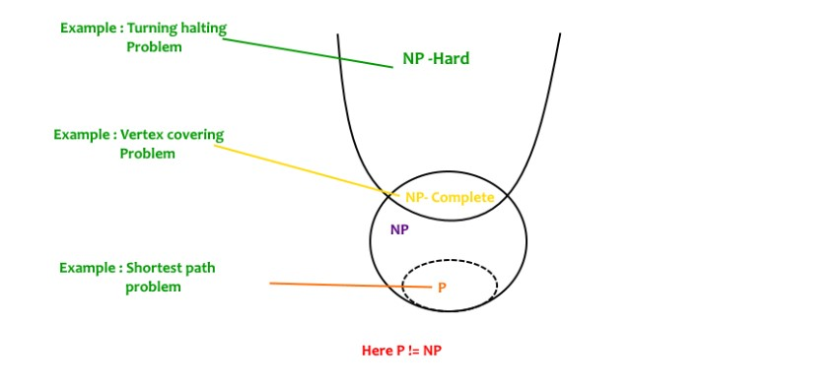

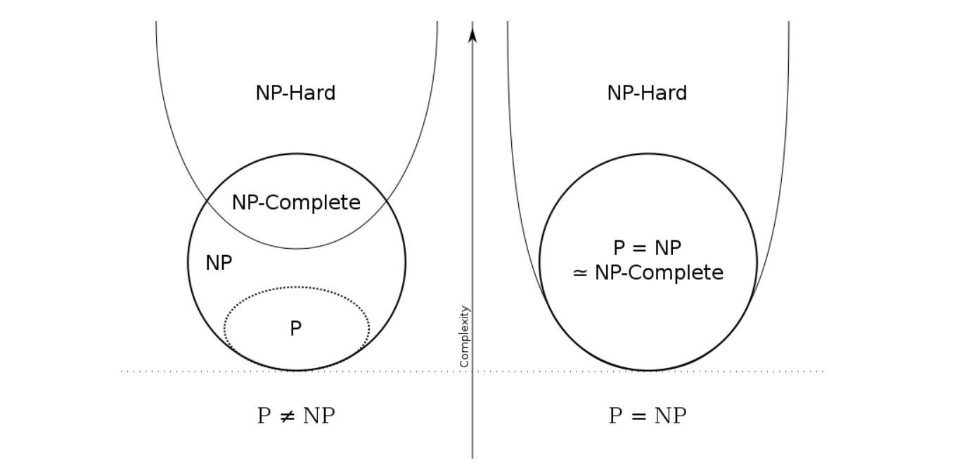

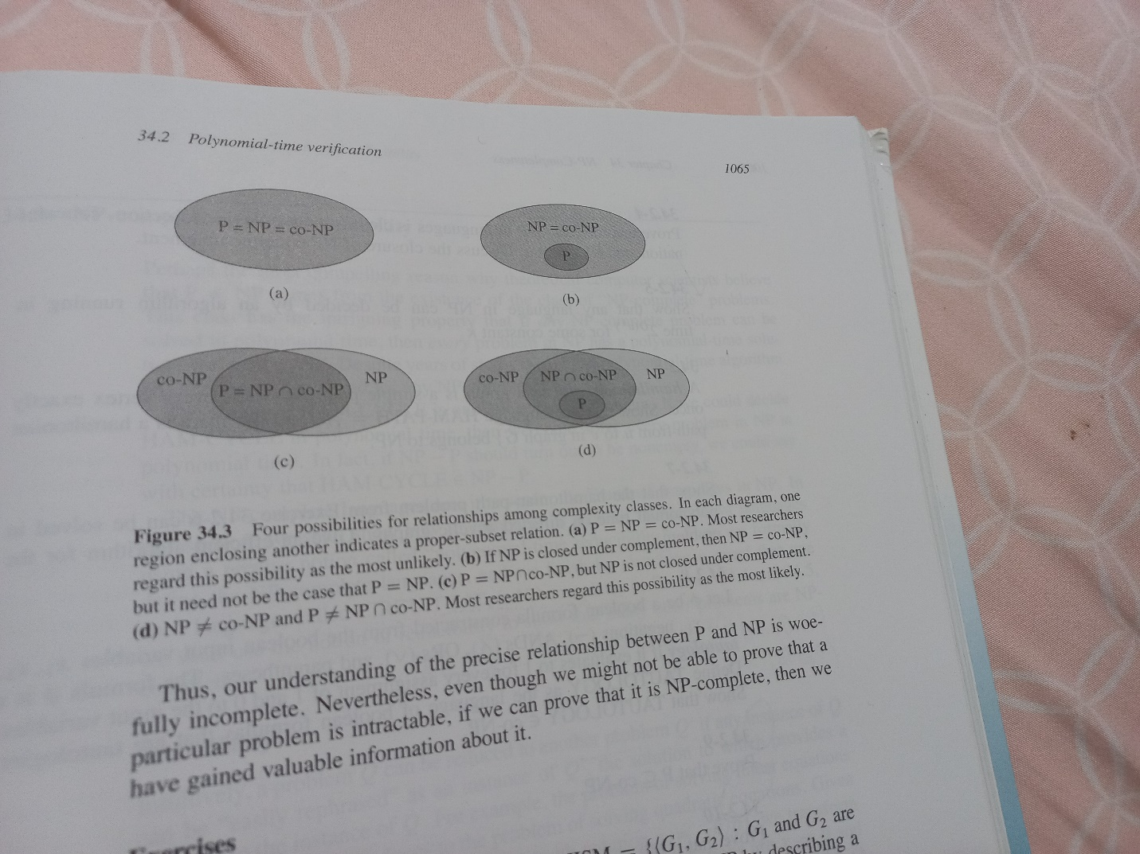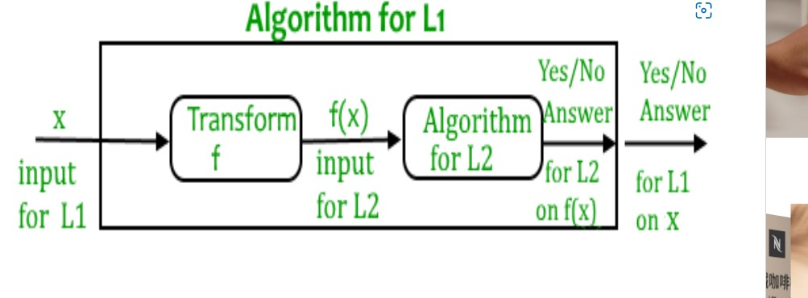

[ref]

[NP-Completeness | Set 1 (Introduction) - GeeksforGeeks](https://www.geeksforgeeks.org/np-completeness-set-1/)

[輕鬆談演算法的複雜度分界：什麼是P, NP, NP-Complete, NP-Hard問題 - YC Note (ycc.idv.tw)](https://www.ycc.idv.tw/algorithm-complexity-theory.html)