Russian peasant multiplication

[intro]

[step]

$$The multipicand is converted to binary representation.$$

$$Then each of them multiply the multiplier, summing them.$$

$$See the following example.$$

[E.g.]

$$238*13$$

|  |  |  |  |  |
| --- | --- | --- | --- | --- |
| $$Round$$ | $$Quotent$$ | $$Power of 2$$ | $$Remainder$$ | $$result$$ |
| $$0$$ | $$13$$ | $$1$$ | $$1$$ | $$238$$ |
| $$1$$ | $$6$$ | $$2$$ | $$0$$ | $$496$$ |
| $$2$$ | $$3$$ | $$4$$ | $$1$$ | $$952$$ |
| $$3$$ | $$1$$ | $$8$$ | $$1$$ | $$1904$$ |
|  |  |  |  |  |
| $$total$$ | $$1*238+0*496+1*952+1*1904=3094$$ | | | |

$$We can notice that {13}_{\left(10\right)}={1101}_{\left(2\right)}$$

$$Thus,$$

$$13*238=\left(2^{0}+0*2^{1}+2^{2}+2^{3}\right)*238$$

$$2^{0}*238+0*2^{1}*238+2^{2}*238+2^{3}*238$$

$$Here its technique relates about binary representation$$

$$and reformed mathematics.$$

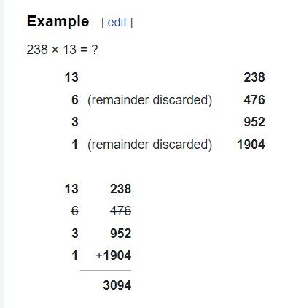

[ref]

[Ancient Egyptian multiplication - Wikipedia](https://en.wikipedia.org/wiki/Ancient_Egyptian_multiplication)

[Ancient Egyptian multiplication - Wikipedia](https://en.wikipedia.org/wiki/Ancient_Egyptian_multiplication)