Strassen’s algorithm

[intro]

$$It can solve matrix multiplication.$$

[step]

$$For two matrix A_{2*2},B_{2*2}$$

$$We must have C_{2*2}=A*B$$

$$\left(1\right)Find m_{1} to m_{7}.$$

$$m_{1}=\left(A_{1,1}+A_{2,2}\right)*\left(B_{1,1}+B_{2,2}\right)$$

$$m_{2}=\left(A_{2,1}+A_{2,2}\right)*\left(B_{1,1}\right)$$

$$m_{3}=\left(A_{1,1}\right)*\left(B_{1,2}-B_{2,2}\right)$$

$$m_{4}=\left(A_{2,2}\right)*\left(B_{2,1}-B_{1,1}\right)$$

$$m_{5}=\left(A_{1,1}+A_{1,2}\right)*\left(B_{2,2}\right)$$

$$m_{6}=\left(A_{2,1}-A_{1,1}\right)*\left(B_{1,1}+B_{1,2}\right)$$

$$m_{7}=\left(A_{1,2}-A_{2,2}\right)*\left(B_{2,1}+B_{2,2}\right)$$

$$\left(2\right)$$

$$C_{1,1}=m_{1}+m_{4}-m_{5}+m_{7}$$

$$C_{1,2}=m_{3}+m_{5}$$

$$C_{2,1}=m_{2}+m_{4}$$

$$C_{2,2}=m_{1}-m_{2}+m_{3}+m_{6}$$

[proof]

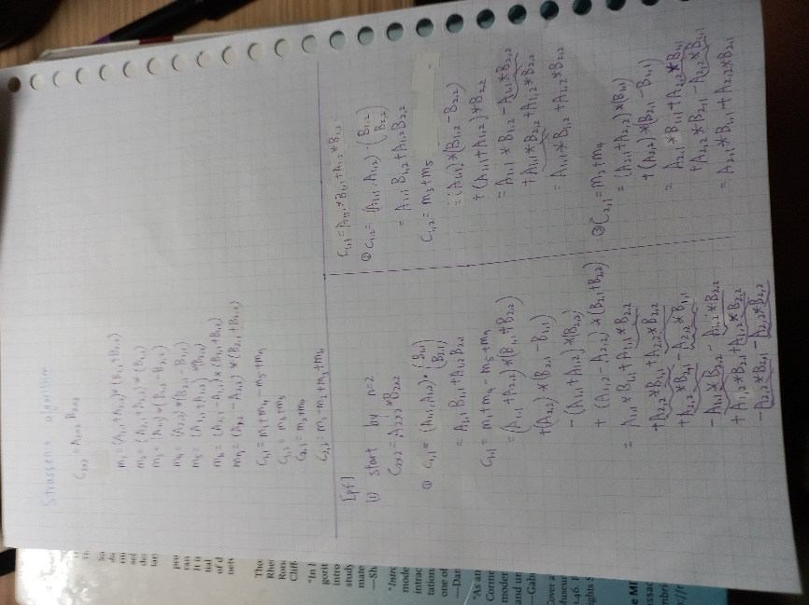

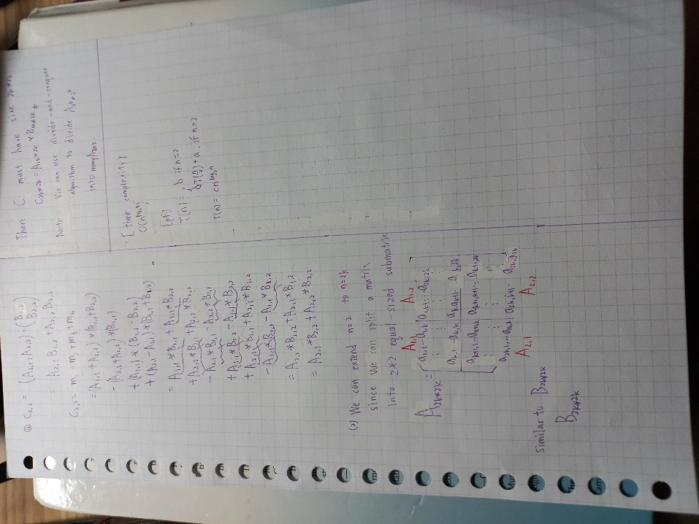

[analysis]

$$time complexity:O\left(n^{\lg{7}}\right)≈O\left(n^{2.81}\right)$$

$$reccurence:$$

$$T\left(n\right)=\left\{\begin{aligned}b,if n≤2 \\ 7T\left(\frac{n}{2}\right)+an^{2},if n>2\end{aligned}\right.$$

$$=>T\left(n\right)=O(n^{\lg{2}})$$

[ref]

[Strassen algorithm - Wikipedia](https://en.wikipedia.org/wiki/Strassen_algorithm)