String matching

[intro]

$$Check two strings are matchings or not.$$

$$\left(1\right)concatentaion:$$

$$The concatentaion of x and y denoted xy.$$

$$\left(2\right)repetition:$$

$$The repetition of x denoted x^{k}=xx…x \left(k times\right)$$

$$∀k∈N=\{0,1,2,…\}$$

$$\left(3\right)signma star:$$

$$∑^{*} the set of all finite-length strings formed by ∑.$$

$$\left(4\right)empty string:$$

$$ε$$

$$\left(5\right)prefix:$$

$$w is a prefix of x denoted w⊏x iff x=wy ∀y∈∑^{*}$$

$$\left(6\right)suffix:$$

$$w is a suffix of x denoted w ⊐x iff x=yw ∀y∈∑^{*}$$

$$\left(7\right)length:$$

$$The length of x donated \left|x\right|.$$

[identity]

$$∀x,y,w∈∑$$

$$∀k∈N=\{0,1,2,…\}$$

$$\left(1\right)εx=xε=x$$

$$\left(2\right)x⊏y iff wx⊏wy$$

$$\left(3\right)x⊐y iff xw⊐yw$$

$$\left(4\right)\left|ε\right|=0$$

$$\left(5\right)\left|x\right|+\left|y\right|=\left|xy\right|$$

$$\left(6\right)x⊏y=>\left|x\right|≤\left|y\right|$$

$$\left(7\right)x⊐y=>\left|x\right|≥\left|y\right|$$

$$\left(8\right)\left|x^{k}\right|=\left|x\right|*k$$

$$\left(9\right)transitivity:x⊏y,y⊏z=>x⊏z$$

$$\left(10\right)transitivity:x⊐y,y⊐z=>x⊐z$$

[theorem]

$$\left(1\right)Overlapping-suffix lemma:$$

$$Suppose that x,y,z are strings such that x⊐z,y⊐z.$$

$$If \left|x\right|≤\left|y\right|=>x⊐y$$

$$If \left|x\right|≥\left|y\right|=>y⊐x$$

$$If \left|x\right|=\left|y\right|=>x=y$$

[pf]

$$\left(1\right)look at the following figure.$$

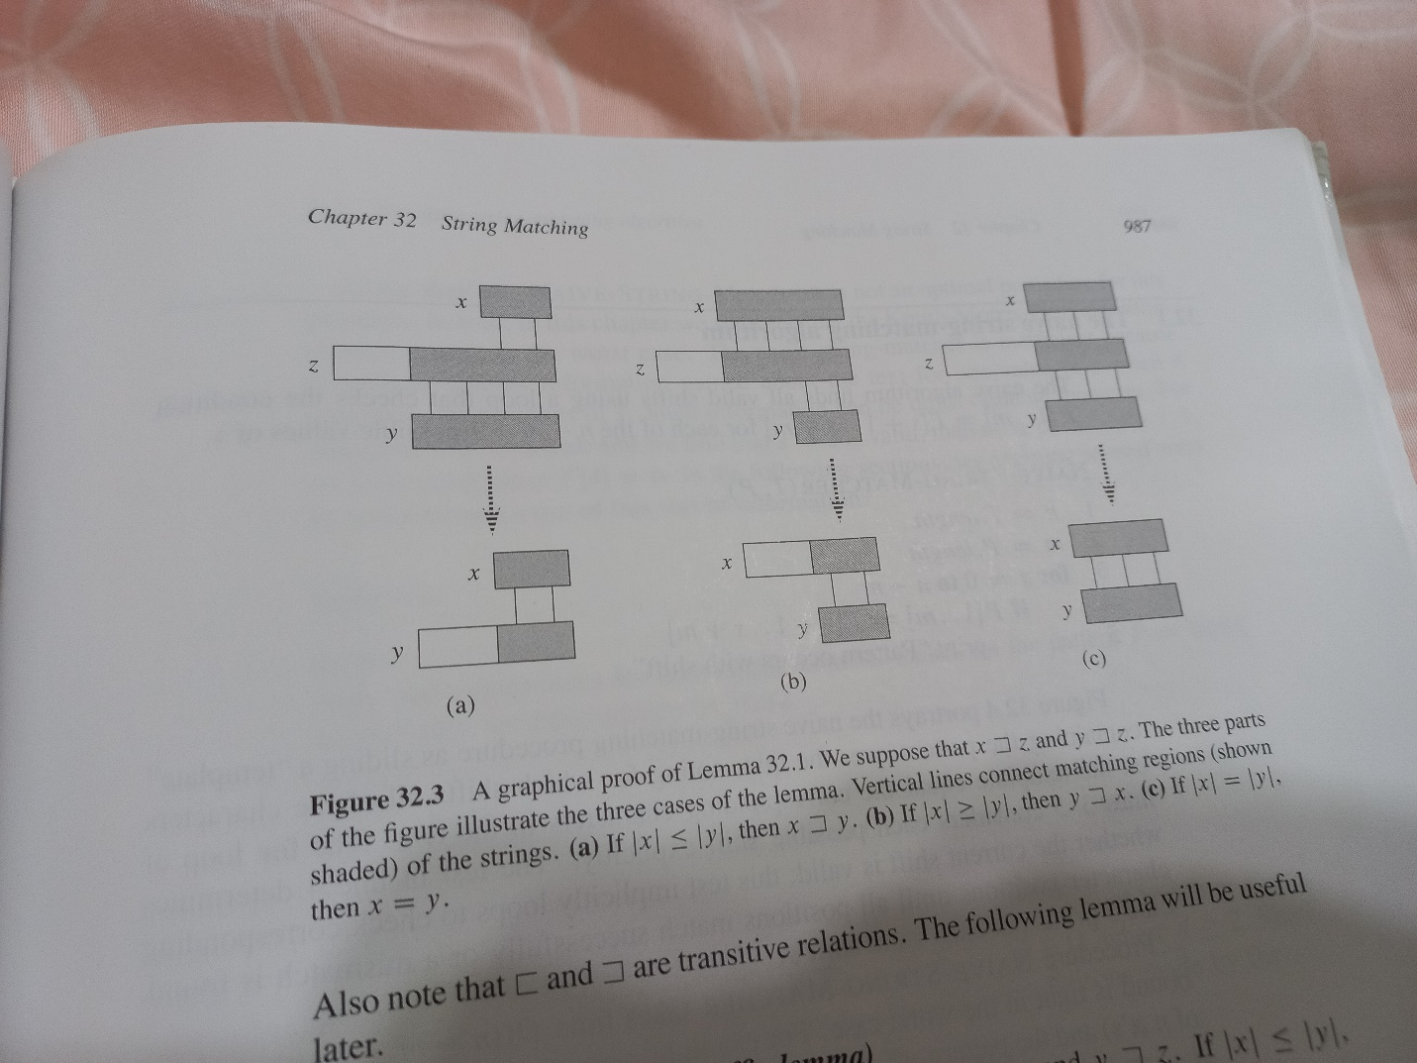

[ref]